Wrapper

Integer -> Double is not possible as they all belong to Number Class. Siblings

Interger-> int (AutoUnboxing) – double (implicit type cast)

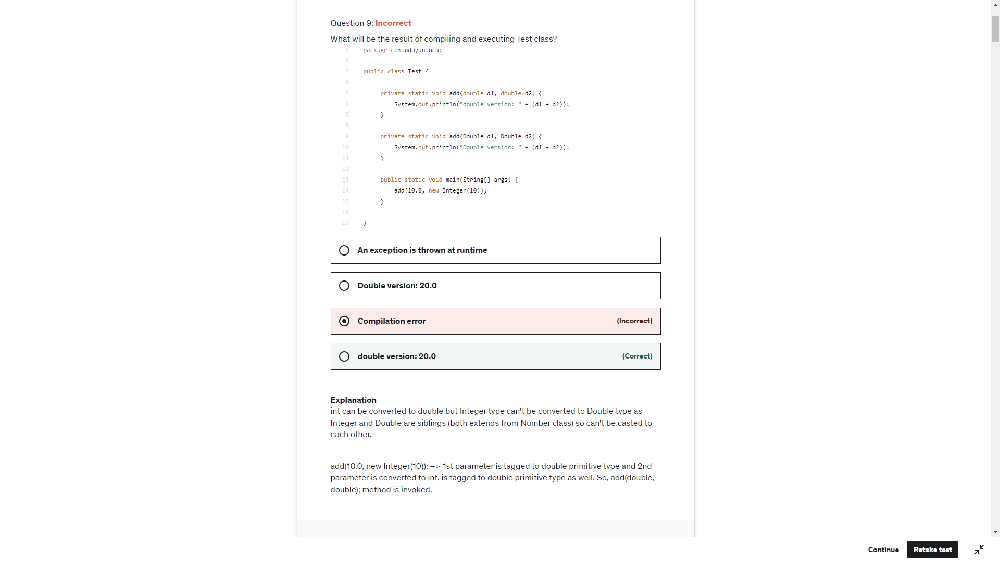

**Two instance of following wrapper objects**

**Boolean, Byte ,**

**Character from (\u0000 to \u007f (7f equals to 127))**

**Short and Integer from -128 to 127.  (Integer and short between value of -128 to 127, byte range) , created through autoboxing will always be same if their primitive values are same:**

Integer d2 = 127;  
Integer d3 = 127;  
System.*out*.println(d2==d3); - True

Boolean b = true;  
Boolean a = true;  
System.*out*.println(a==b);

Boolean b = null;  
System.*out*.println(b); -> null

System.*out*.println(b.toString()); -> Null Pointer Exception

Boolean b = null;  
if(b){ -> Unboxing of b produces null pointer exception  
 System.*out*.println("1");  
}

**For 1st statement, list.add(27); => Auto-boxing creates an integer object for 27.**

**For 2nd statement, list.add(27); => Java compiler finds that there is already an Integer object in the memory with value 27, so it uses the same object.**

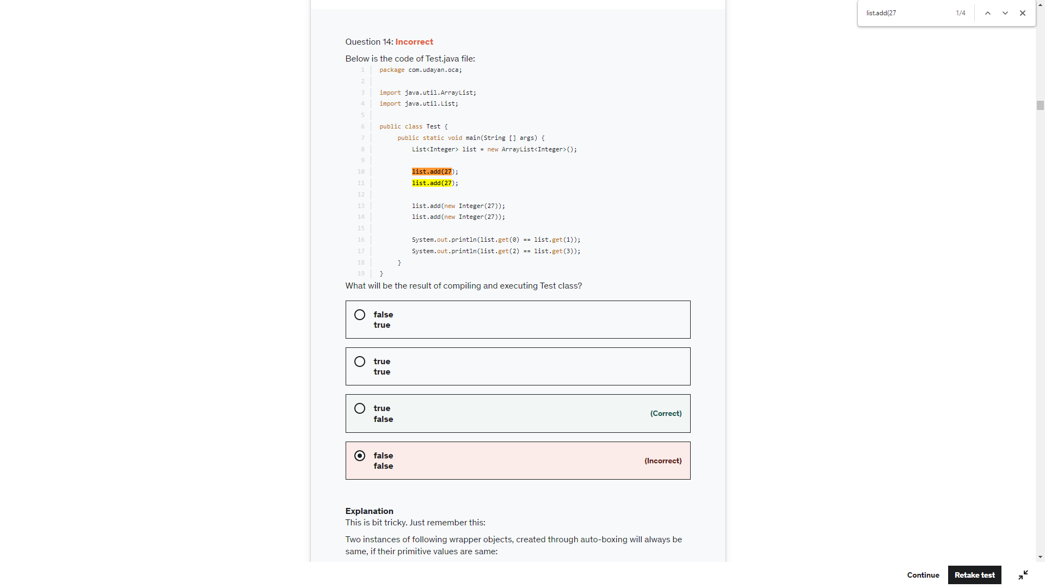

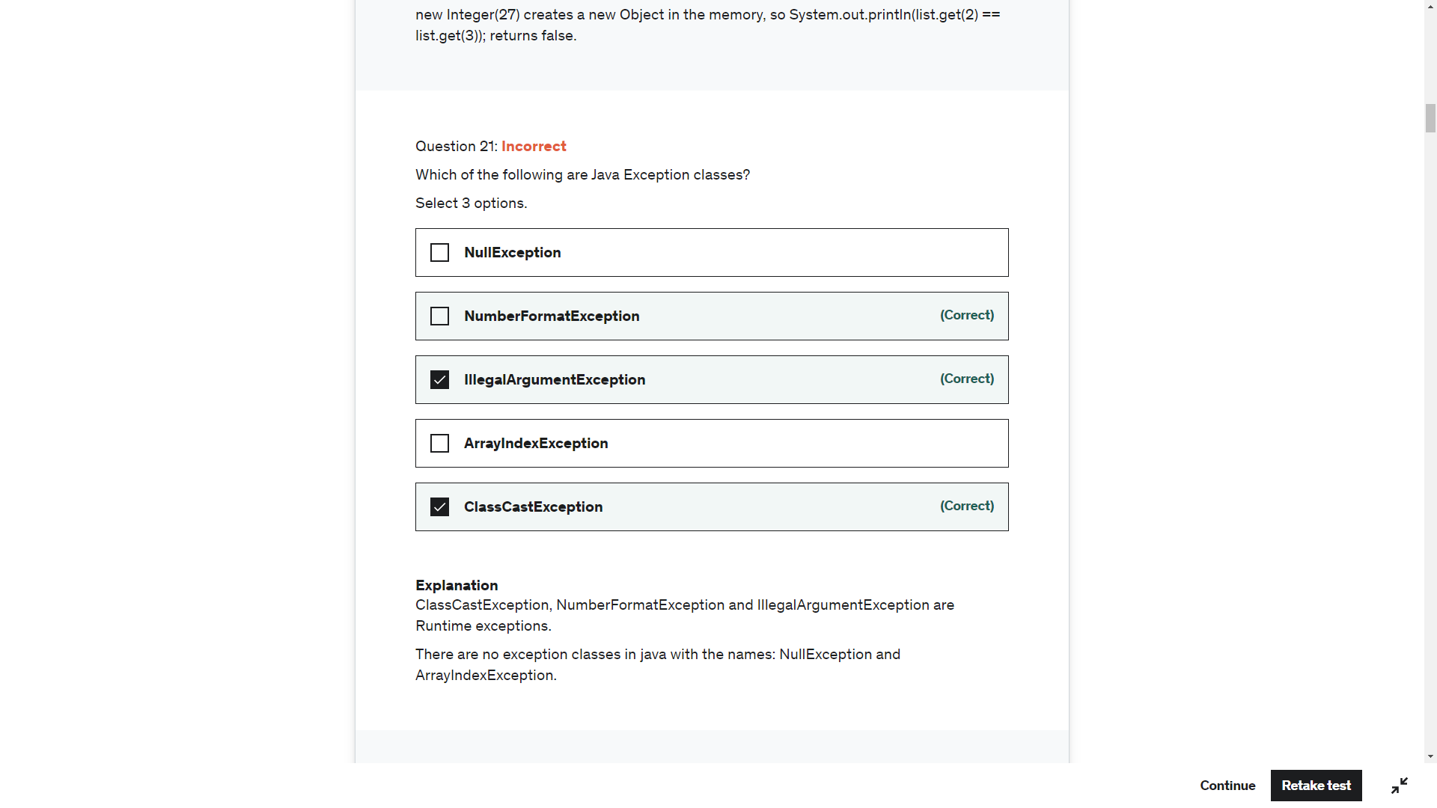

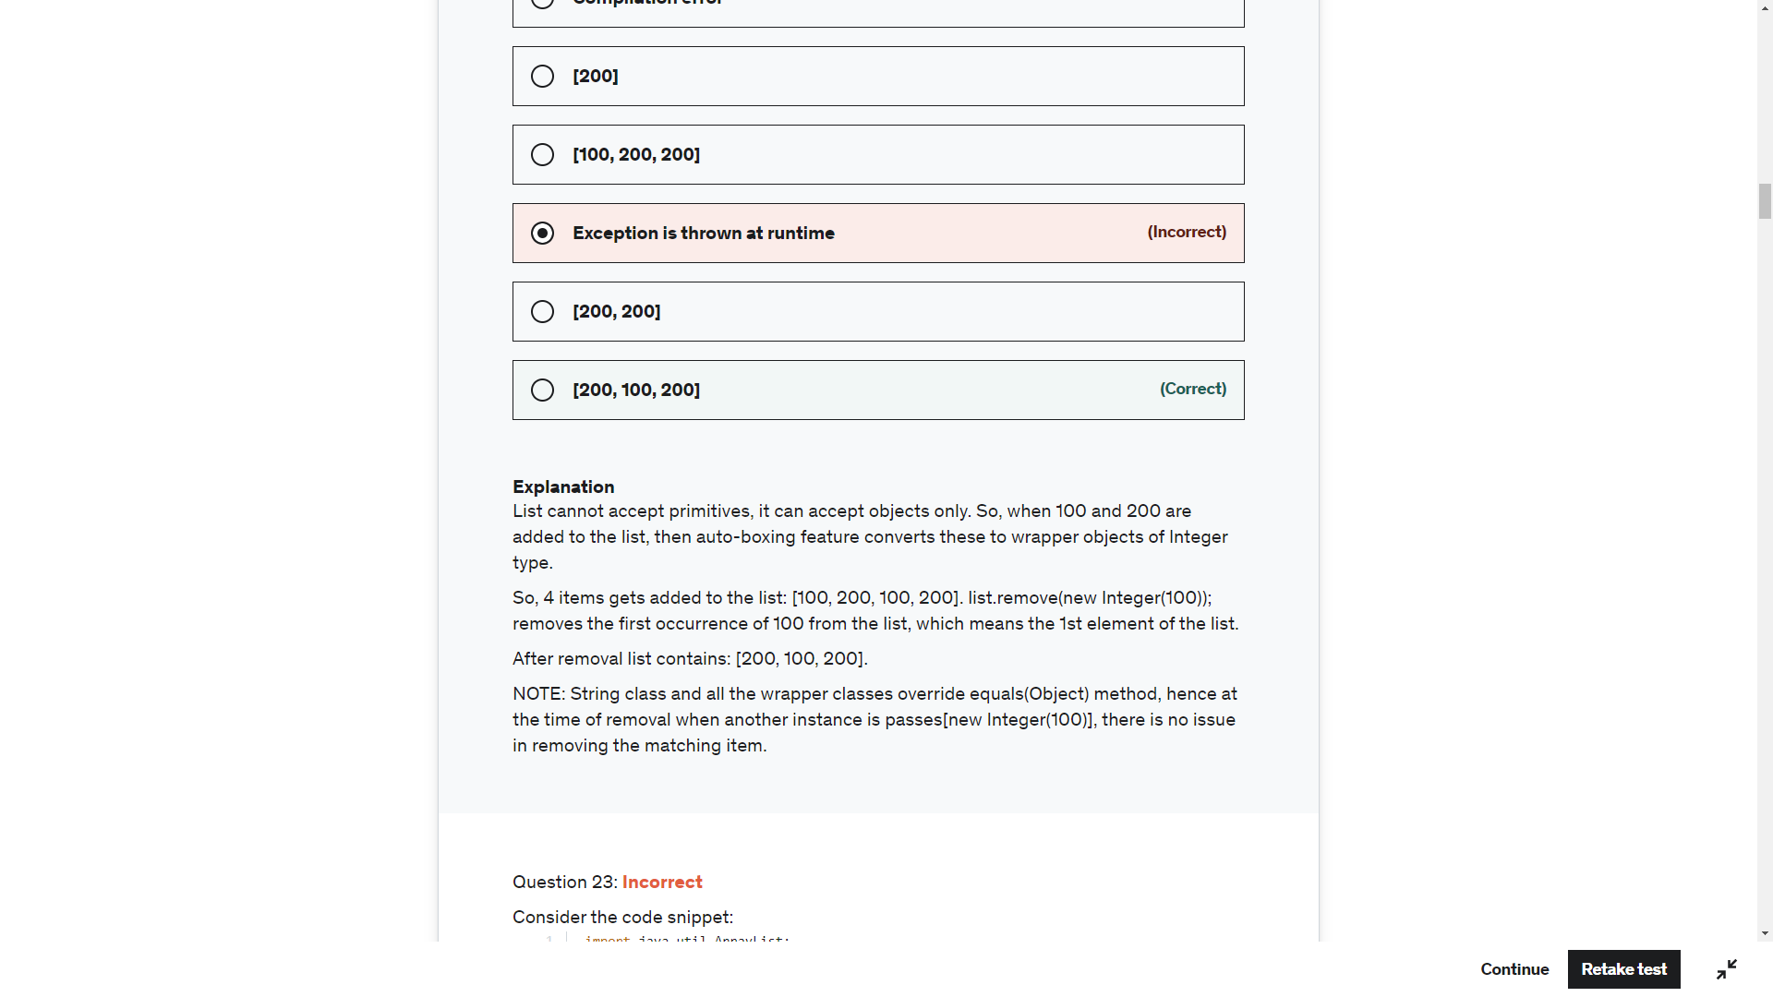

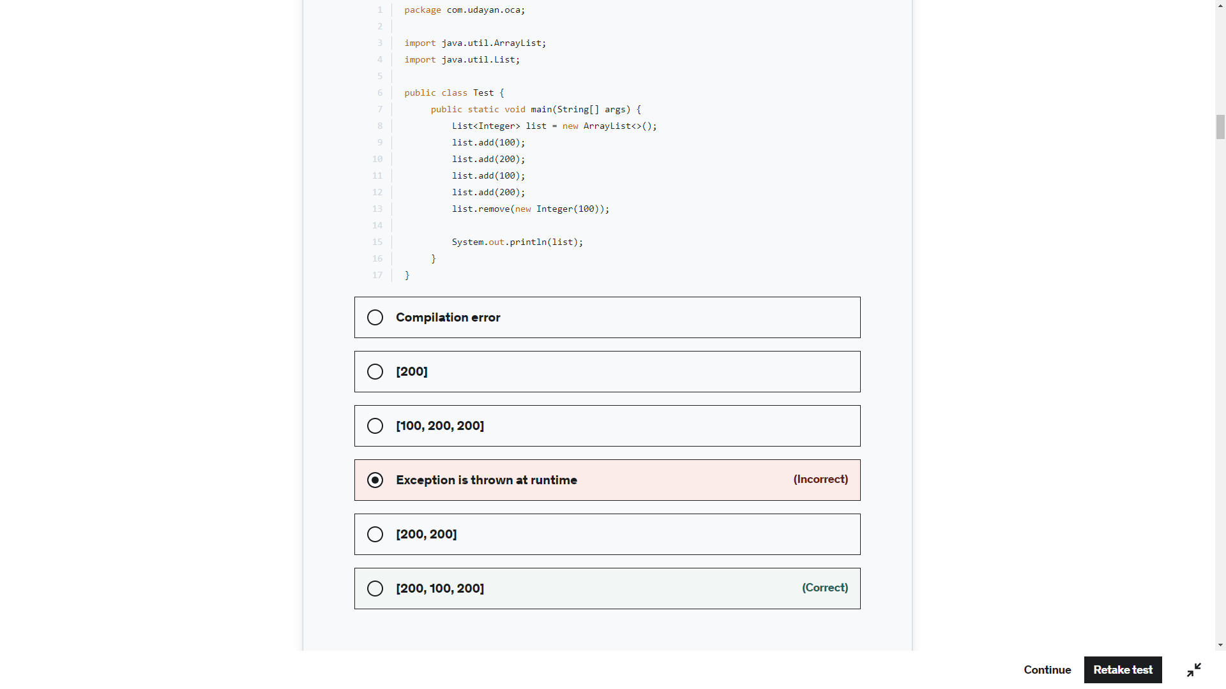

List<> list = new ArrayList(); - CE – Java Illegal start of type

List<> list = new ArrayList<>(); CE Illegal start of Type for List<>

List<> list = new ArrayList<String>(); CE Illegal start of Type for List<>

List list = new ArrayList<String>(); Valid (Warning) – Raw Use

List list = new ArrayList<>(); Valid (Warning) – Raw Use

List list = new ArrayList(); Valid (Warning) – Raw Use

List<String> list = new ArrayList(); Valid (Warning) – Raw Use

List<String> list = new ArrayList<>(); Valid No Warning

List<String> list = new ArrayList<String>(); Valid No Warning

Type parameter can be ignored from right side but <> need to there to avoid warning

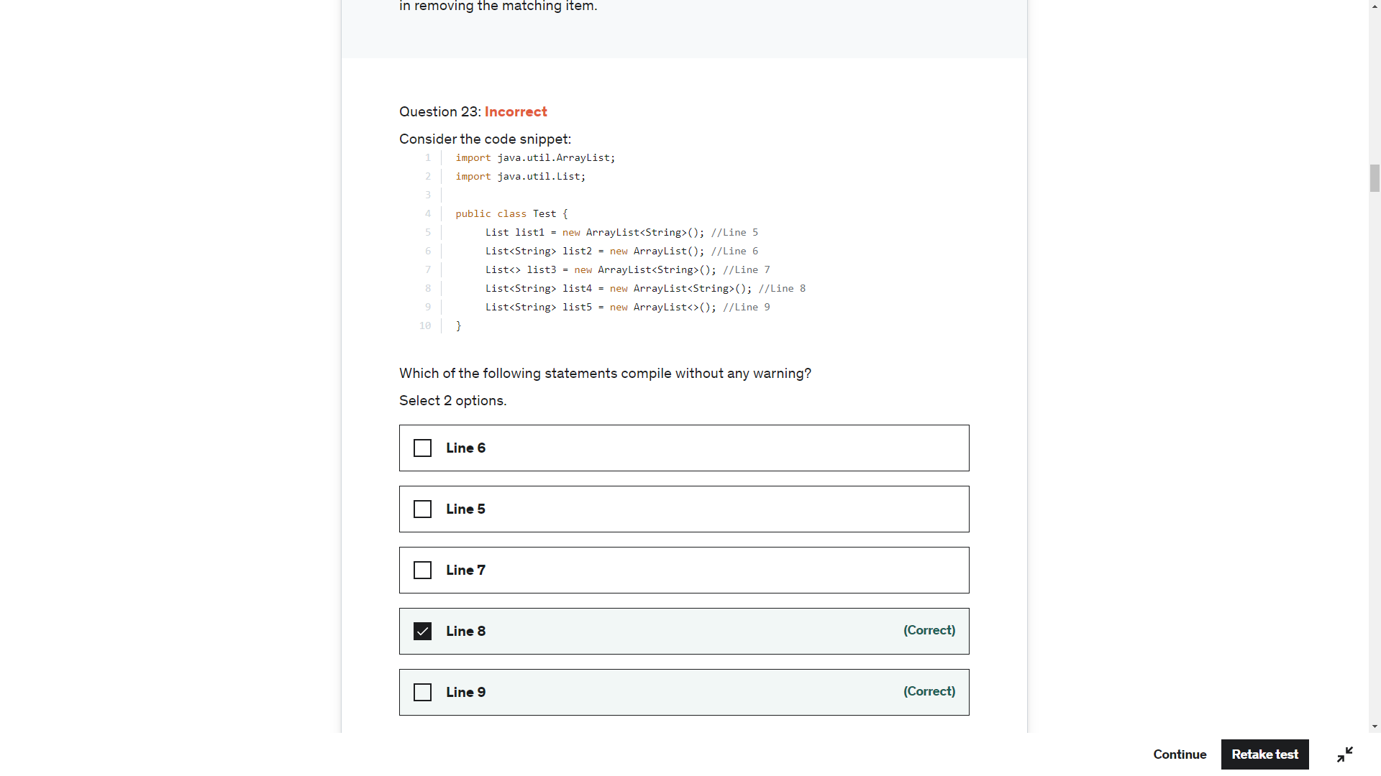

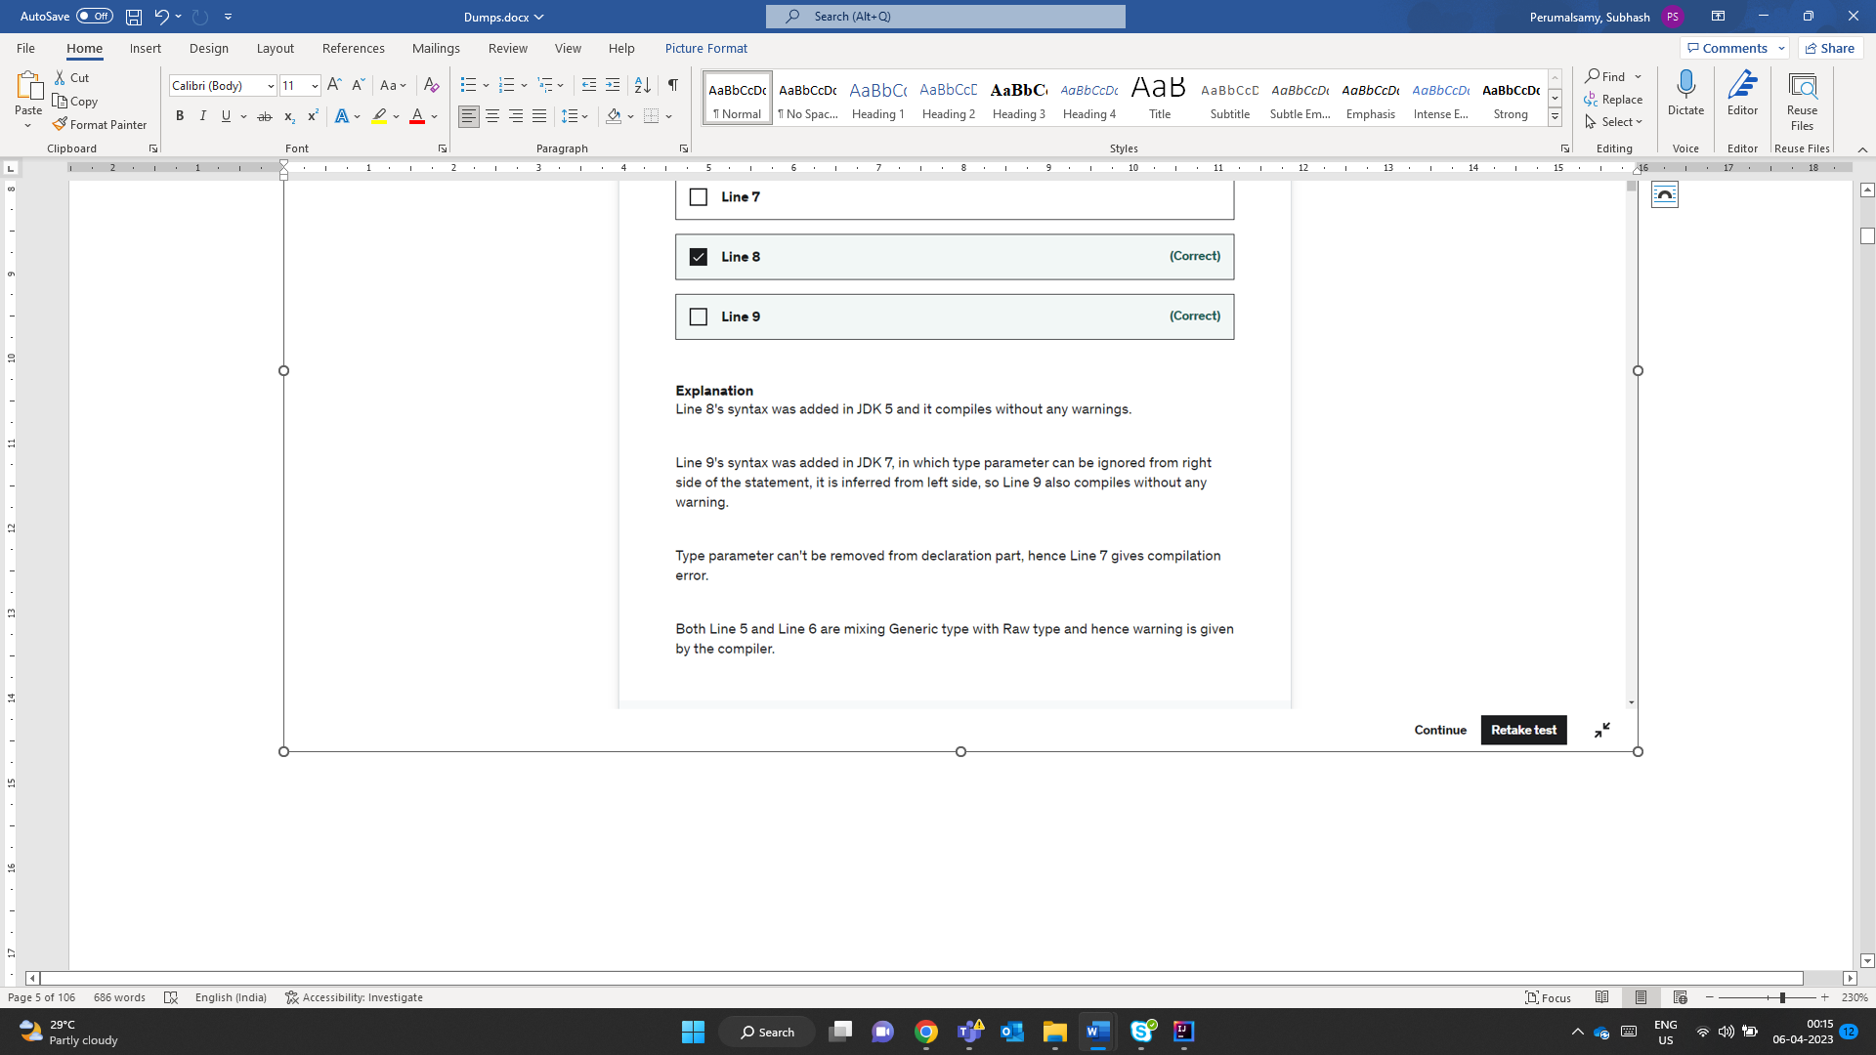

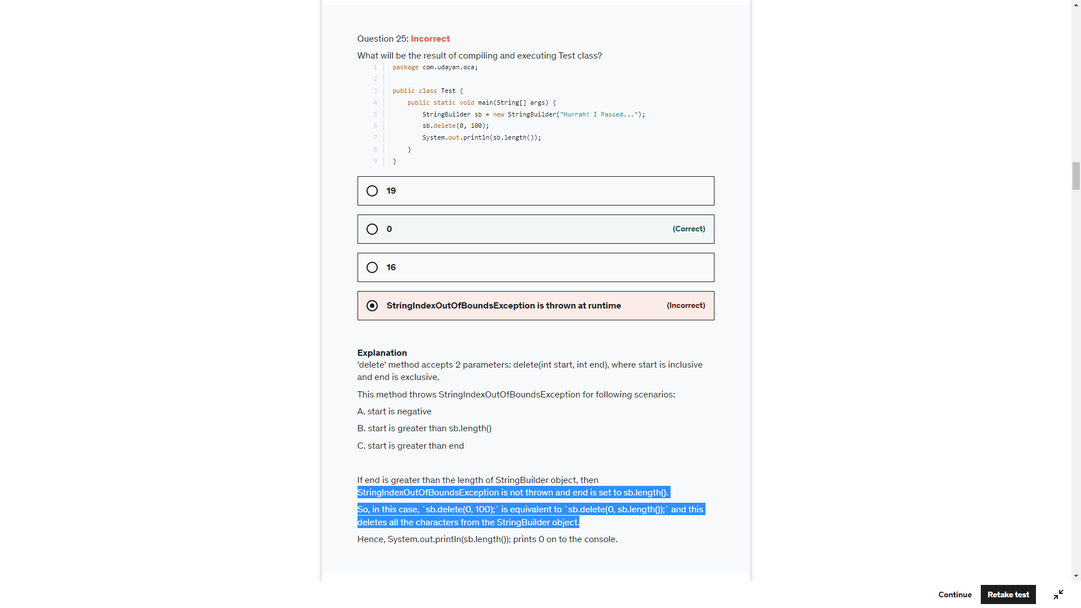

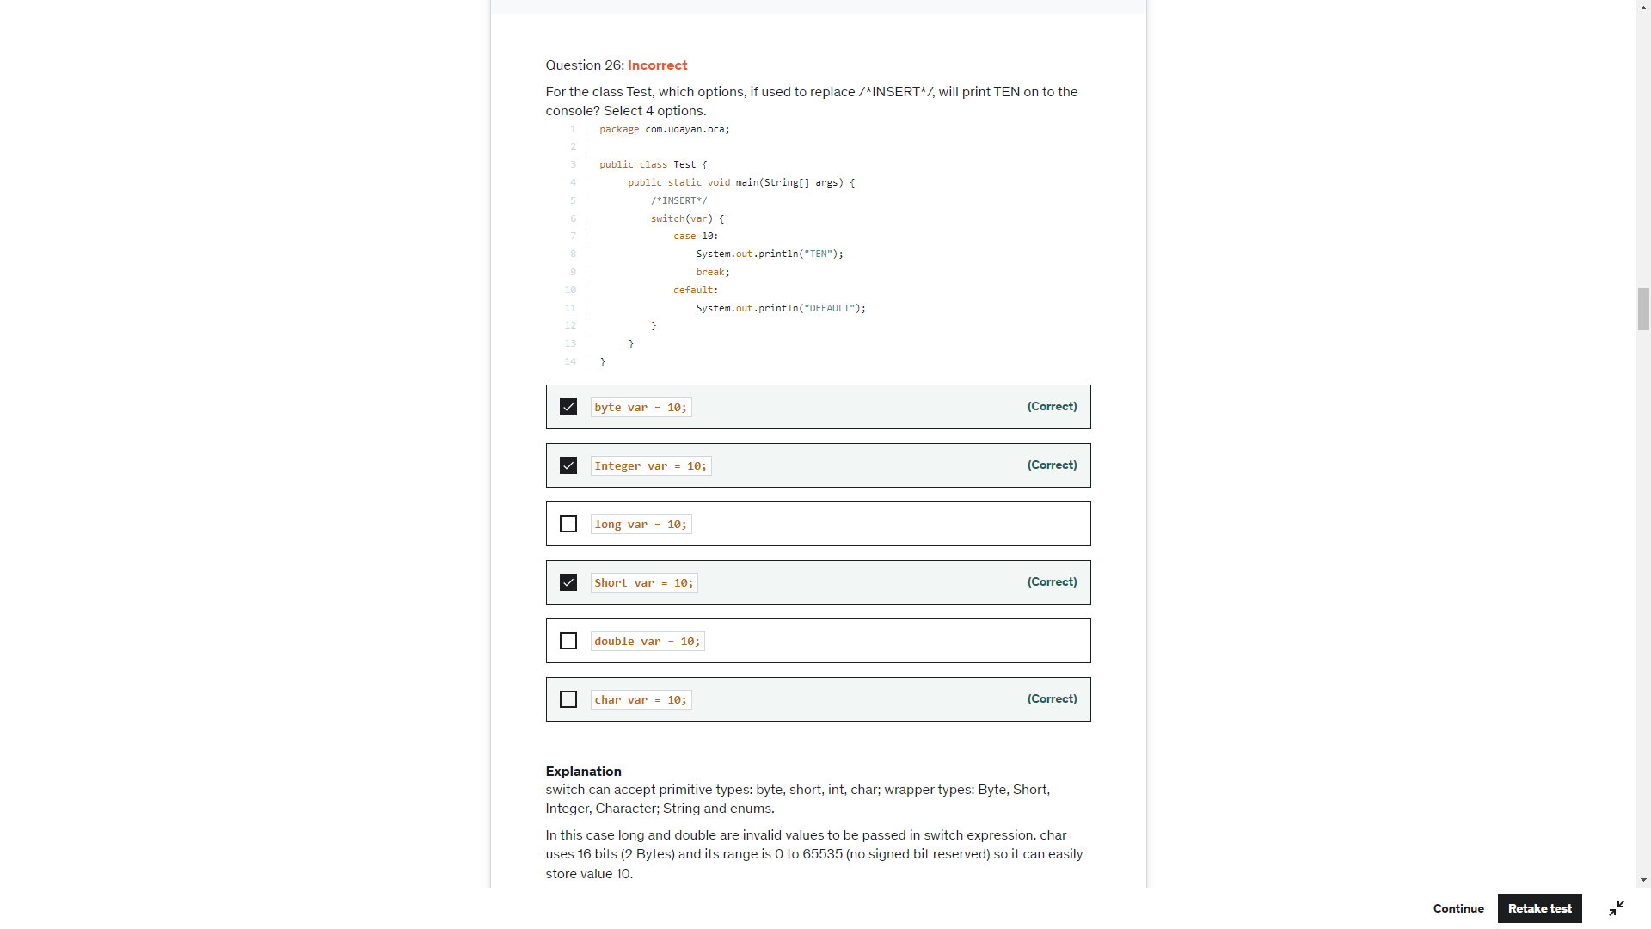

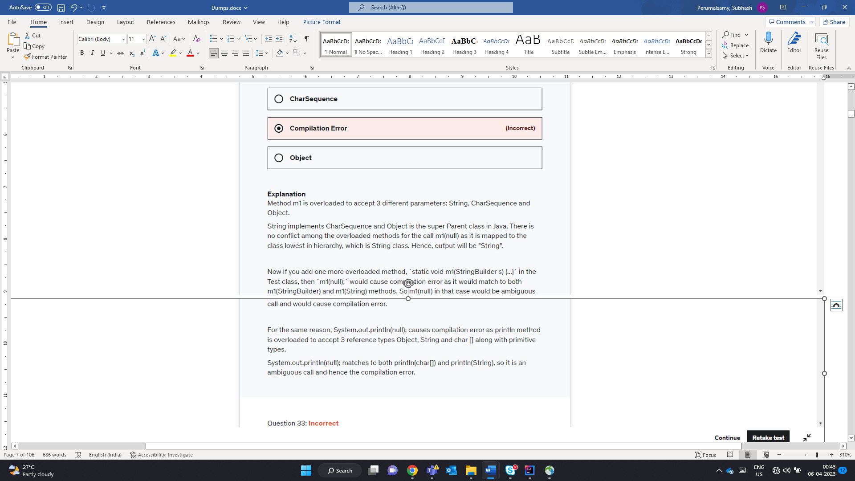

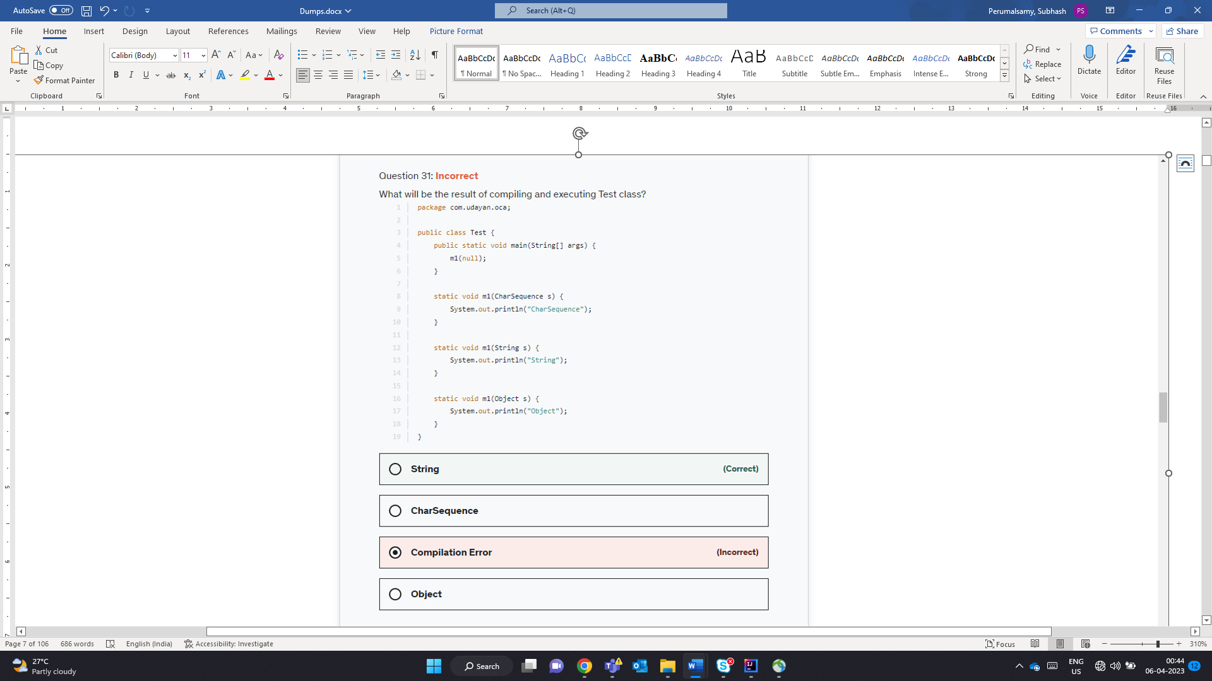

Double d = null;  
System.*out*.println(d+""); - No CE or RE

System.*out*.println(d+12); this would perform unboxing and null.doubleValue() – RunTime Exception

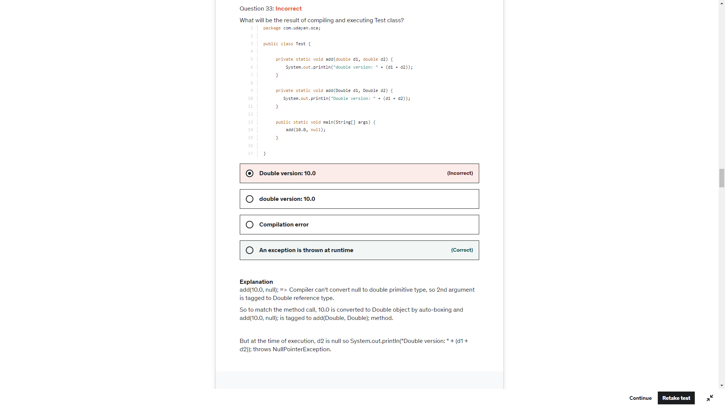

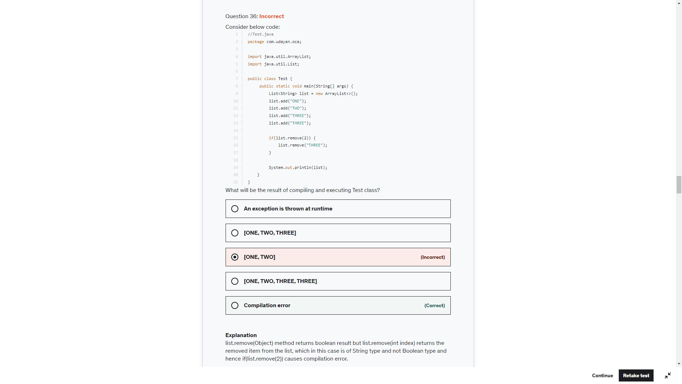

List.remove(0) -> returns the object -> null

List.remove(null)-> returns true if the object is found

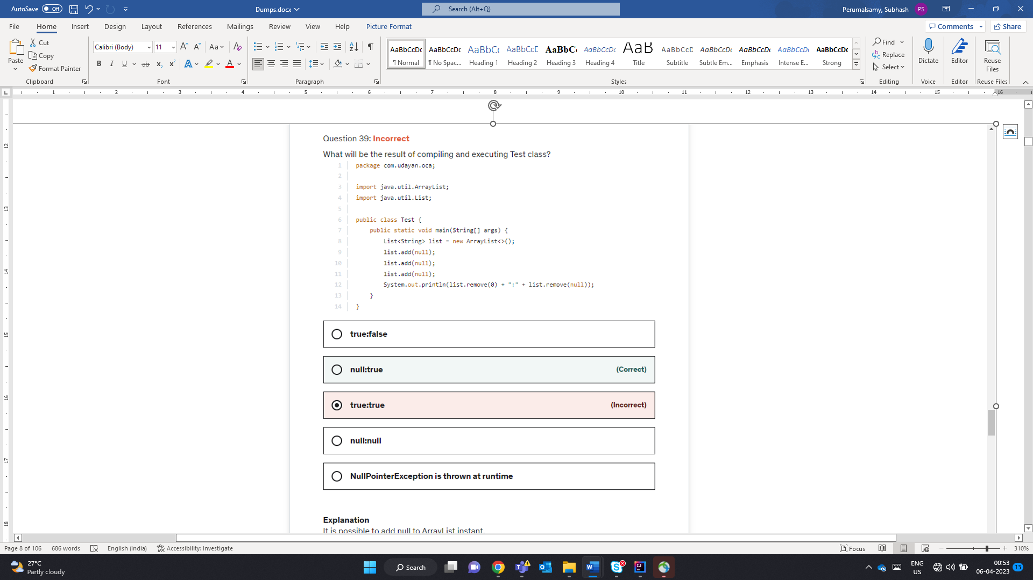

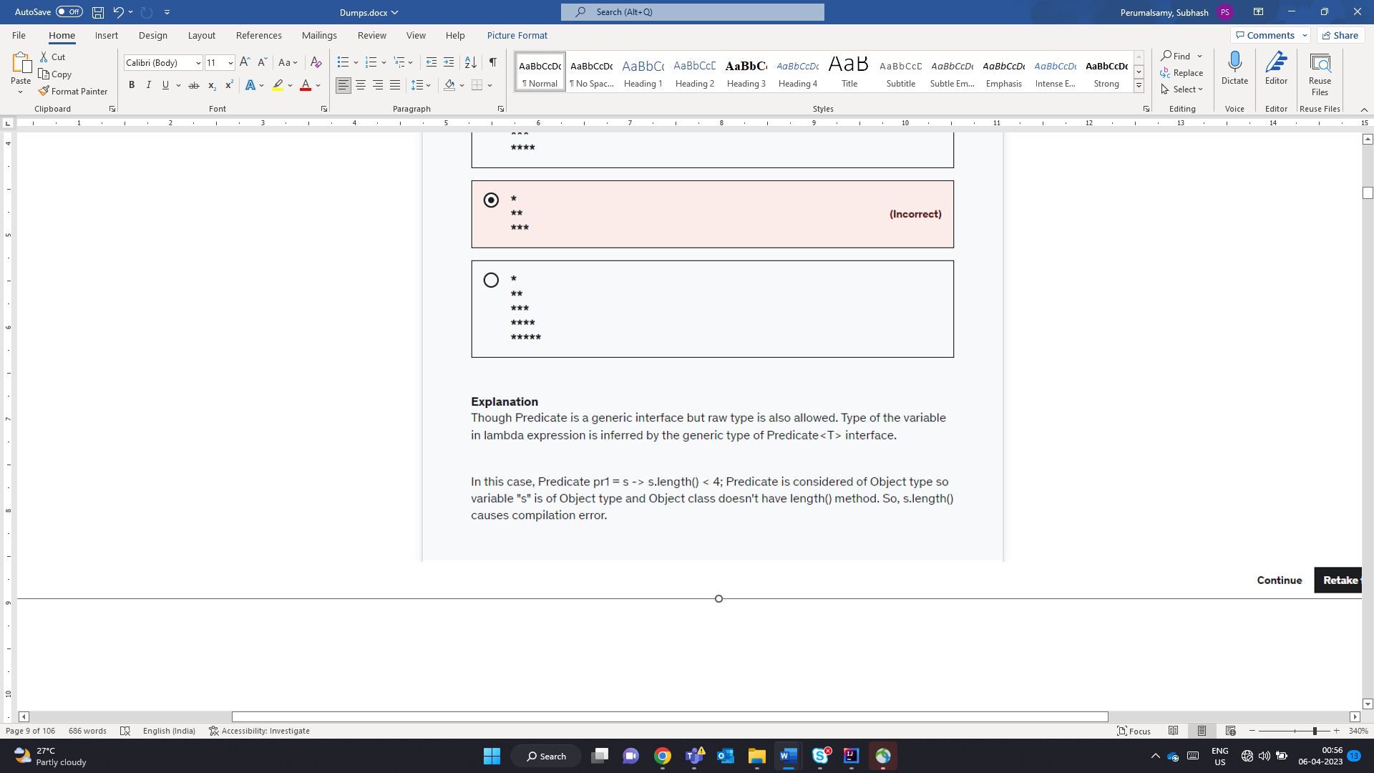

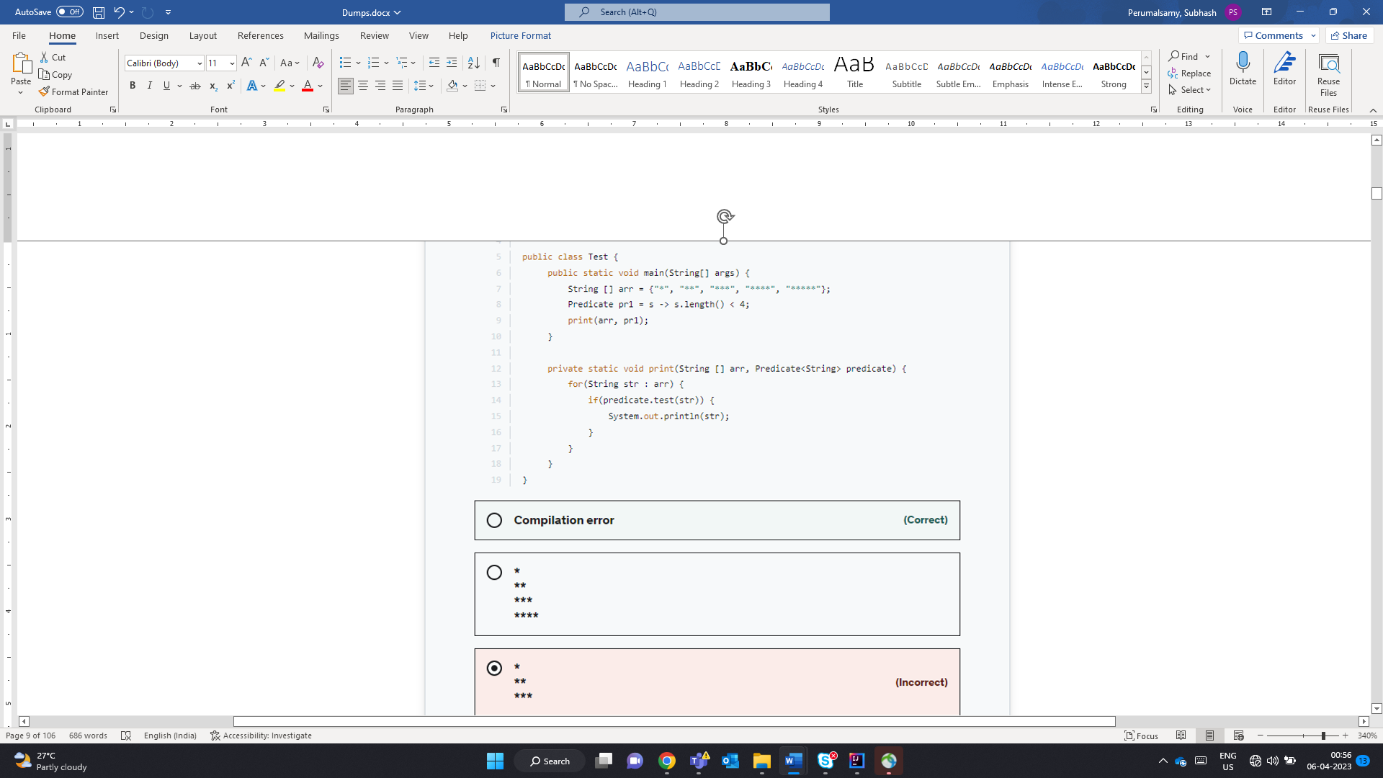

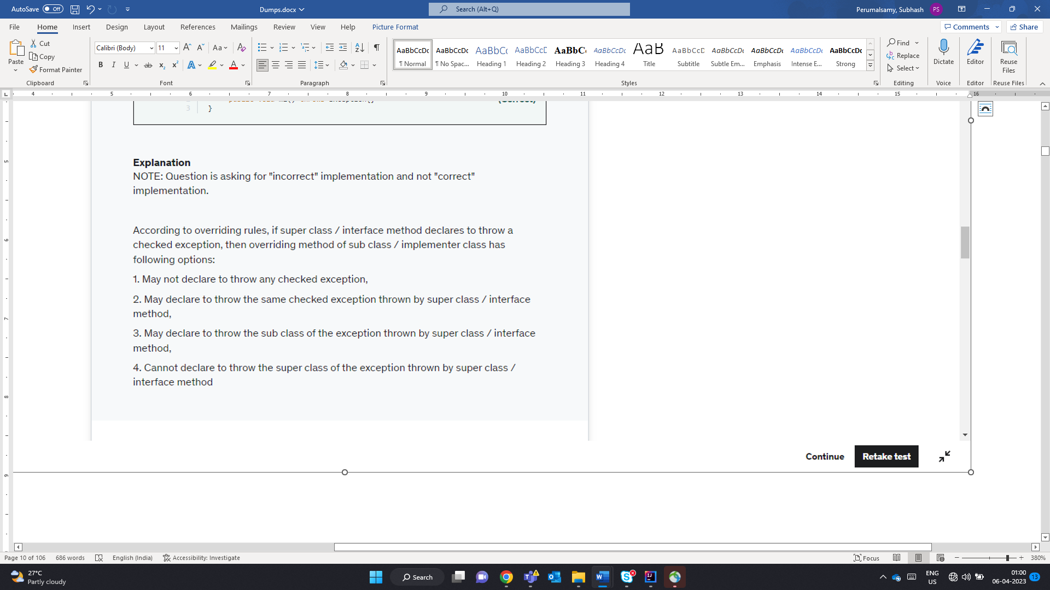

InCorrectly Implements

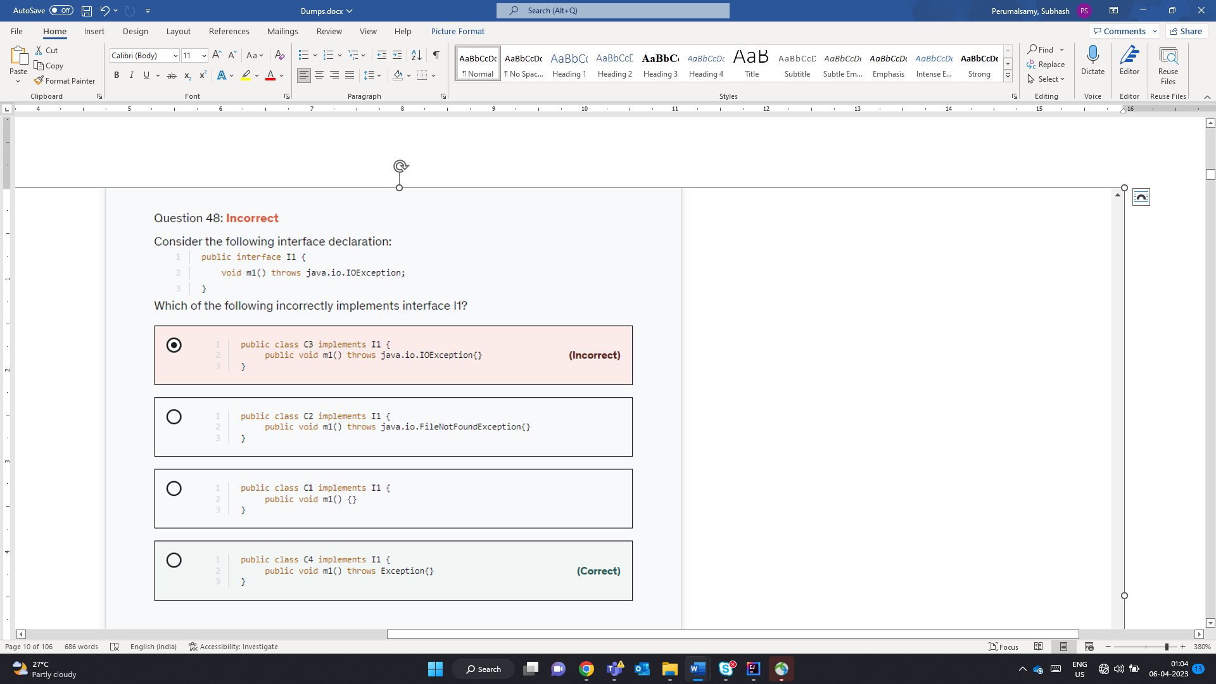

* **If the superclass method does not declare an exception**
  + If the superclass method does not declare an exception, subclass overridden method cannot declare the checked exception but it can declare unchecked exception.
* **If the superclass method declares an exception**
  + If the superclass method declares an exception, subclass overridden method can declare same, subclass exception or no exception but cannot declare parent exception.

When a new String object is created using new Keyword – 2 Objects gets created – Heap Area and SCP.

Compile Time constants -> Literals or Final Variable

Compile time string computation using concatenation will be referred is SCP

RunTime String Computation using concatenation will be referred are newly created. Therfore distinct (If the resultant Expression is not a constant Expression)

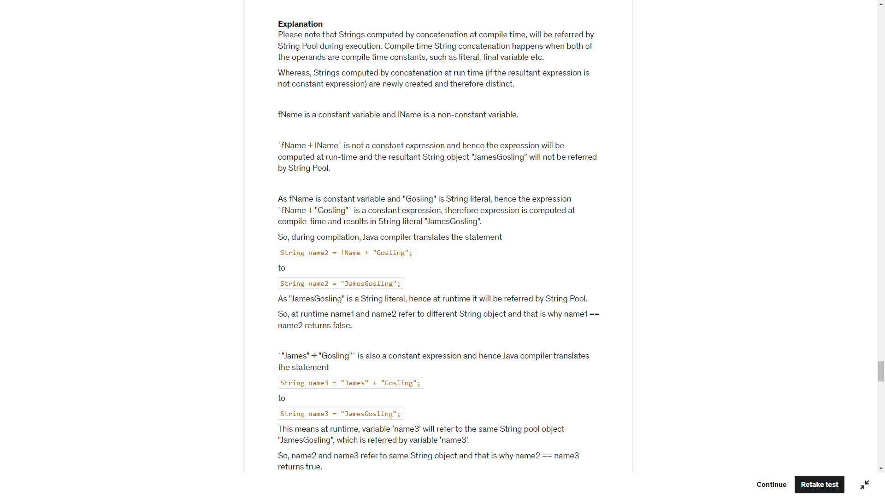

Fname – Constant

Lname – non constant

Name1 = fname+lname -> Non Constant -> Run Time NewObject

Name 2-> fname+ “Cosling” -> Final Constant + Literal Constant -> String Pool (JamesGosling)

Name 3 -> String Pool (JamesGosling)

False

True

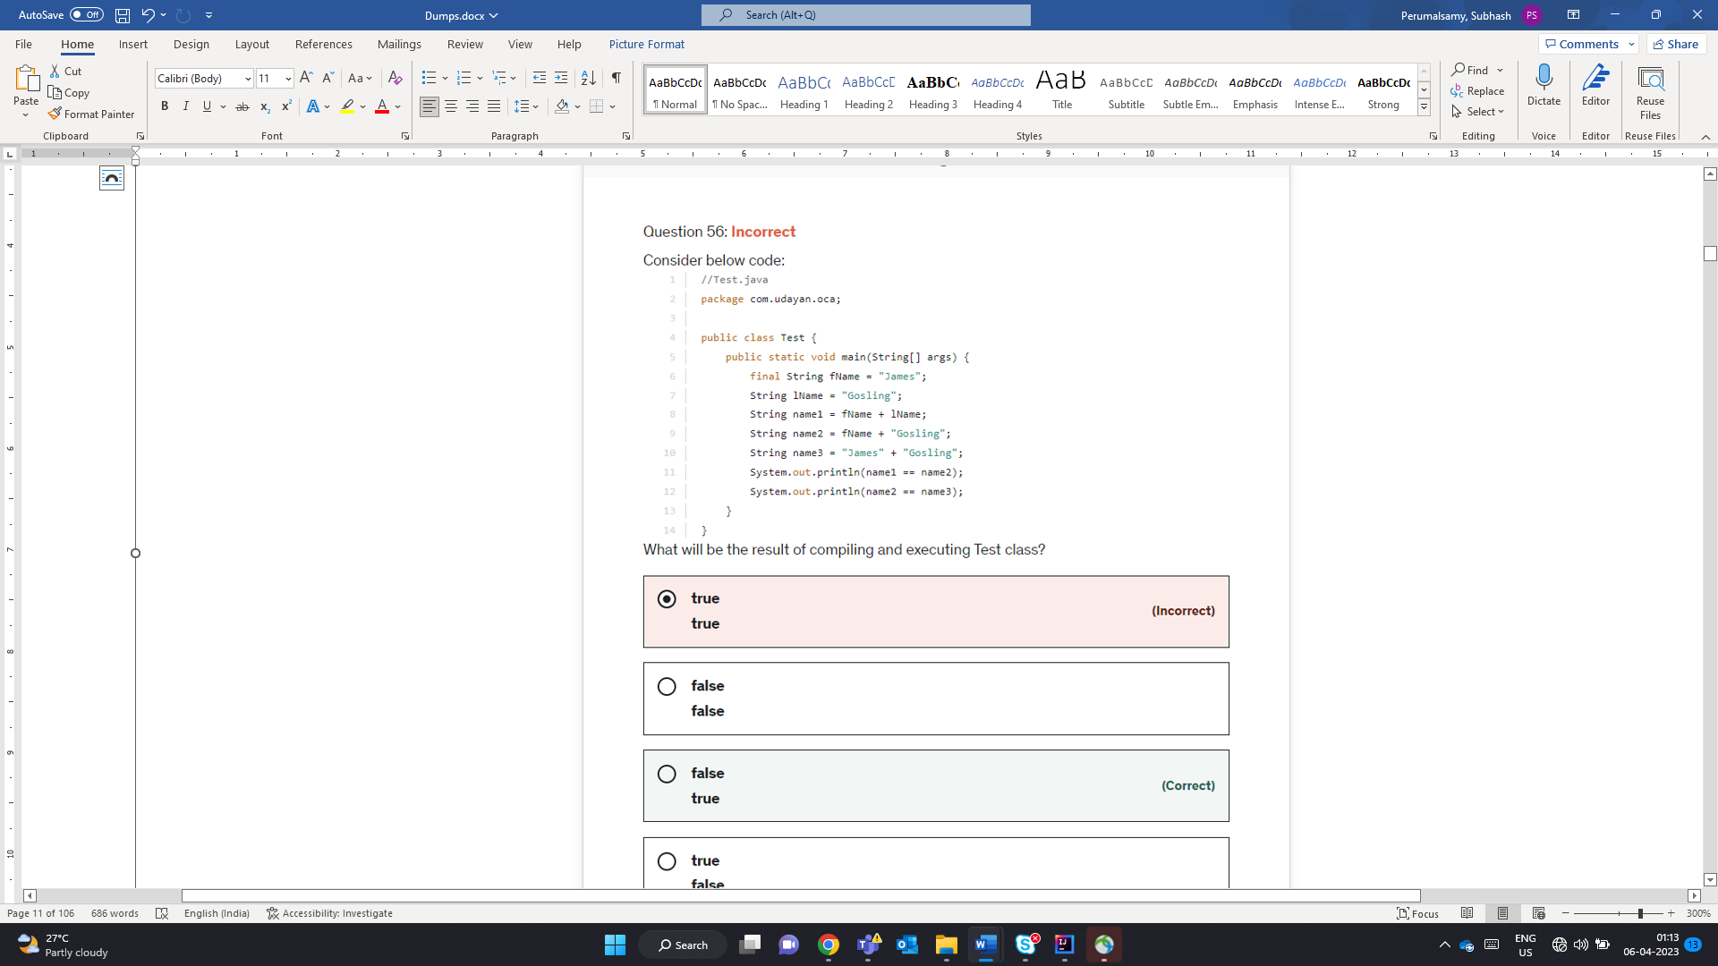

Only long float and double can be suffixed by l f d

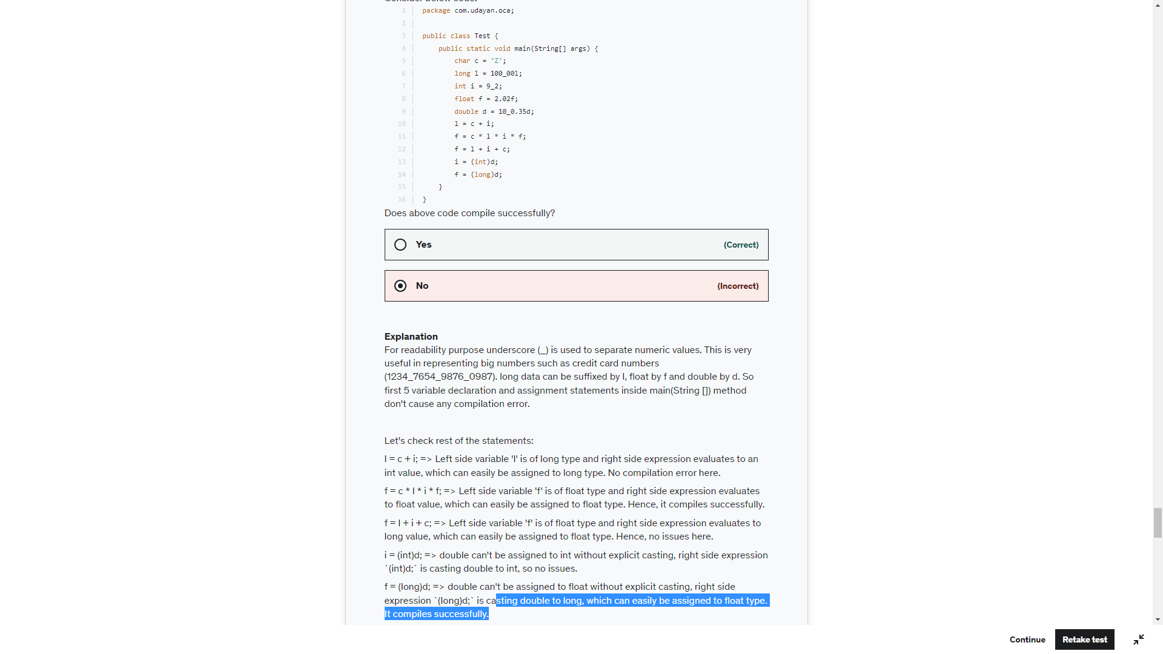

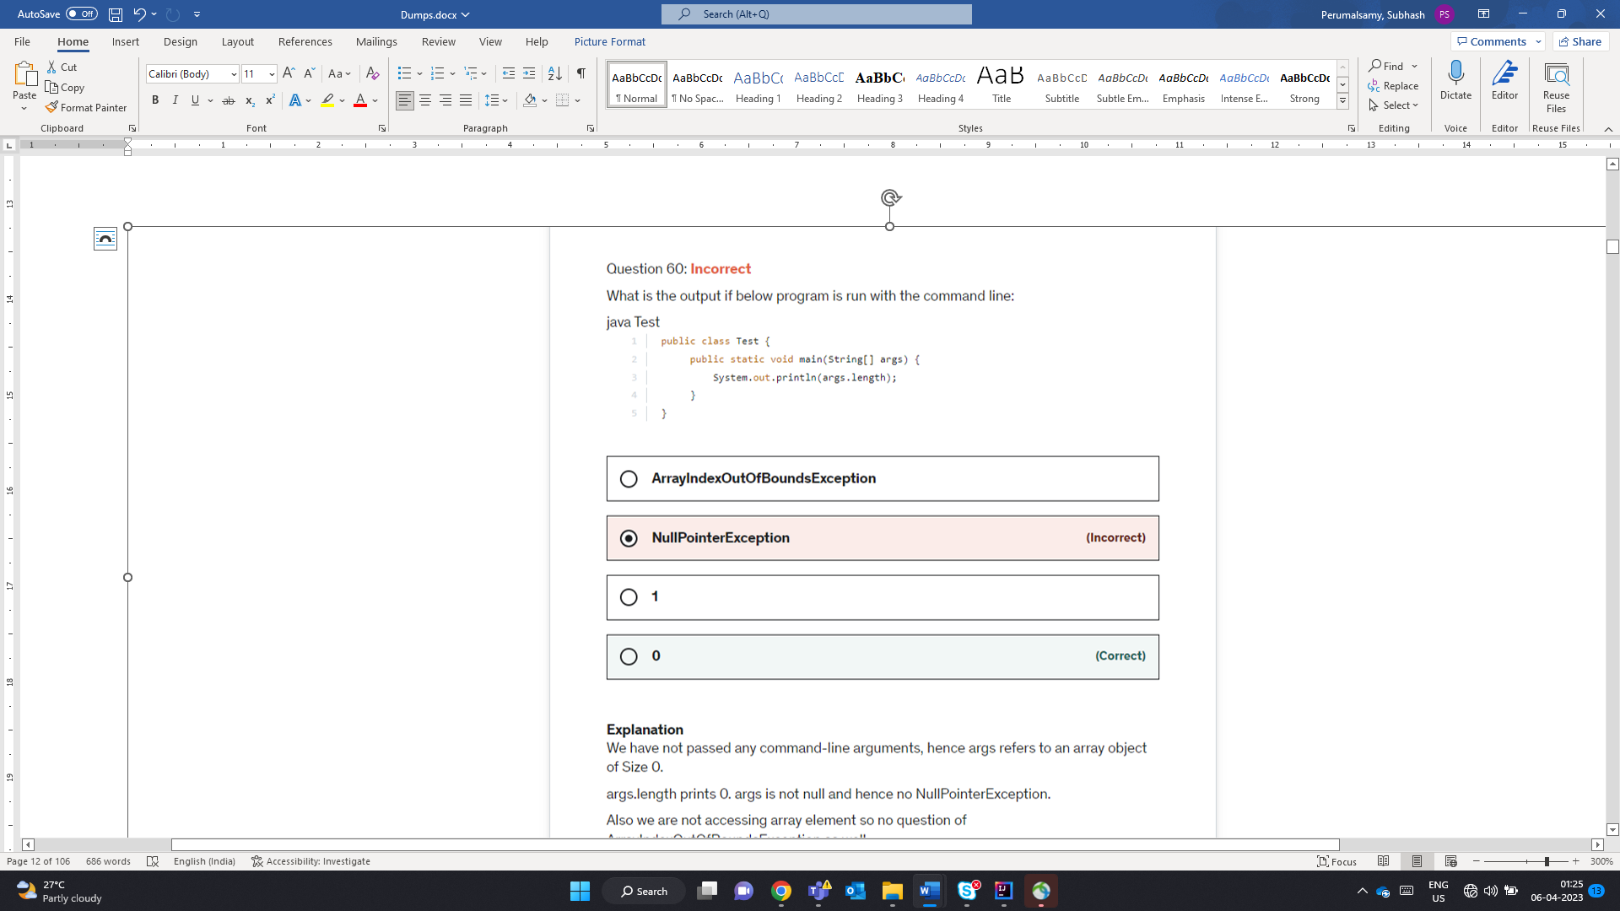

All wrapper classes are immutable. Any operations would create a new object and not modify the old

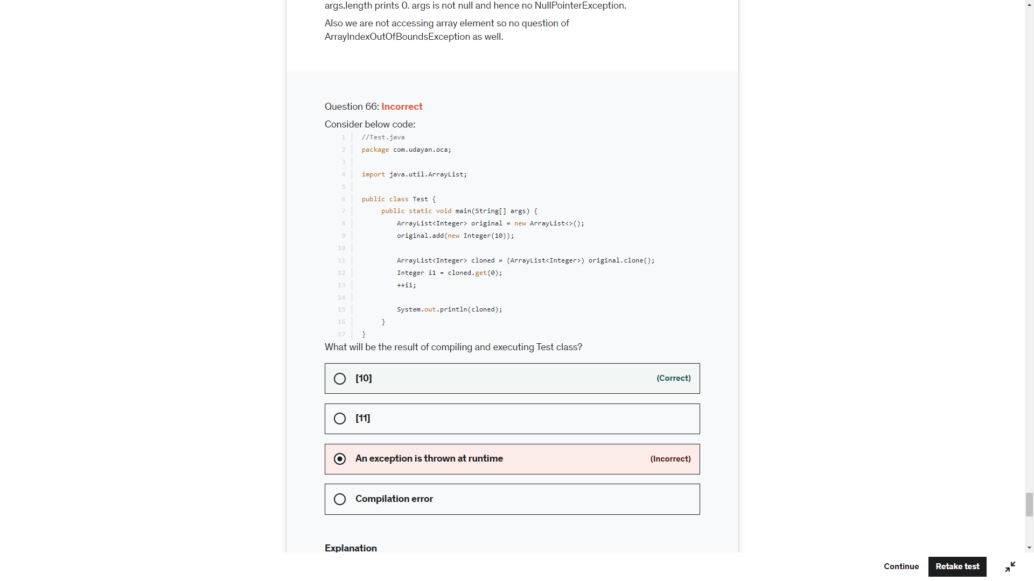

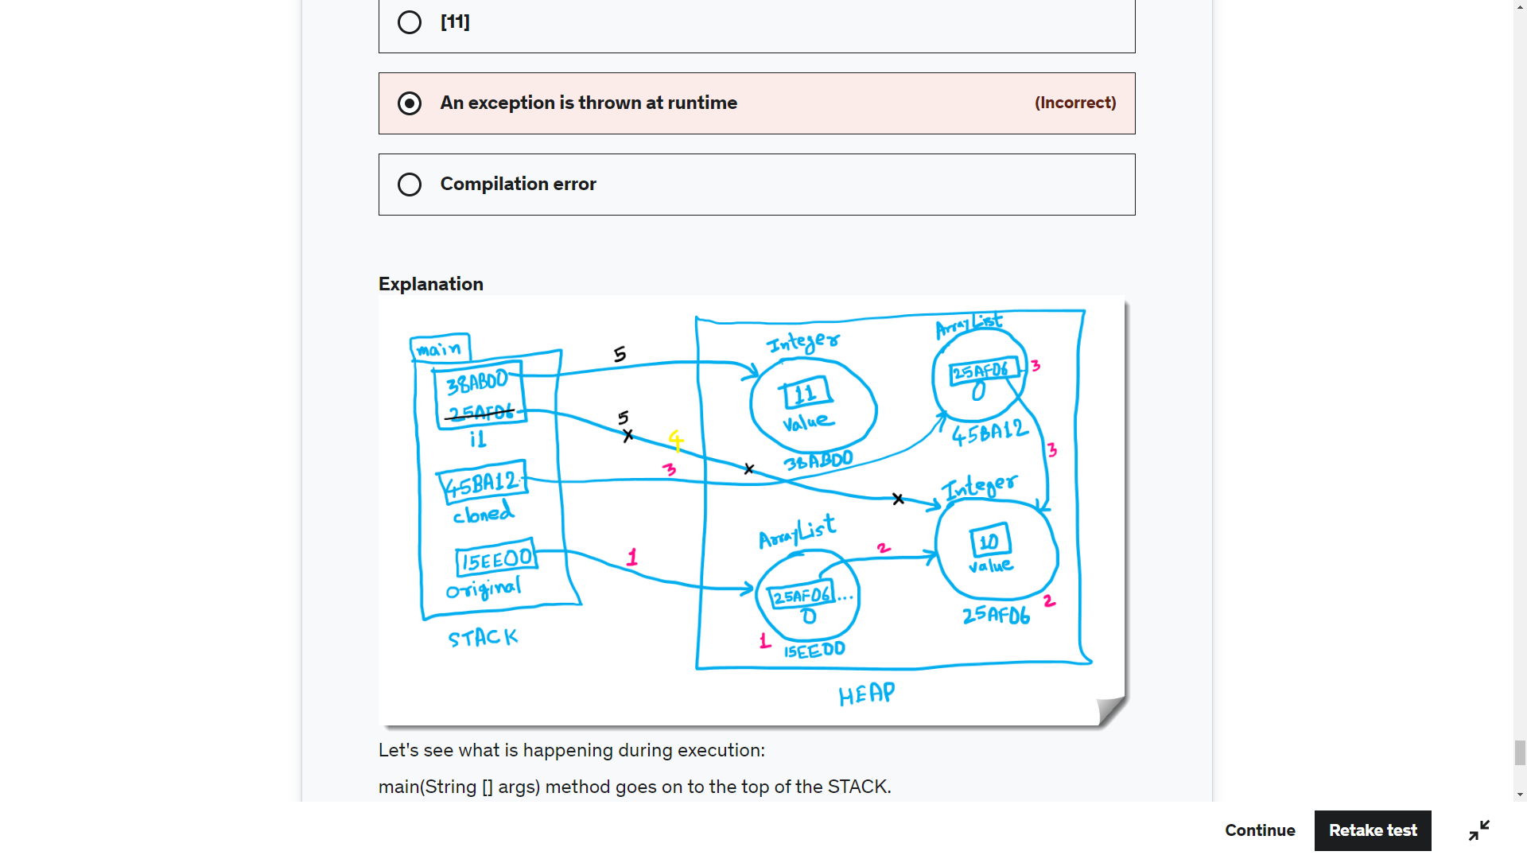

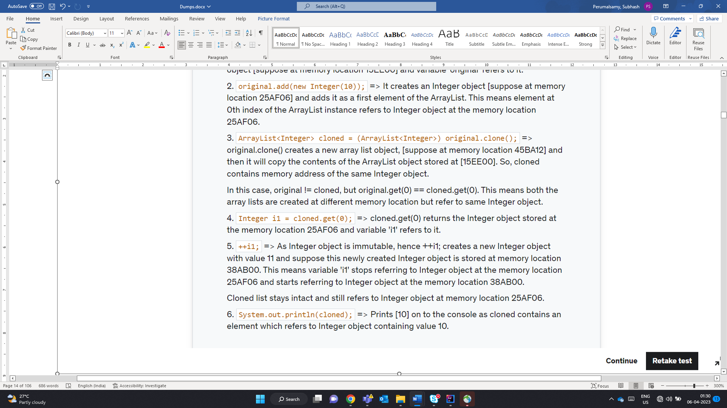

M – Month

m- minute

D- Day of the year

d- day of the month

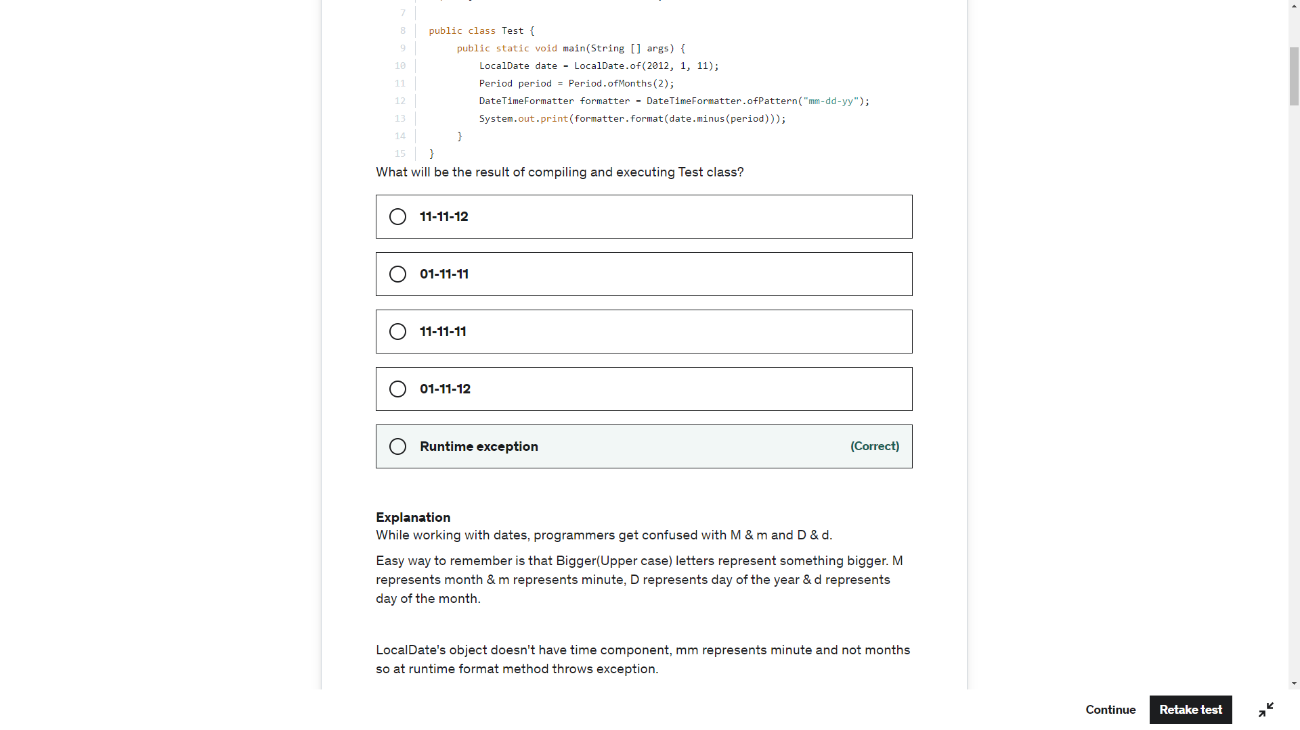

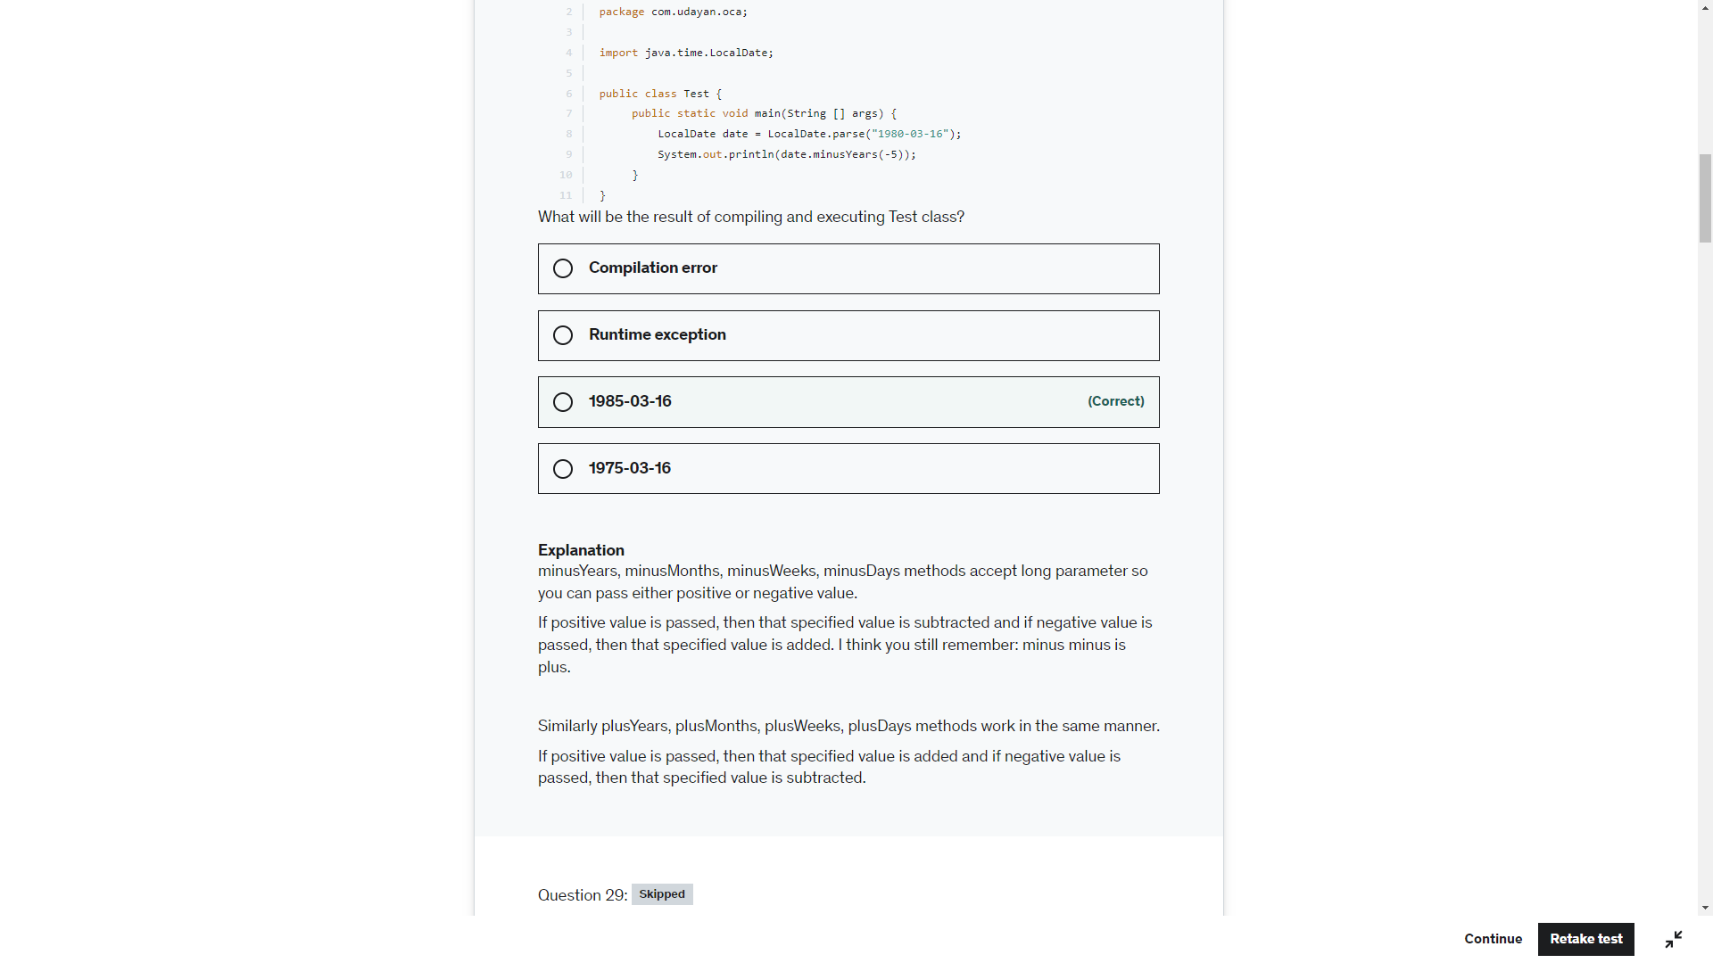

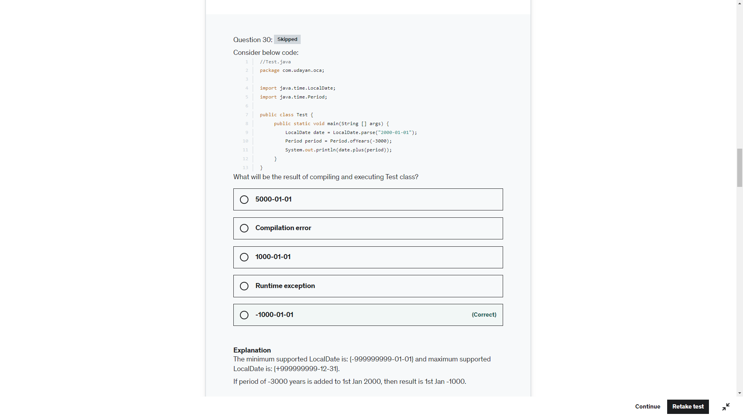

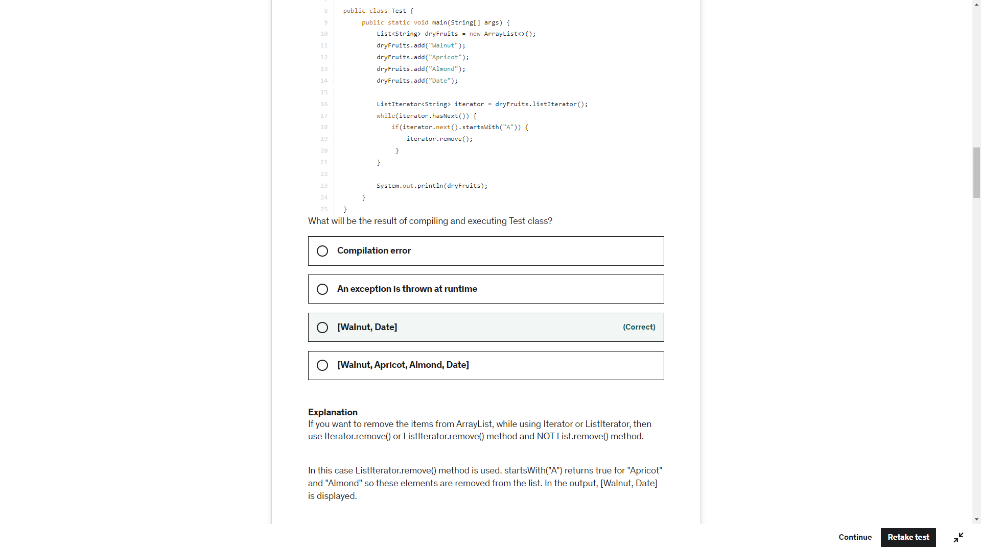

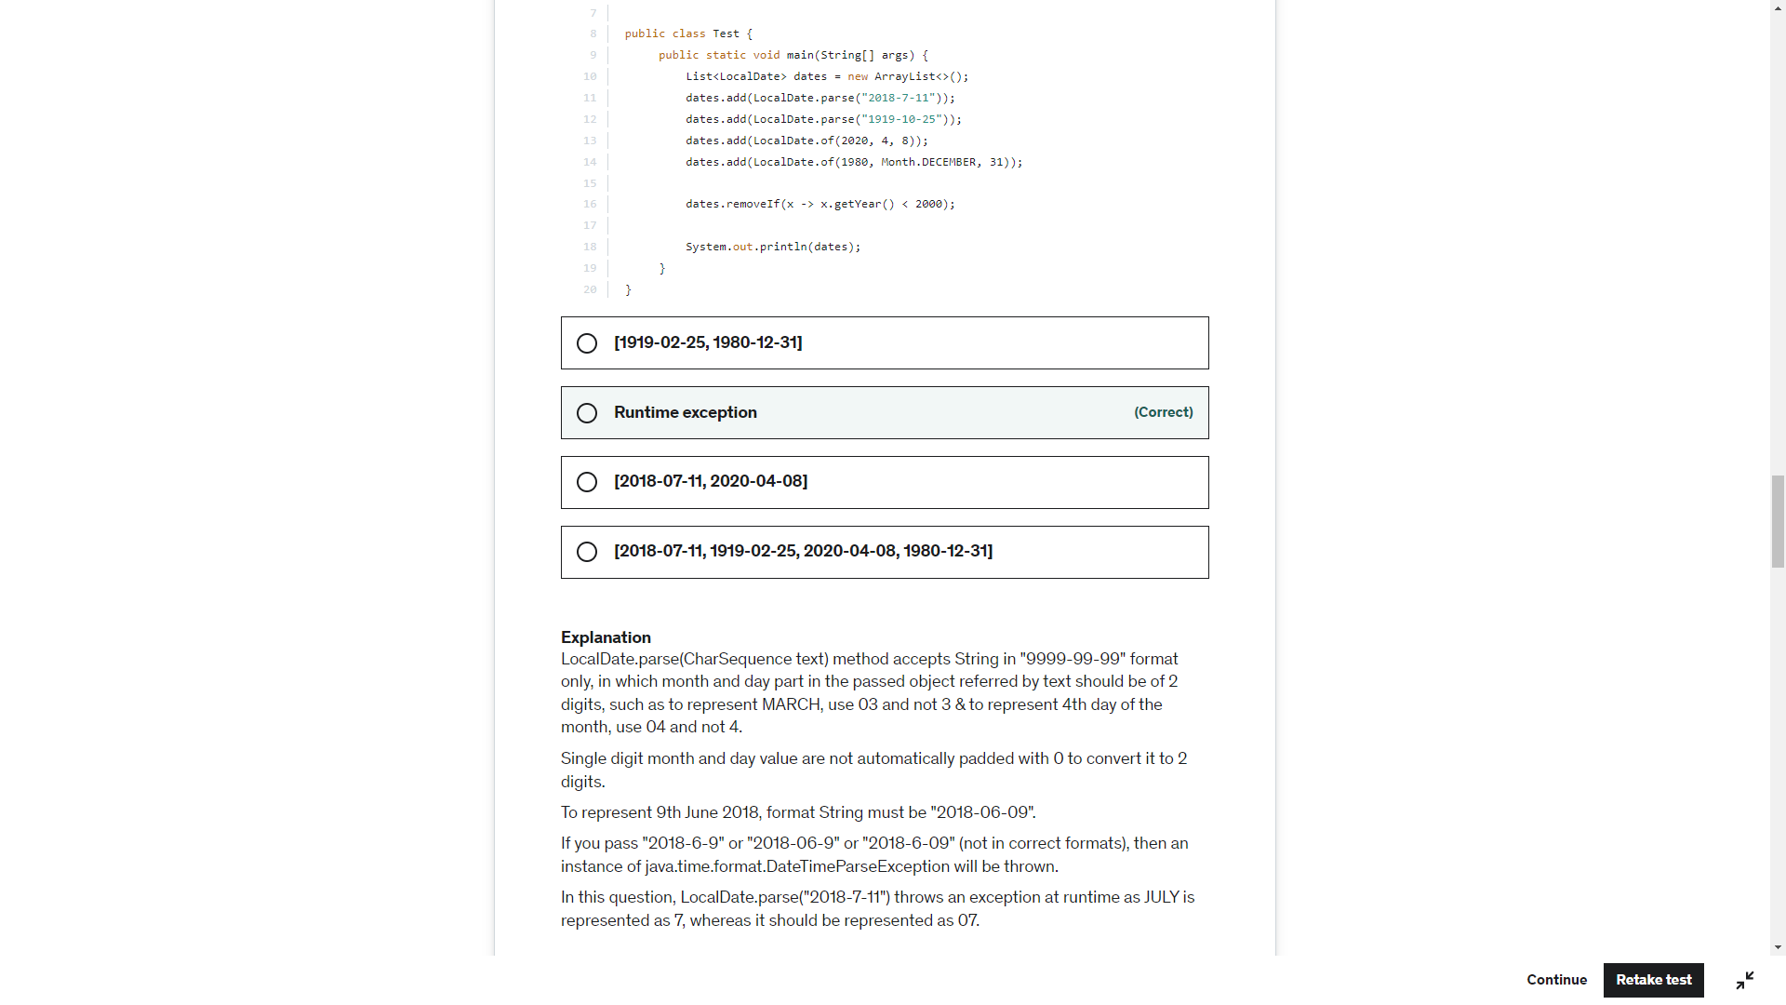

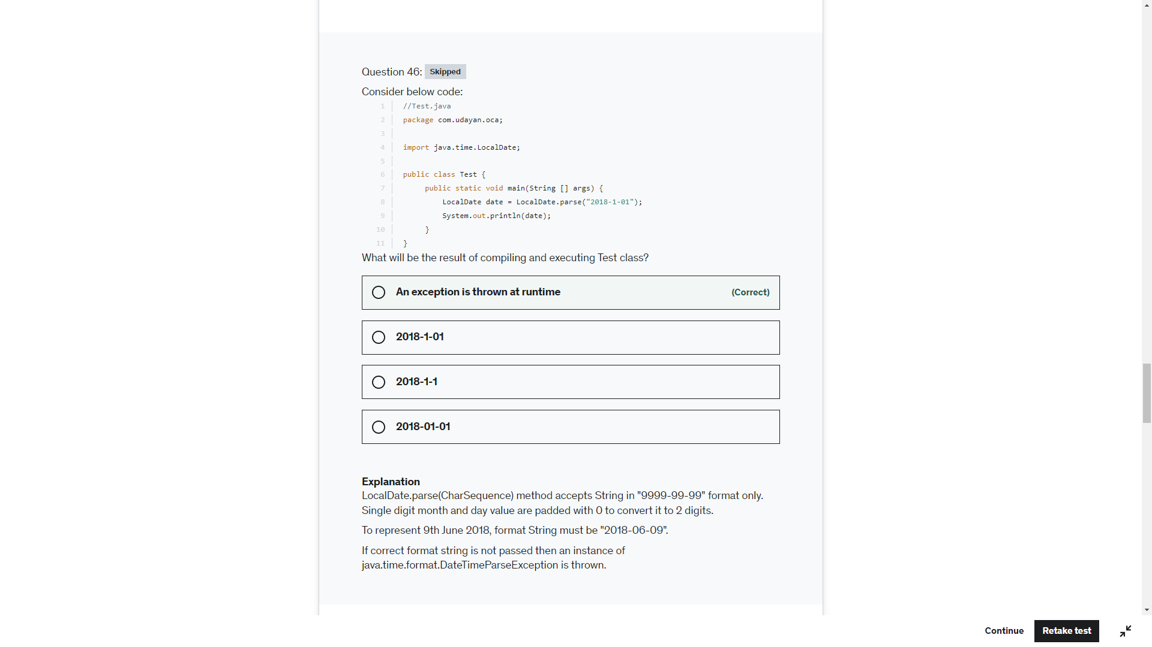

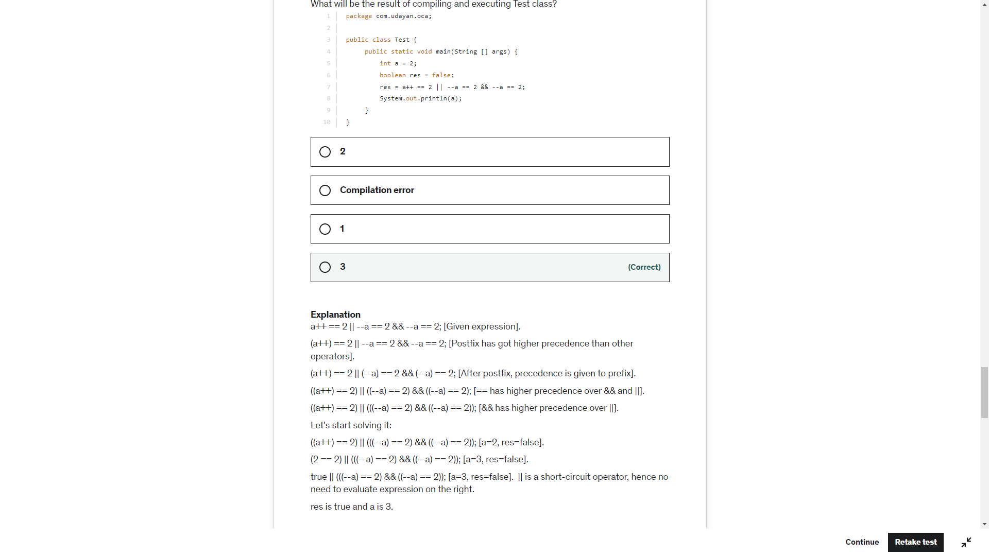

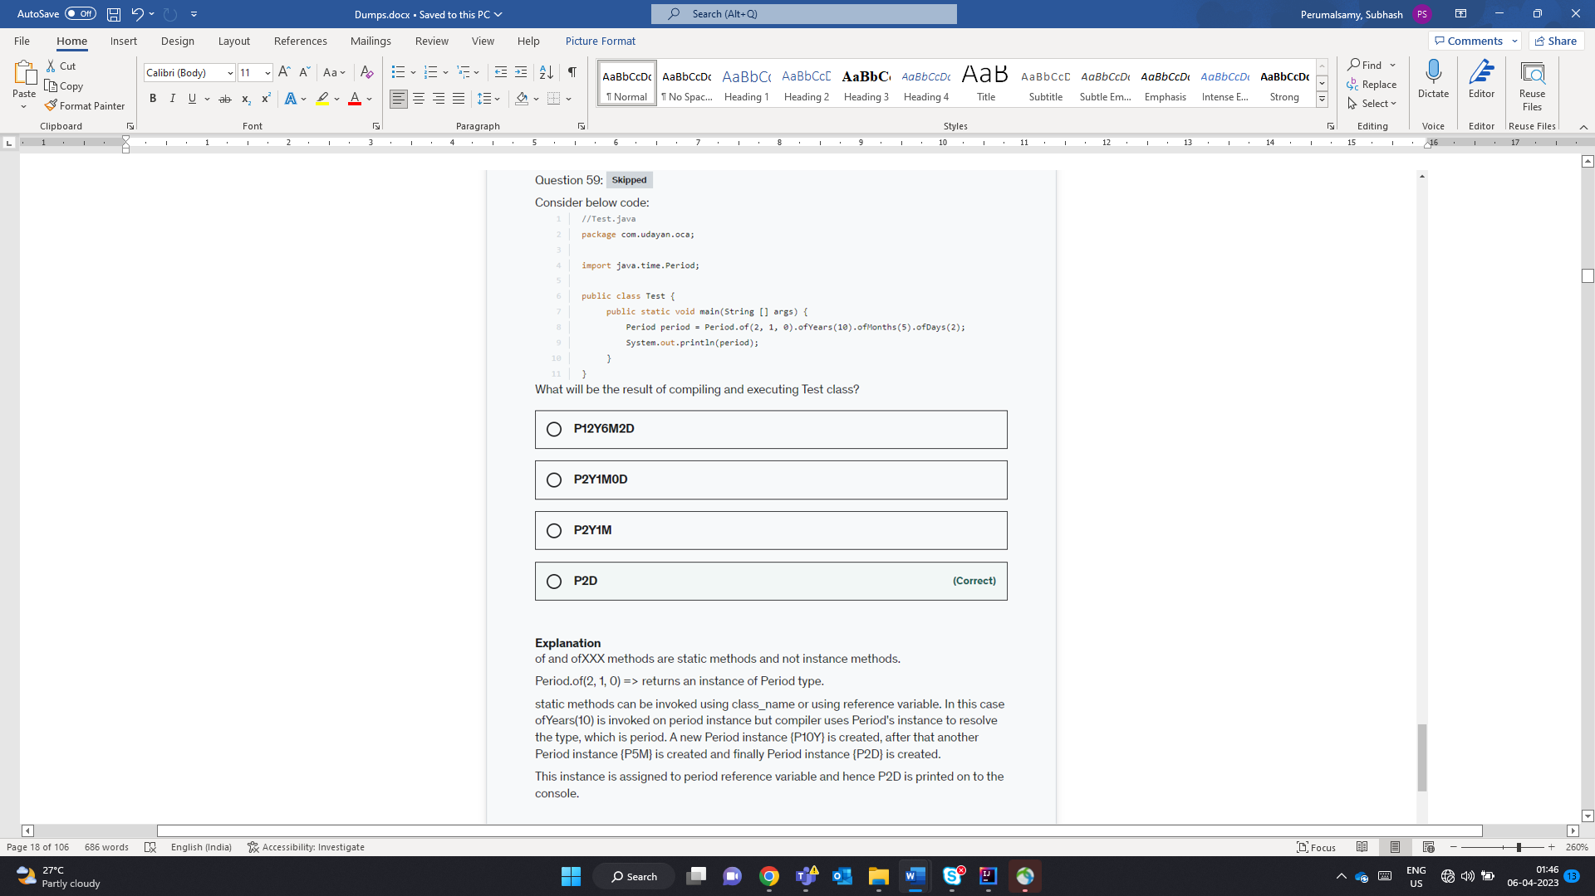

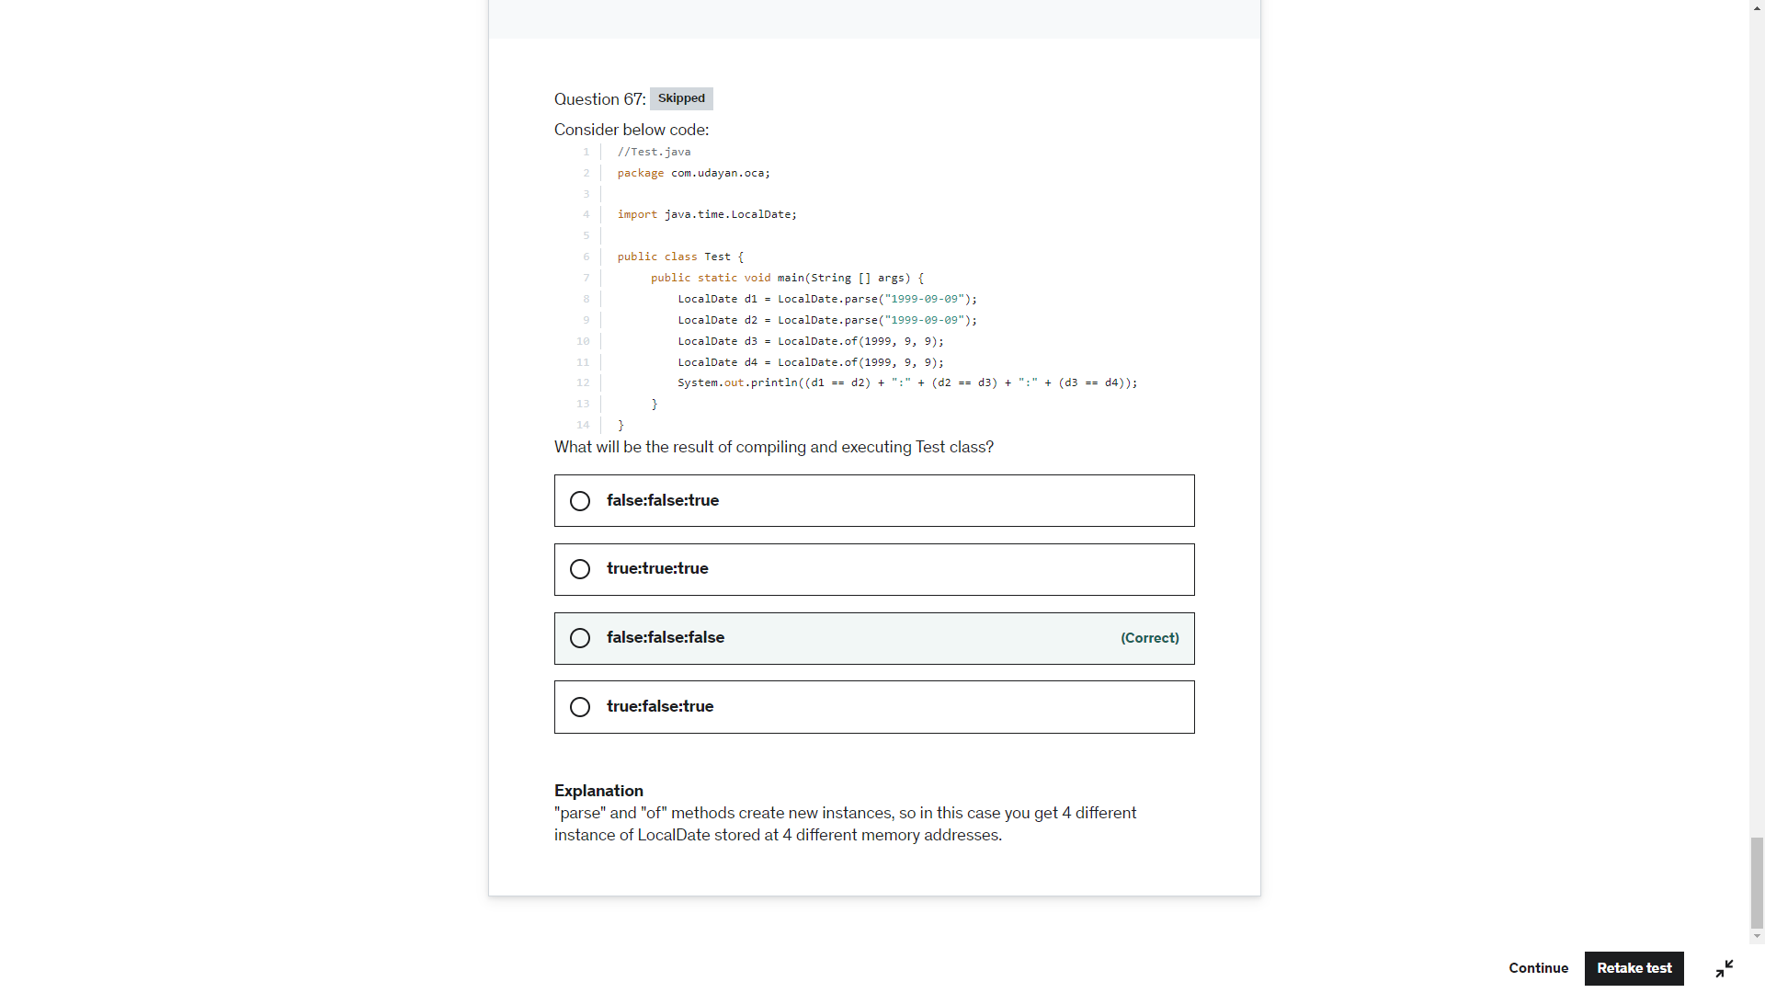

StringBuilder sb= New StringBuilder(null) -. Null pointer Exception

New StringBuilder.append(null) -> null value ambiguous between StringBuilder.append(String) or (CharSequence) or (Object ) or (StringBuilder) or (Char[])

String str = null;

Sop(str) -> null

Sop(null) -> CE ambiguous between String and Char[]

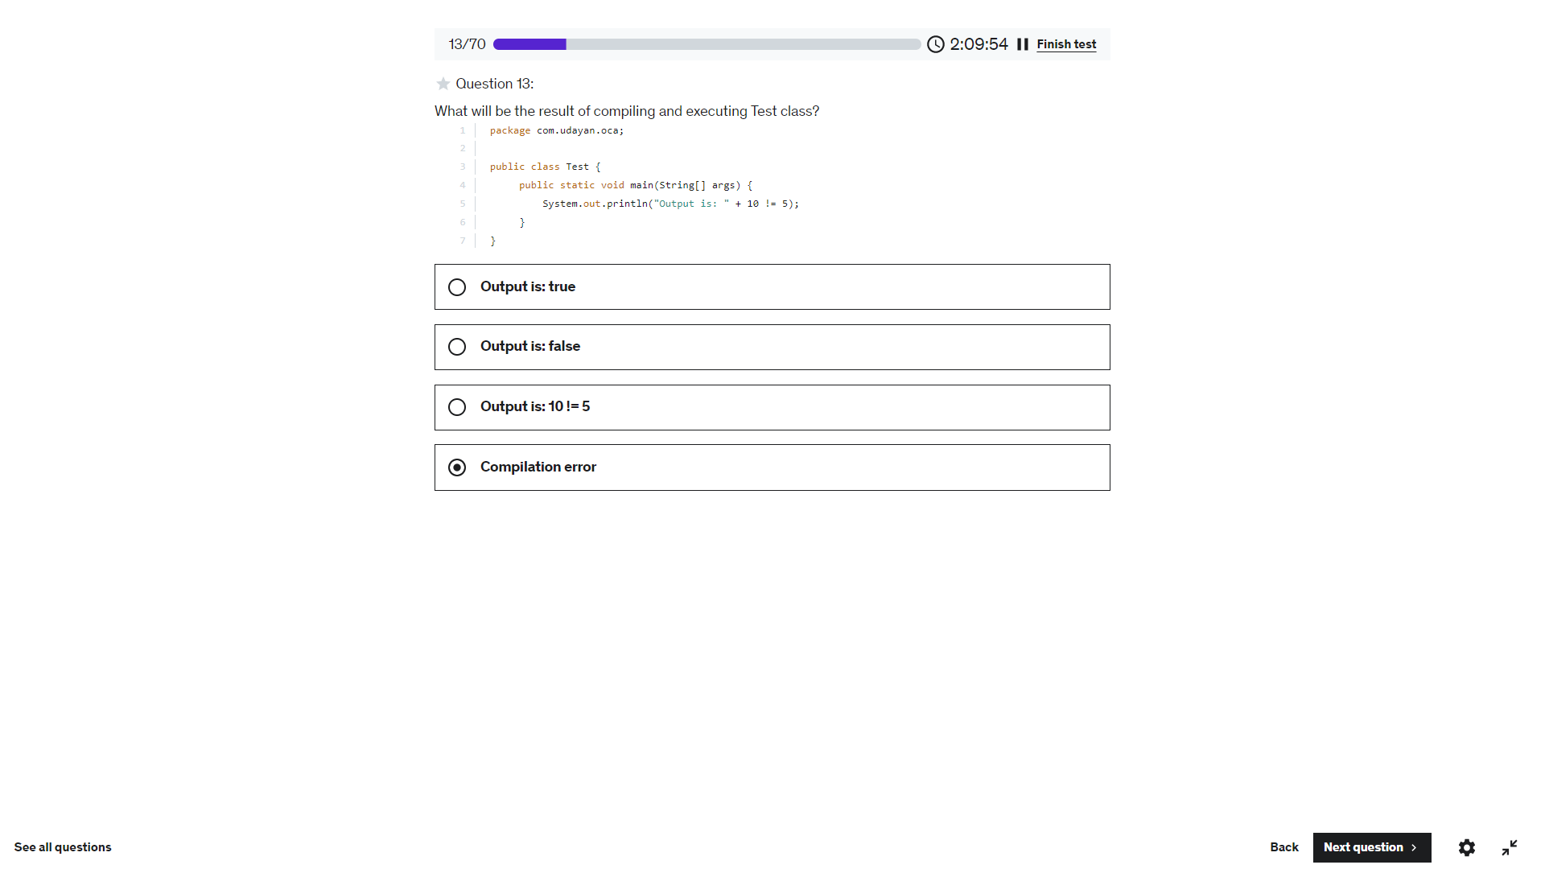

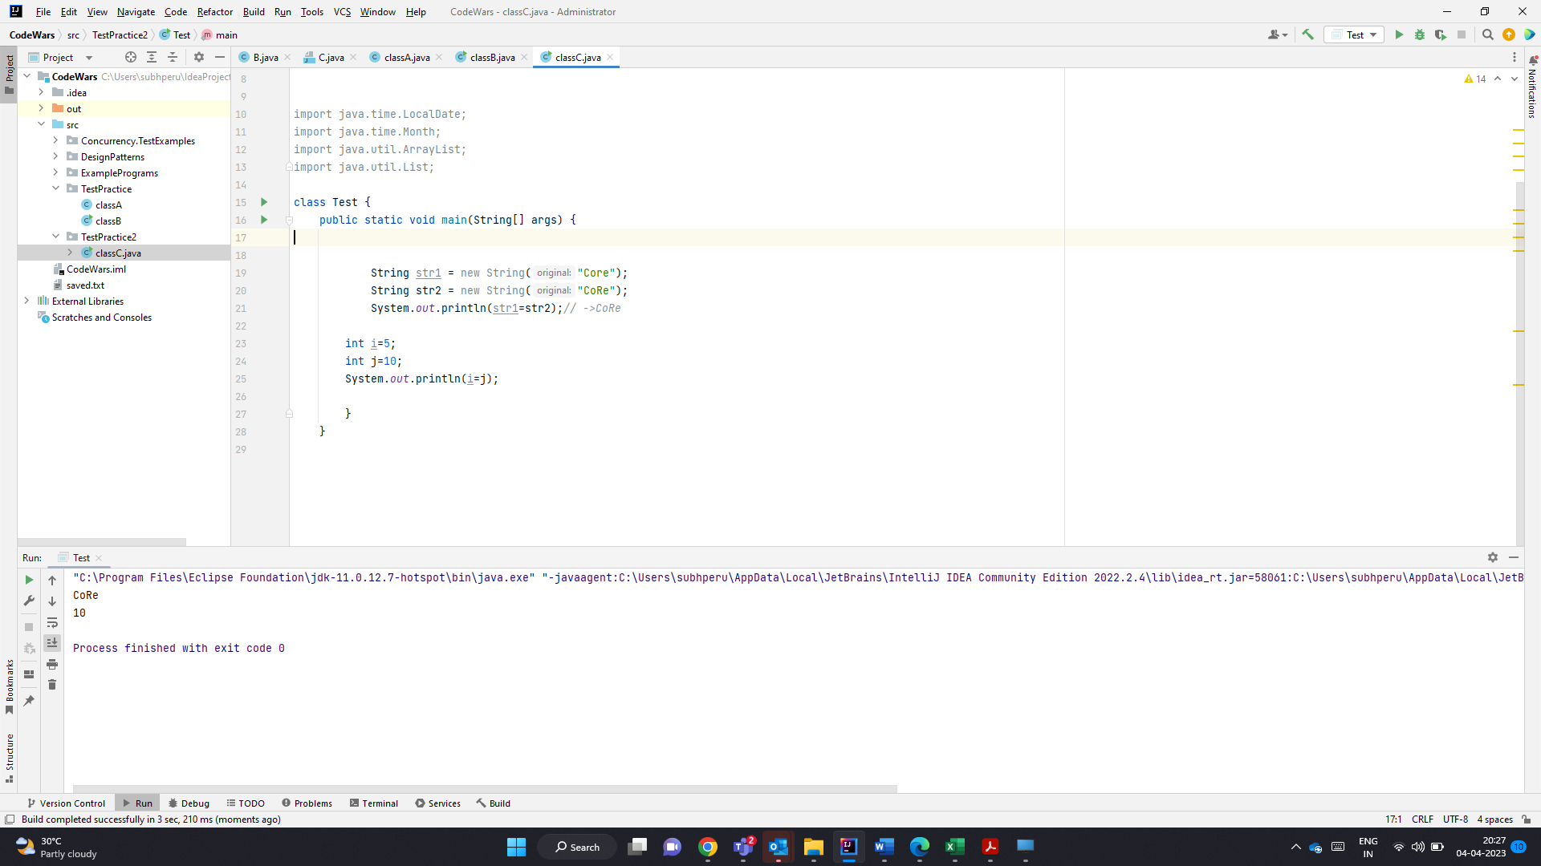

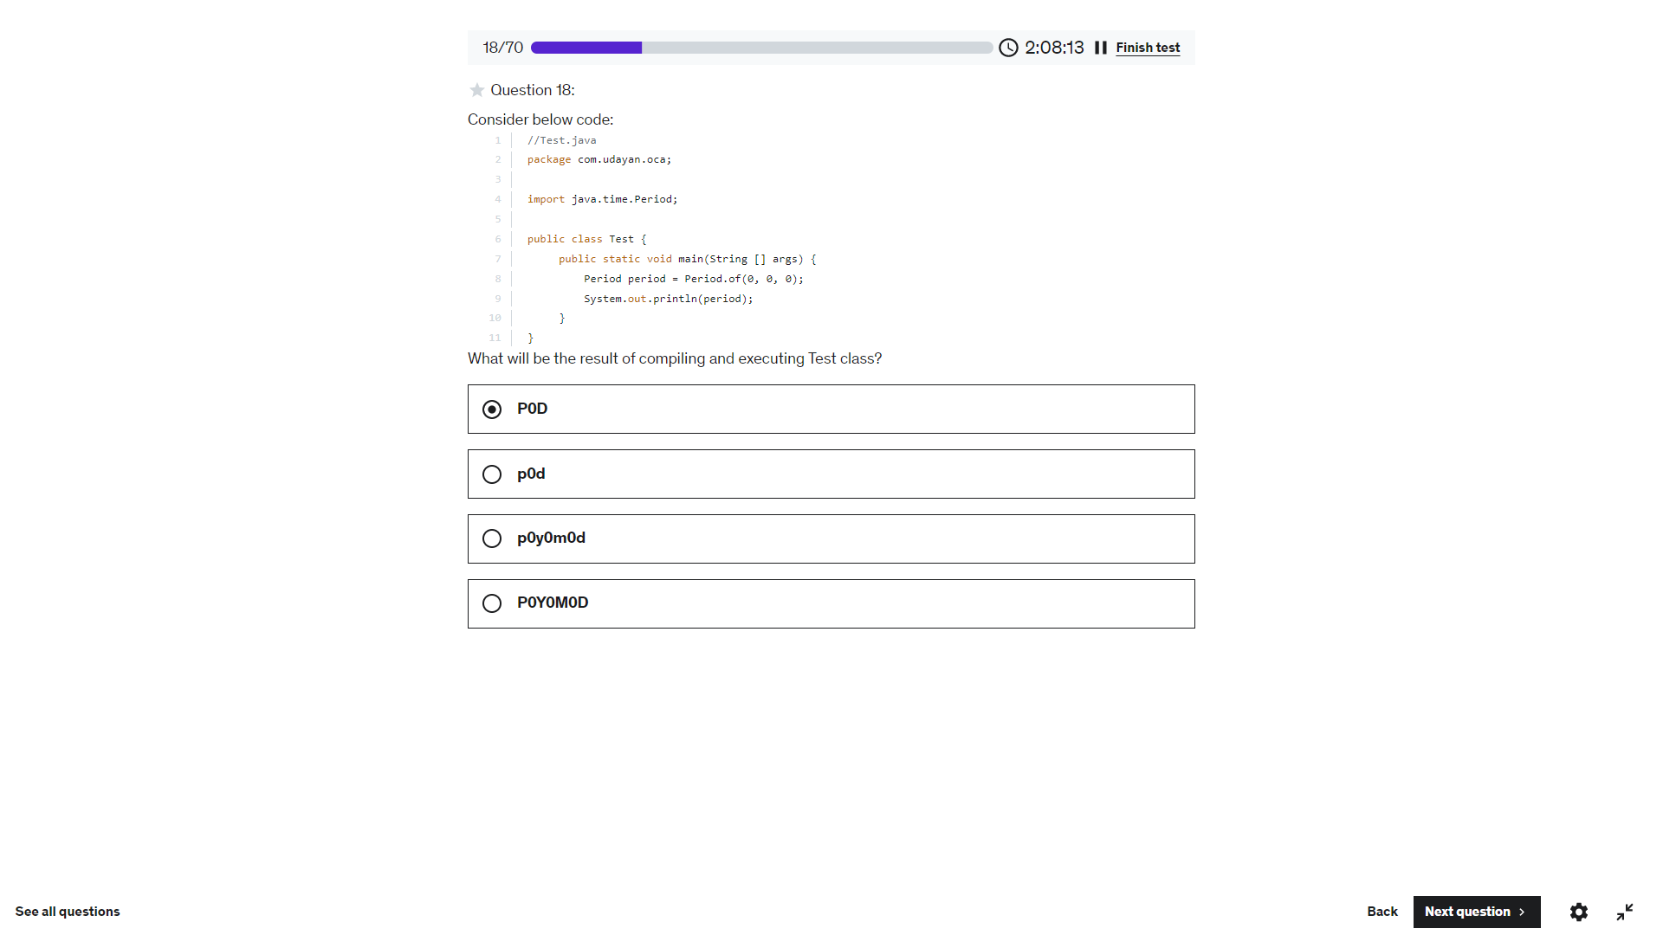

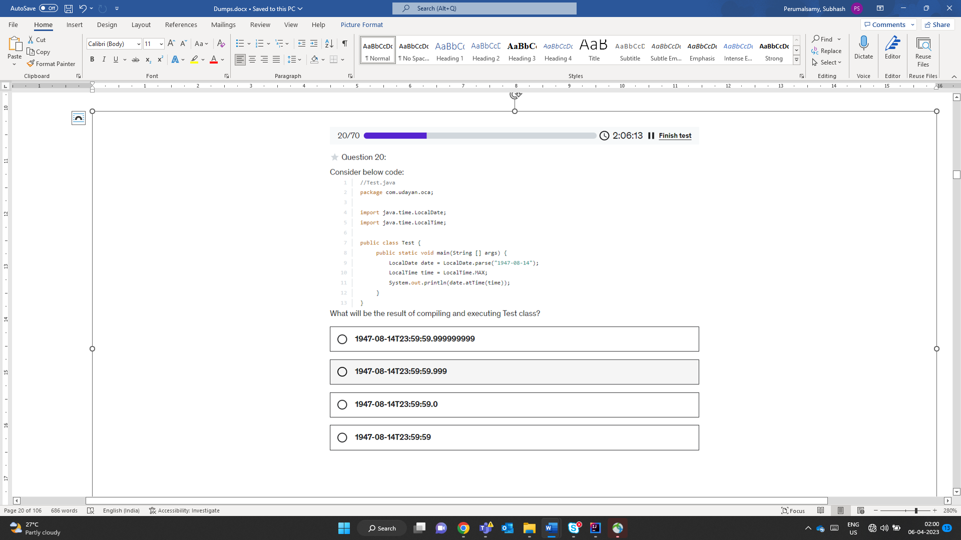

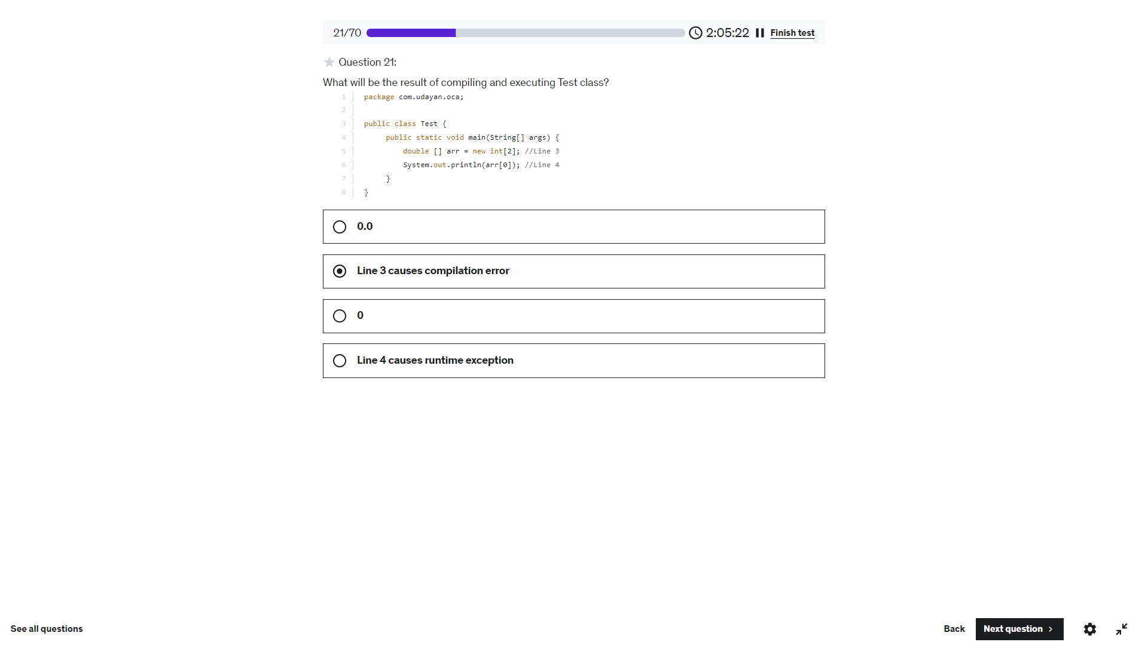

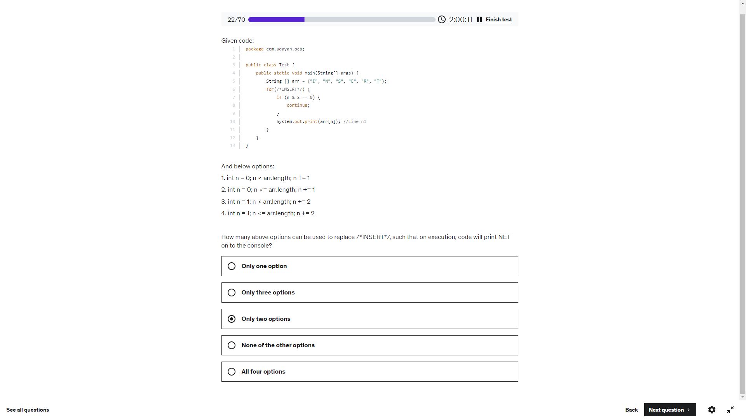

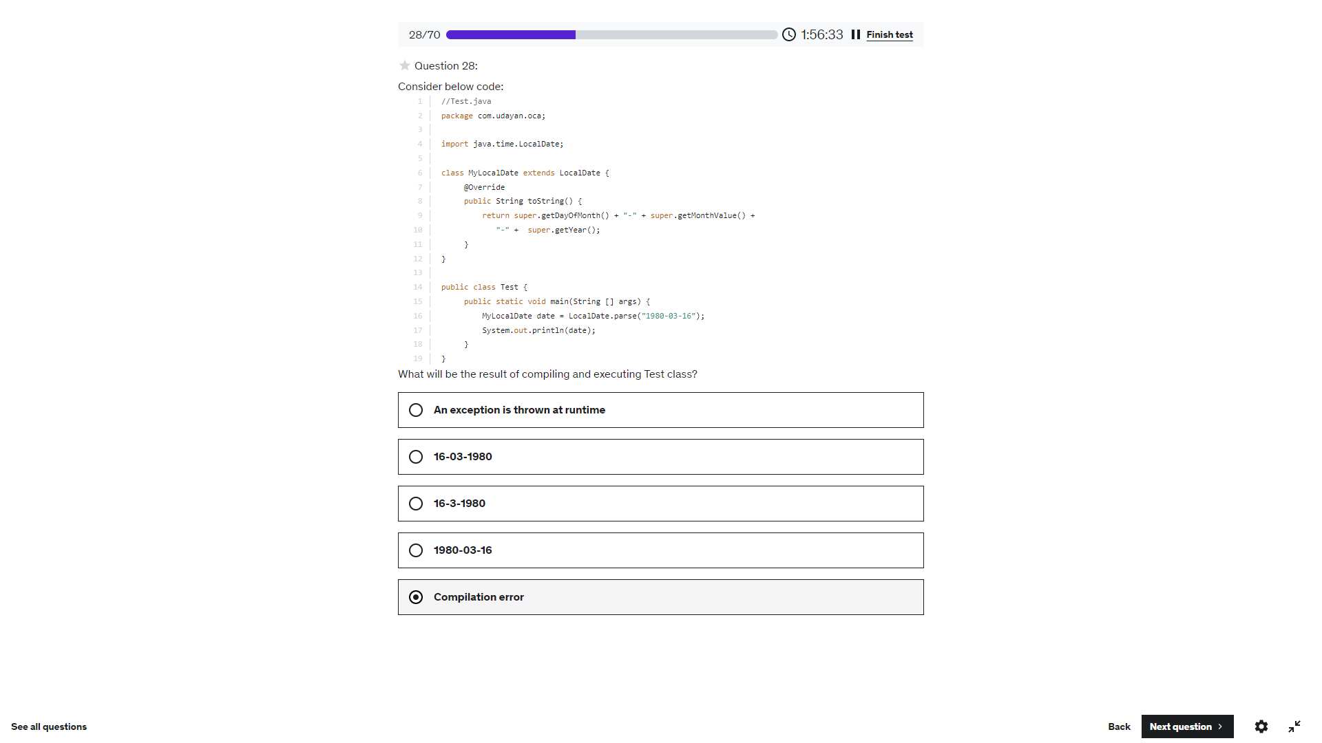

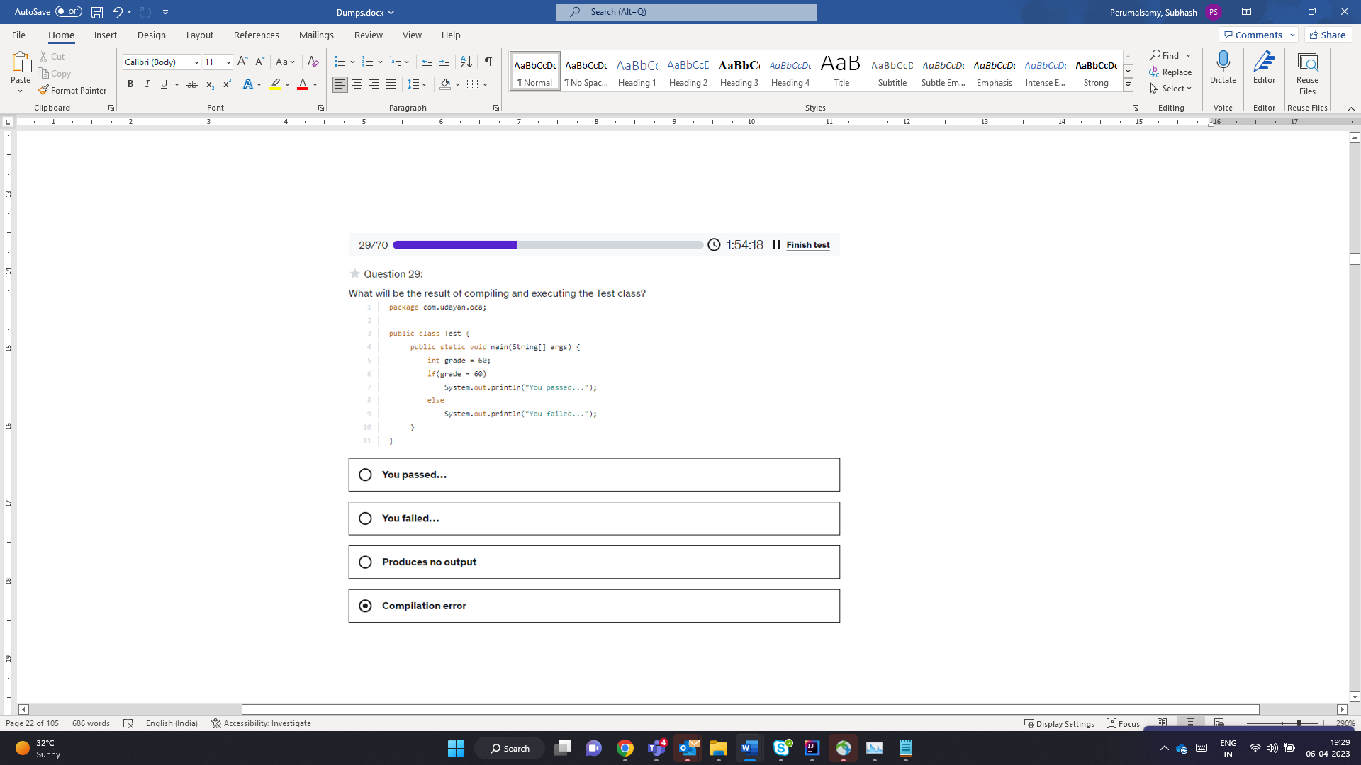

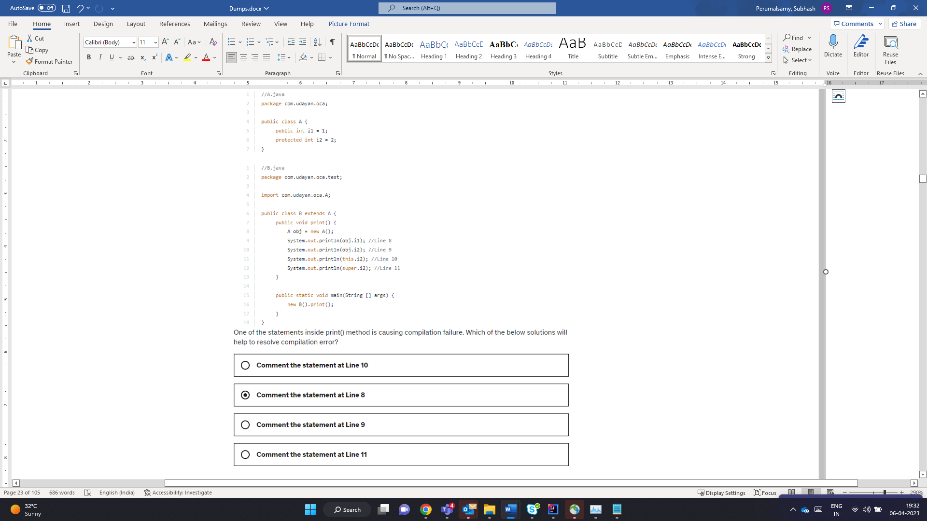

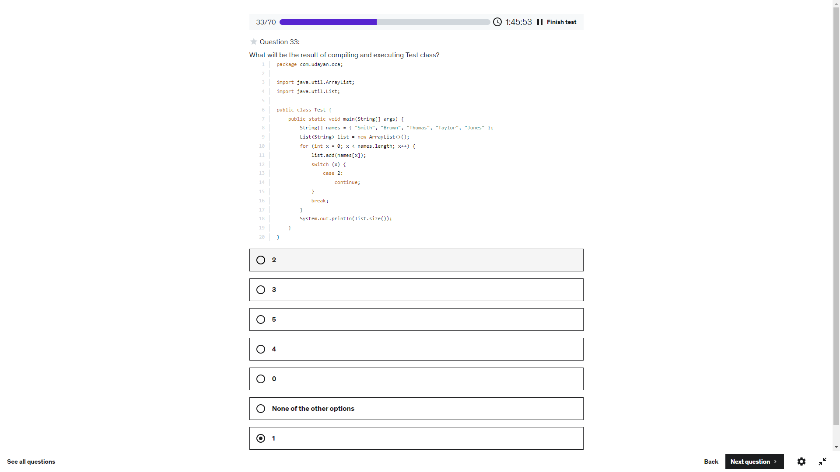

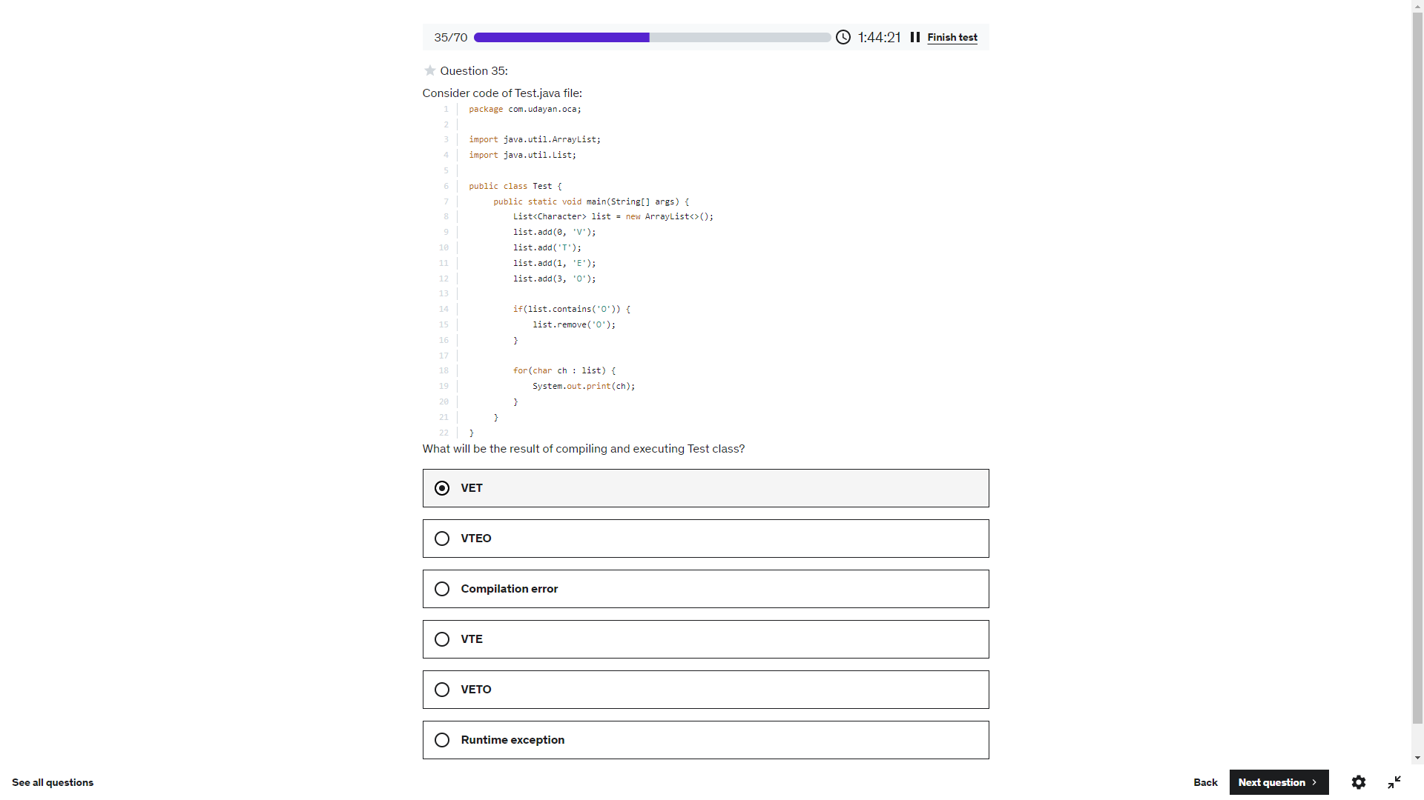

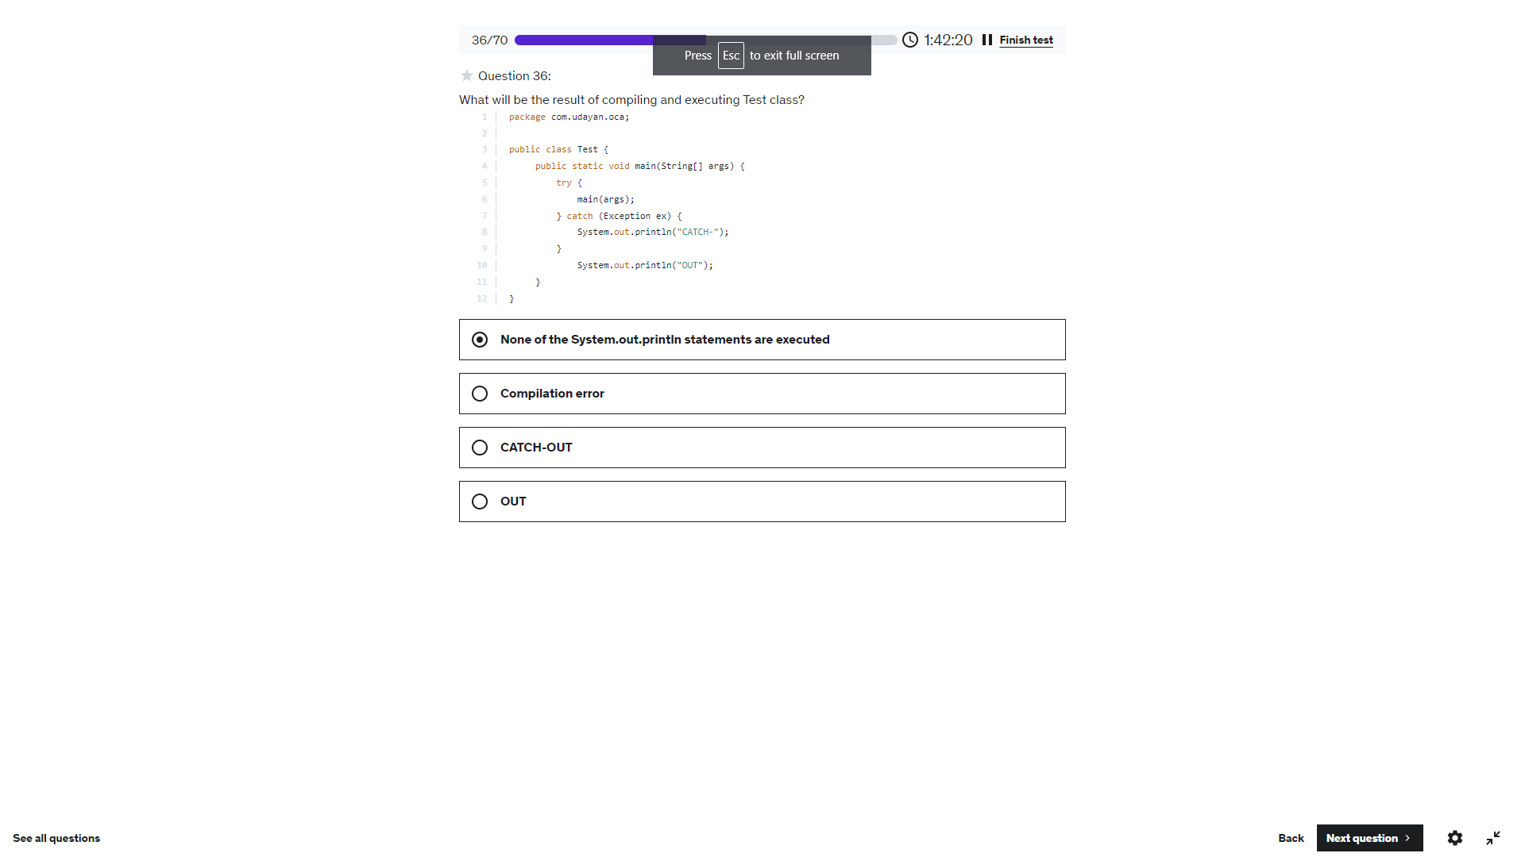

[2,1]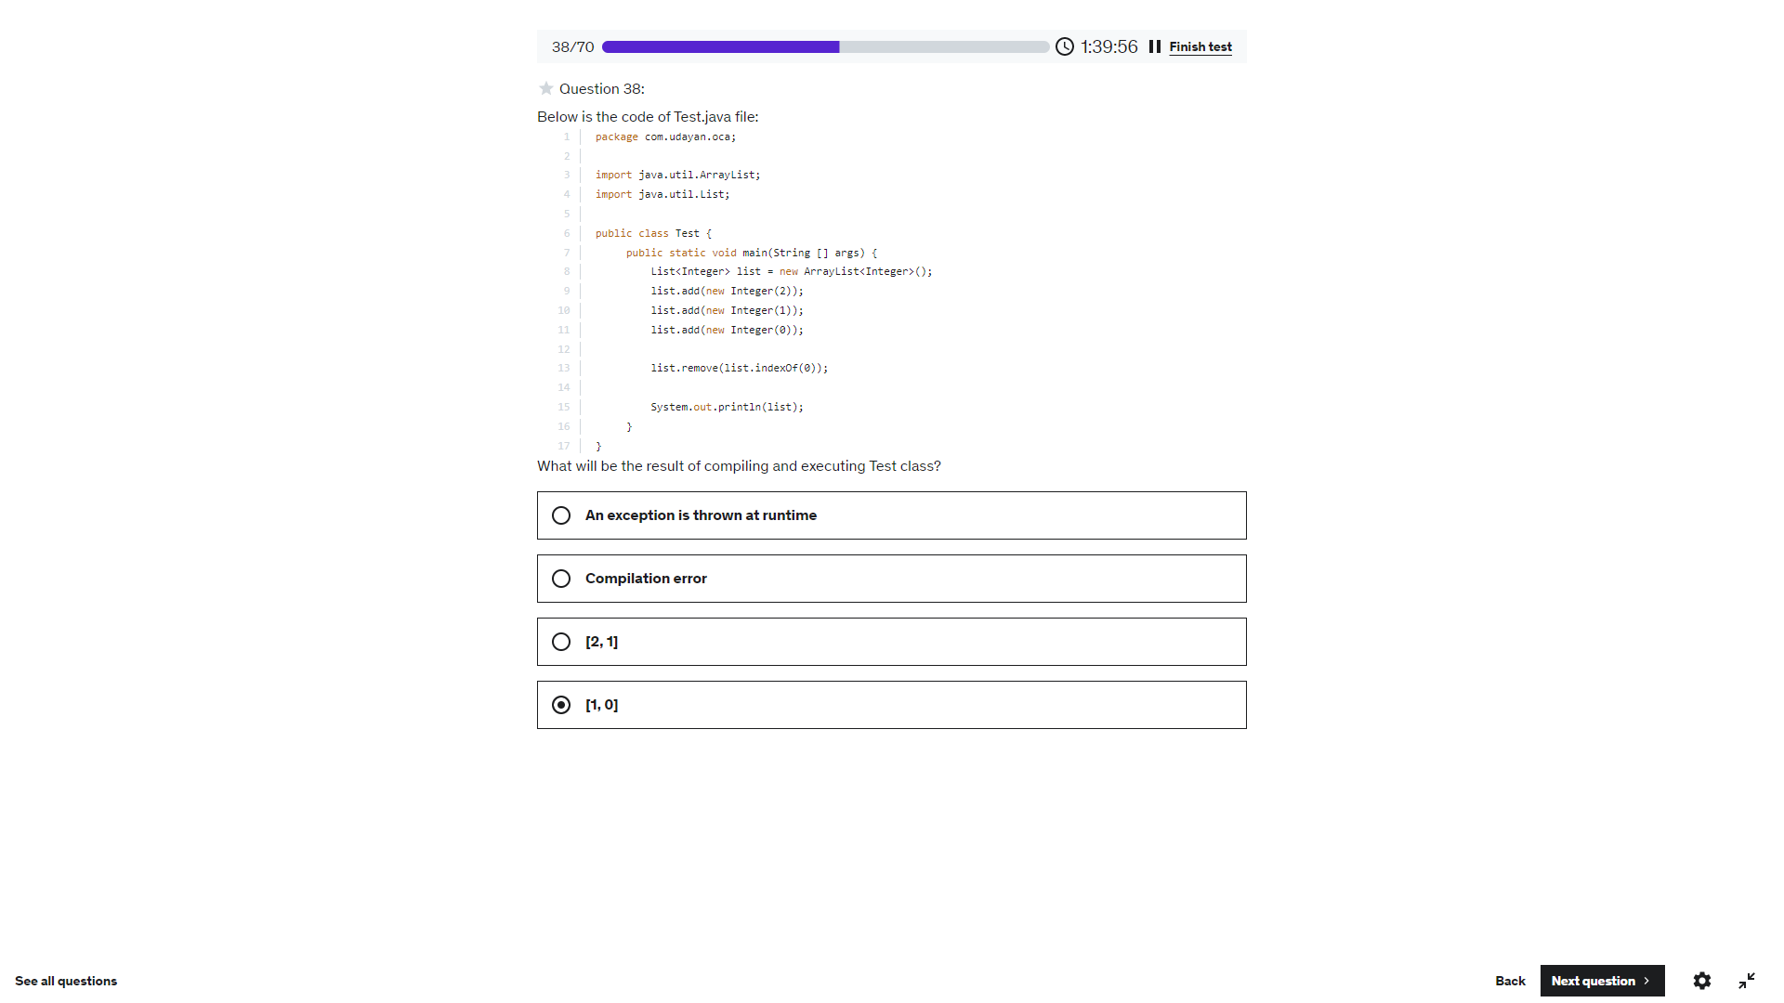

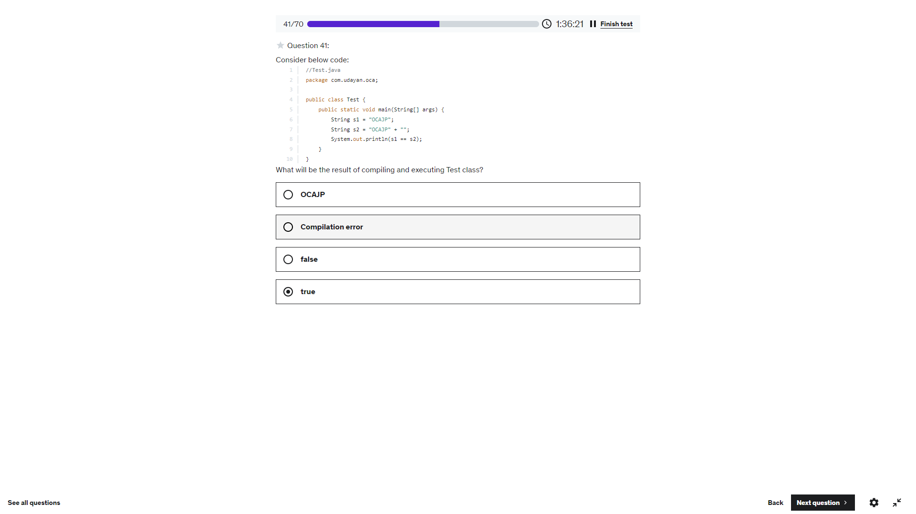

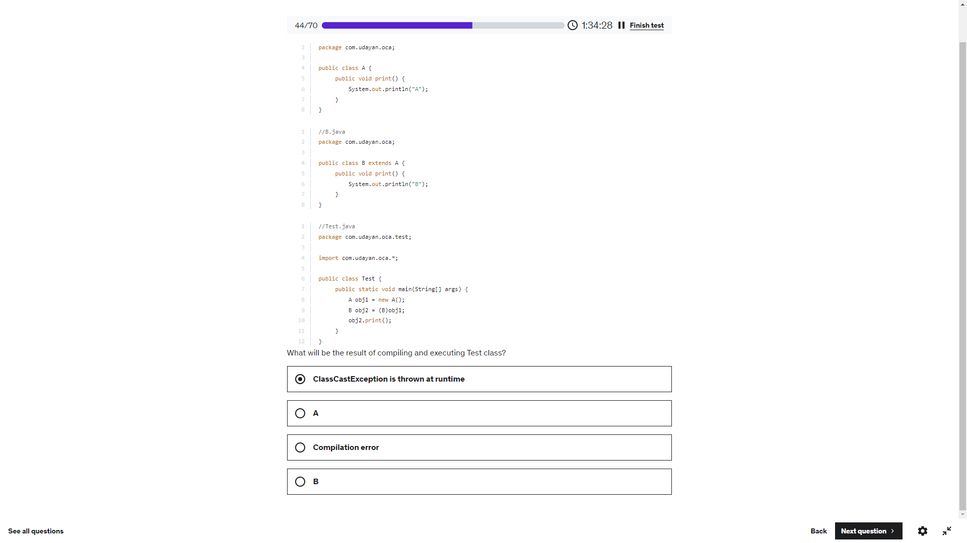

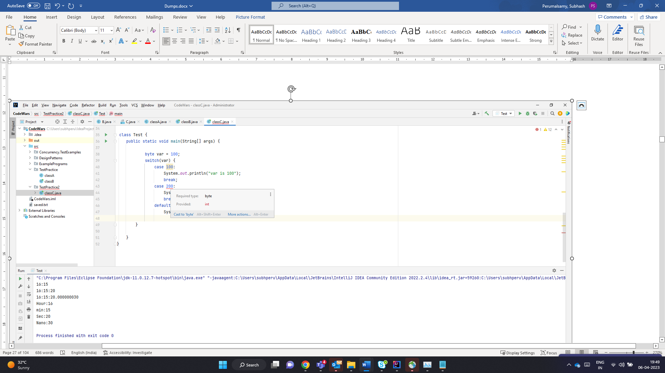

Super class throws IOException – Derived class can throw IOException or its child class Exceptio or not throw any exception.

But Derived class throw FileNotFoundException, either to be handled by try catch should declare throws – FileNotFoundException / IOException/ Exception or Throwable – can be used. But since Super class throws IOException- sub class cannot be clared using throws Exception or Throwable.

Hence we are left with IOException or FileNotFoundException. The below throws IOException which is the parent of FileNotFound which is ok – No issue with Derived class

Main Class – Has try catch for FileNotFoundException – but its not Handling IOException – So compile time error

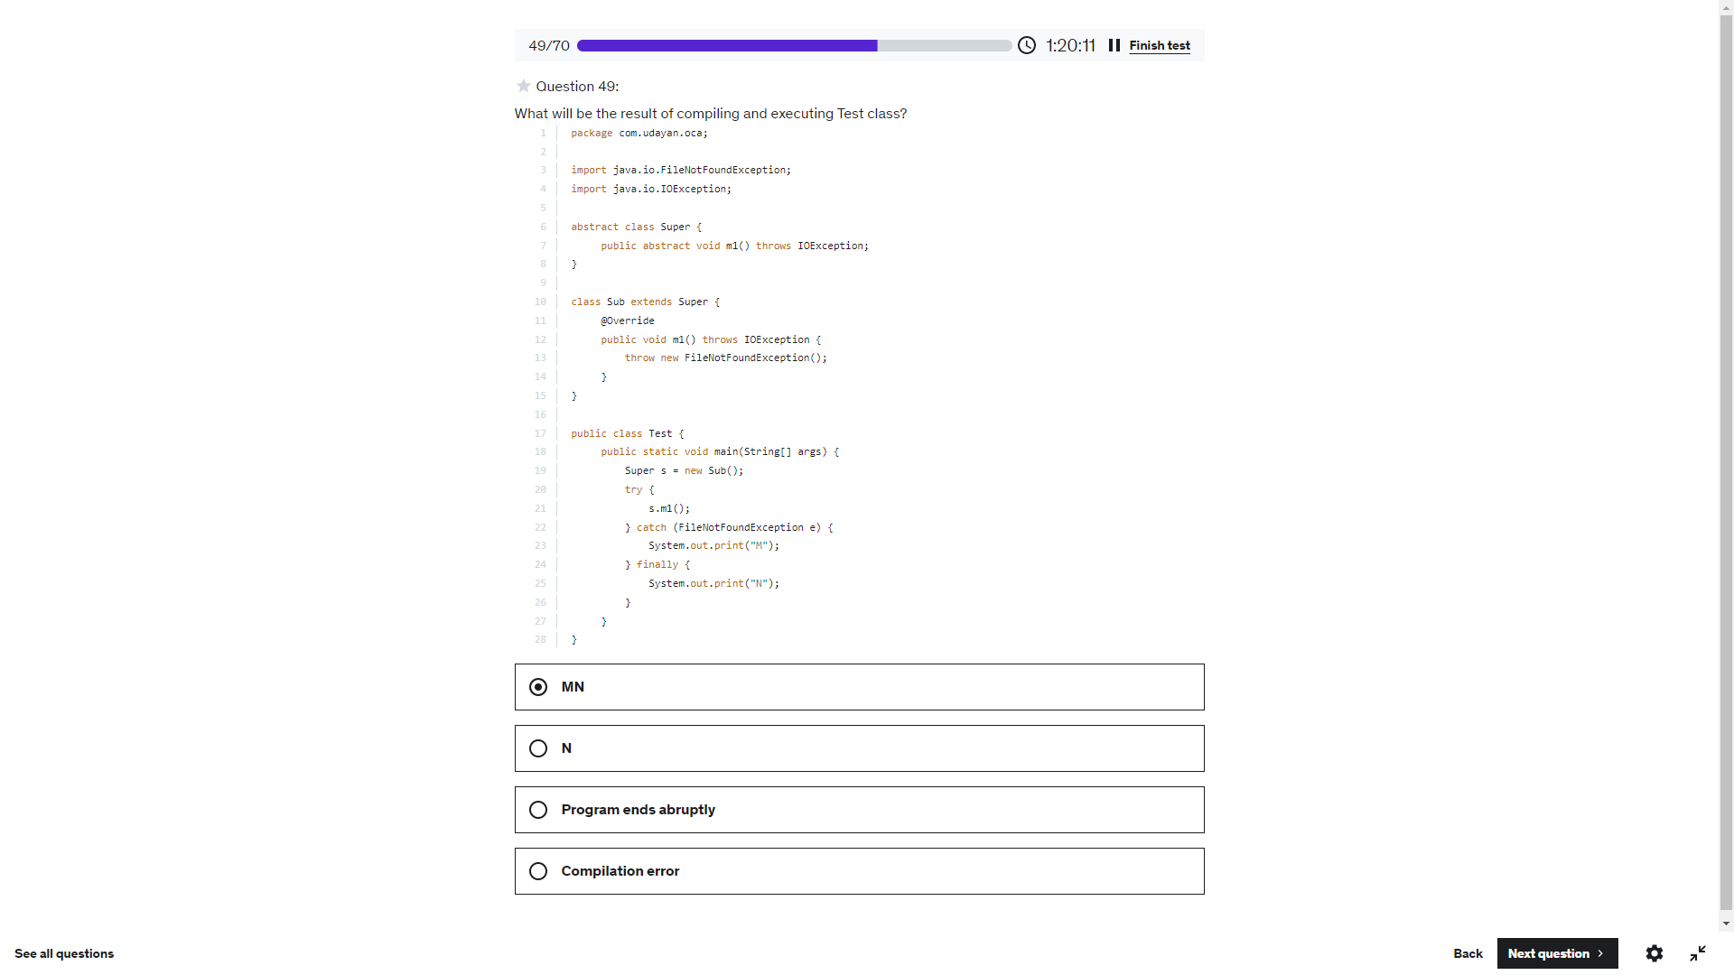

-100

101

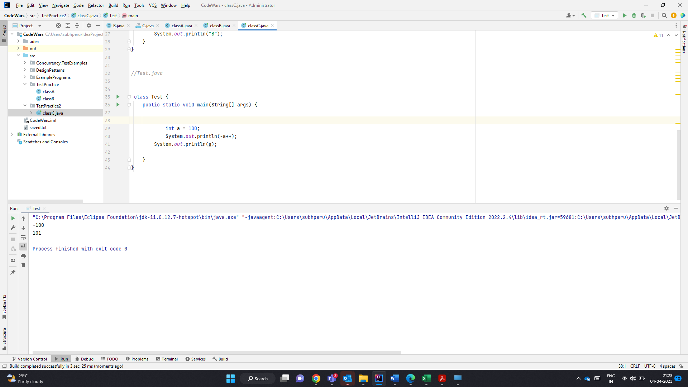

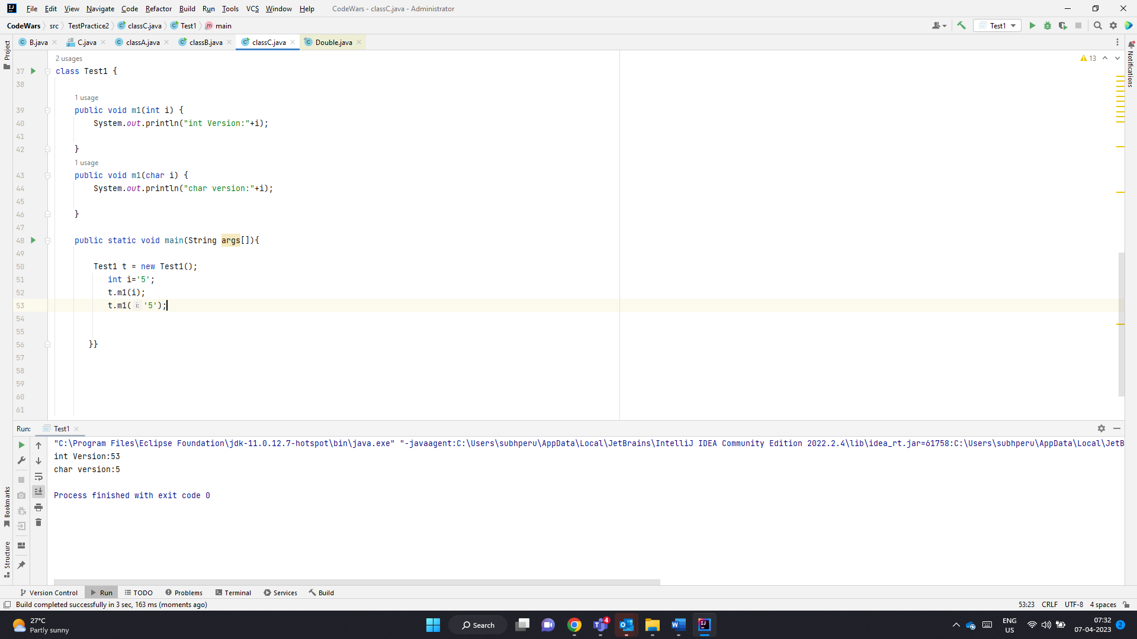

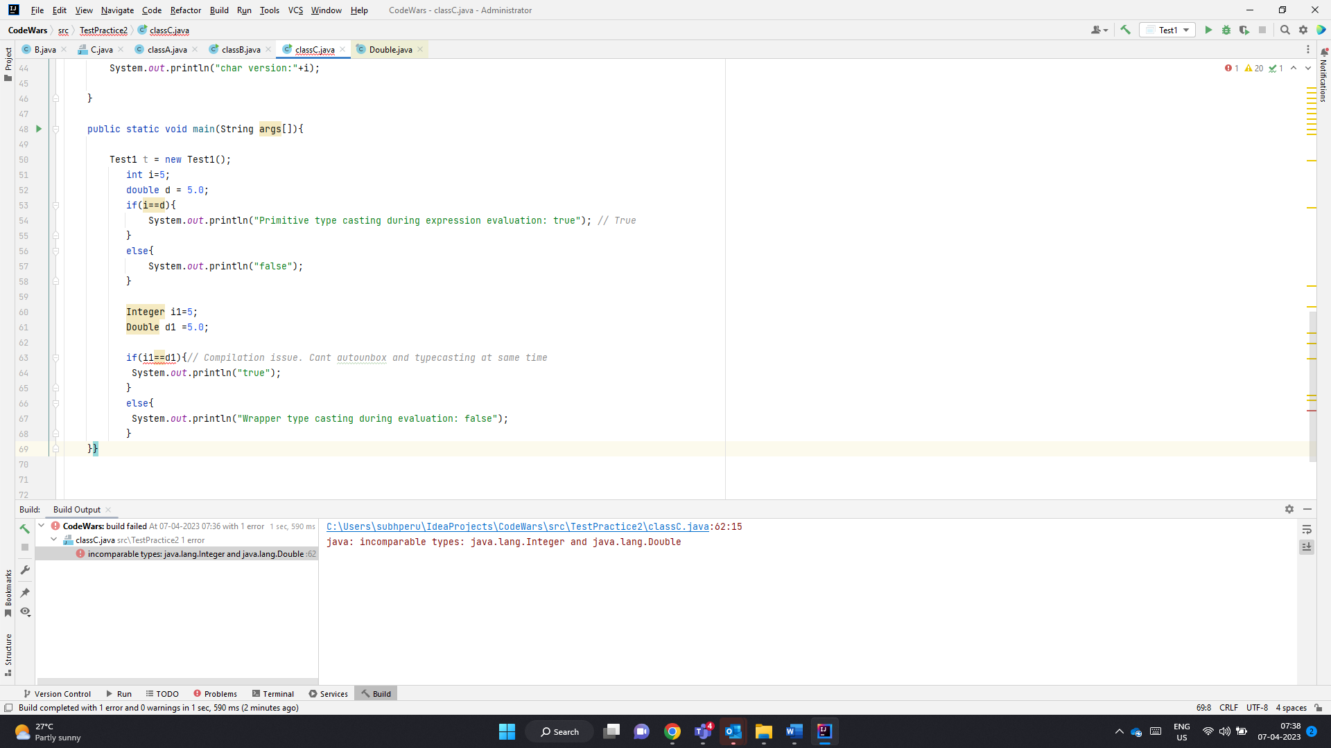

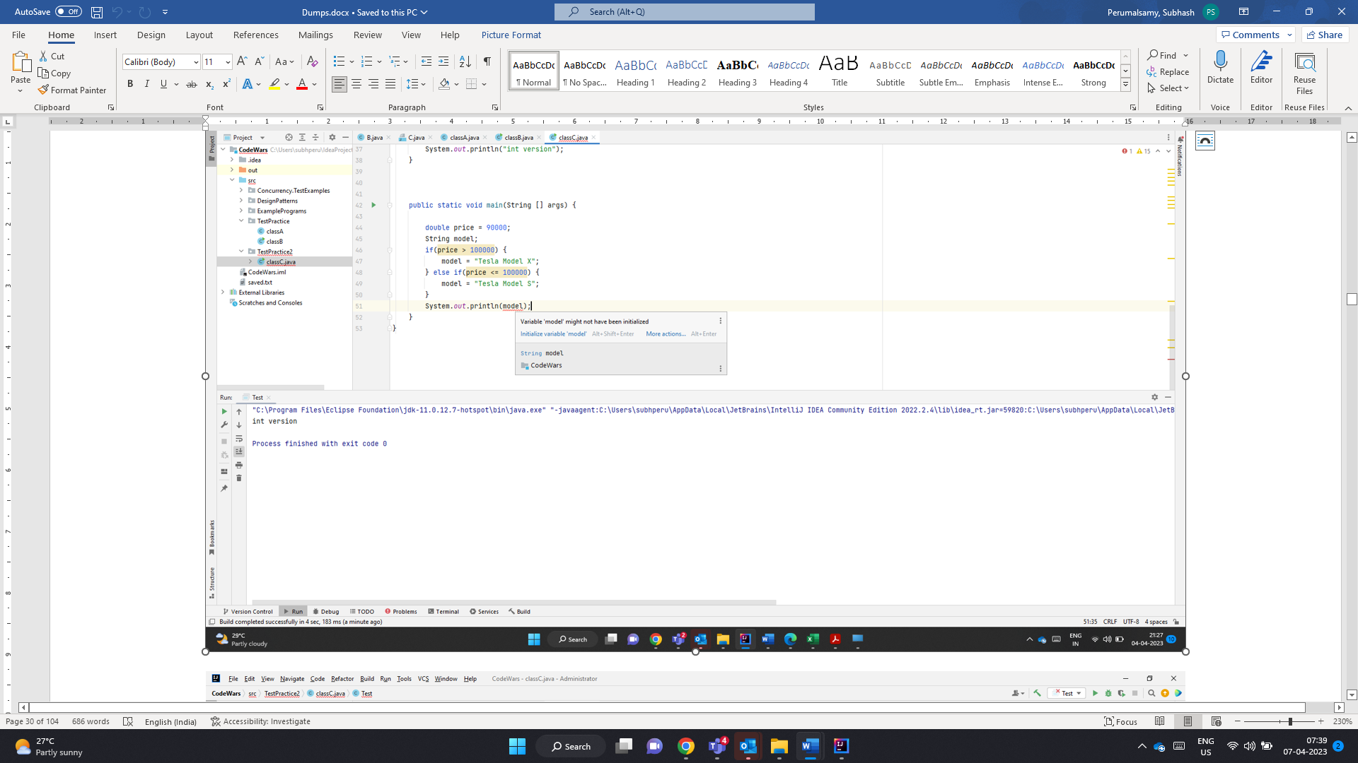

Void followed by method name

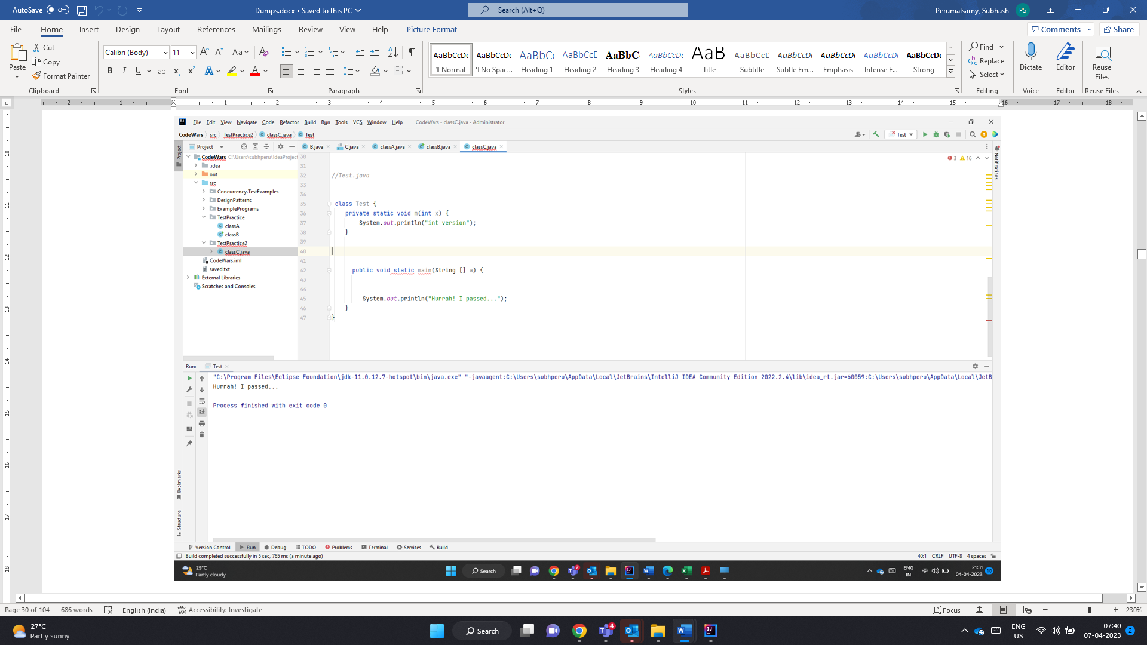

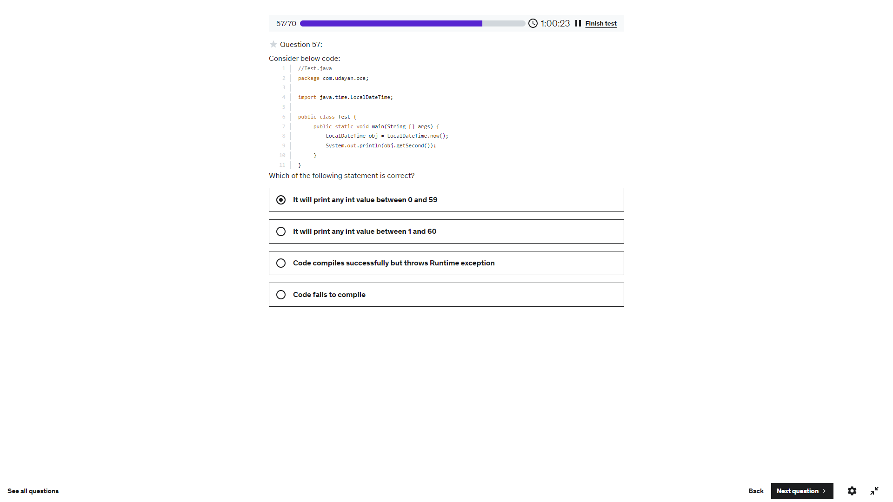

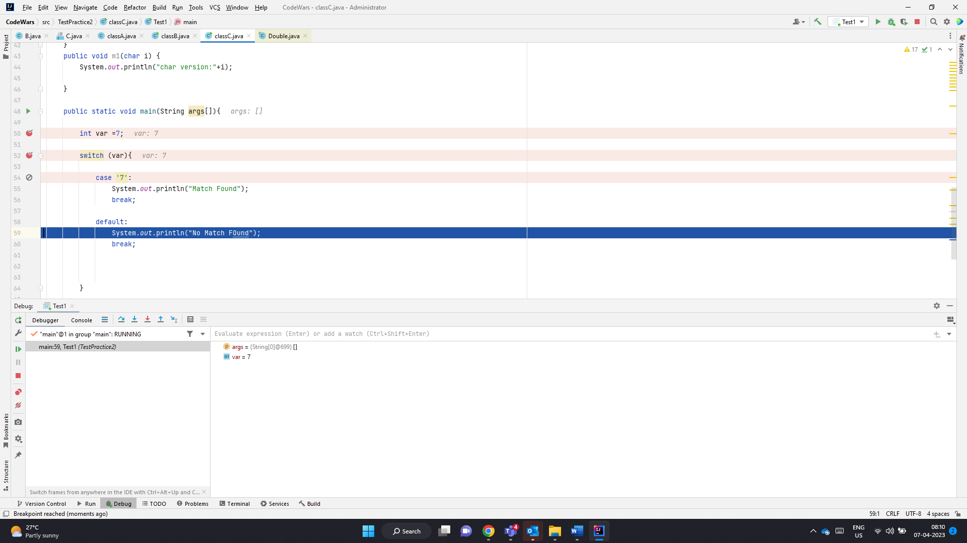

Var is int. Case Label ‘7’ char does not throw any error.

Executes Default

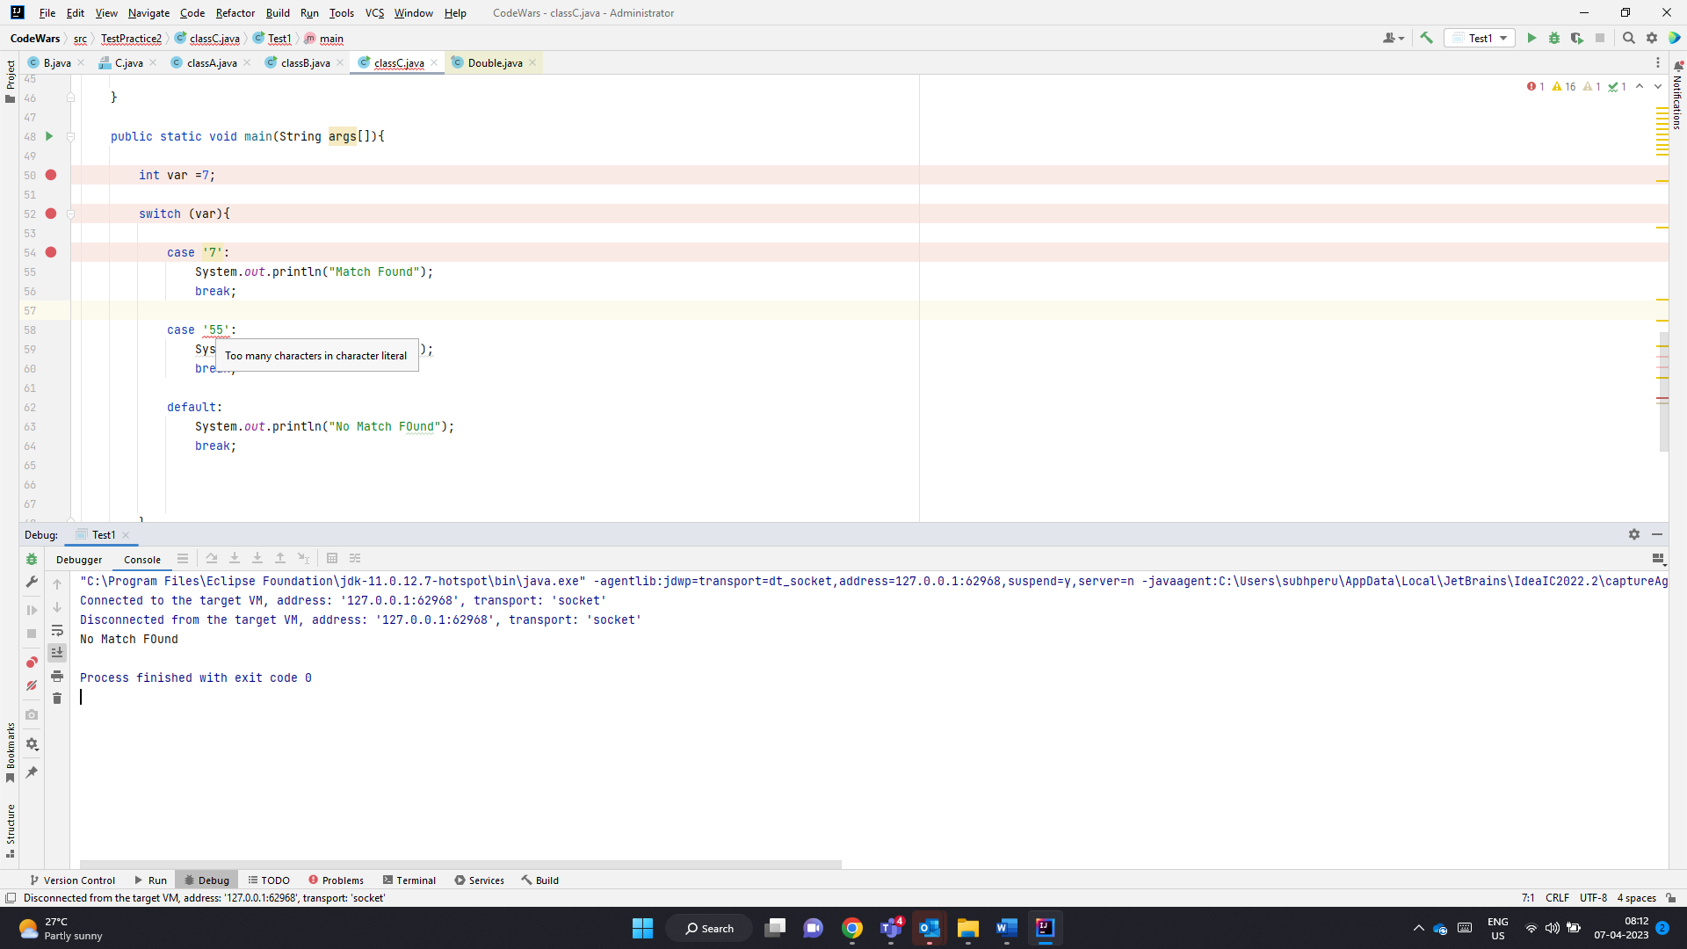

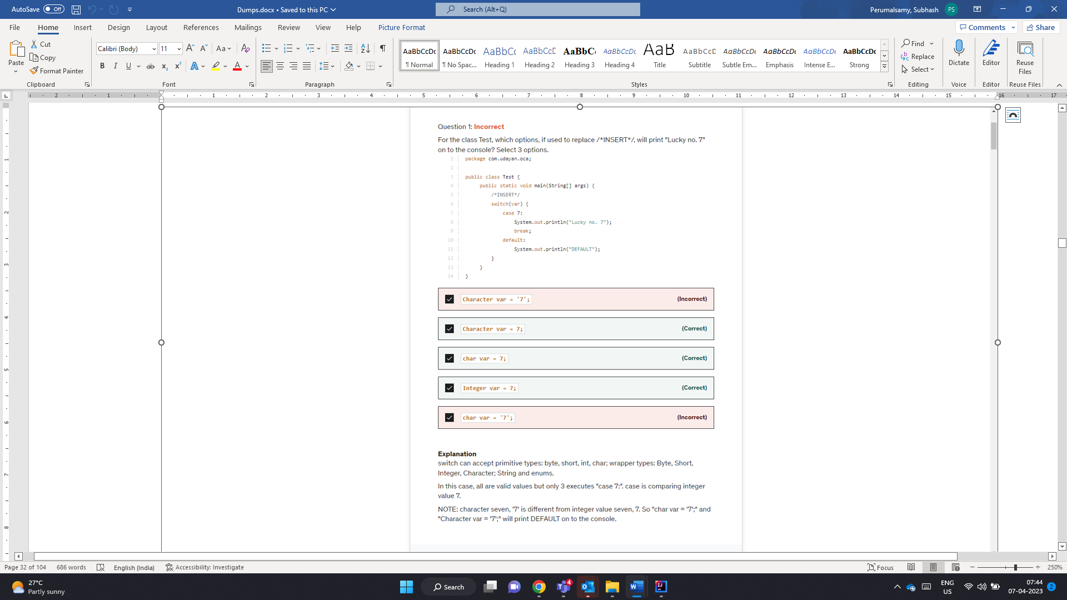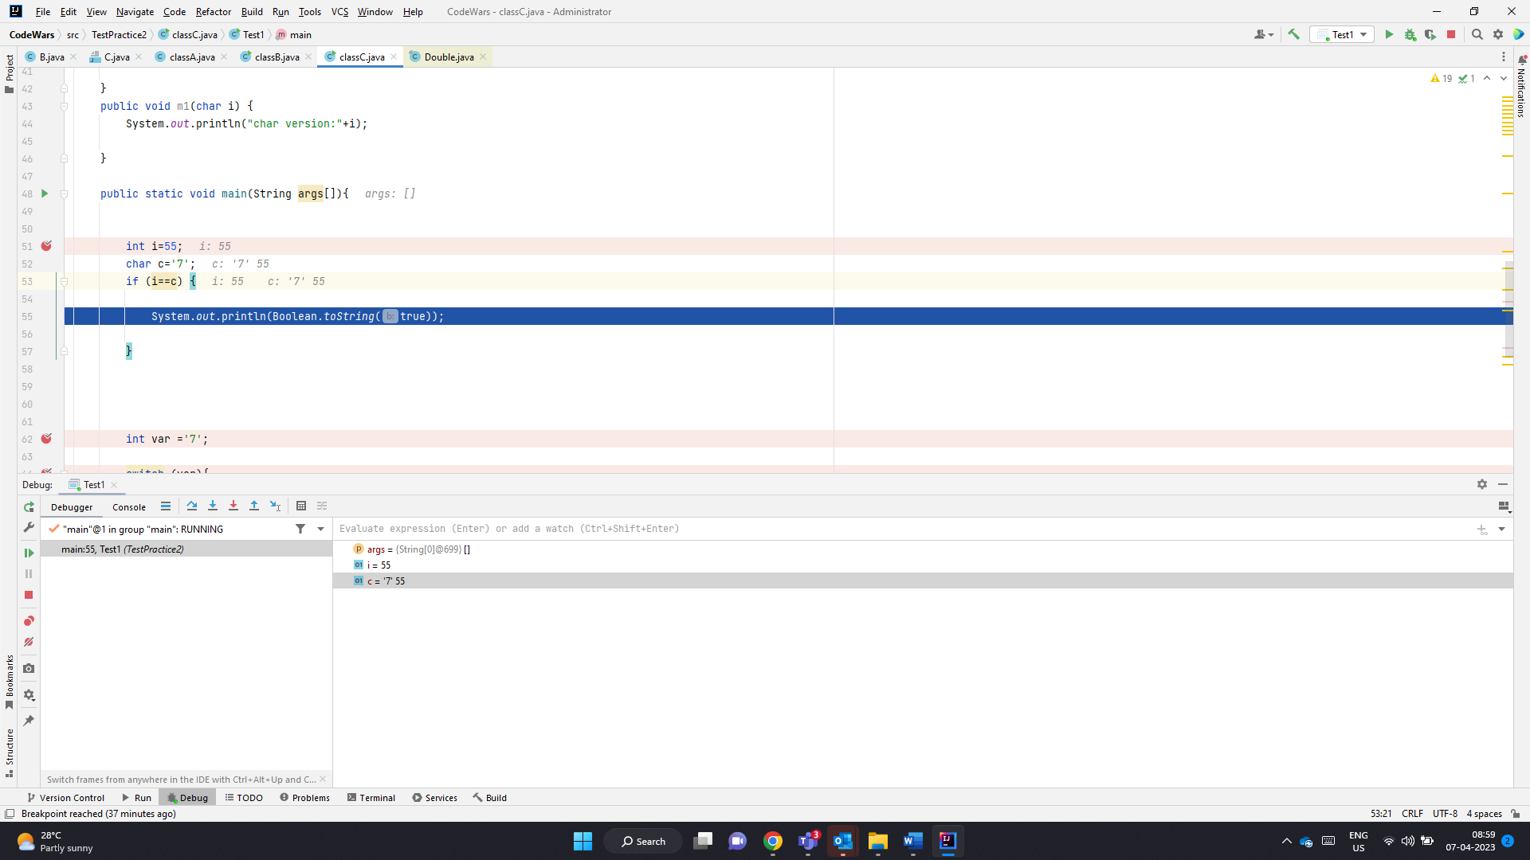

Character var=’7’

Here var-> Character. So Case 7: int 7 is converted to char

‘\u0007’ Mismatches

Character var =7 -> int to Char -> ‘\u0007’

Case 7: int->Char -> ‘\u0007’

Char var =7; int to Char -> ‘\u0007’

Case 7: int->Char -> ‘\u0007’

Integer var=7;-> Int 7

Case 7: int 7

Char var =’7’ ->’7’

Case 7 -> ‘\u0007’

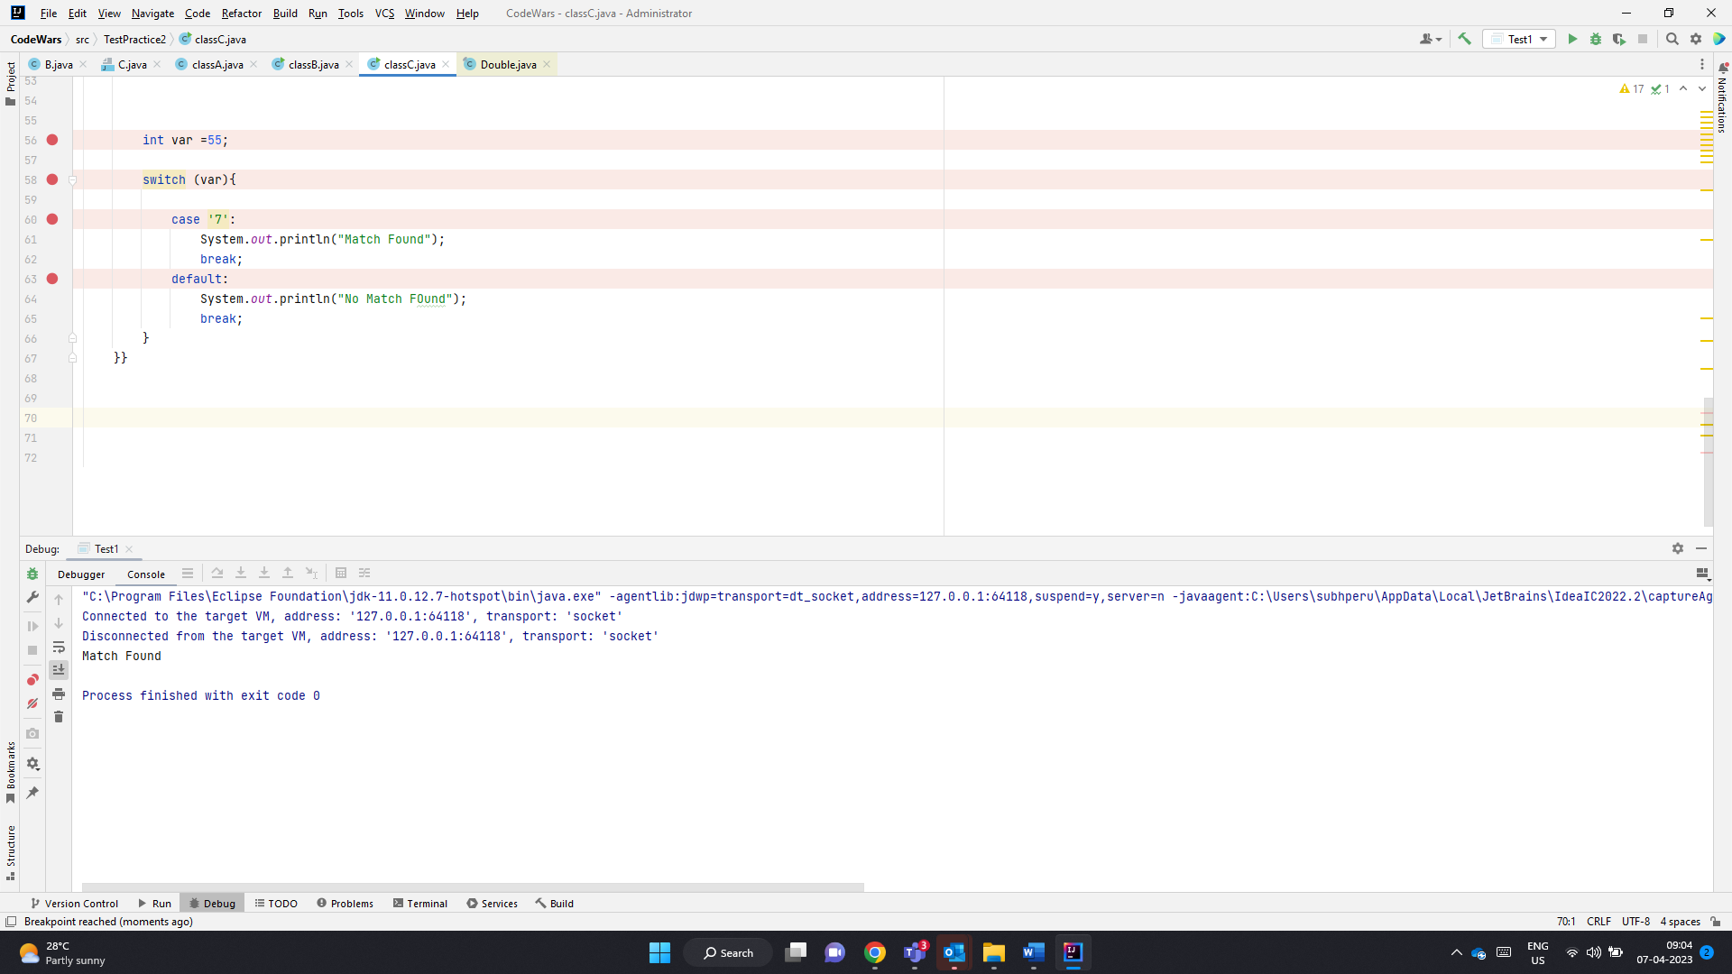

Here char ‘7’ in case label is converted to int 55 and comparison works

Character or char can always be converted to int . Even if the case label is char can be converted to int. Character comparison is always perofmed using int

Below char ‘7’ is converted to int 55 and there happens to be duplicate value.. SO CE

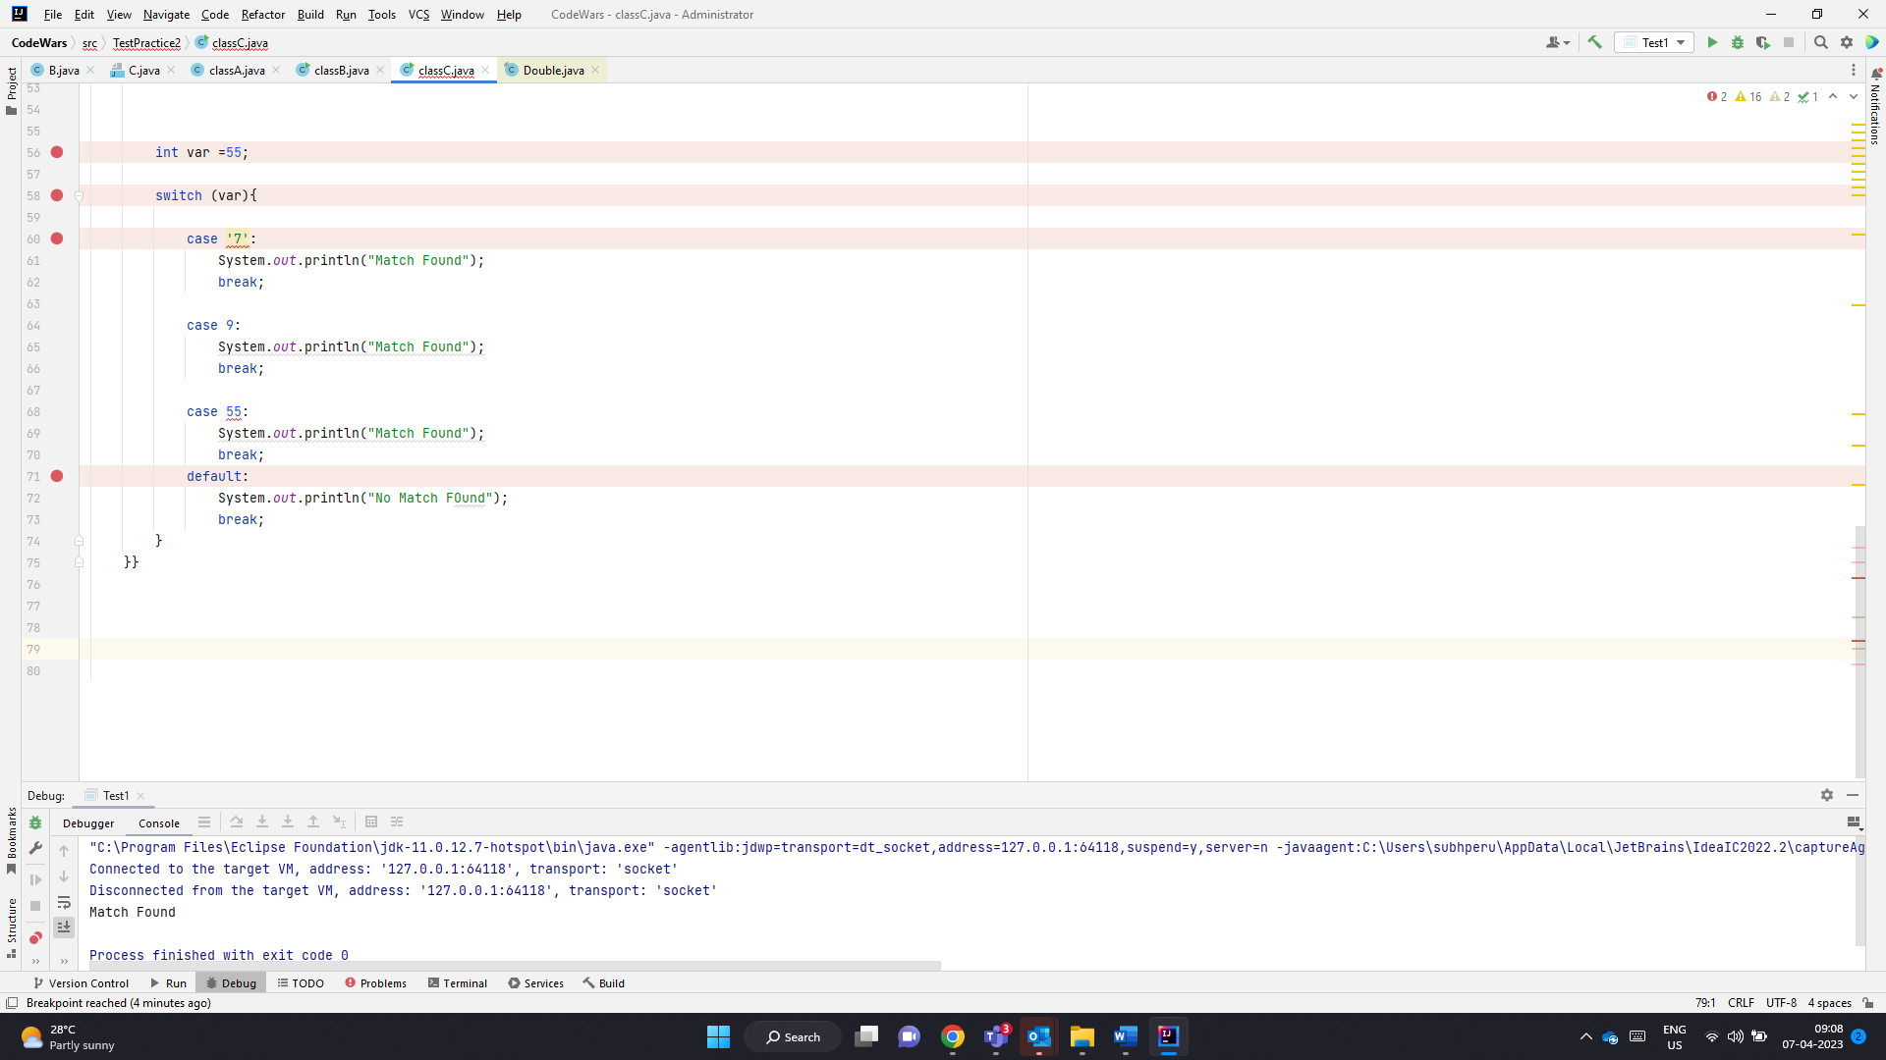

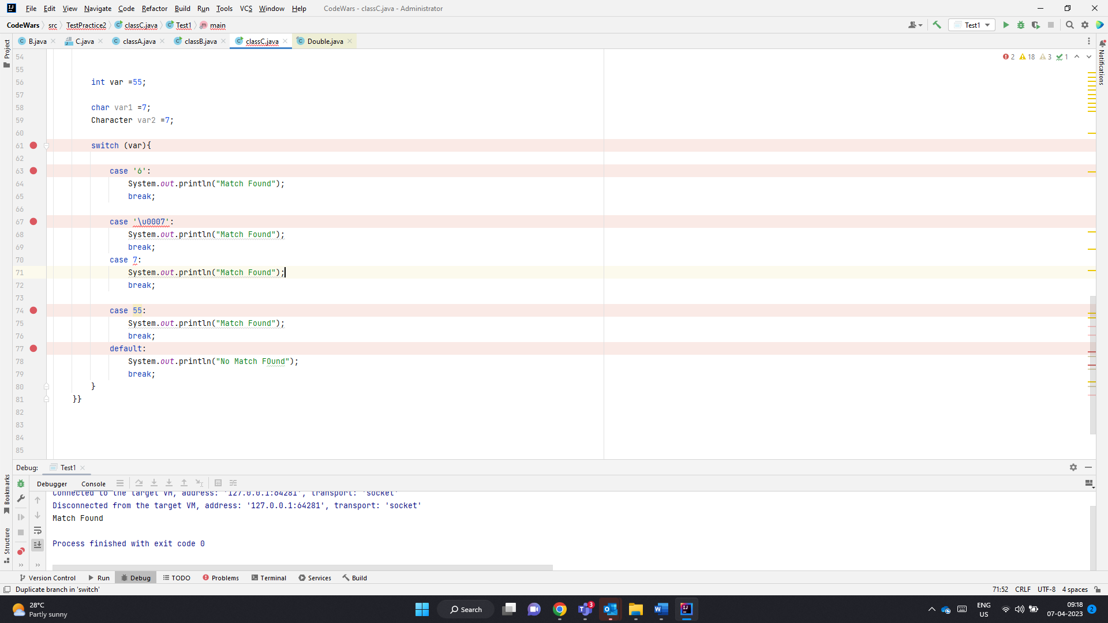

‘7’ == 7

9 ==’9’

Will always fail

‘7’==55 -> int value of ‘7’ will pass.

Chars are converted to int for expression evaluation

List cant accept primitives. So primitive ints are converted to Integers. When

1. E remove(int index): This method removes the element at the specified index and returns it. The subsequent elements are shifted to the left by one place. This method throws IndexOutOfBoundsException if the specified index is out of range. If the list implementations does not support this operation, UnsupportedOperationException is thrown.
2. boolean remove(Object o) This method removes the first occurrence of the specified Object. If the list doesn’t contain the given element, it remains unchanged. This method returns true if an element is removed from the list, otherwise false. If the object is null and list doesn’t support null elements, [NullPointerException](https://www.digitalocean.com/community/tutorials/java-lang-nullpointerexception) is thrown. UnsupportedOperationException is thrown if the list implementation doesn’t support this method.

[A,C,C,B,A]

[B]

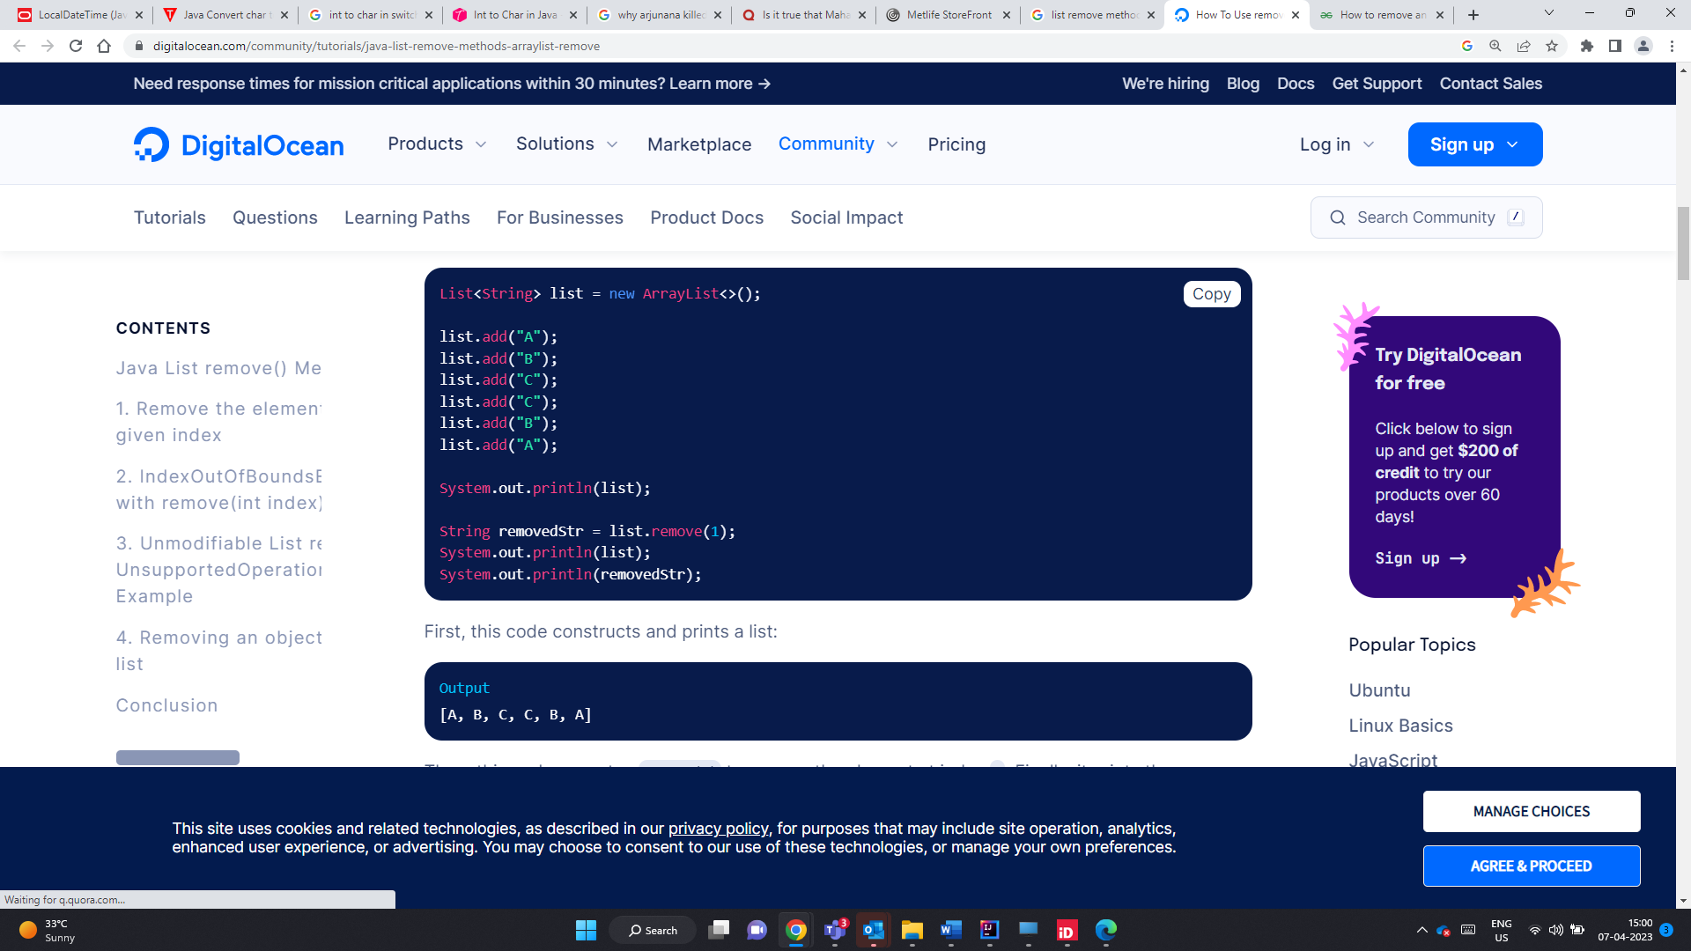

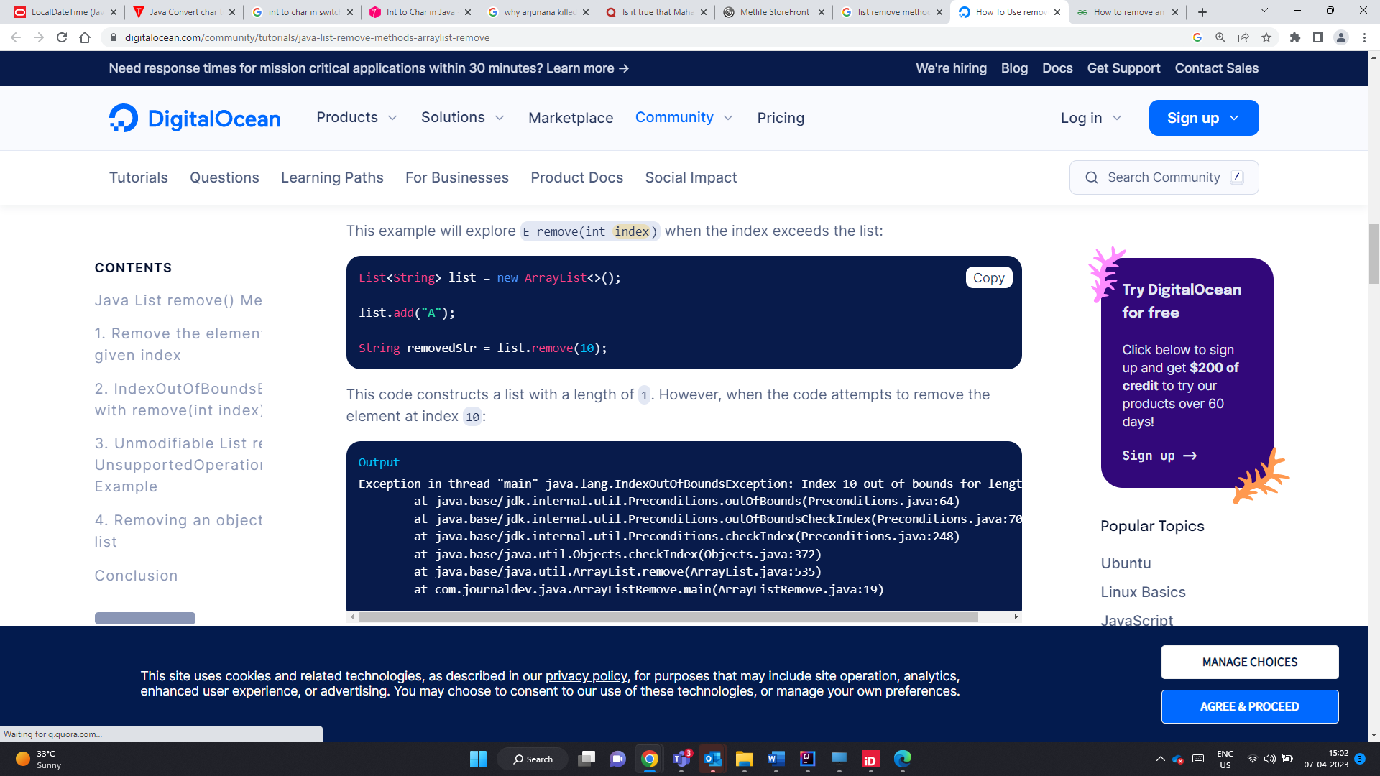

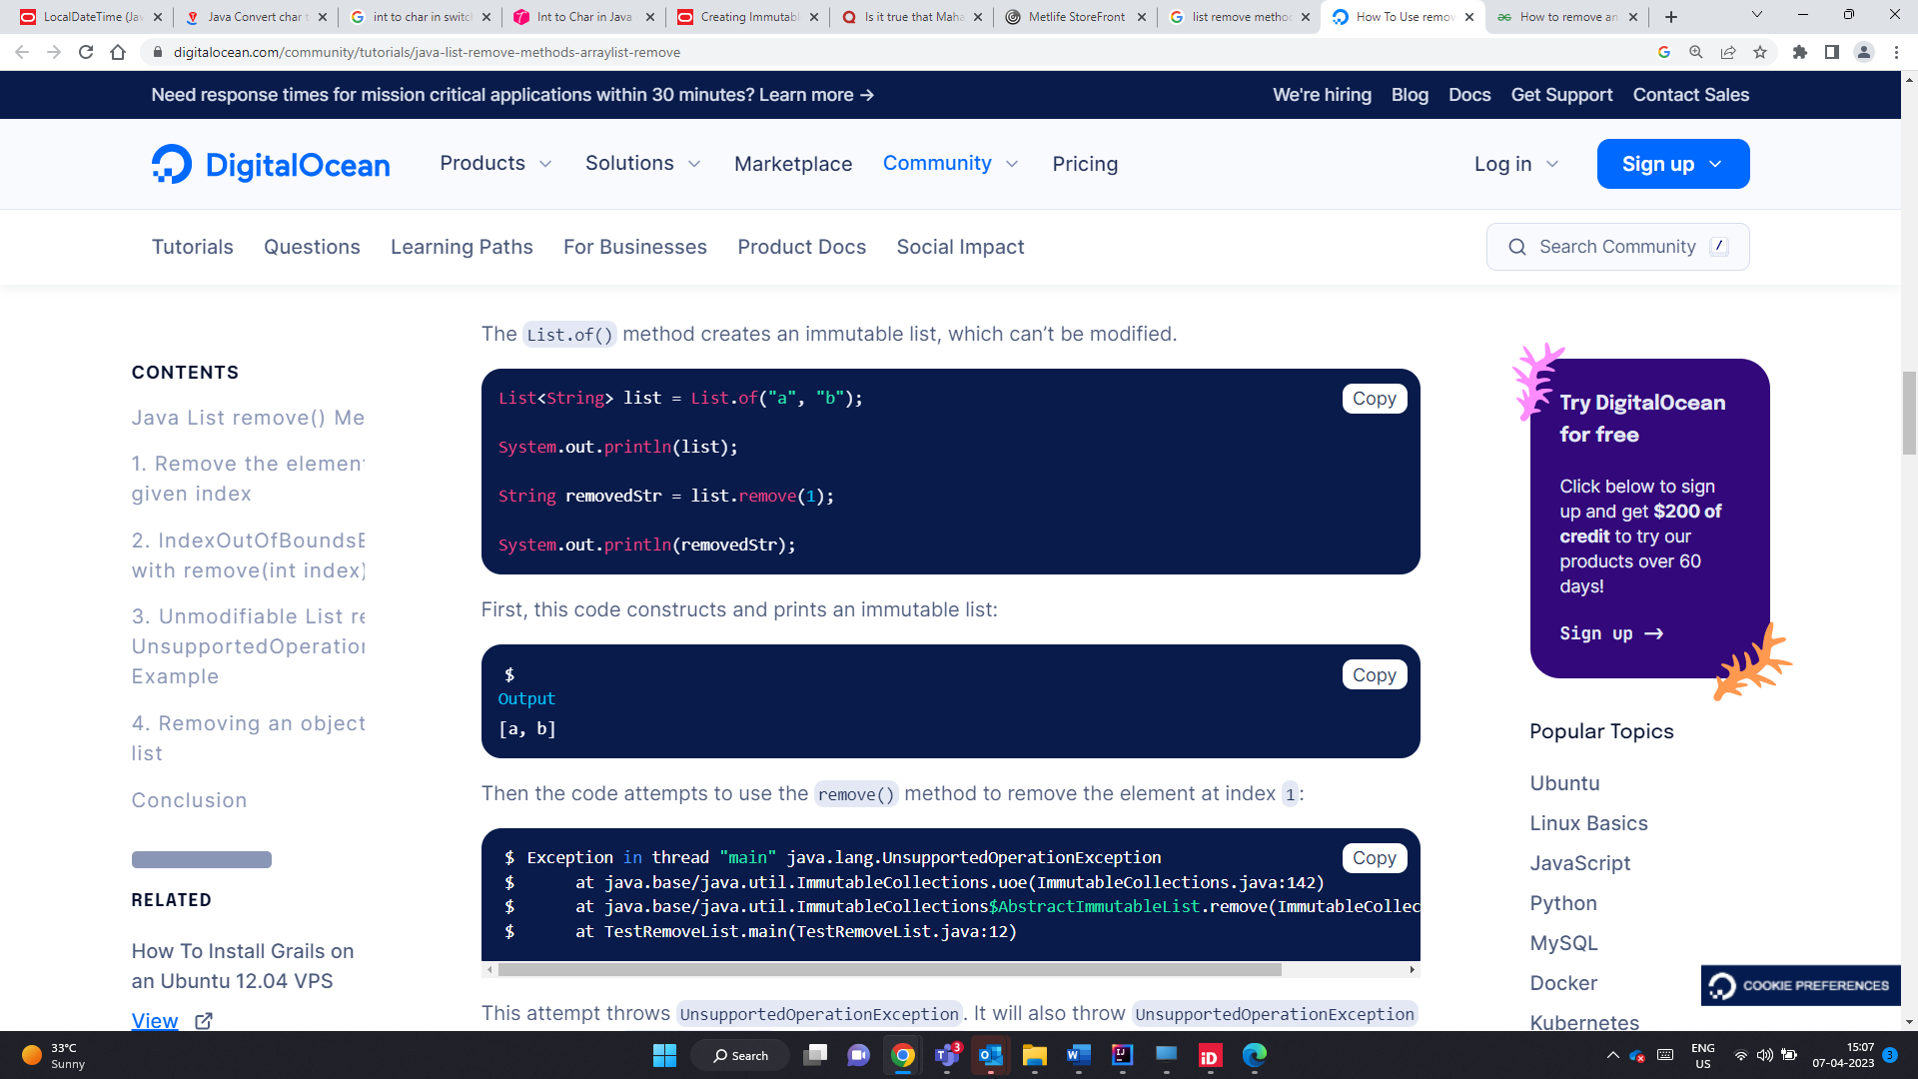

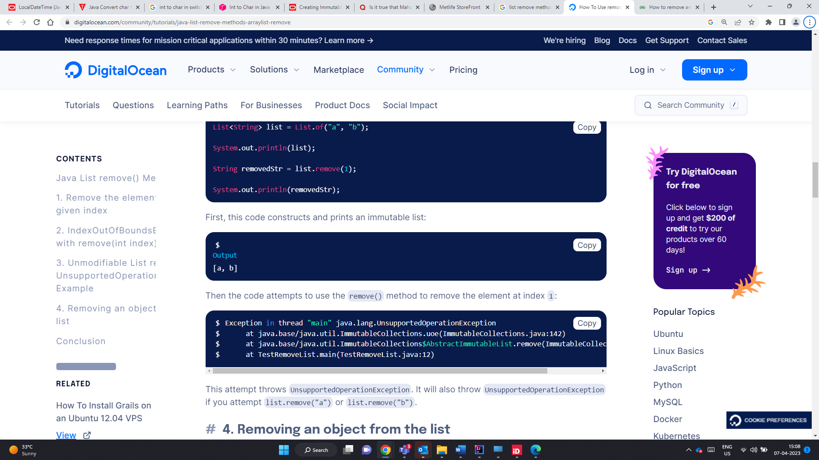

IndexOutOfBound Excpetion

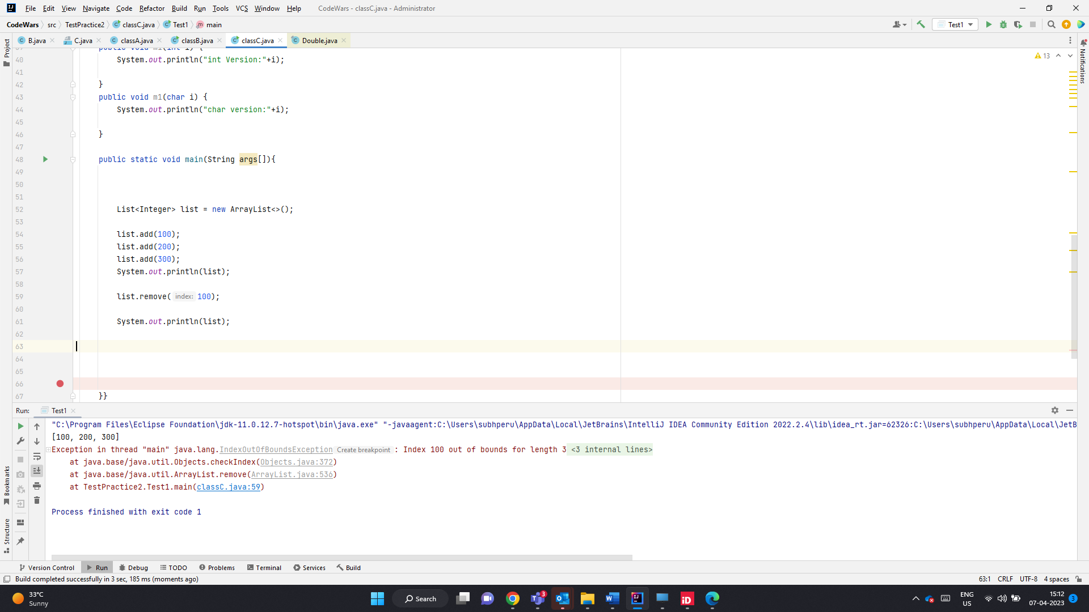

E remove(int index) -> method is overridden to remove the element at index.

Causes index out of bound exception

Since remove(int)- is a valid method it does not perform autoboxing in this case

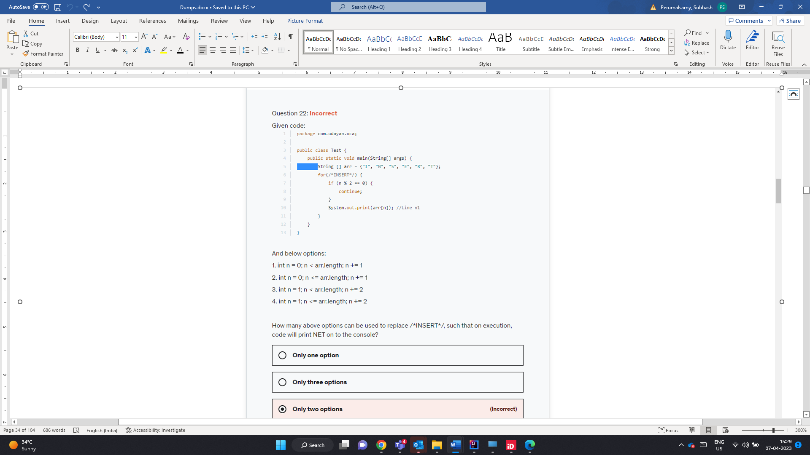

N E T – index 1 , 3 , 5 % 2 != 0 will be printed

0,2,4 nos % 2==0 so these nos will not be printed

1. 0,1,2,3,4,5 -> N E T will be printed
2. 0,1,2,3,4,5,6 -> Here arr[6] is not called . so no run time error.
3. 1,3,5
4. 1,3,5

All 4 are valid methods

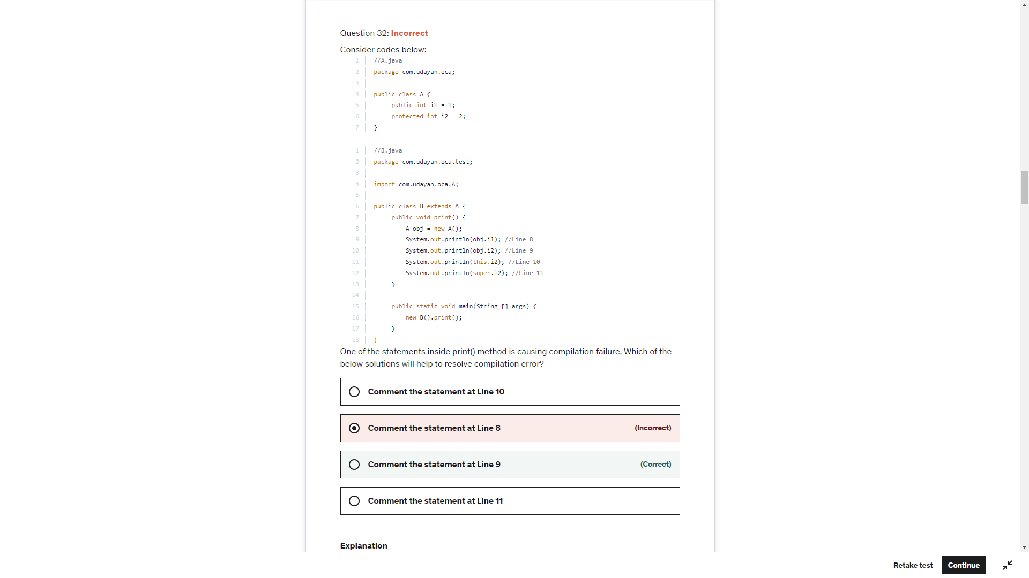

Current object is

Of type B which is of child class ref

And can access protected member of parent class

Obj.i1 is accessing public member-valid

Obj.i2 – Parent Ref accessing protected variable- Throws error in Derived class of diff package

This.i2-> current object which is child ref and is trying to i2 which is super class pro variable – valid

super.i2 -> current object which is child ref of A can access super class i2 - Valid

List.remove(int) – will always look for index value of int no matter what objects the list holds

List.remove(char) – will be converted to int (ASCII value of the character) and performs index retrieval

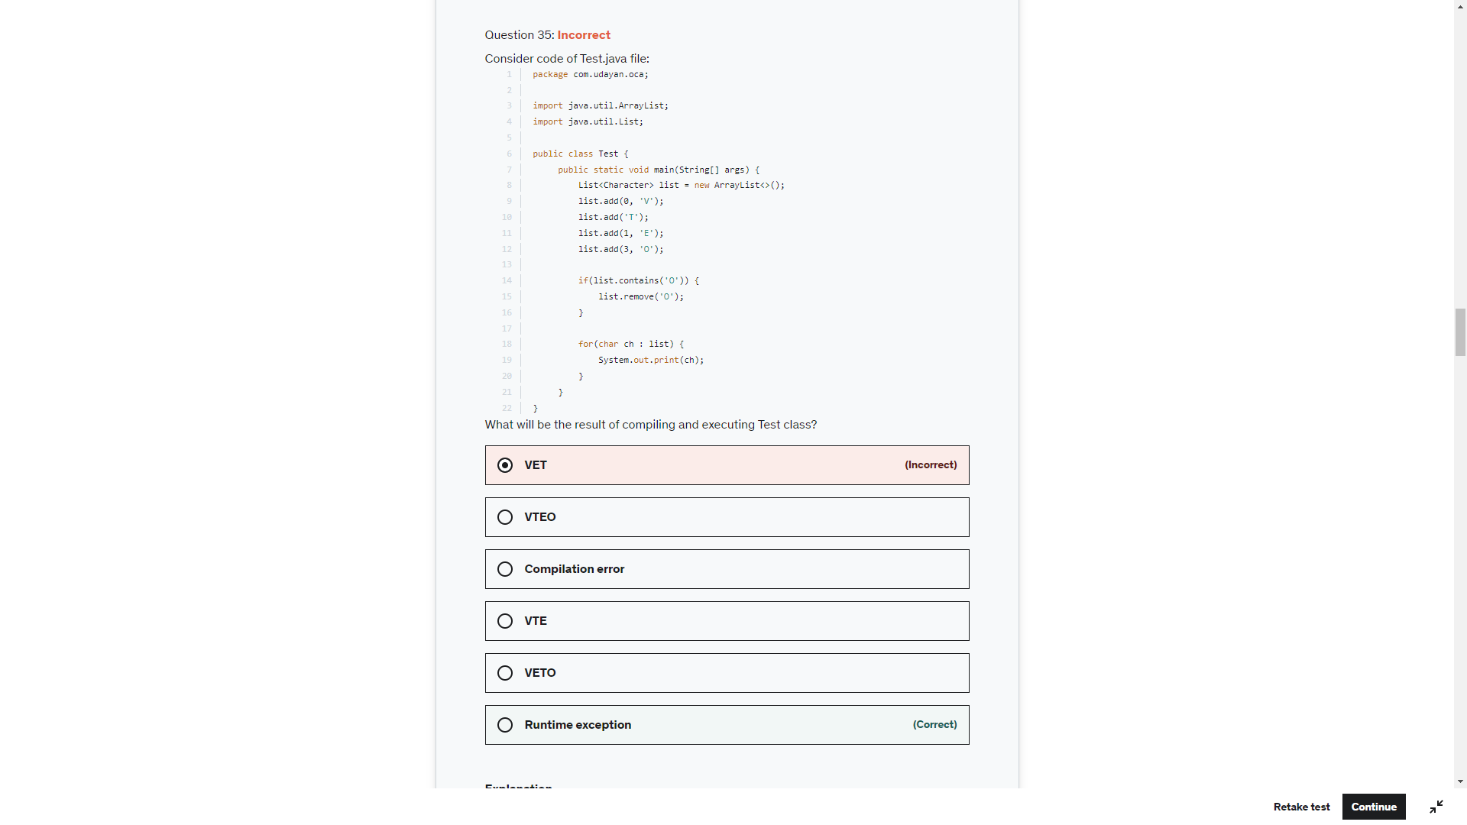

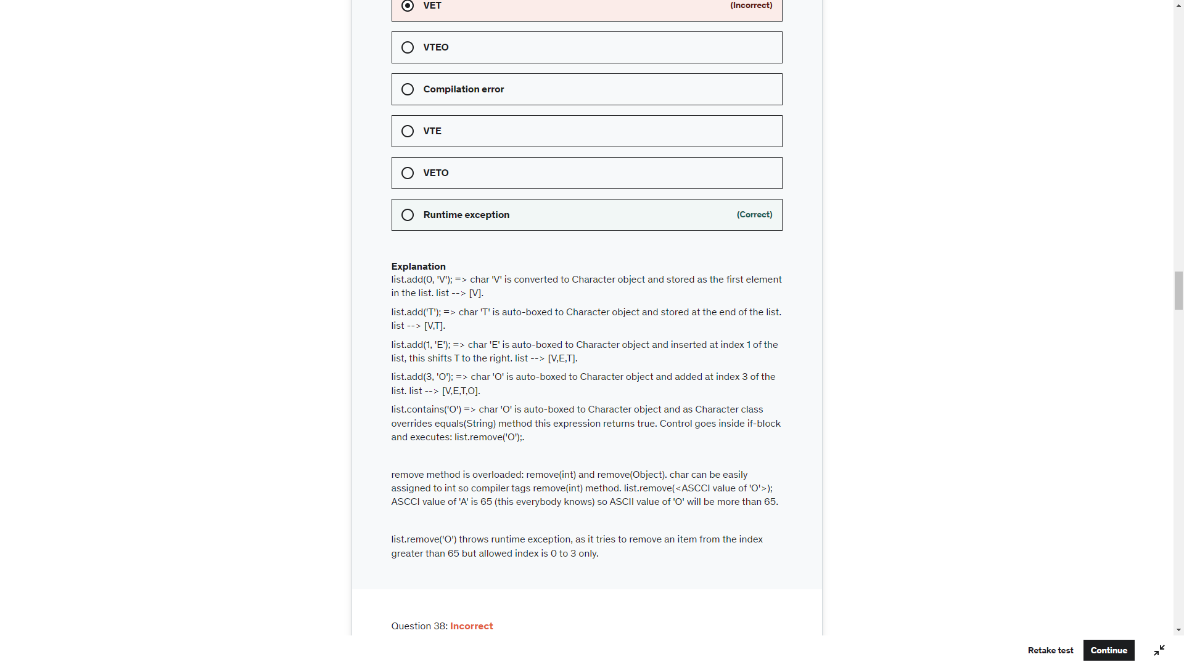

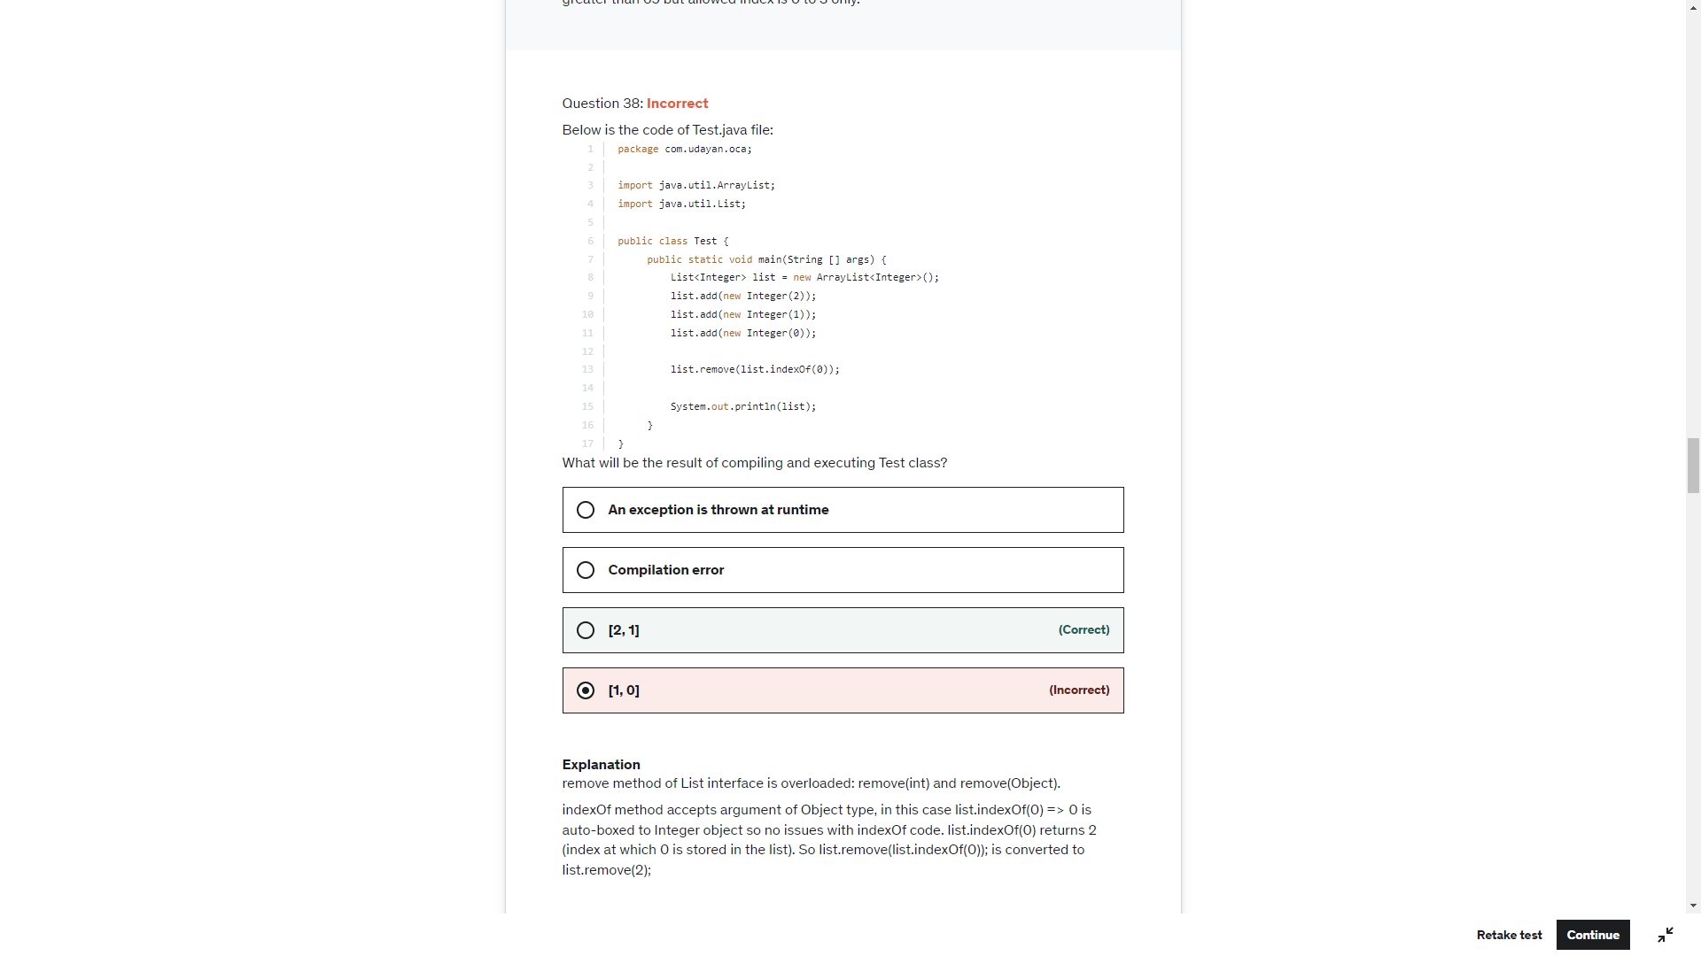

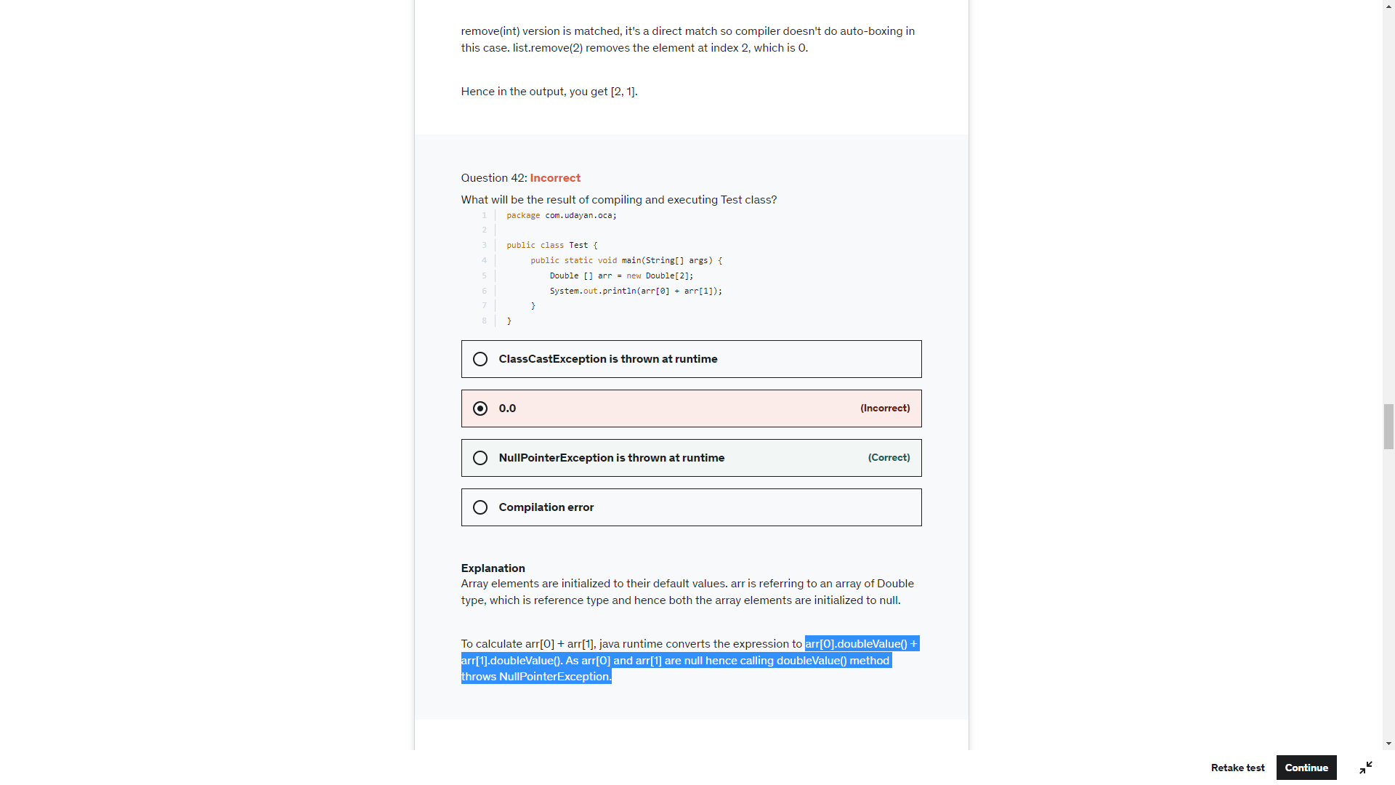

Arr[0]+”” will print null as toString() method will be call

Arr[0]+Arr[1] is an expression and tries to return the XXXValue() and throw RunTime Exception

To String is perfomed in first three cases and hence null

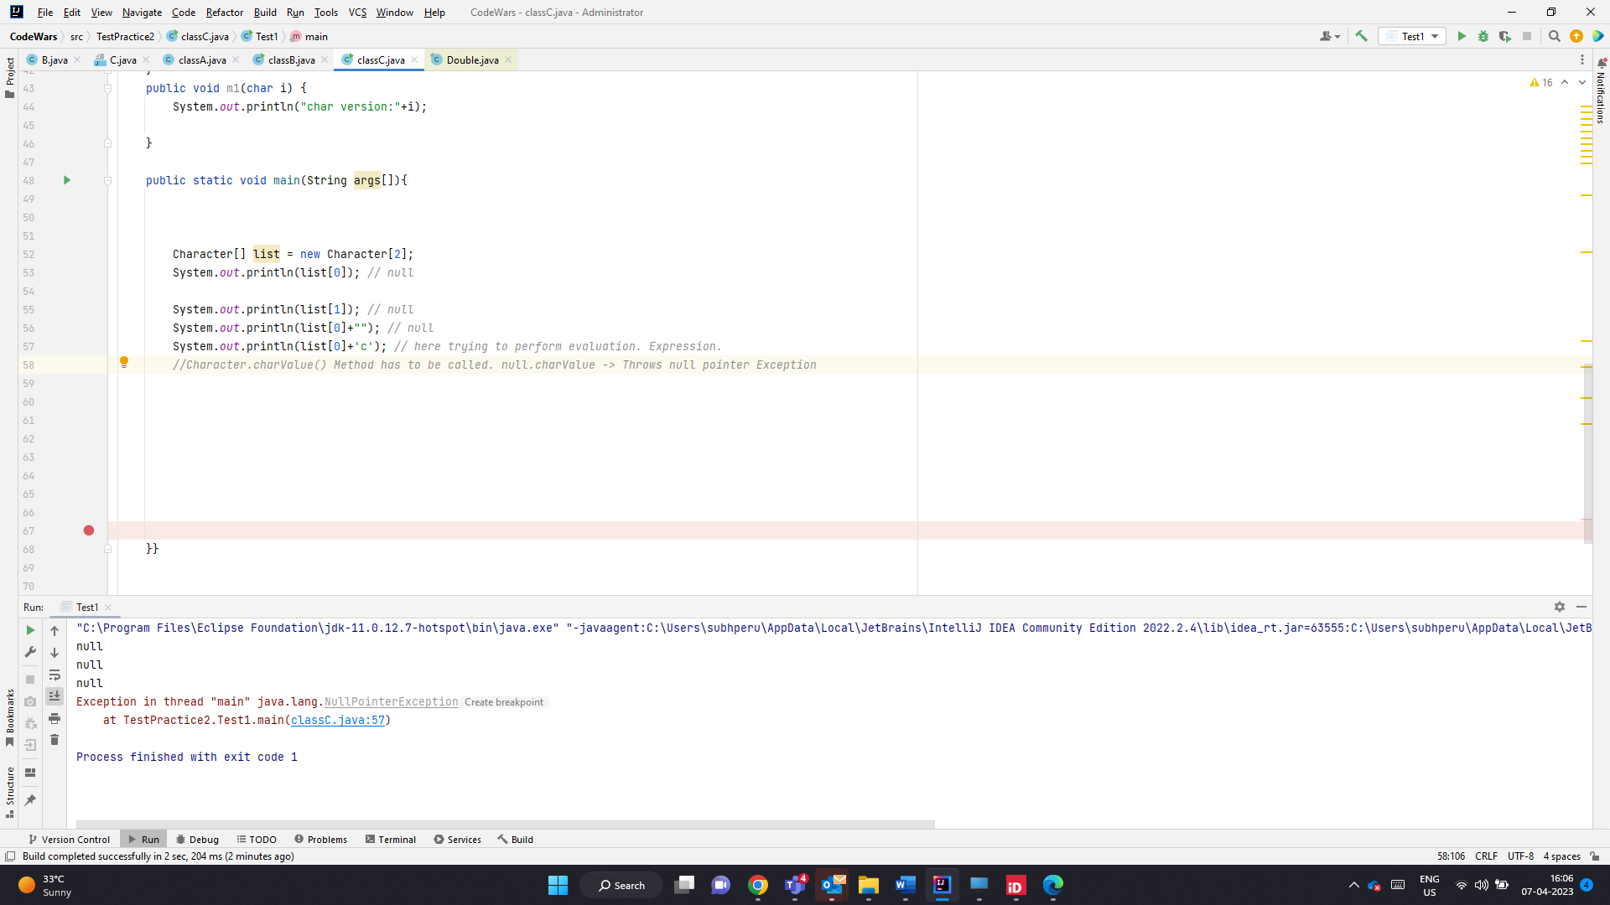

When an expression has to evaluated. Wrapper.xxxValue() will be called and on Null ref will throw null pointer exception

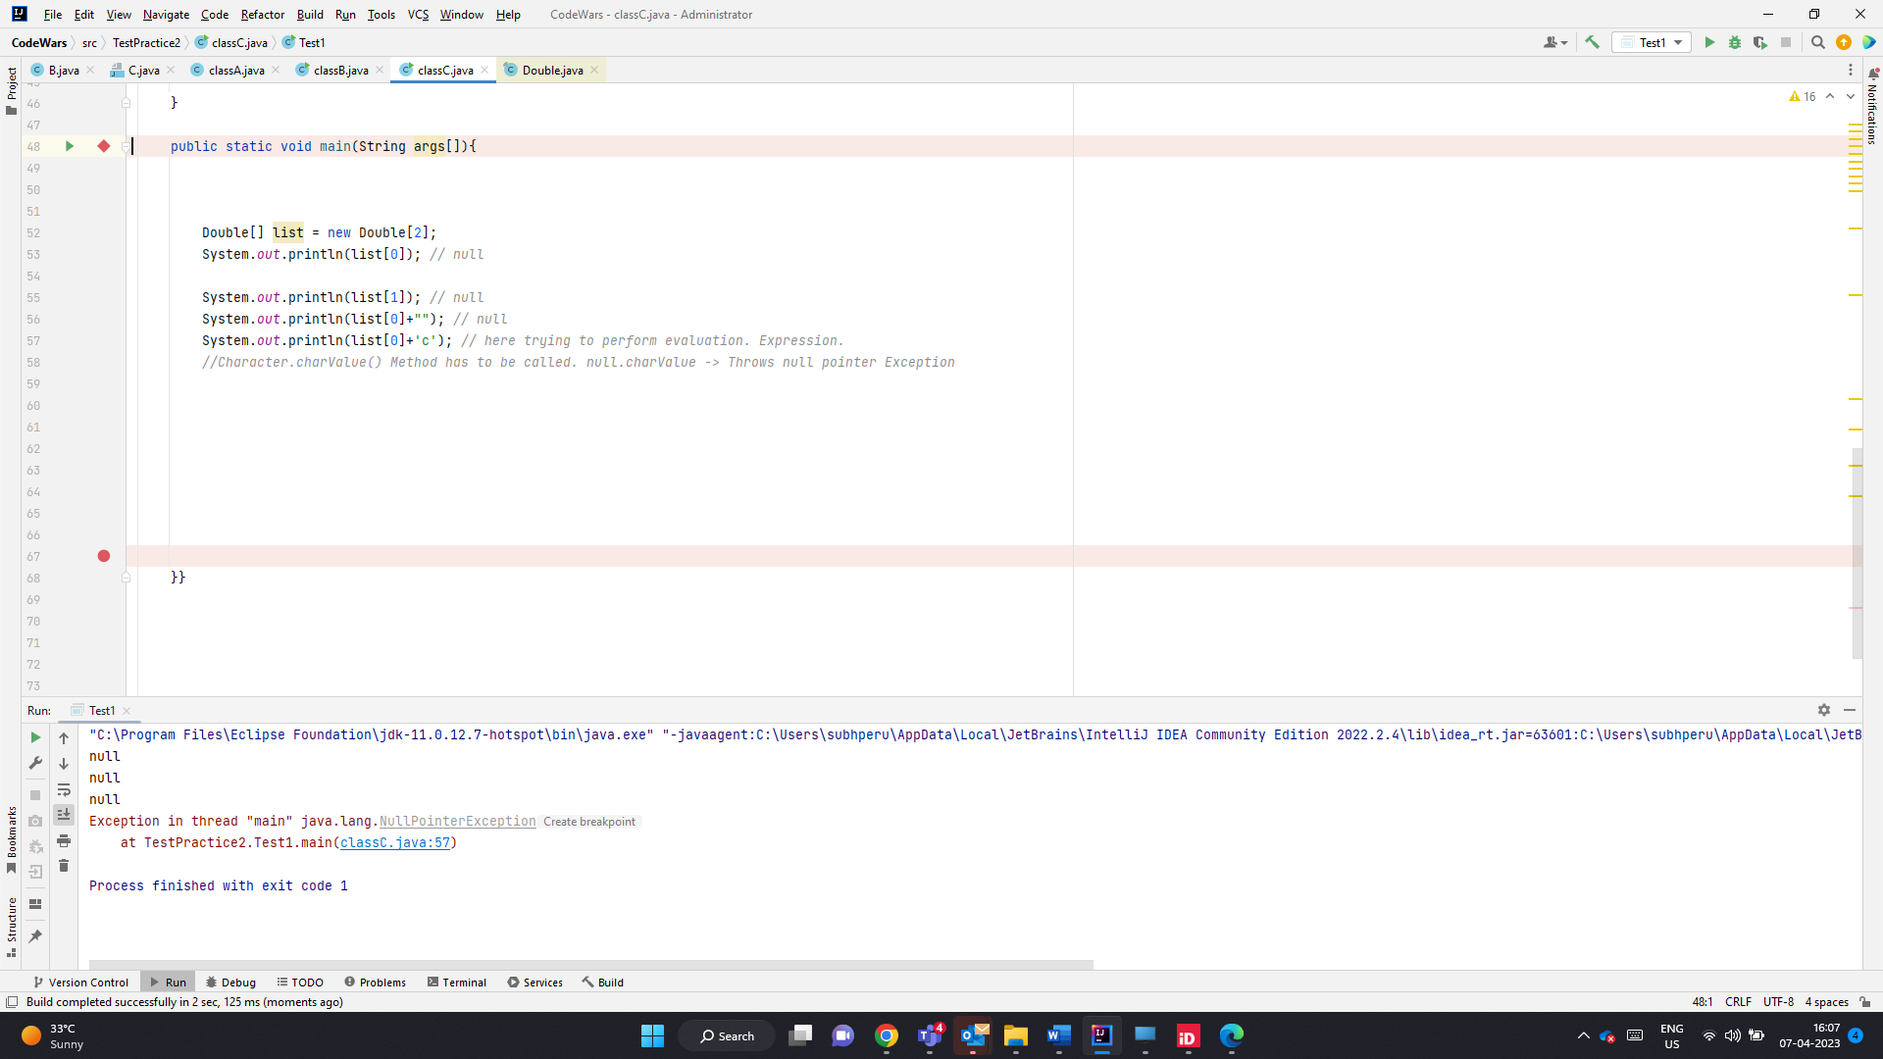

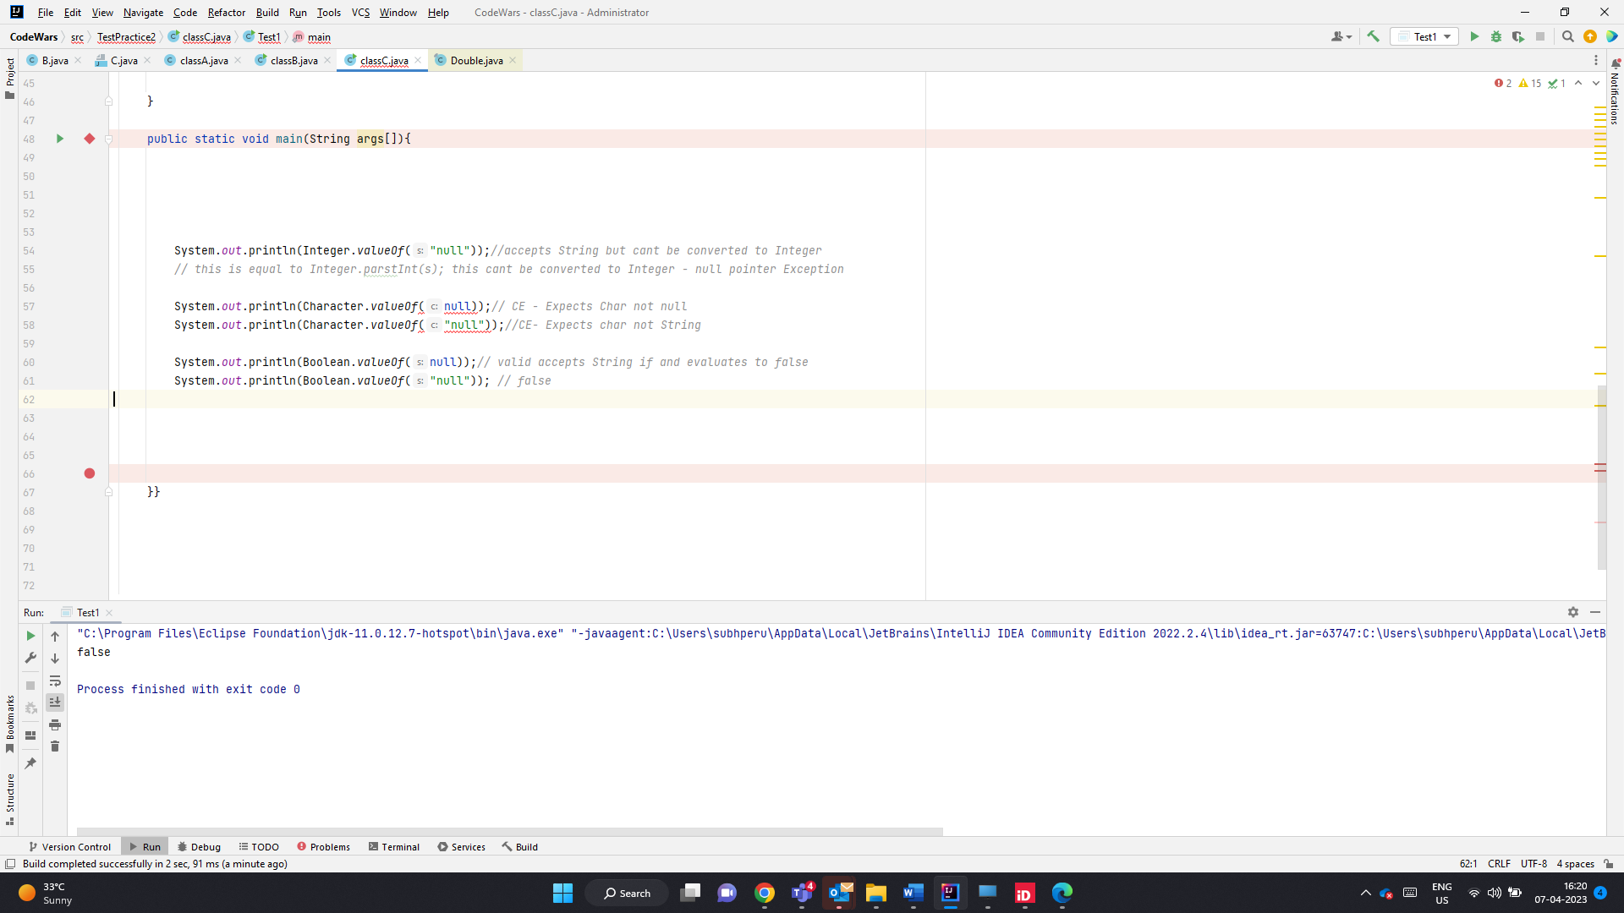

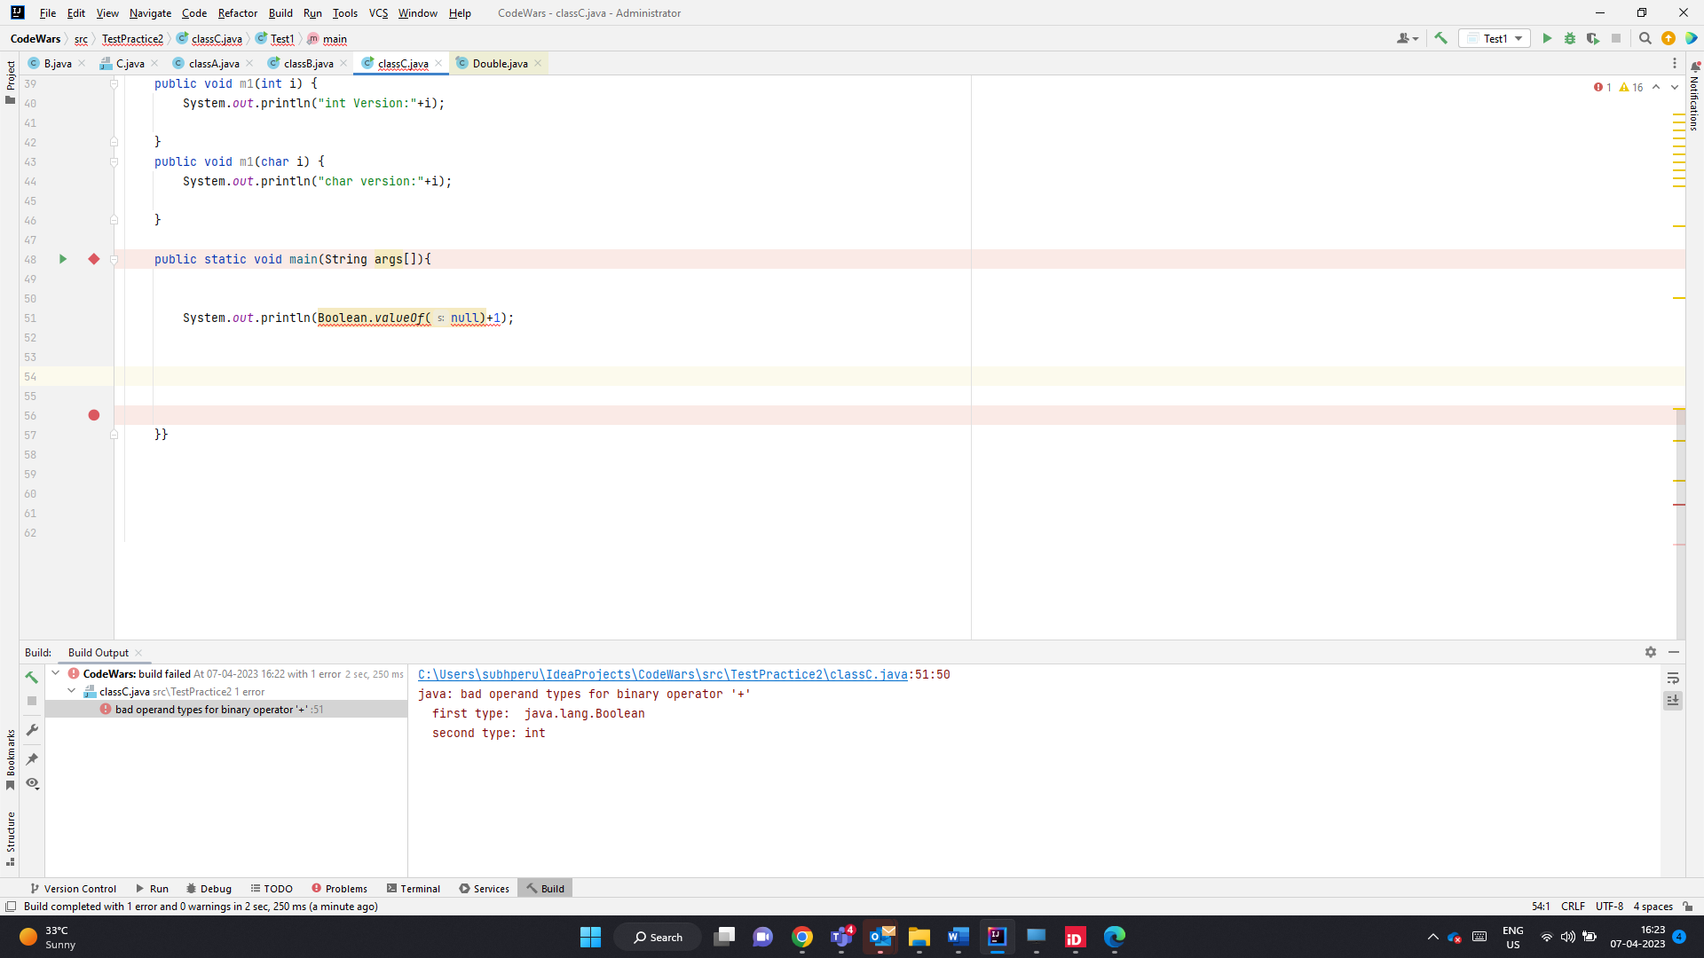

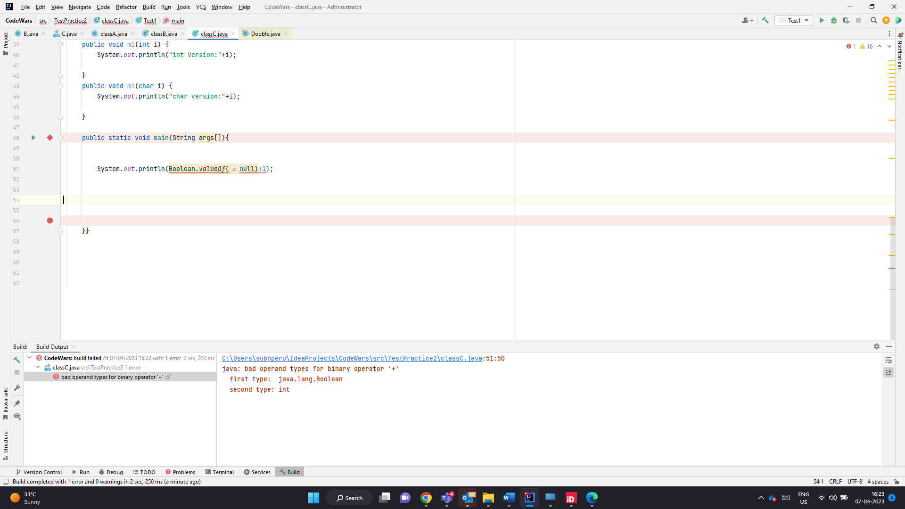

Null pointer Excpetion for below

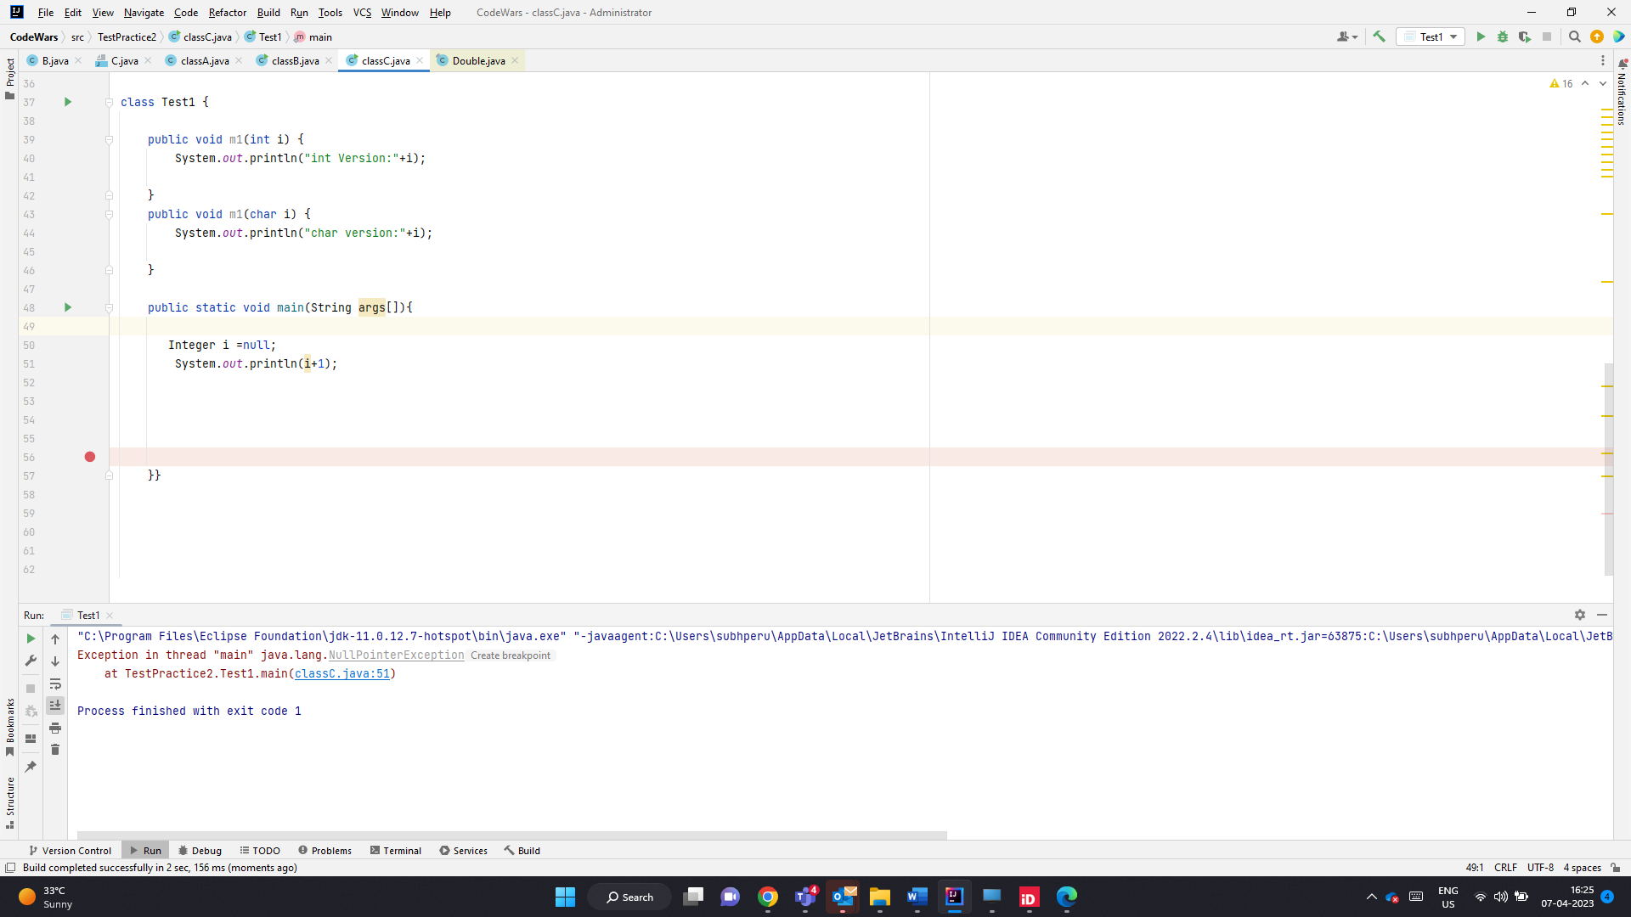

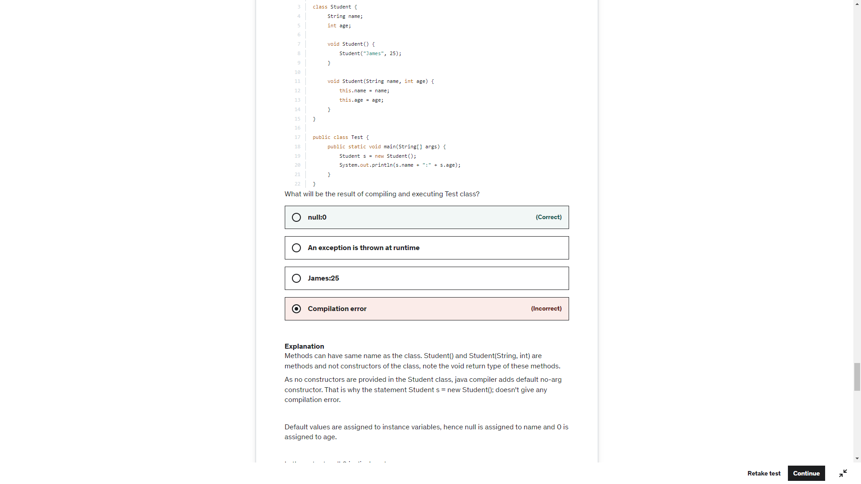

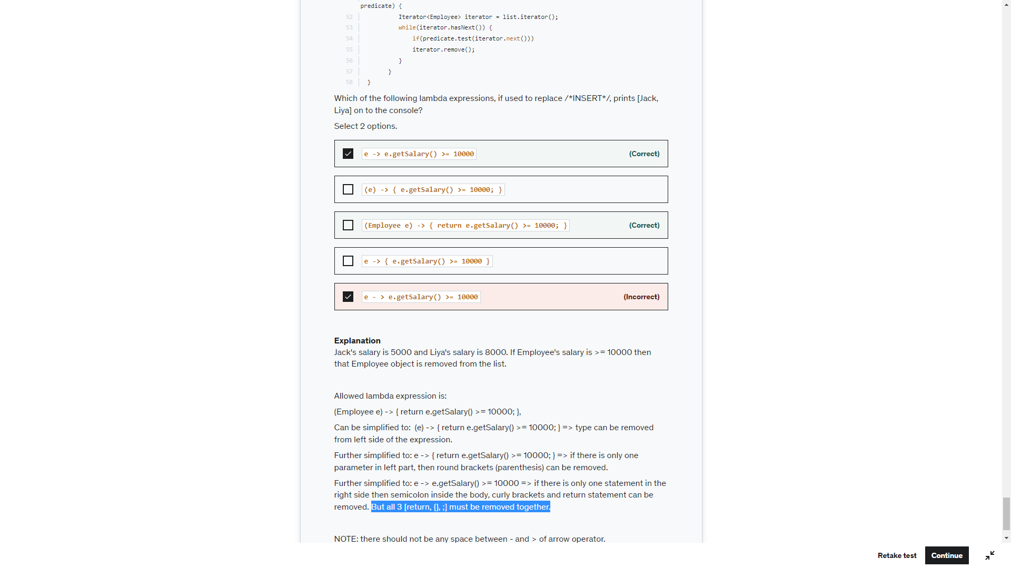

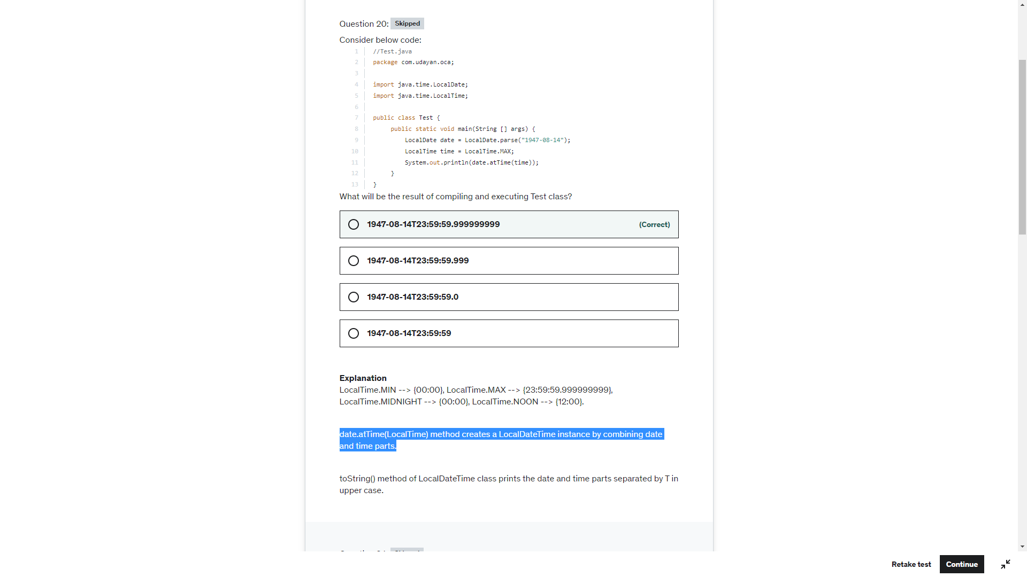

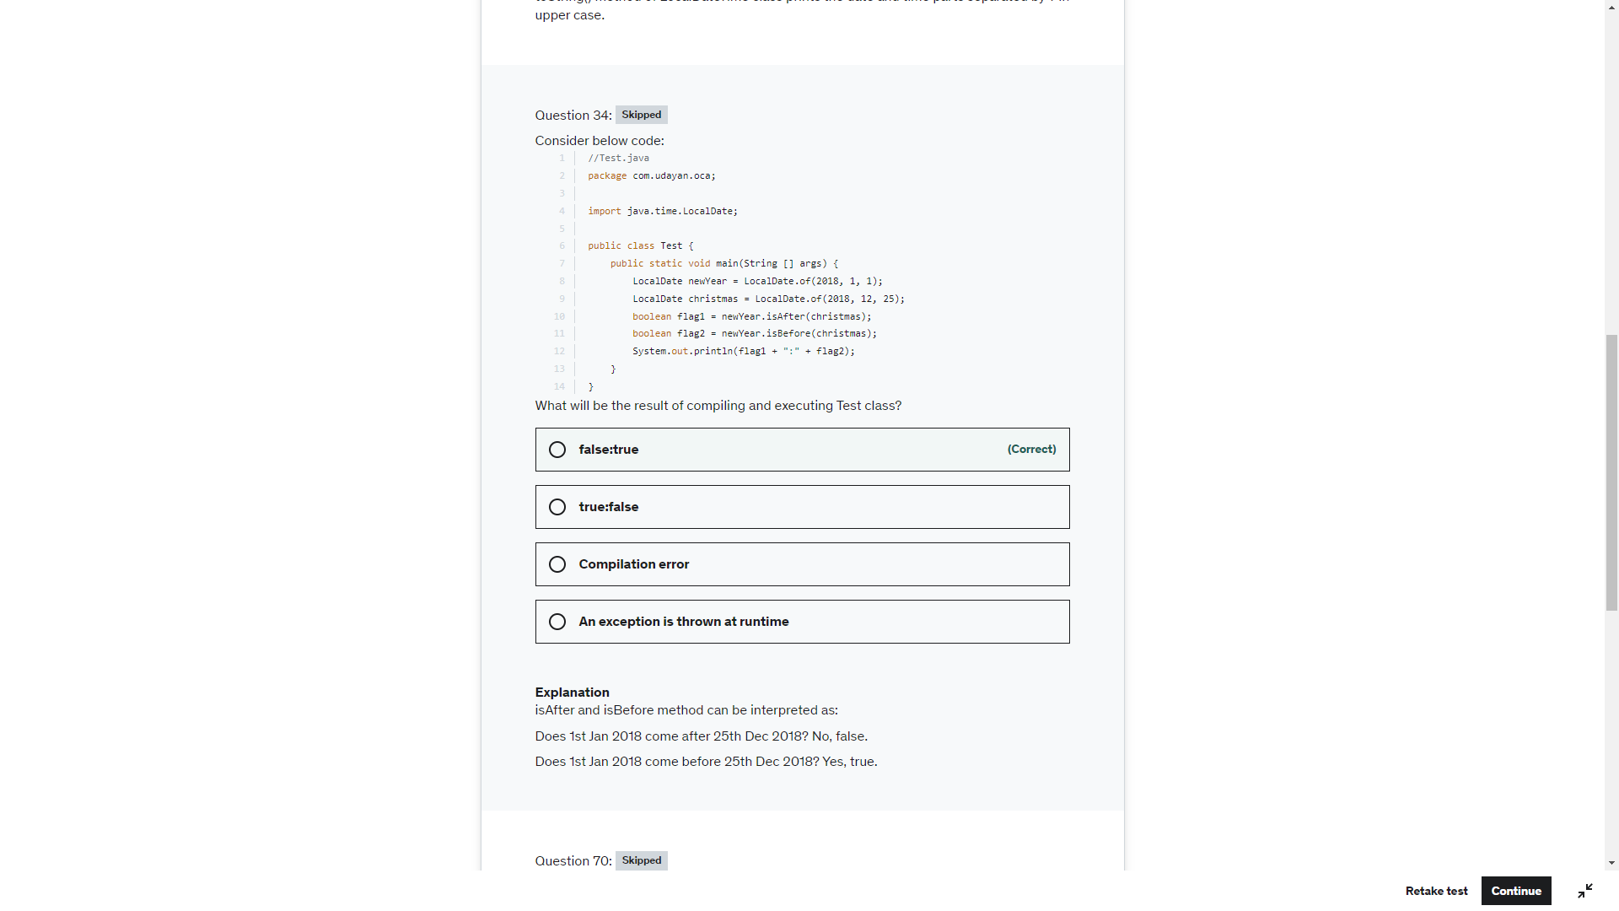

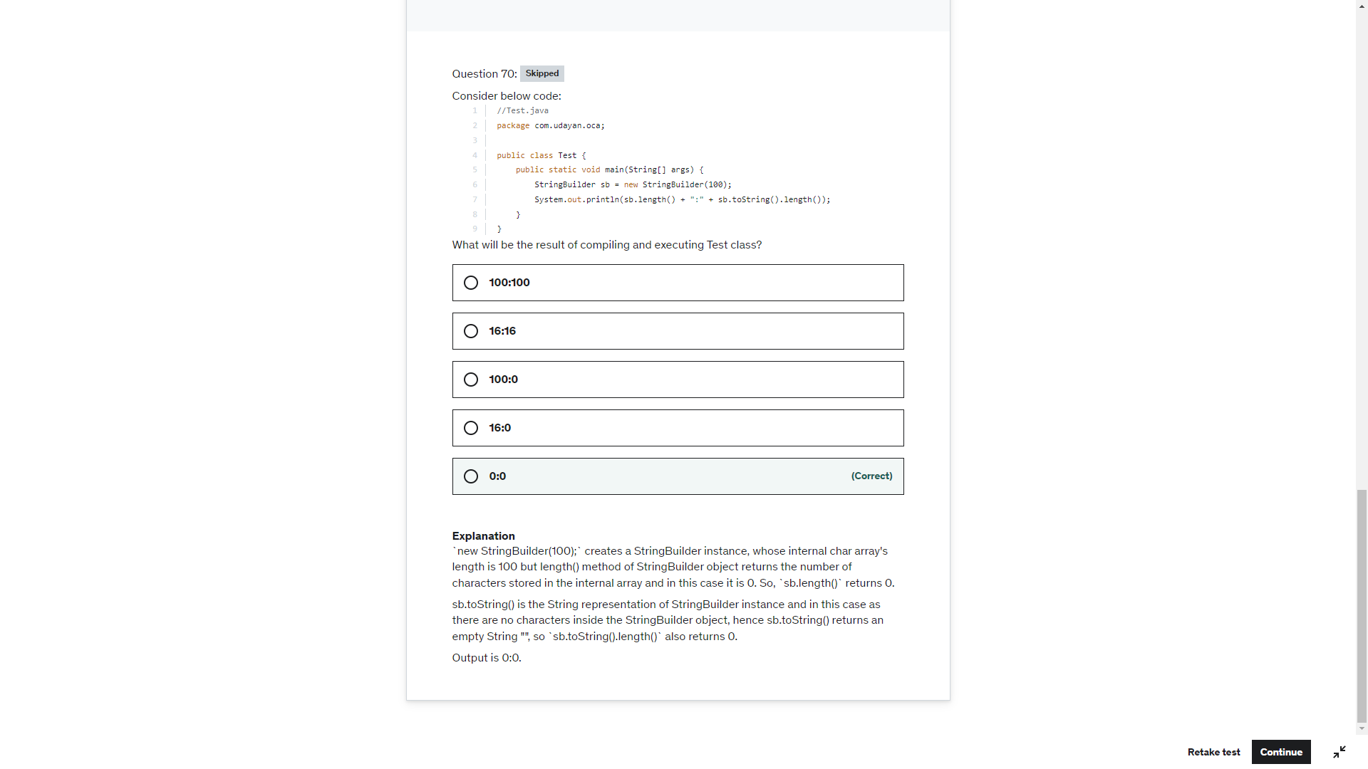

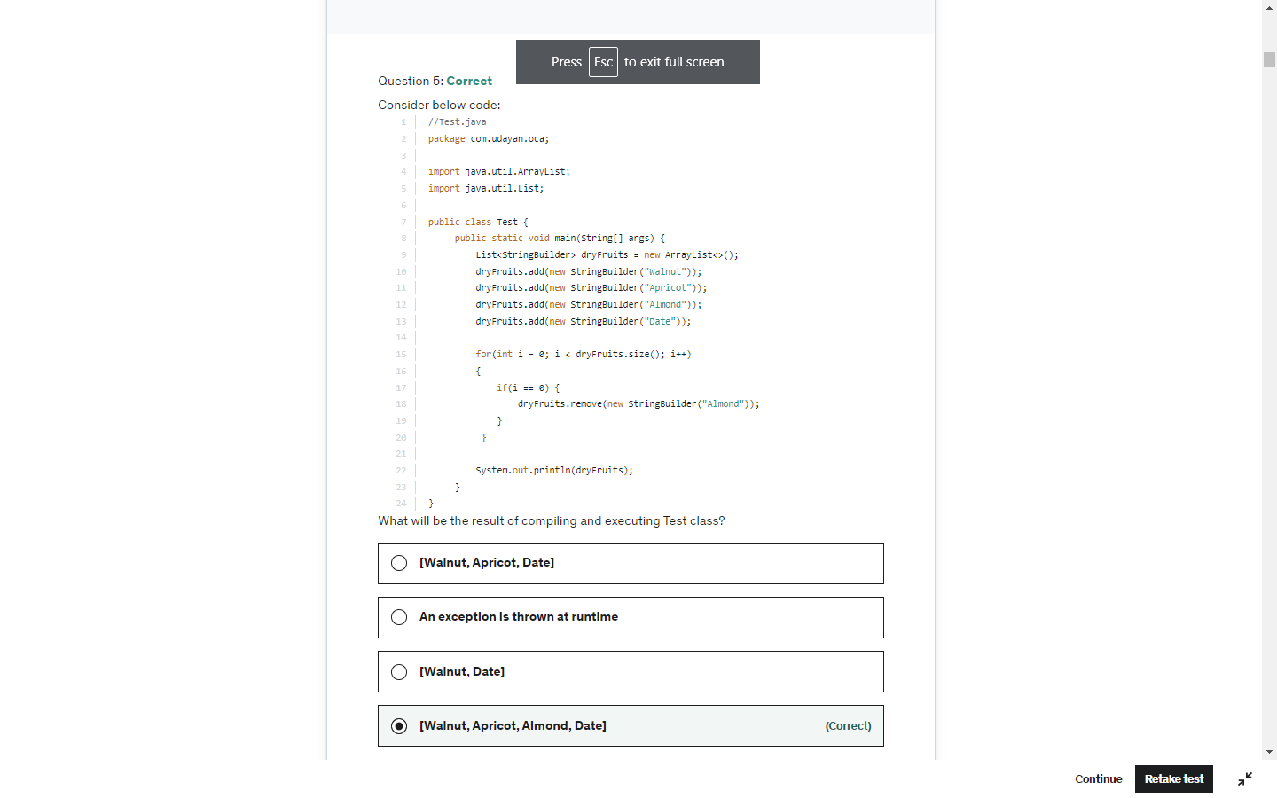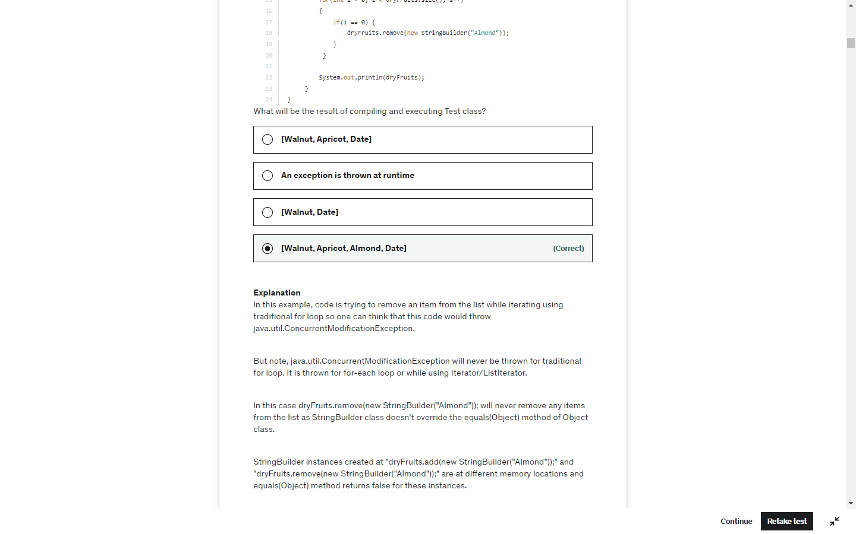

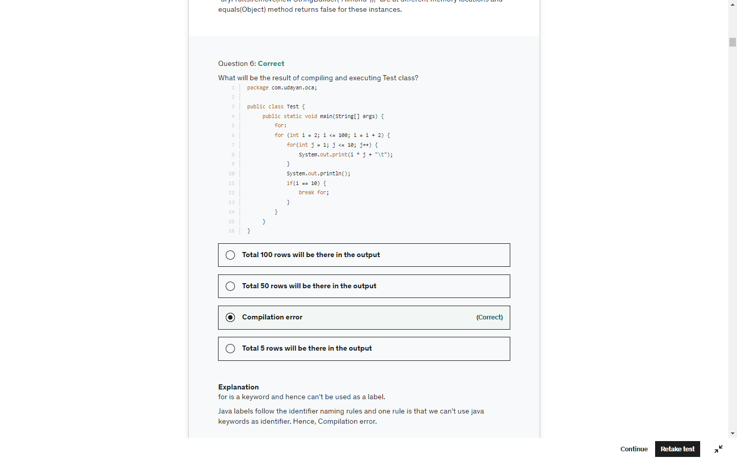

Interface methods are by default public and abstract

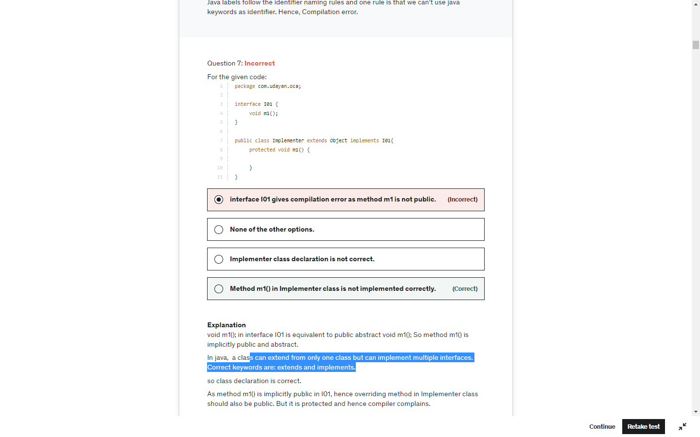

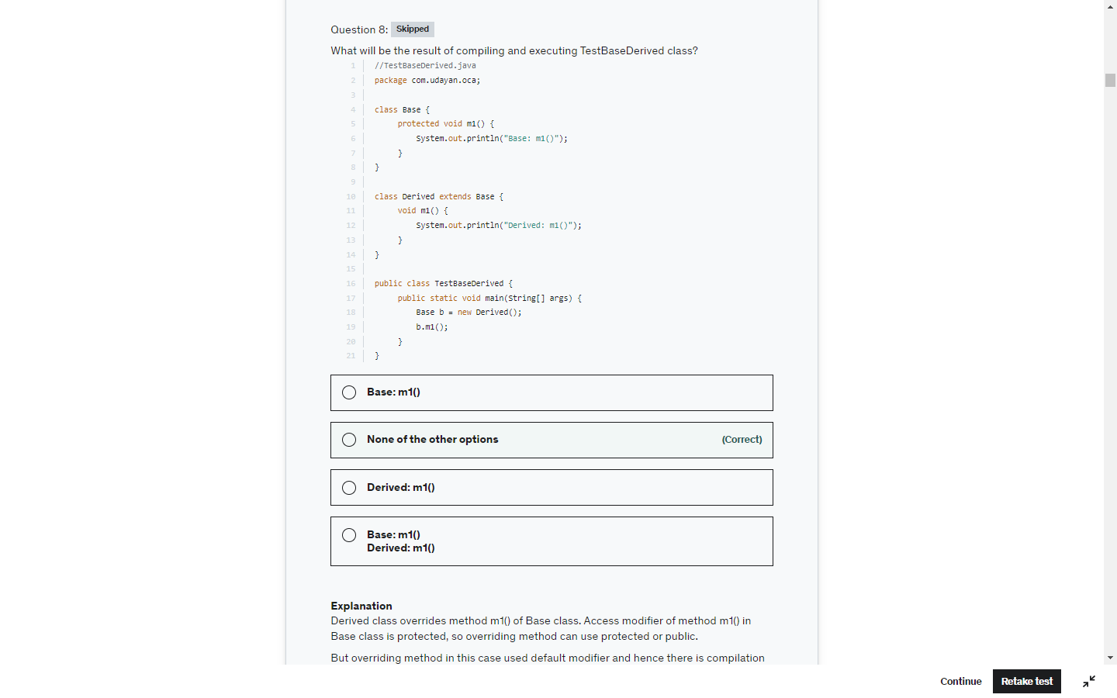

The **java instanceof operator** is used to test whether the object is an instance of the specified type (class or subclass or interface).

The instanceof in java is also known as type *comparison operator* because it compares the instance with type. It returns either true or false. If we apply the instanceof operator with any variable that has null value, it returns false.



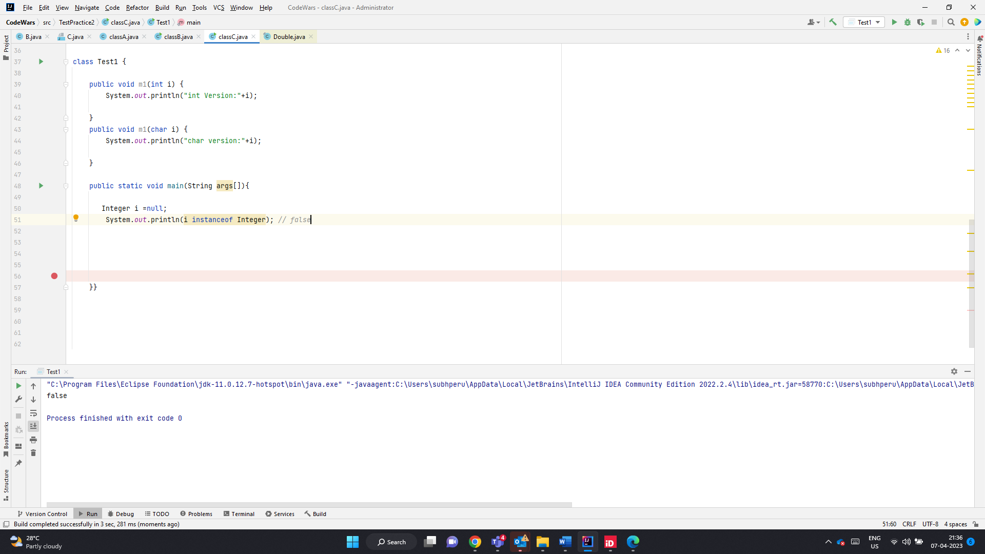

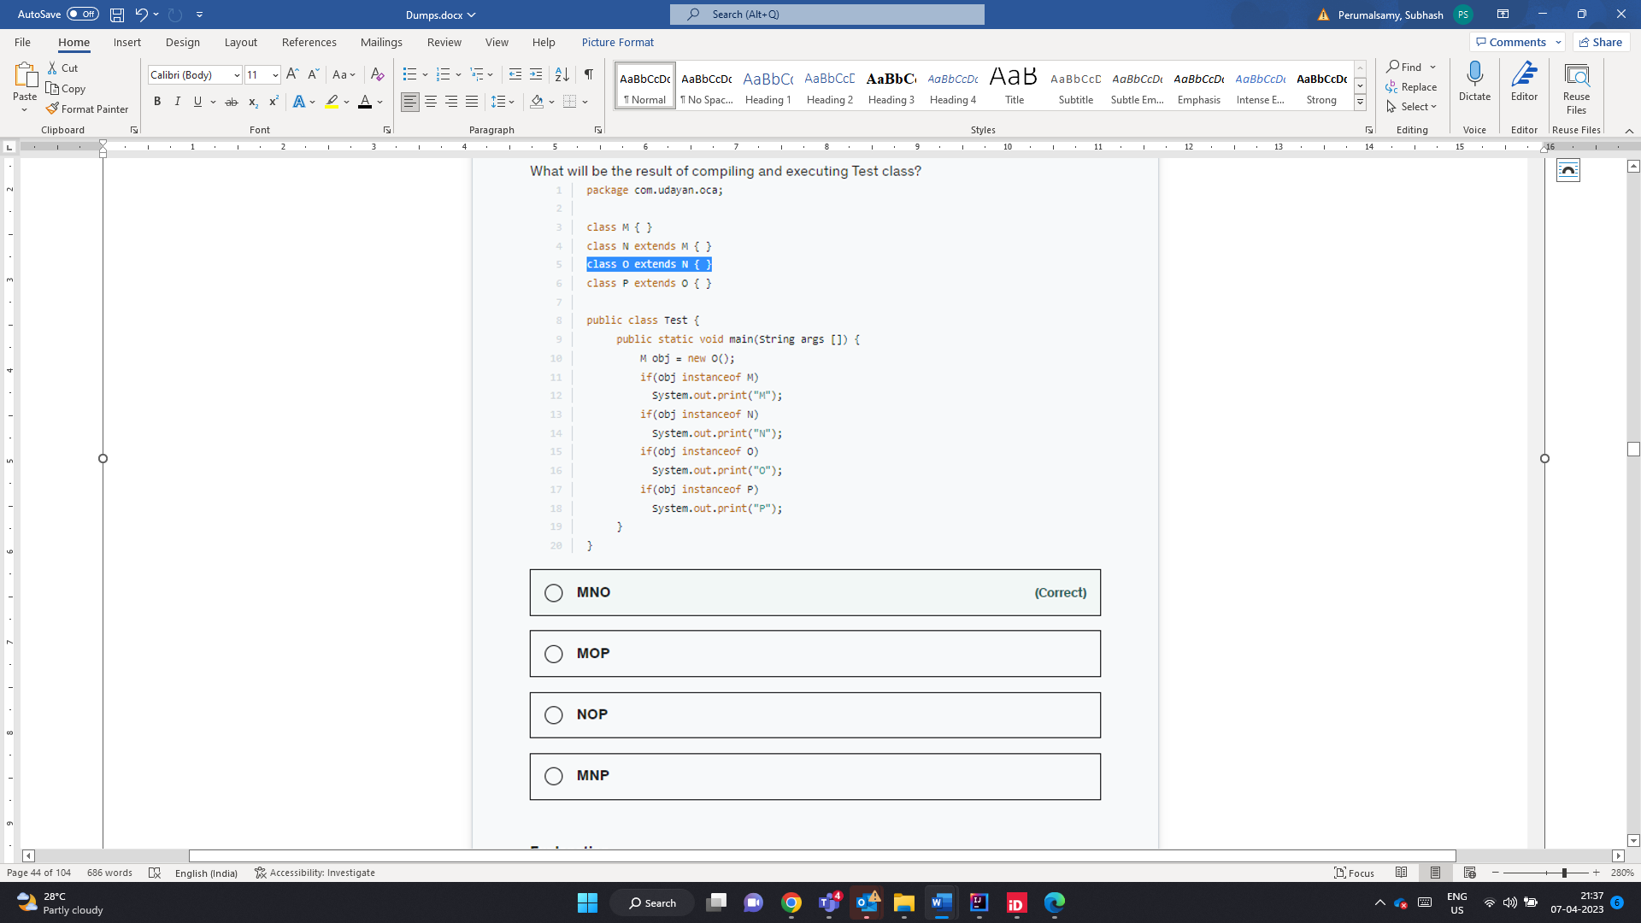

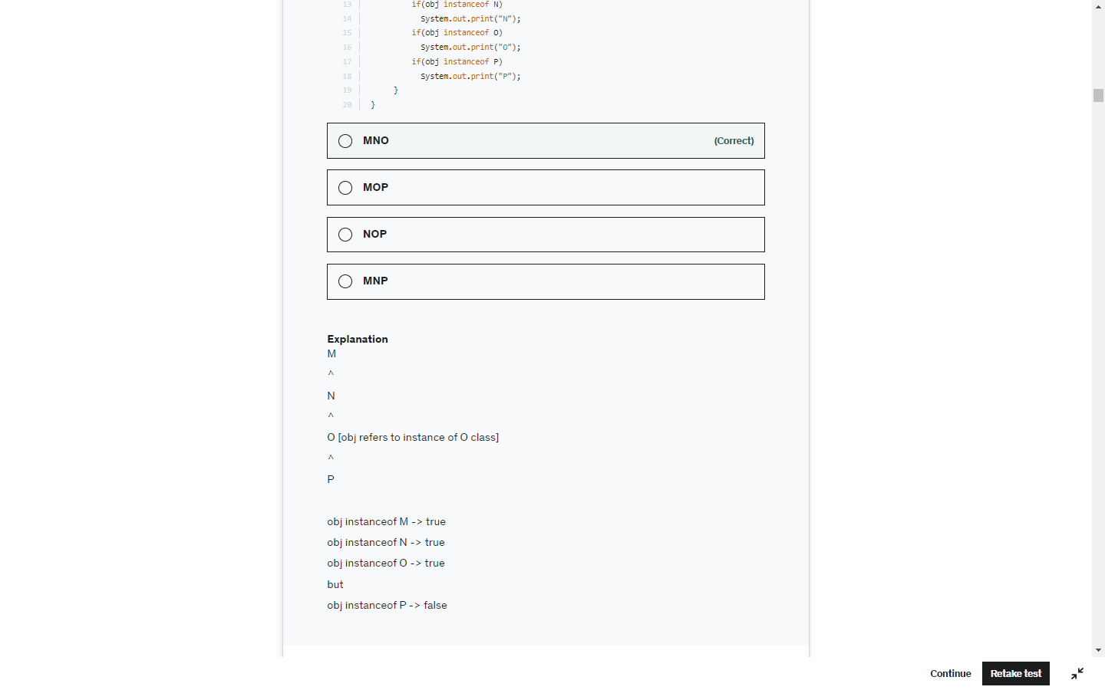

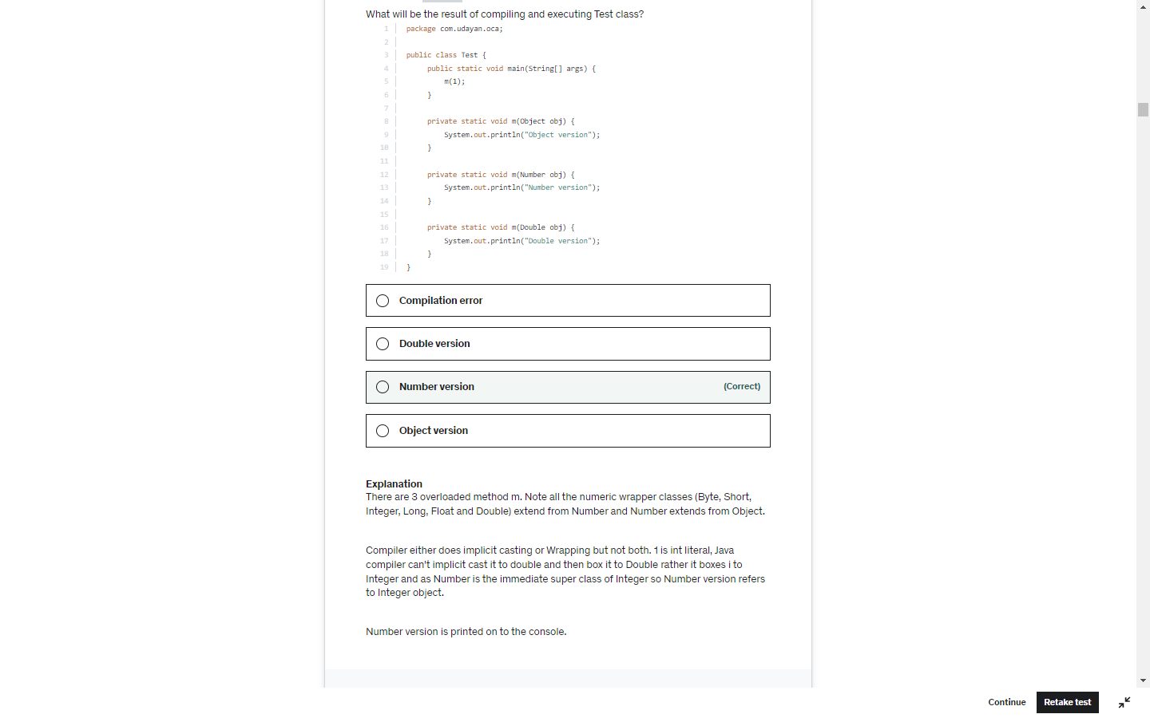

StringBuffer.delete(5,6) substring of (5-6) that is only 5

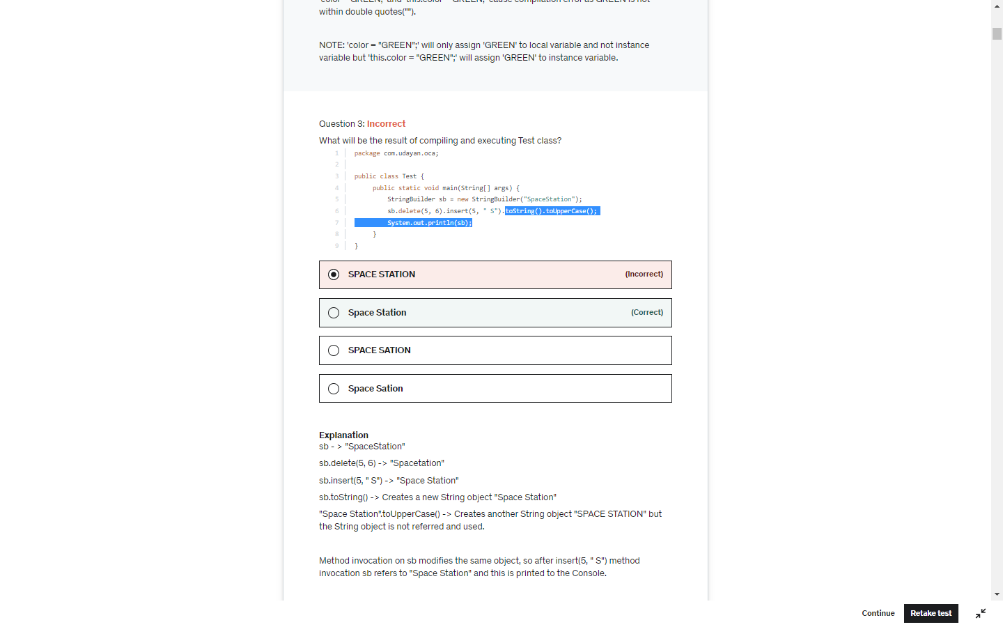

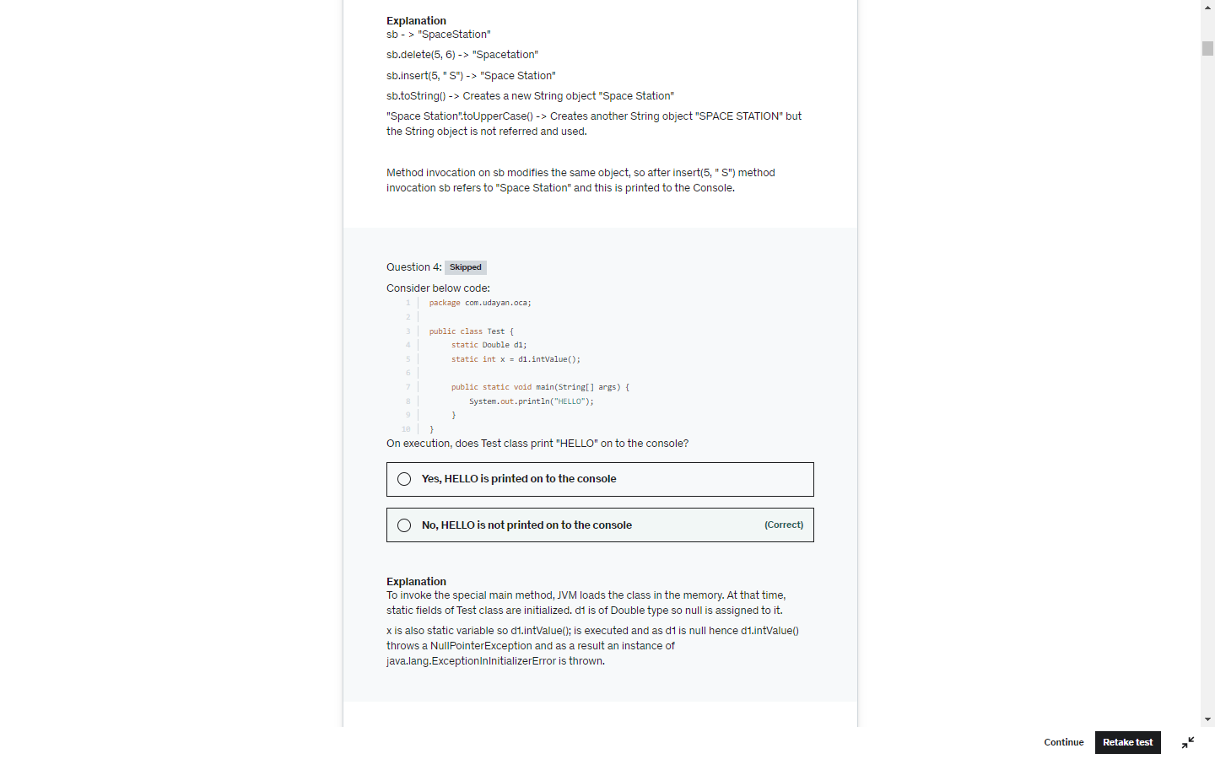

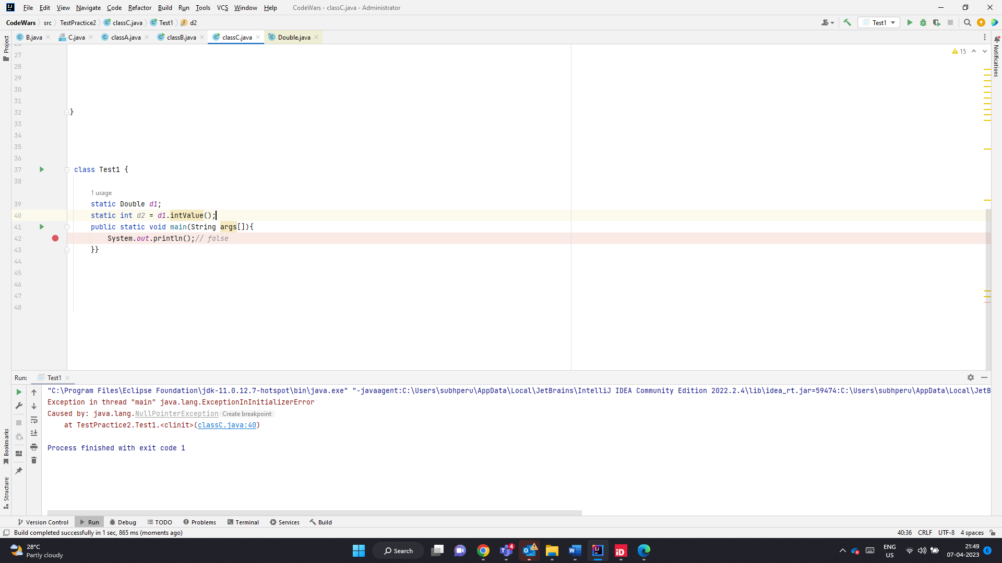

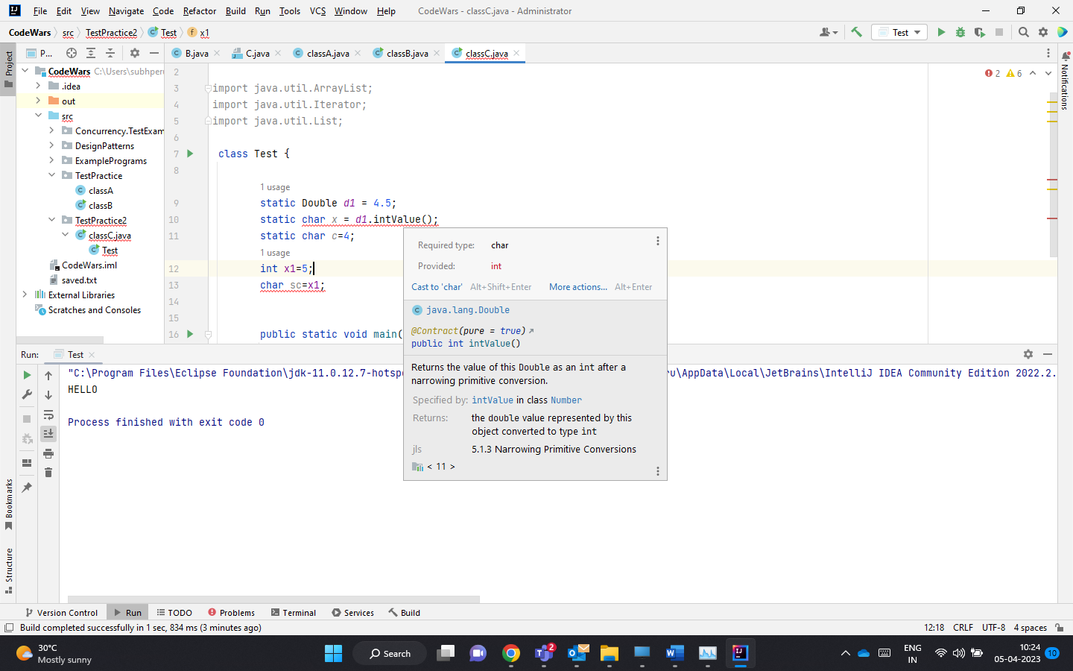

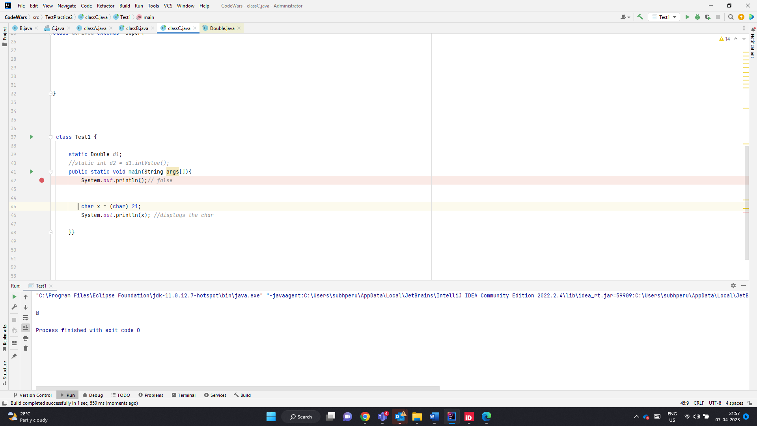

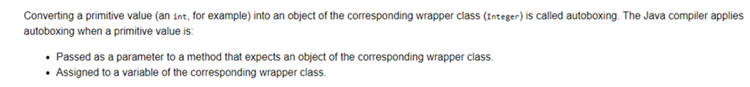

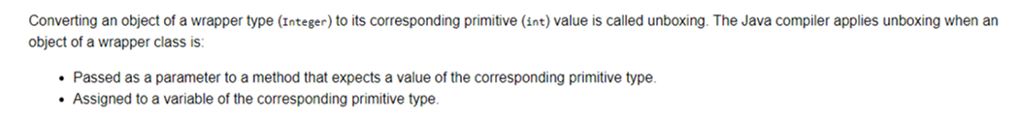

Char to int widening, Int to char is narrowing should be explicitly casting is req

1. **double** -> **float** -> **long** -> **int** -> **char** -> **short** -> **byte**

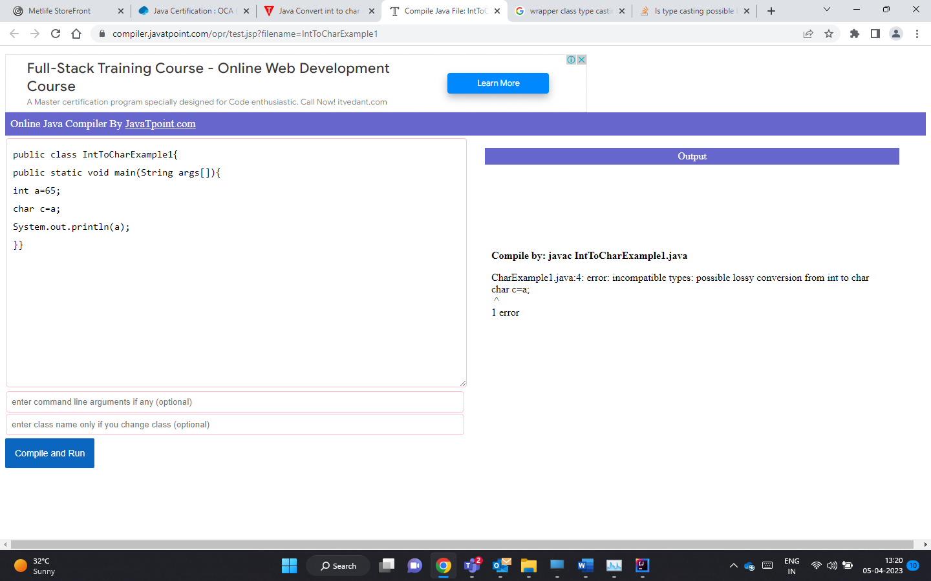

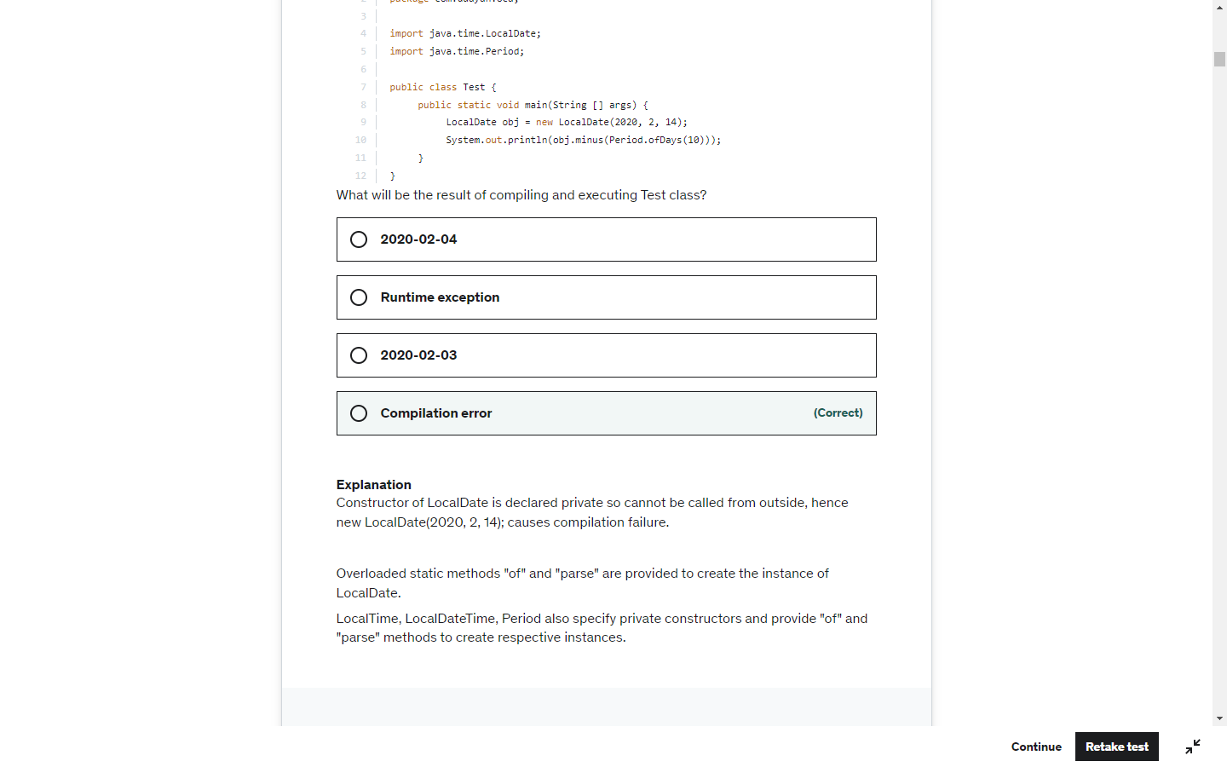

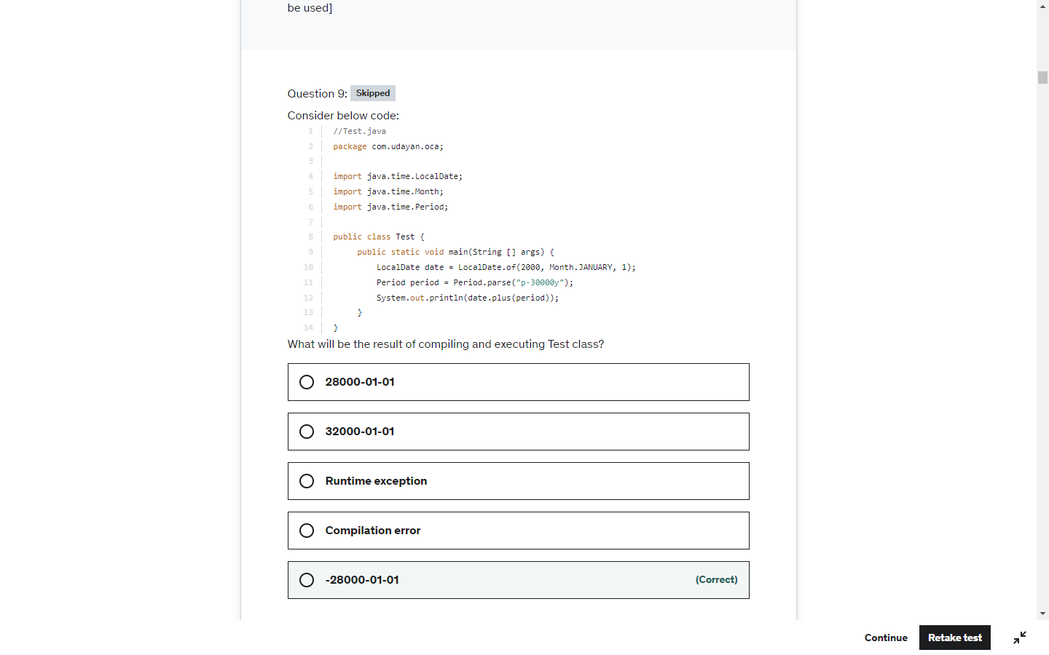

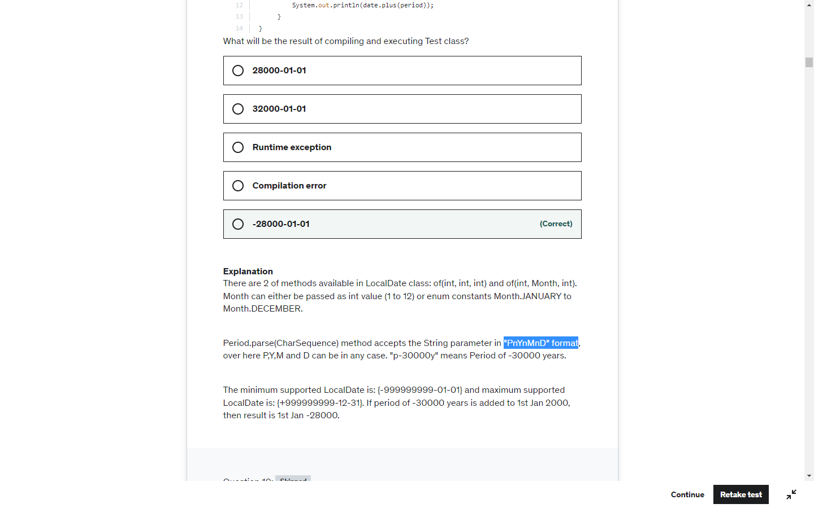

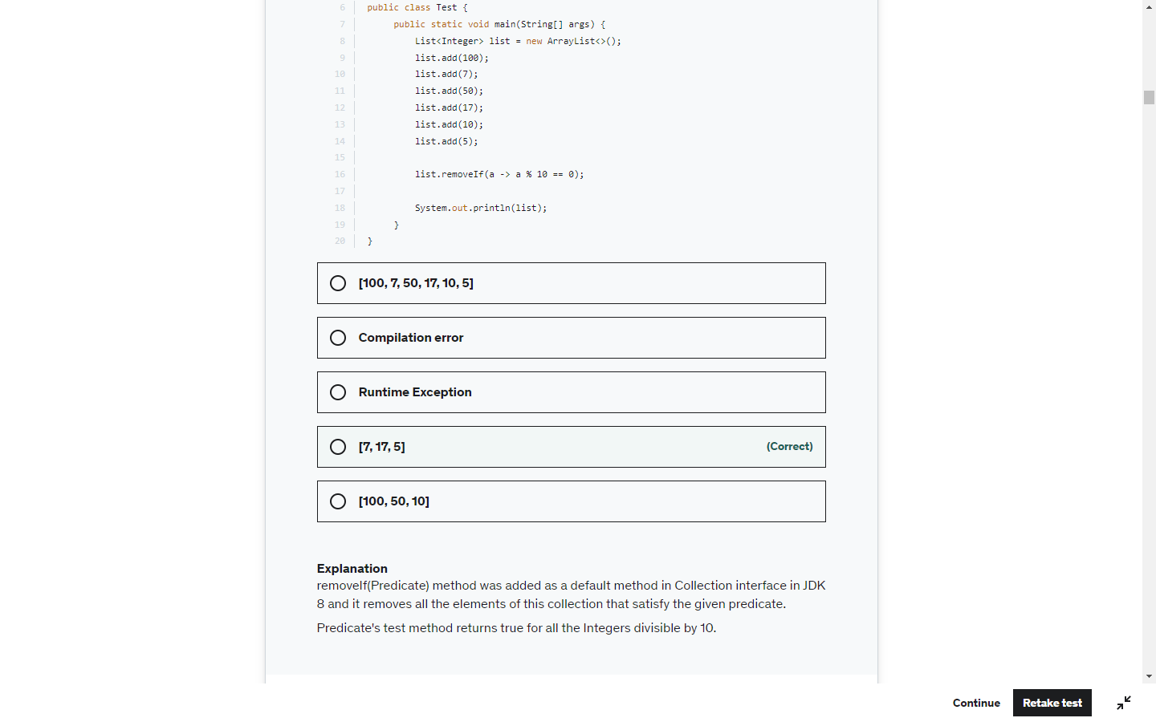

Loop 1-10

Will be skipped if start%2 ==0

So 2,4,6,8,10 will be skipped. 1,3,5,7,9 -> 25

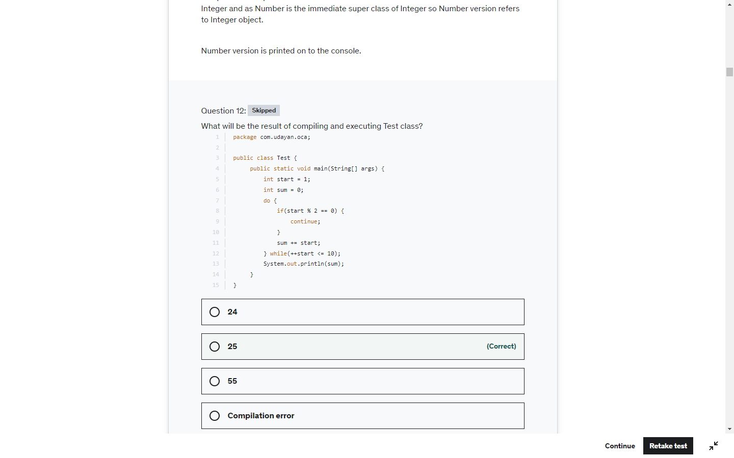

LocalDate. LocaDateTime .LocalTime or immutable . Here the date value is not changed

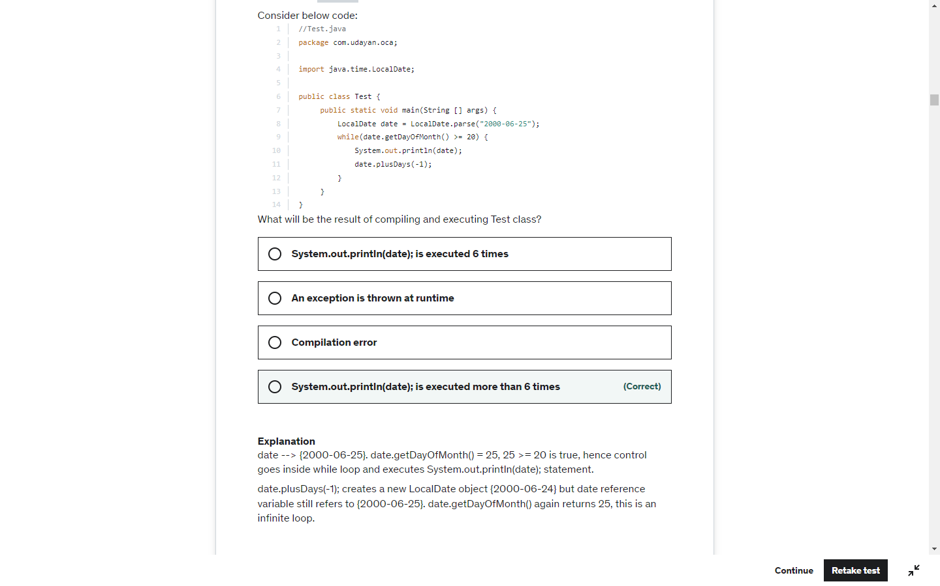

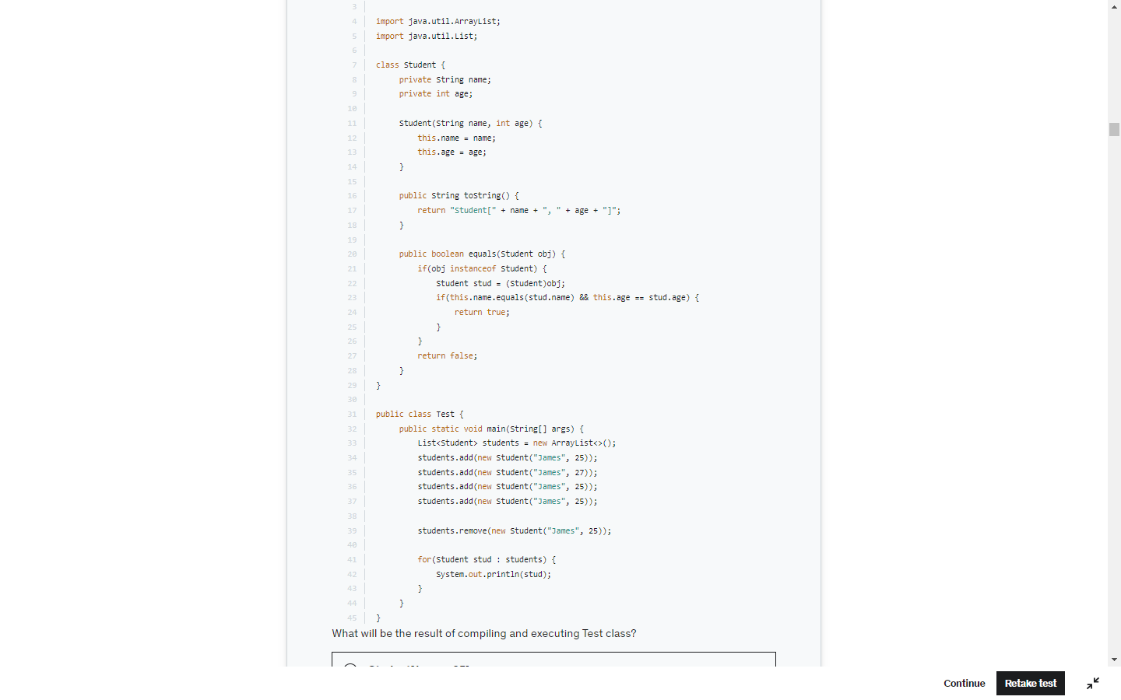

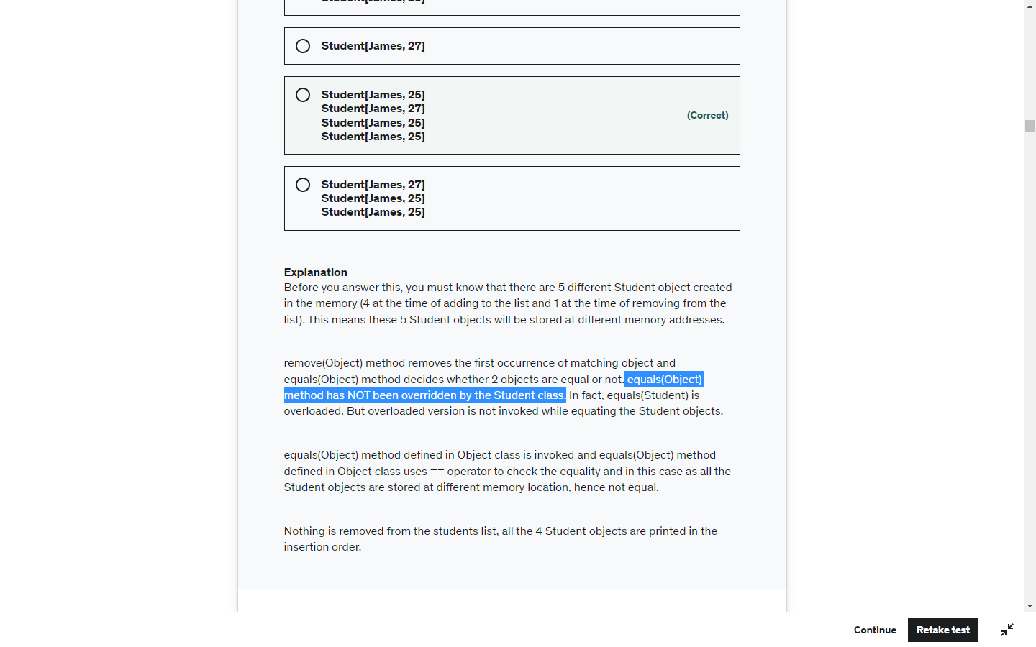

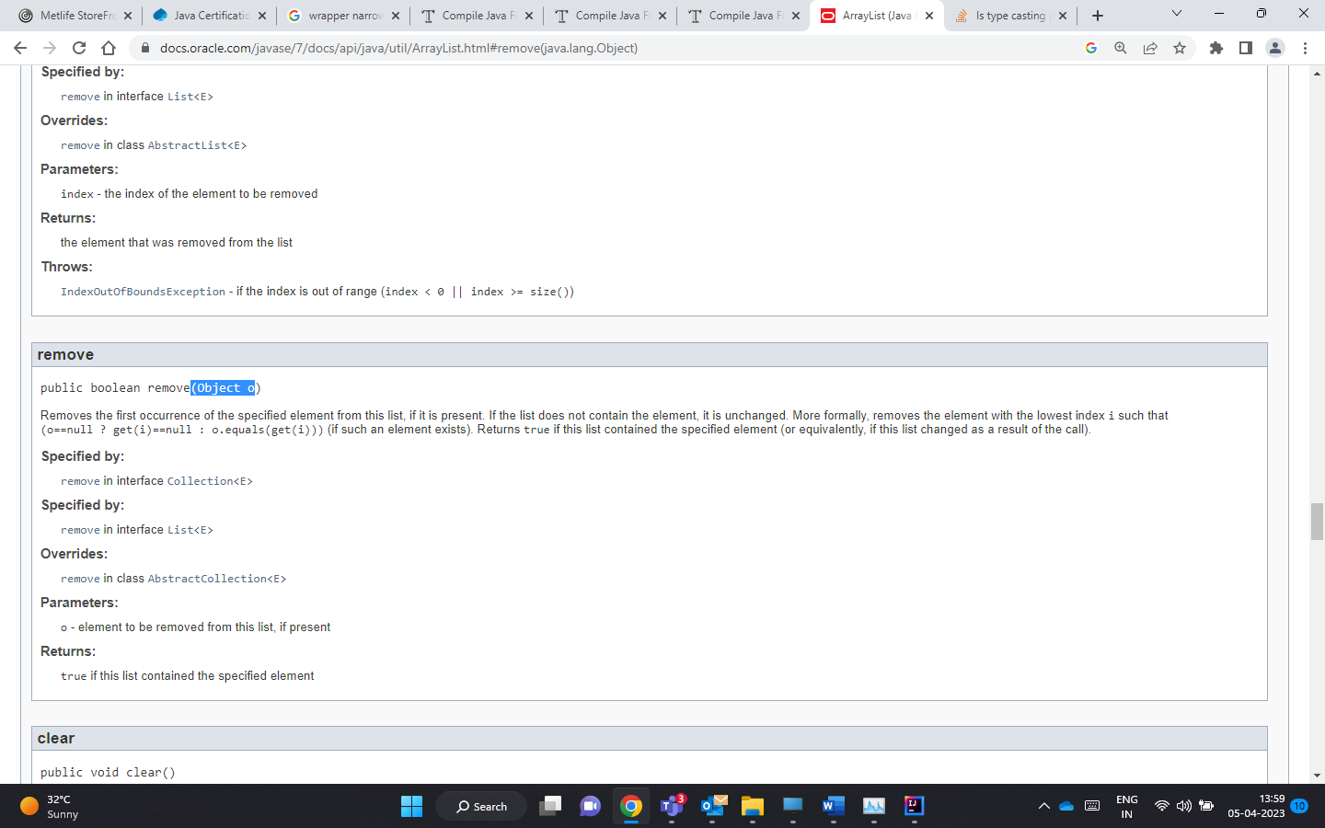

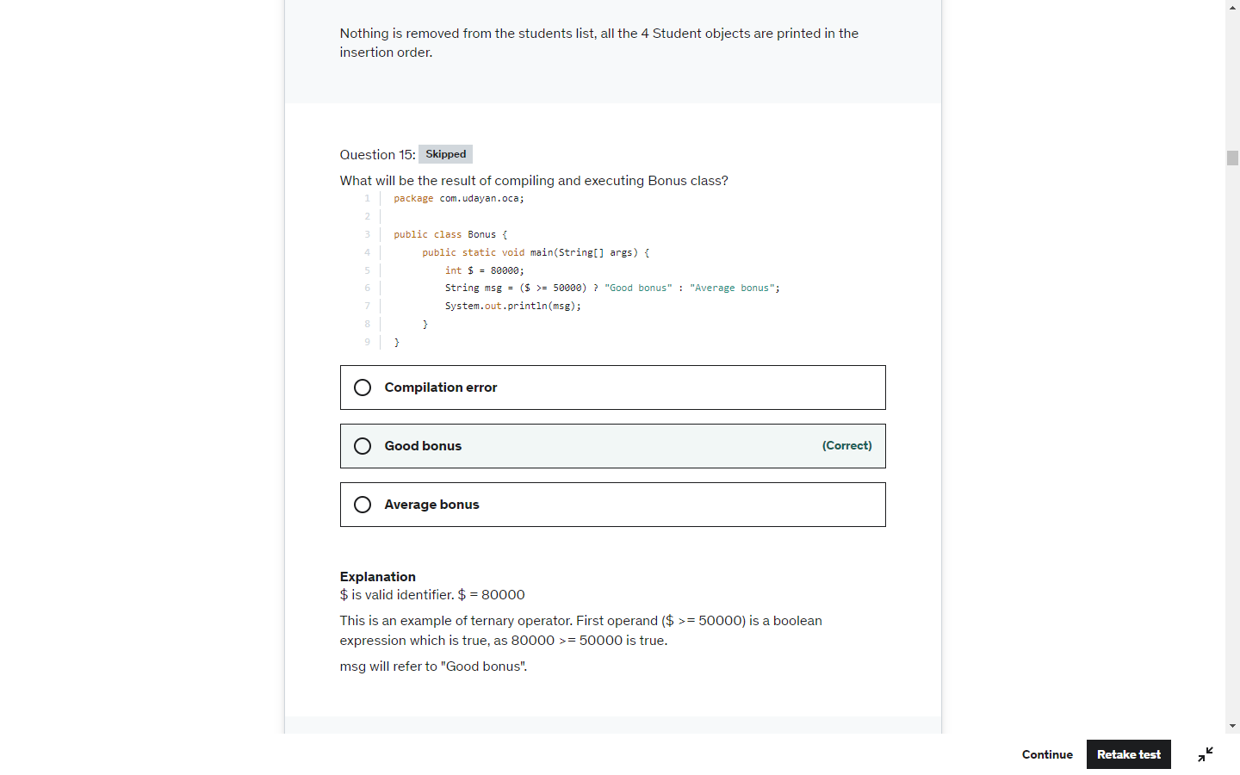

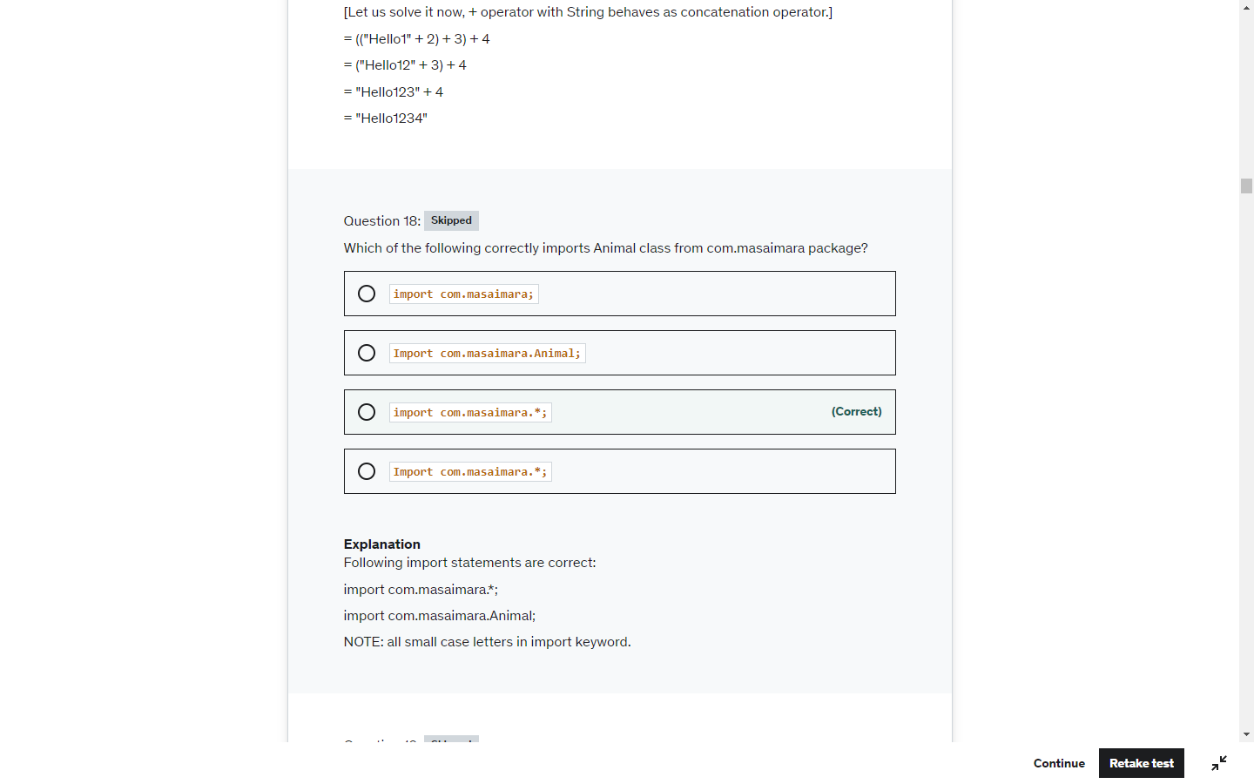

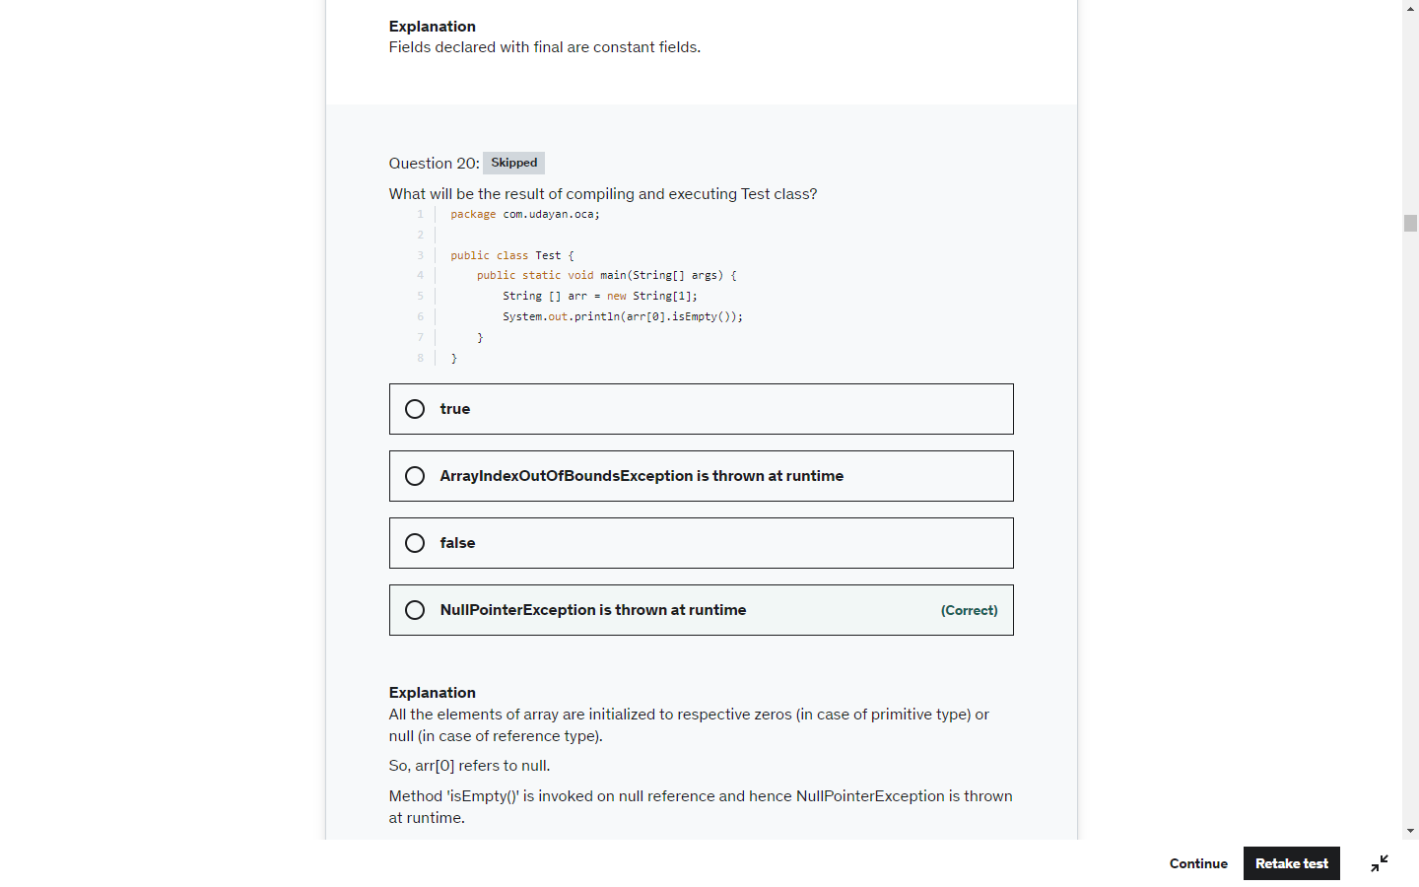

Again LocalDate LocalTime and LocalDateTime are immutable

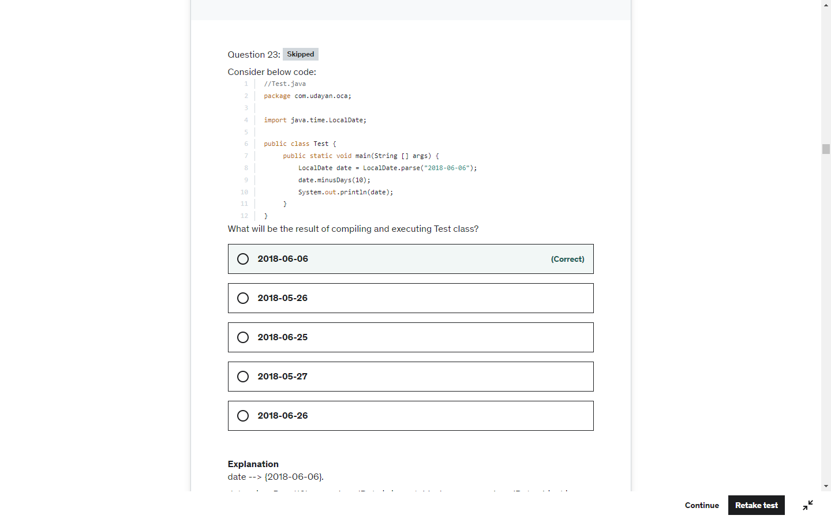

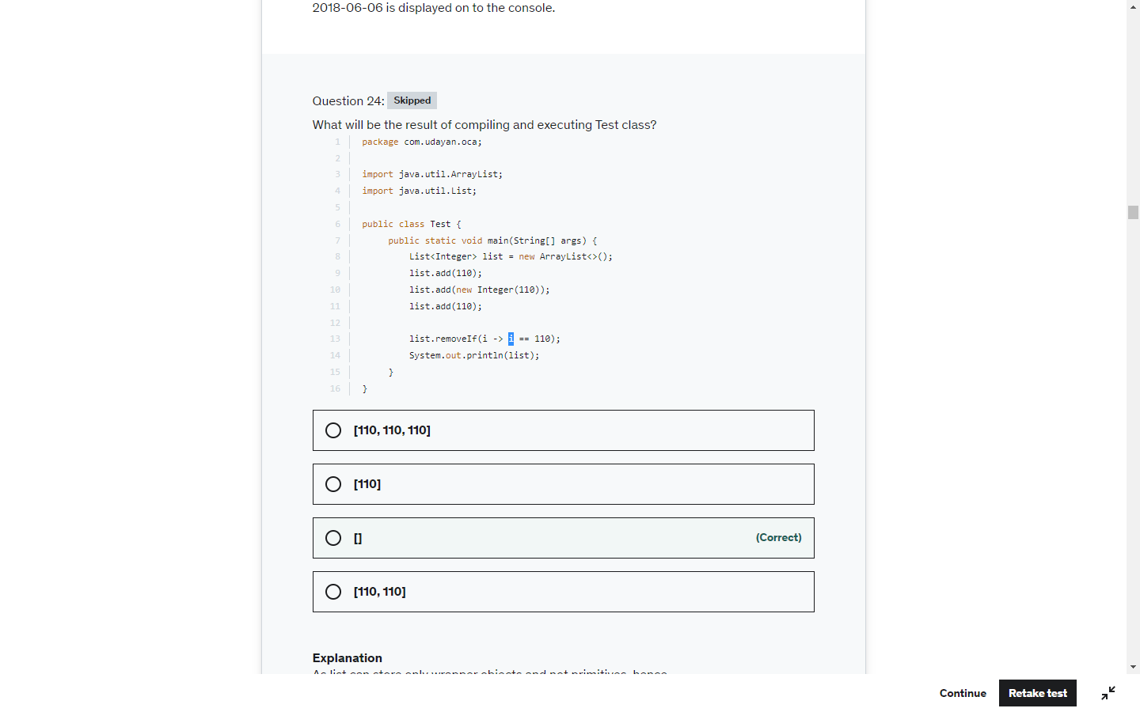

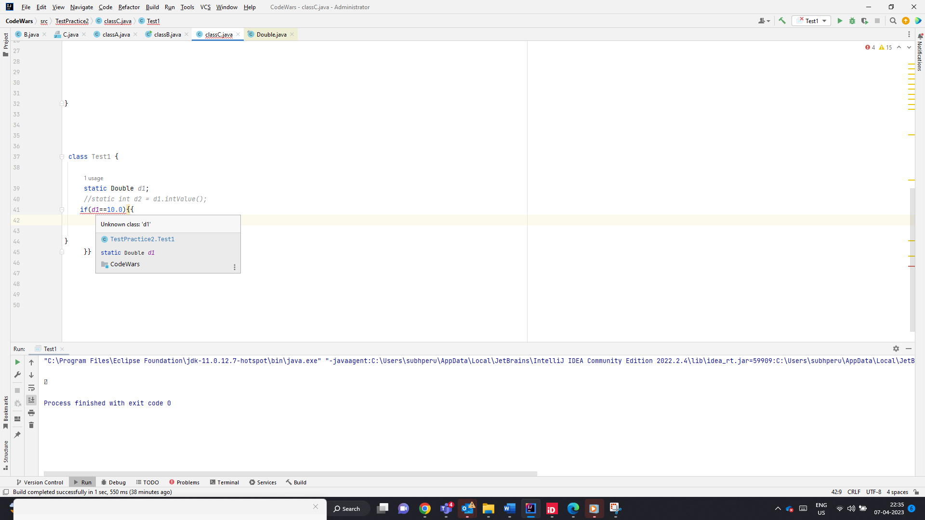

Null Pointer Exception, when doing Double.IntValue();

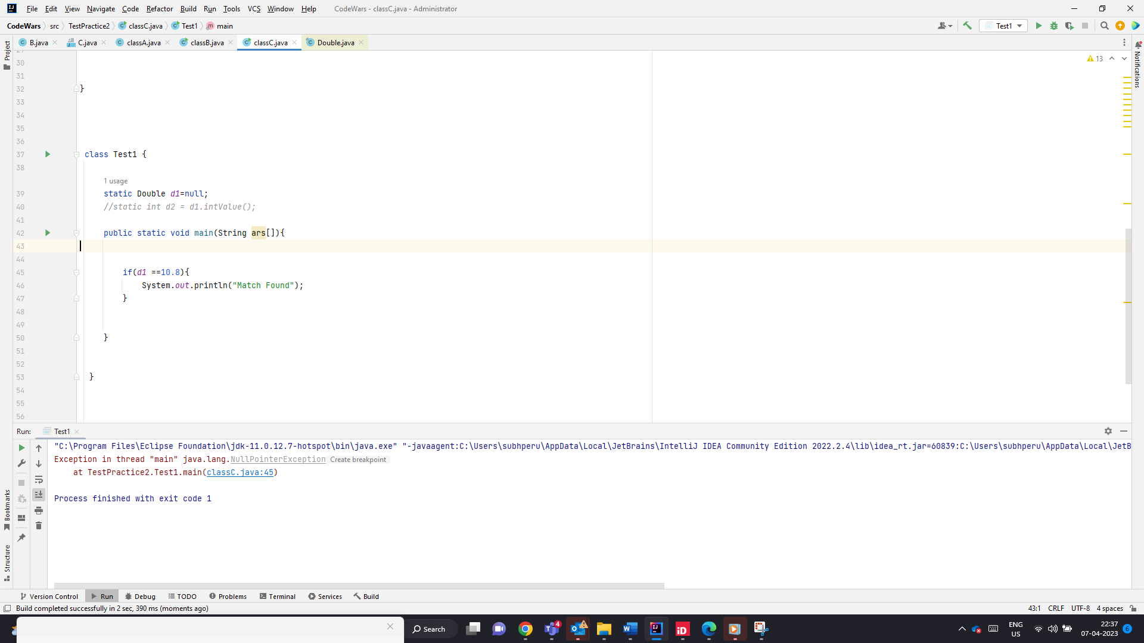

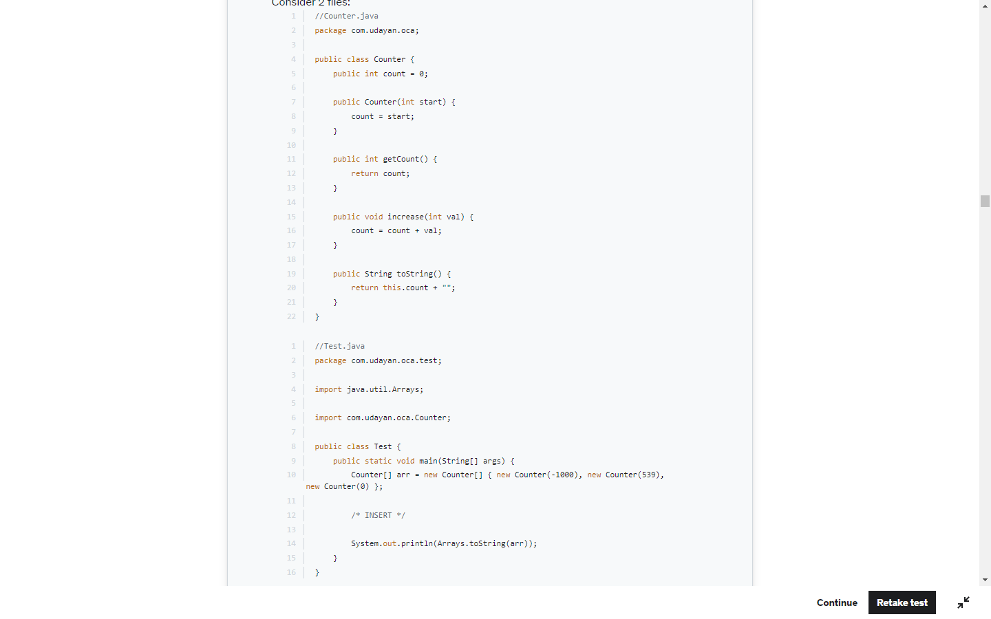

A number can be made 100 by subtracting the no with the same no and adding 100 to it

500+ (-500+100) or

500 + (100 – 500)

-2000

(-2000)+(100-(-2000))

-2000+2100=100

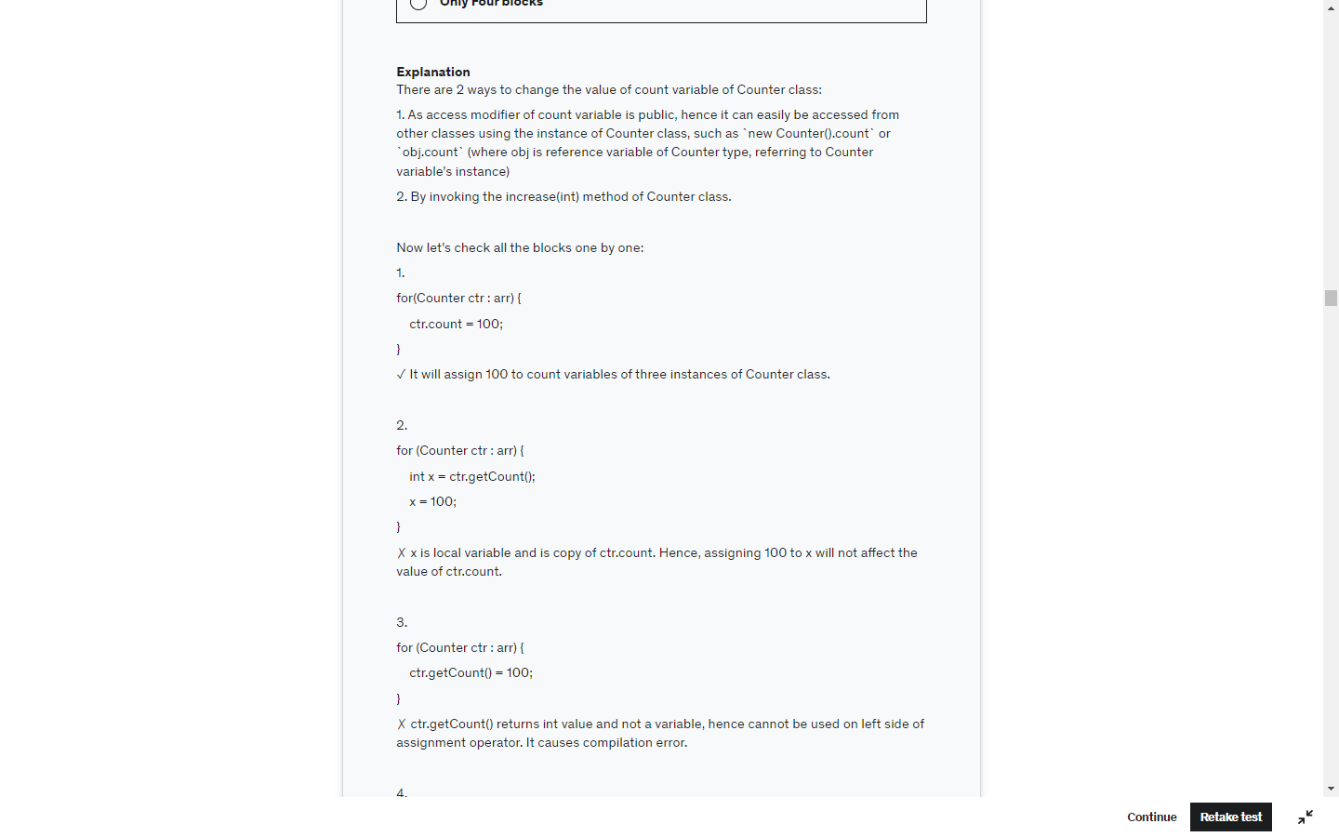

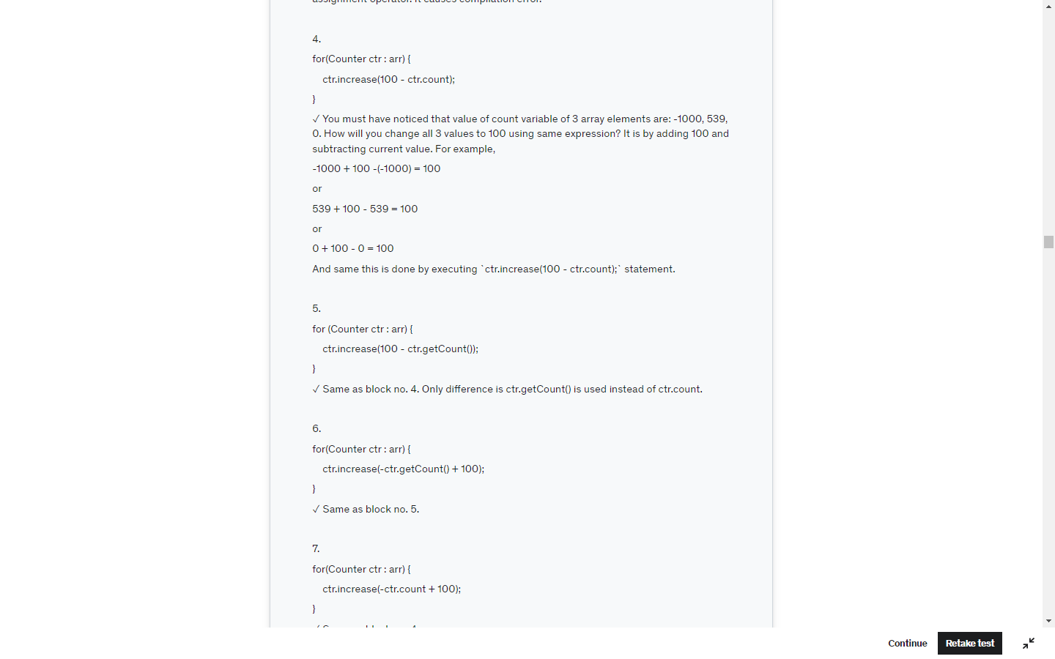

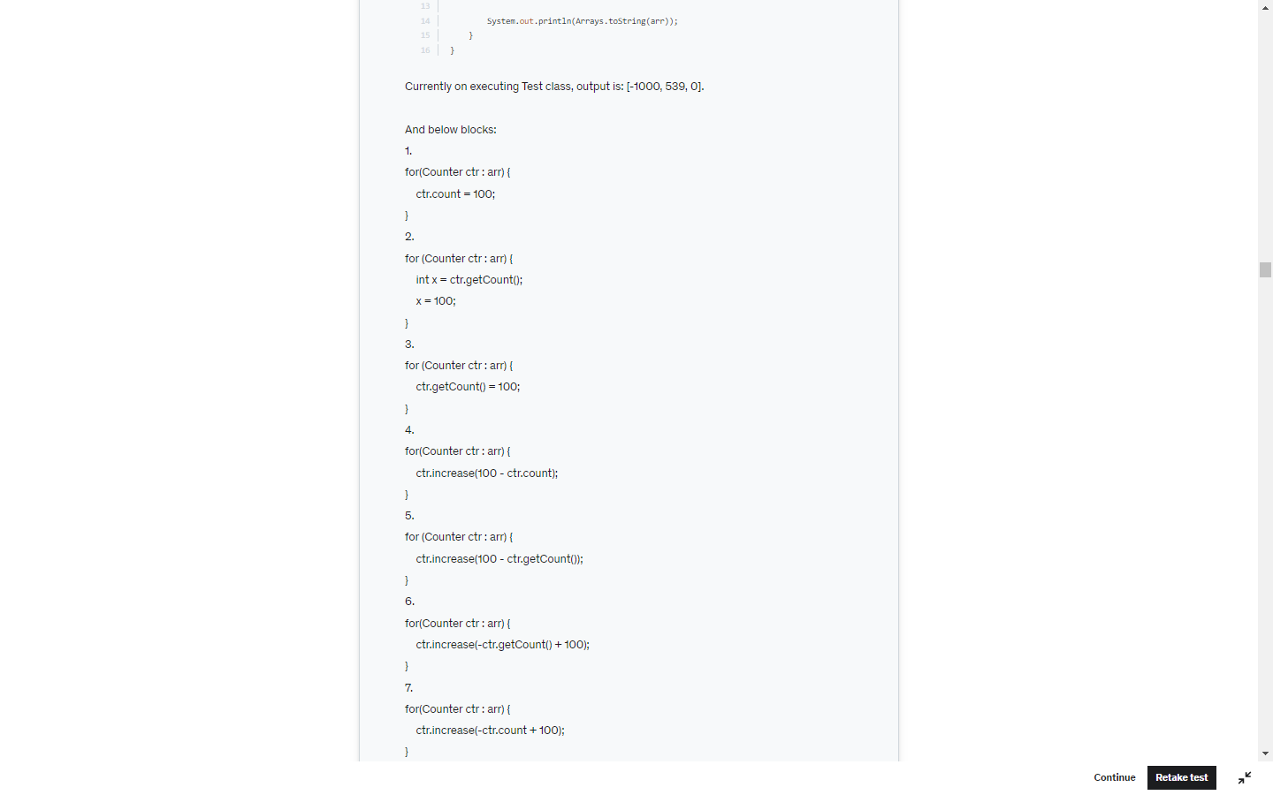

Runtime exceptions can occur anywhere in a program, and in a typical one they can be very numerous. Having to add runtime exceptions in every method declaration would reduce a program's clarity. Thus, **the compiler does not require that you catch or specify runtime exceptions** (although you can).

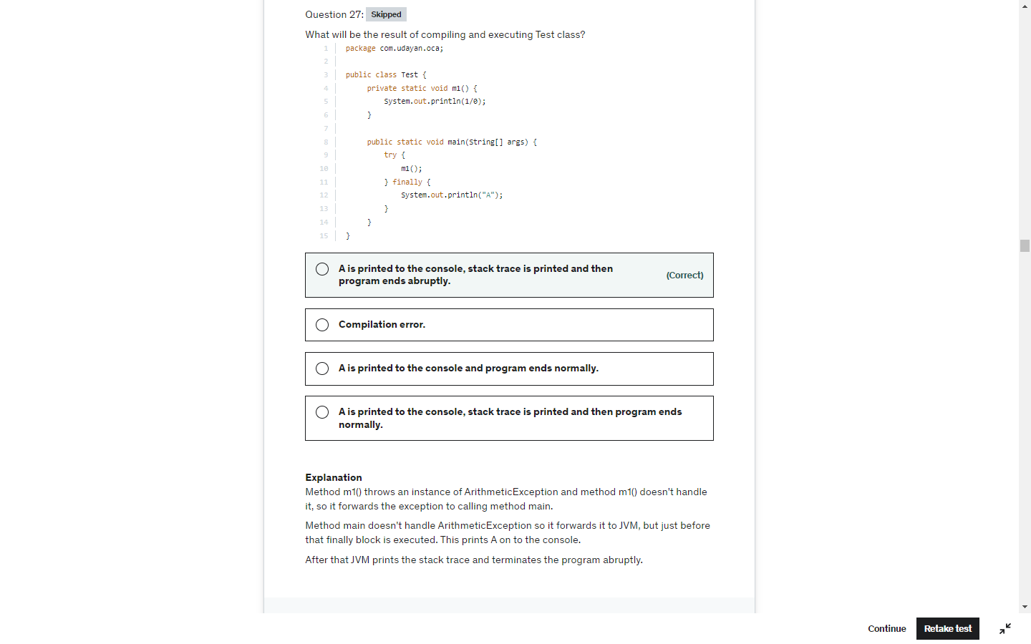

Don’t over see , check all details return type and the value returned

Int -> null . null is not a valid int value

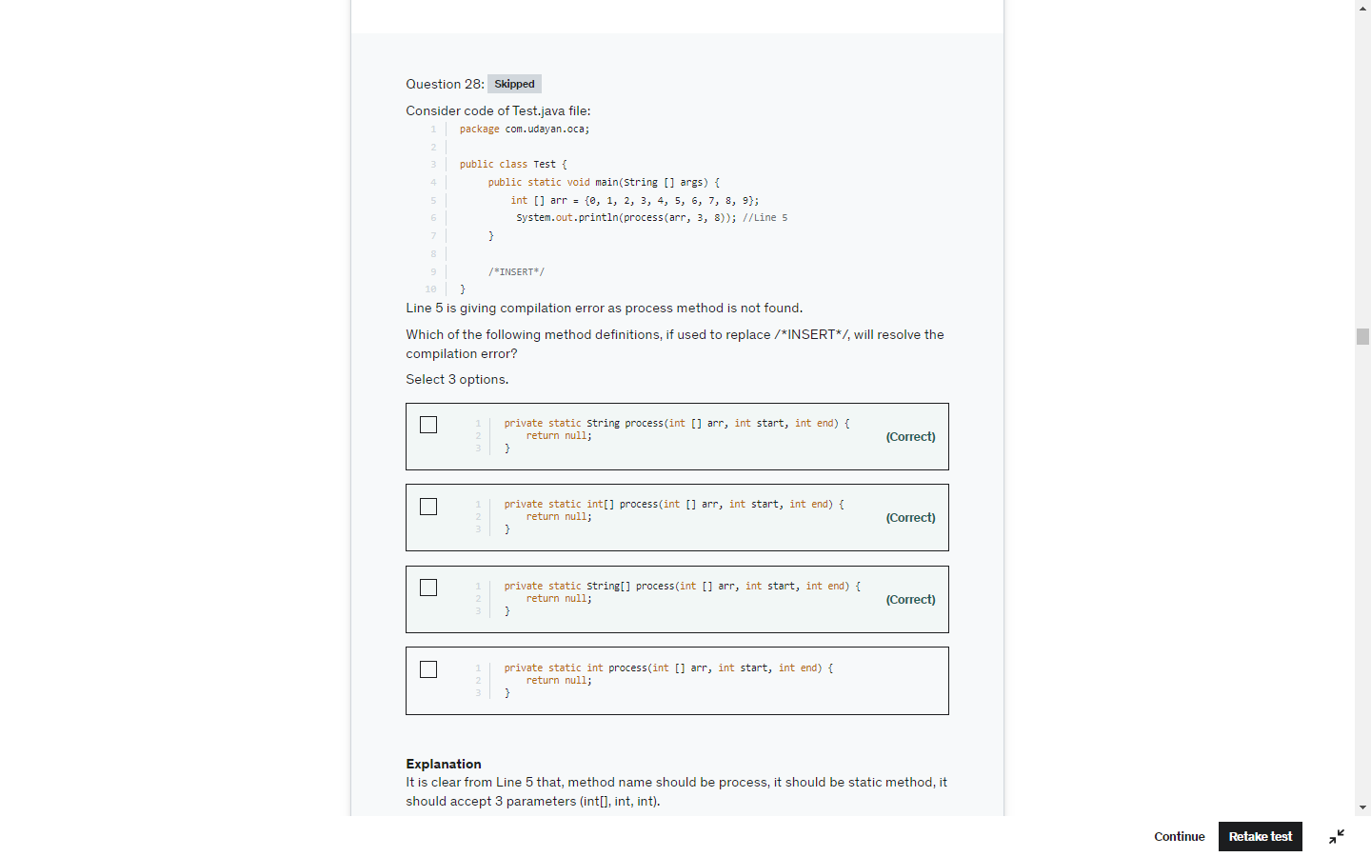

Here double 10.5 cant be implicitly converted to int so, compiler converts int to double implicity

And the value would be 10.0 so not equals.

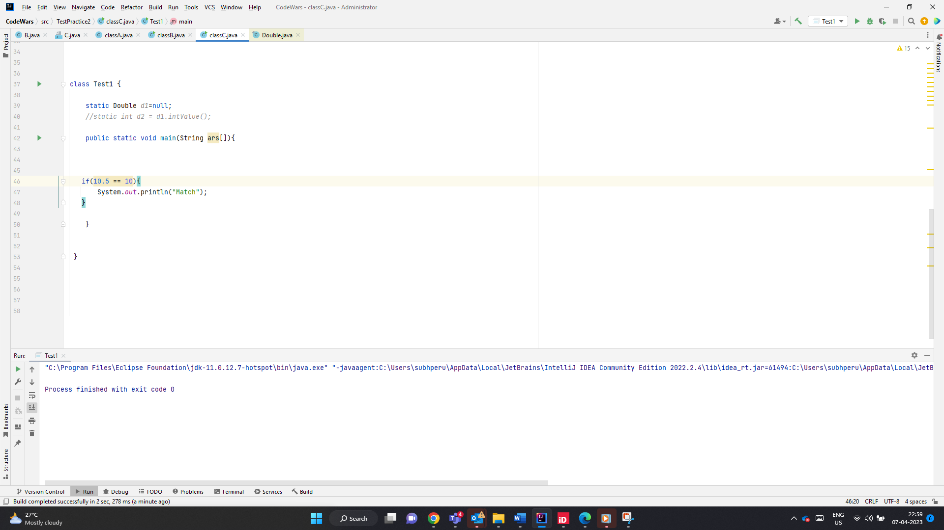

List.set -> Replcaes the element

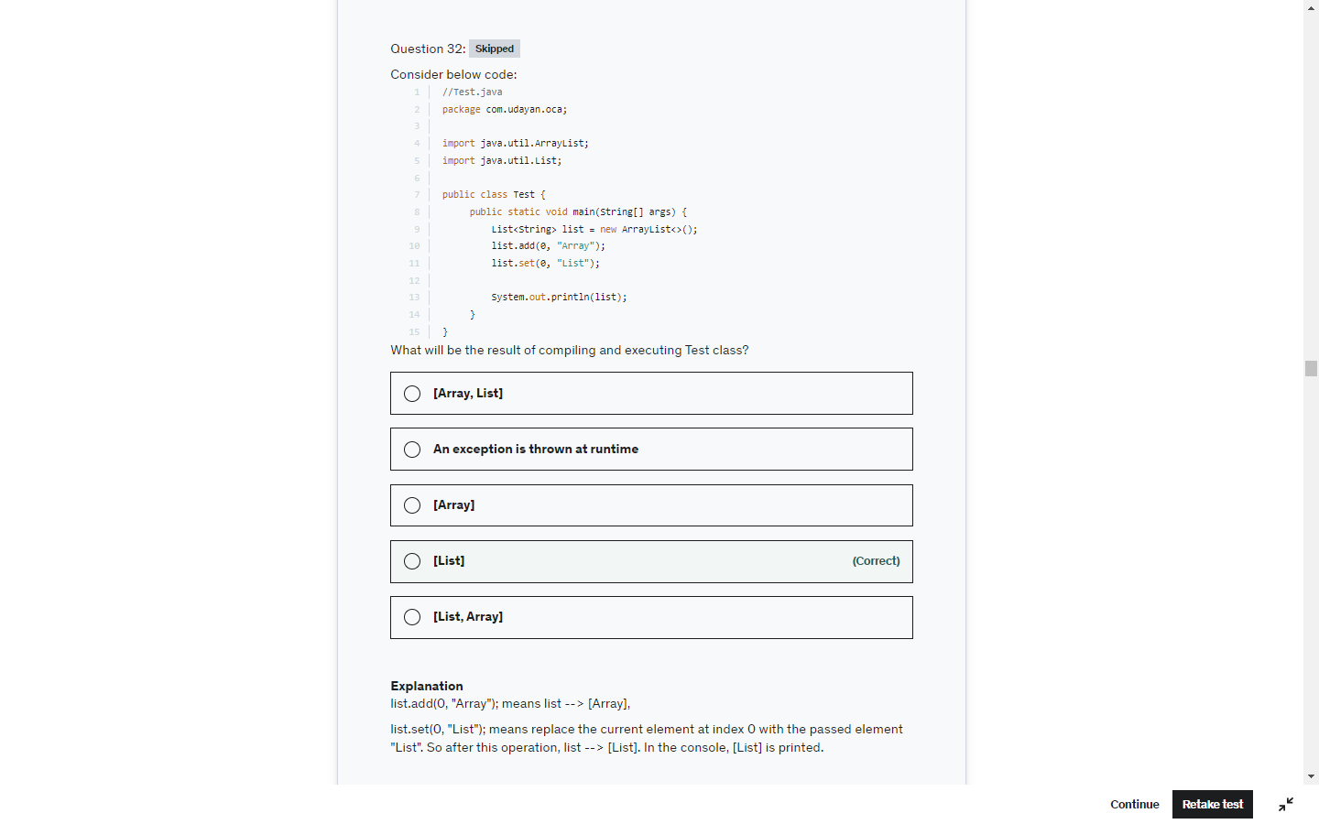

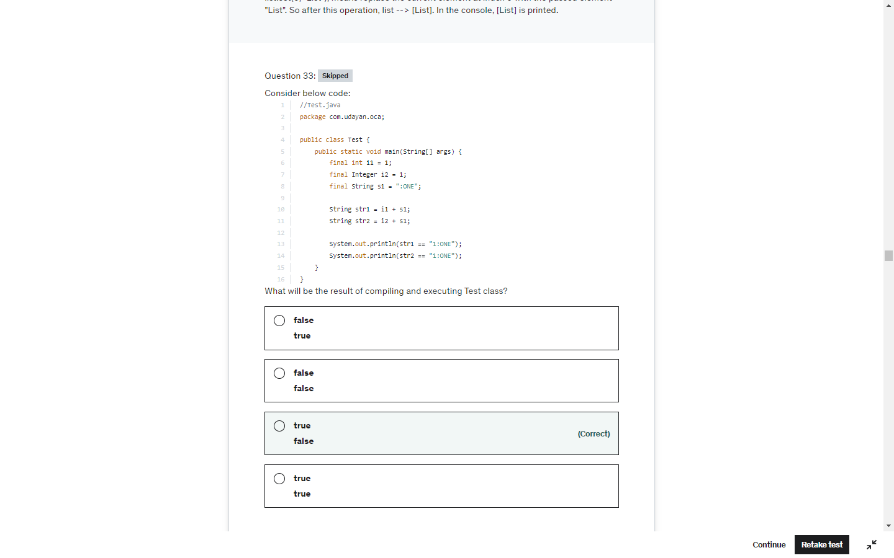

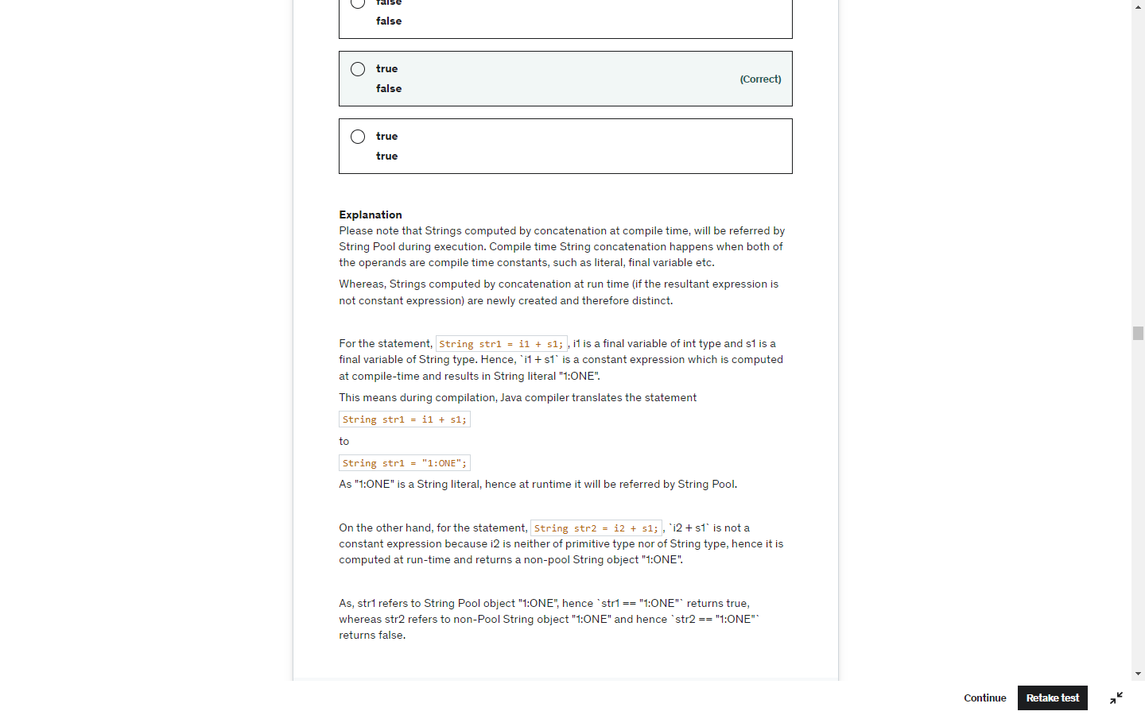

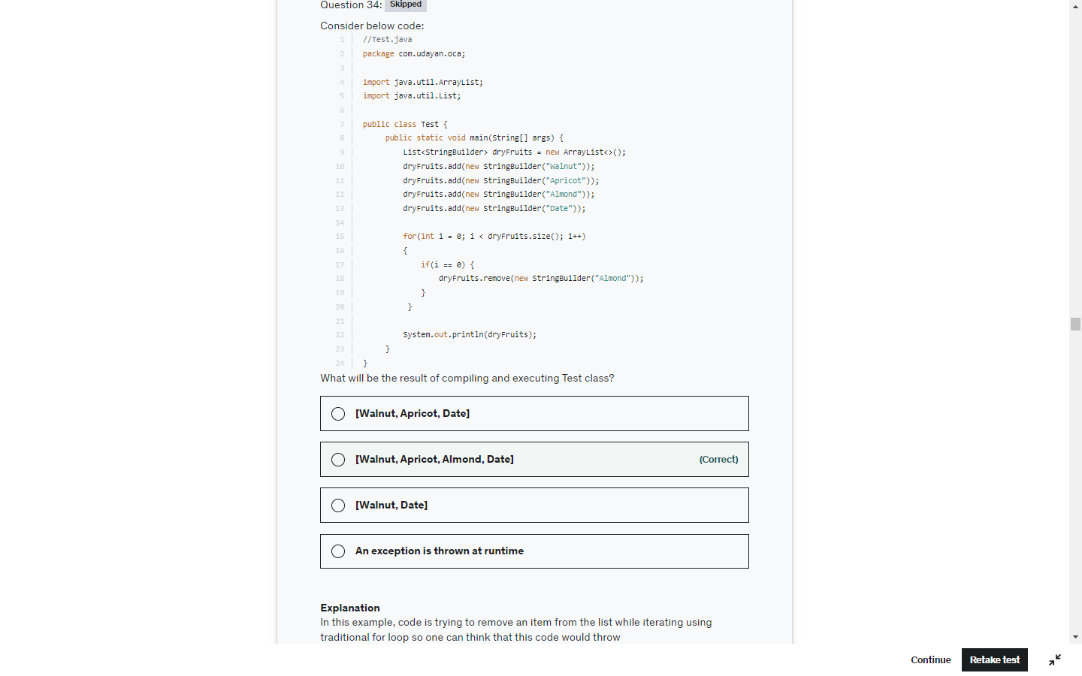

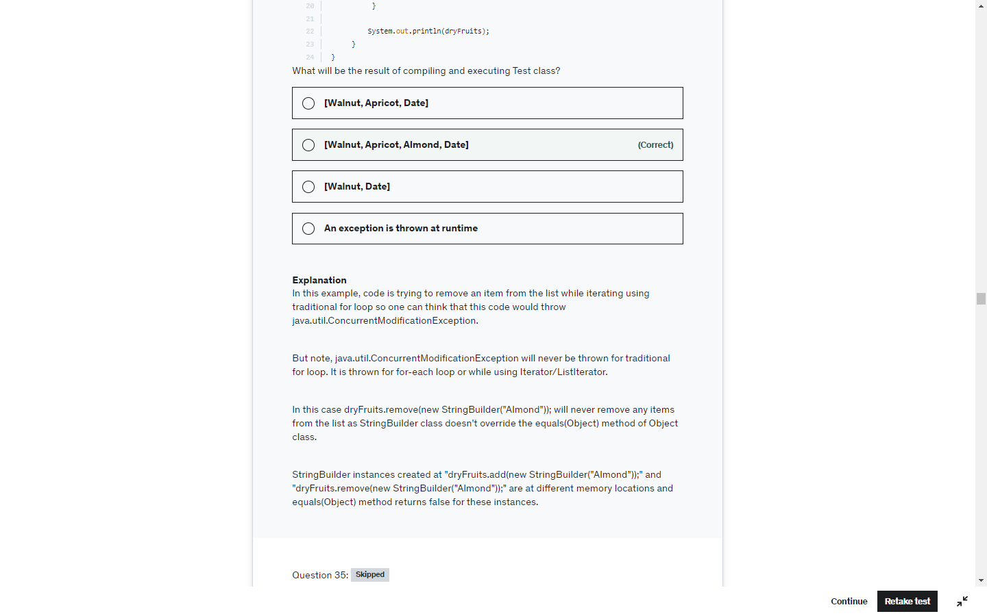

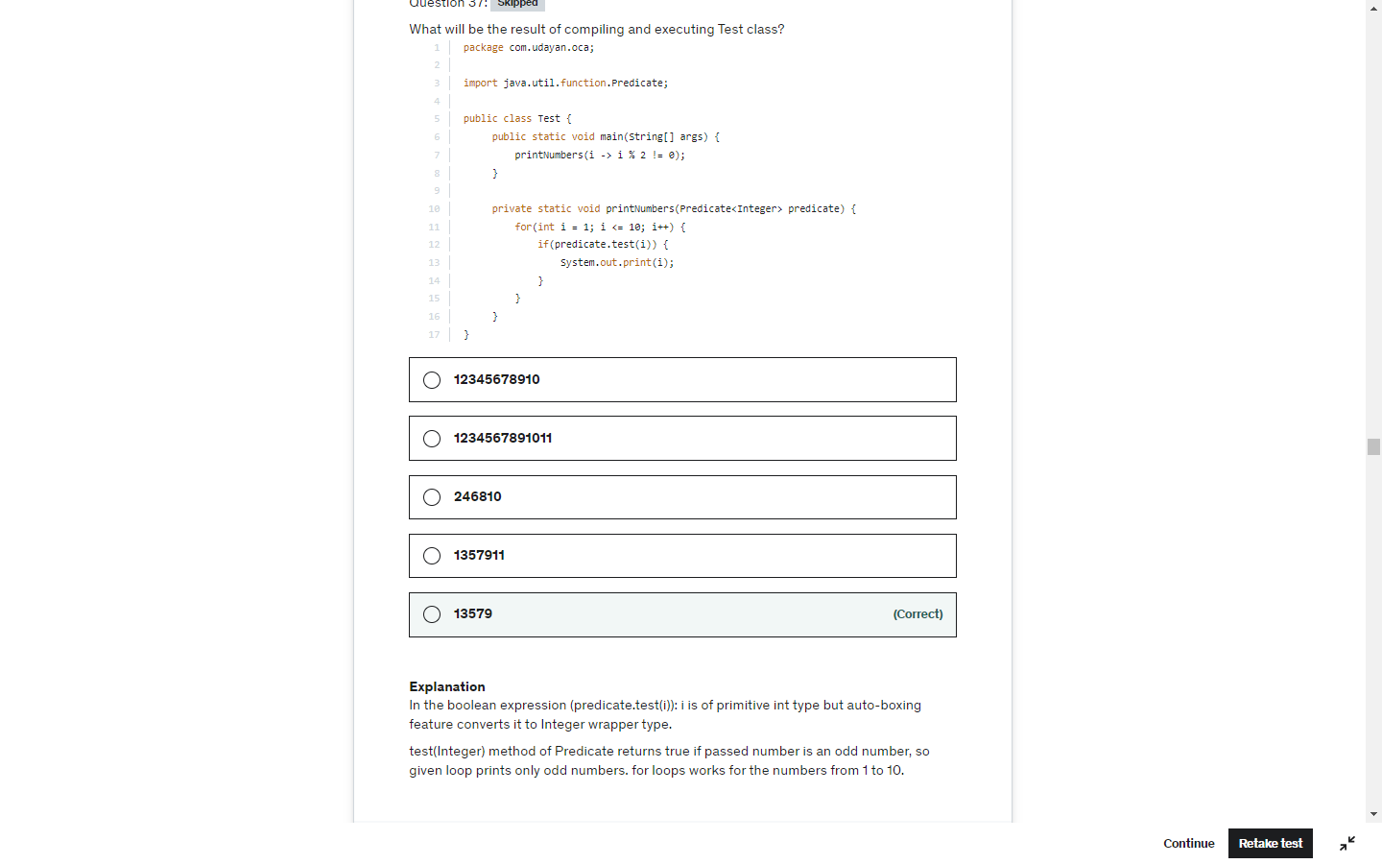

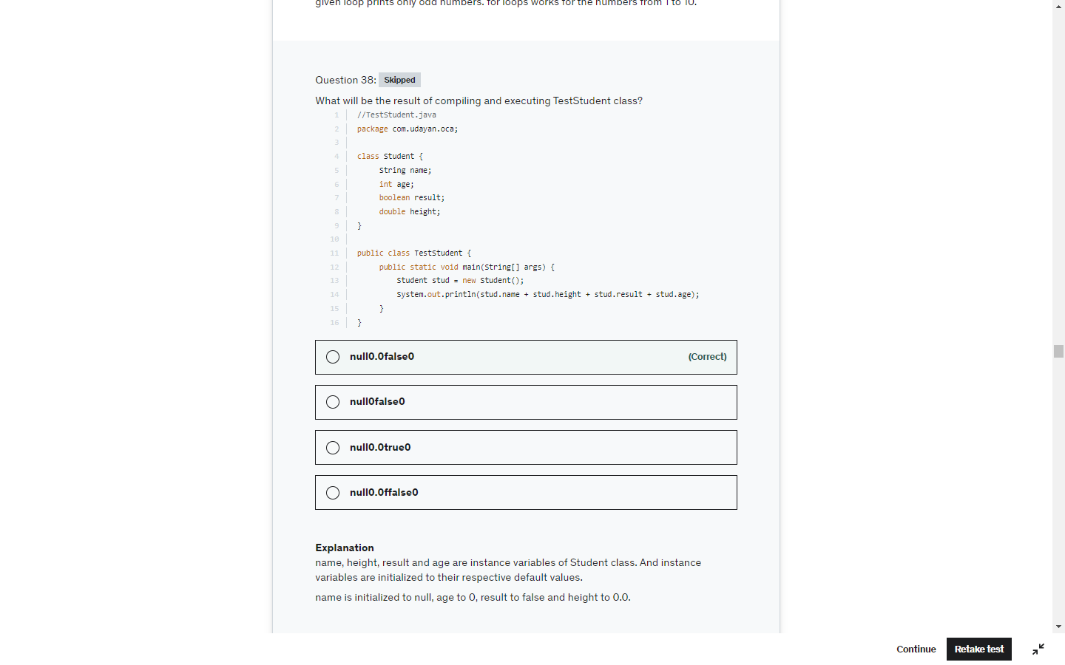

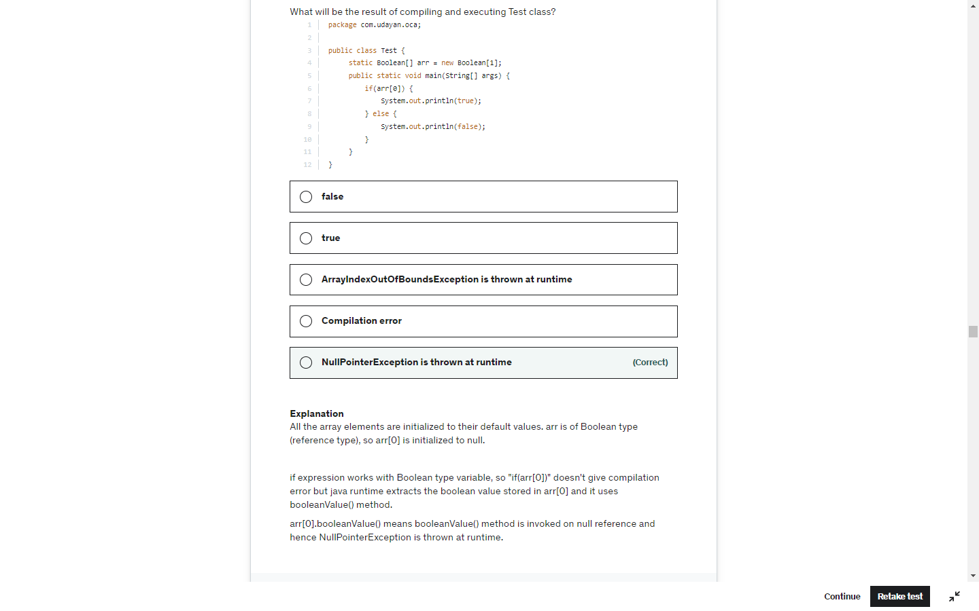

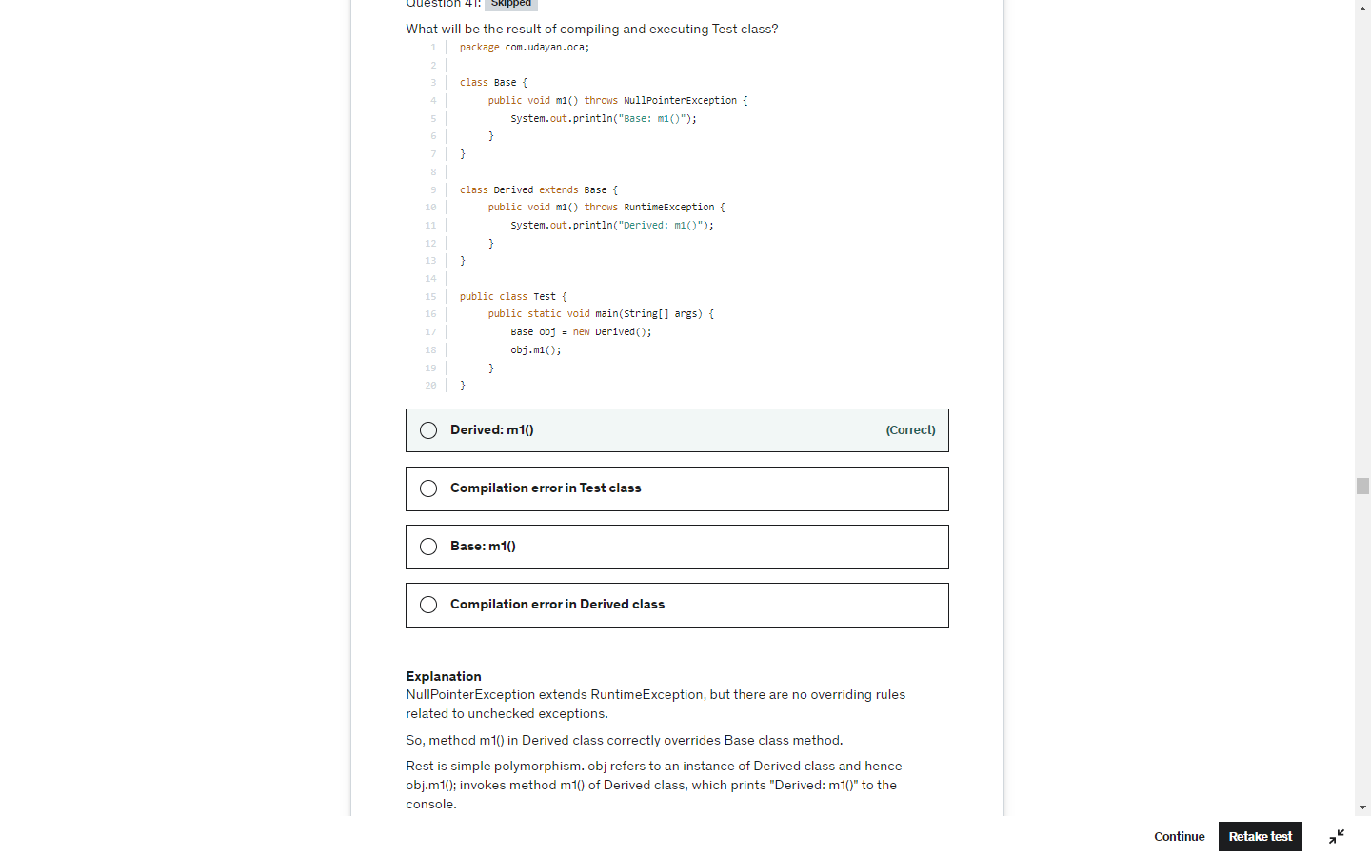

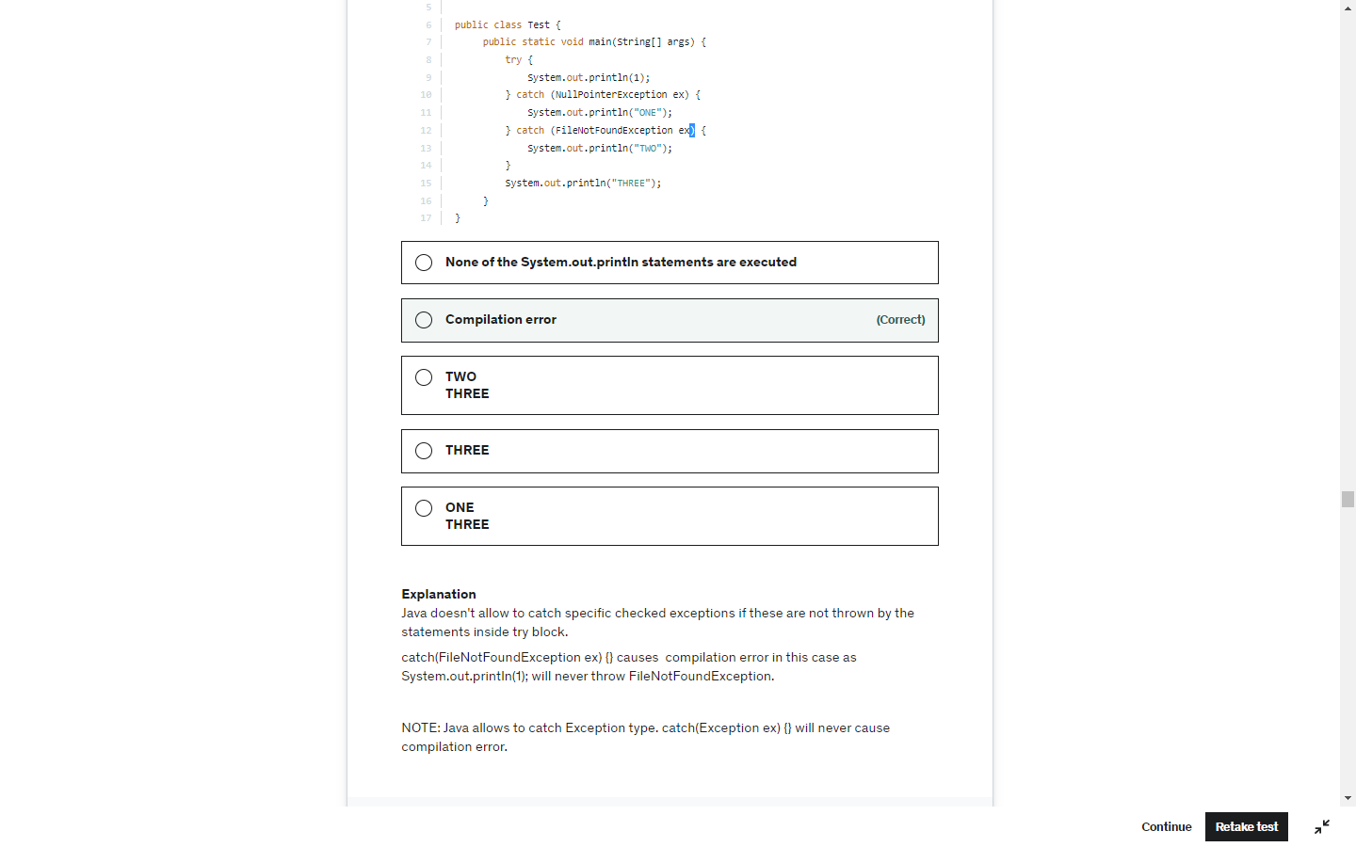

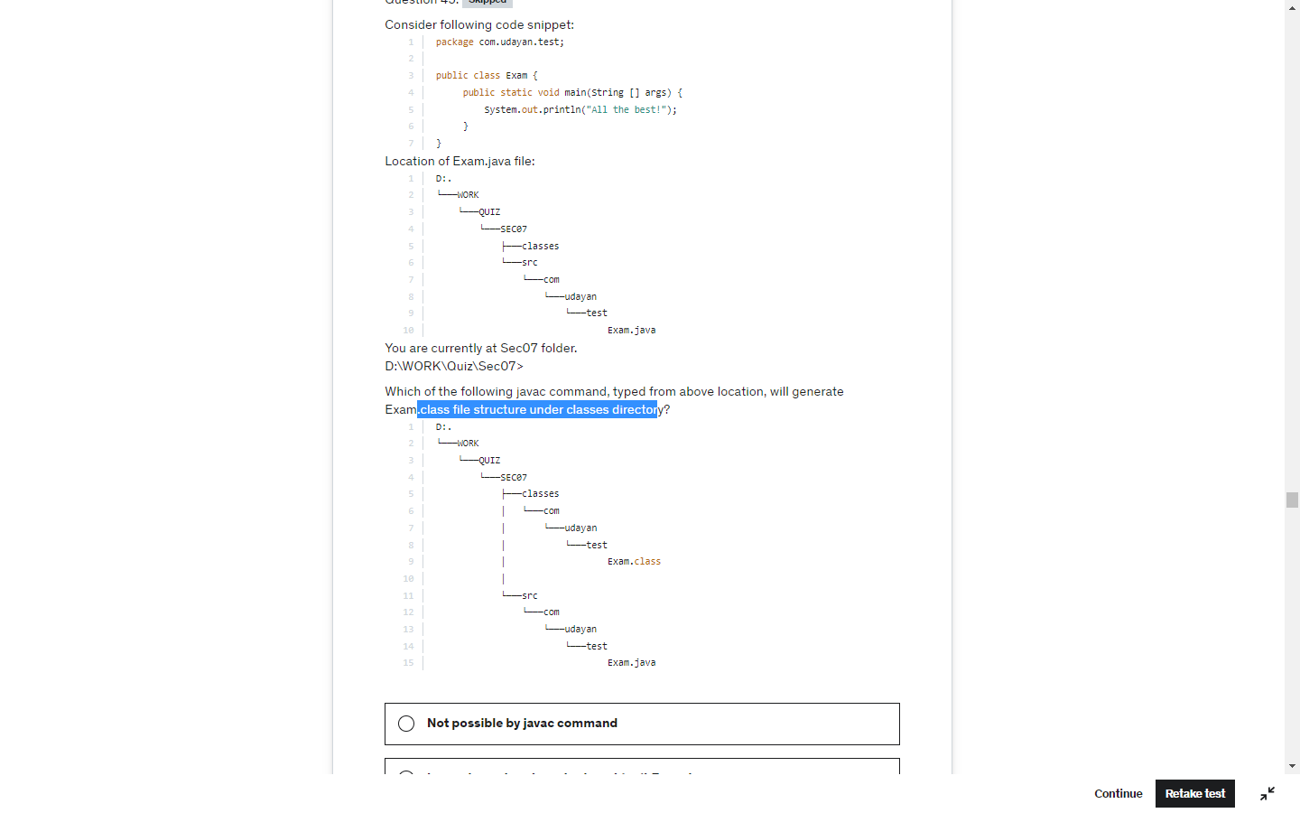

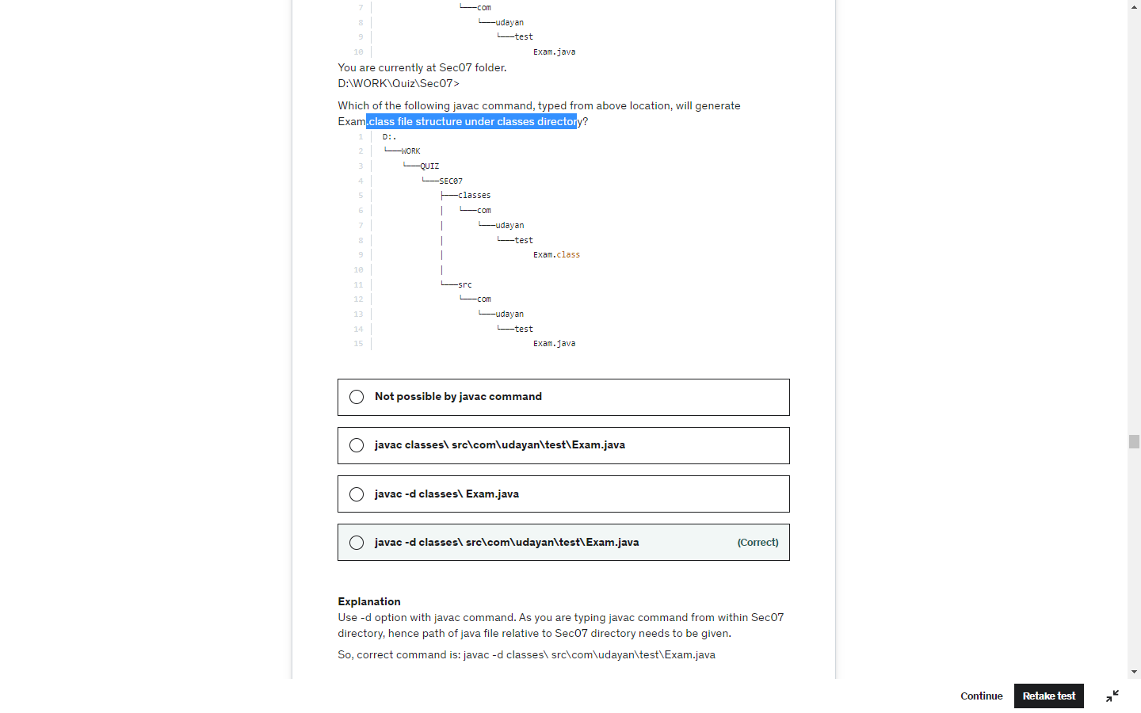

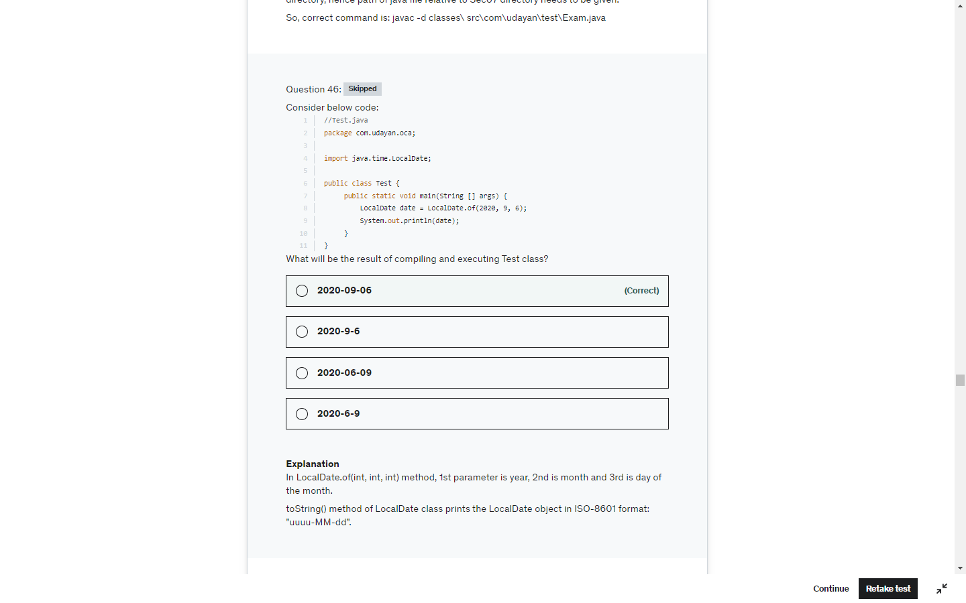

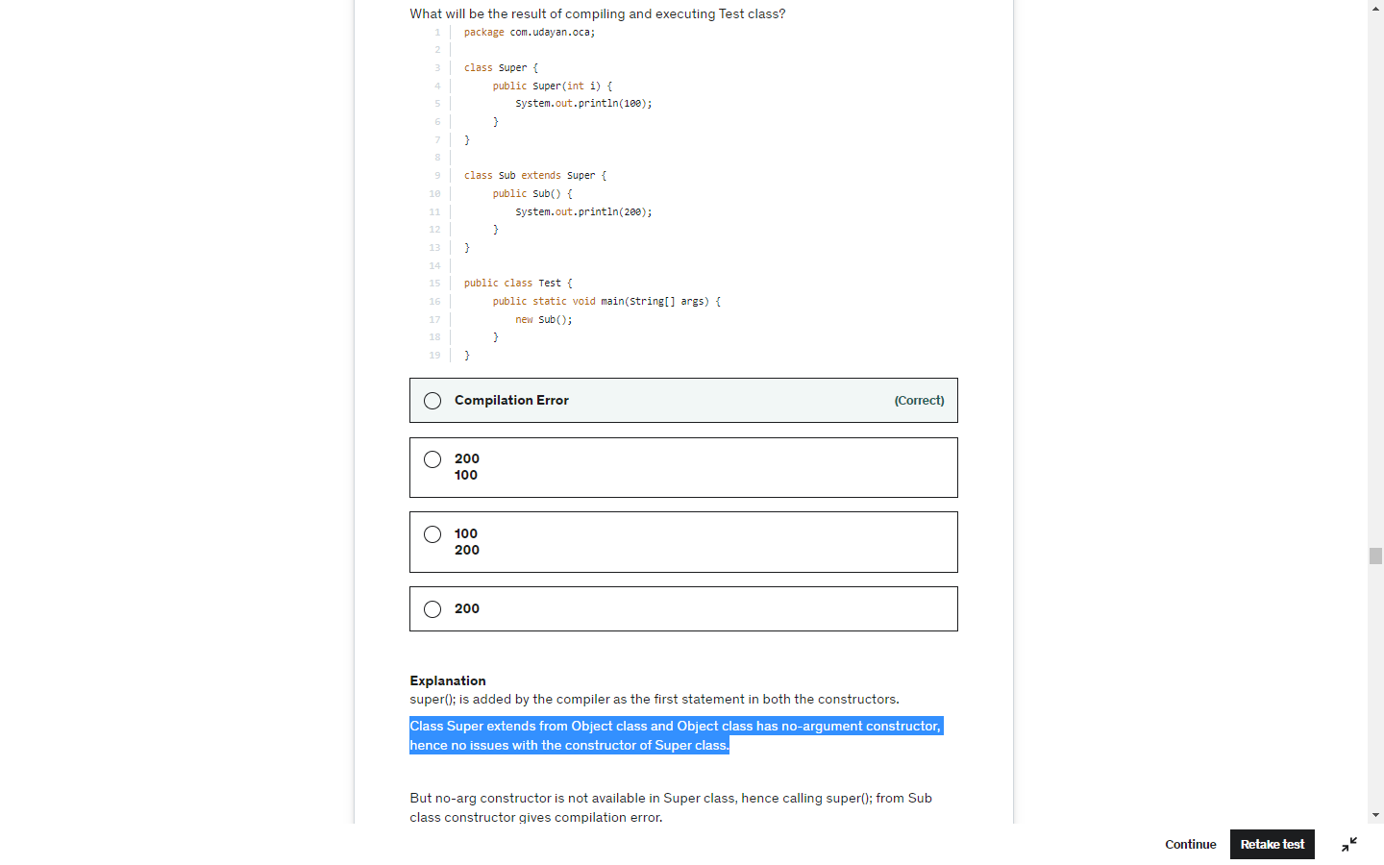

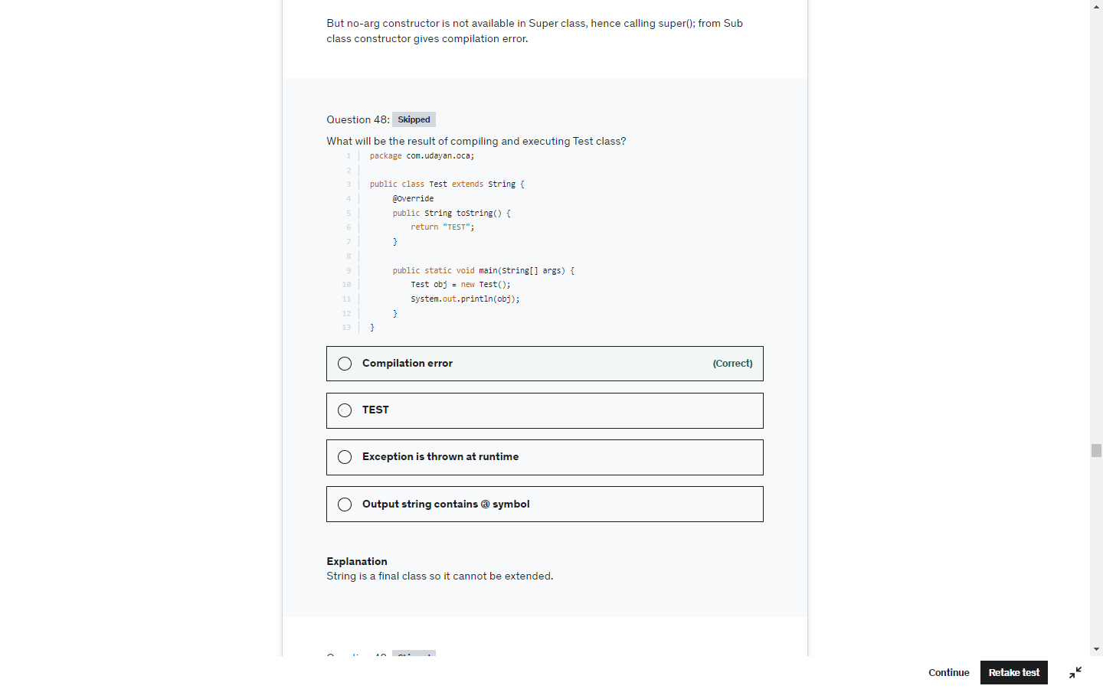

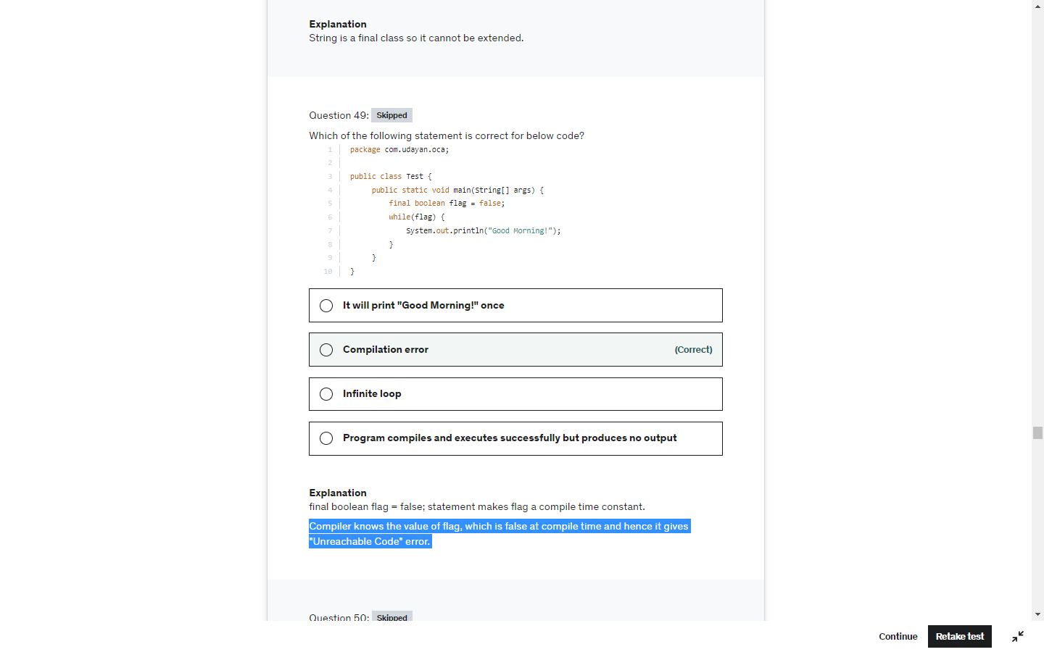

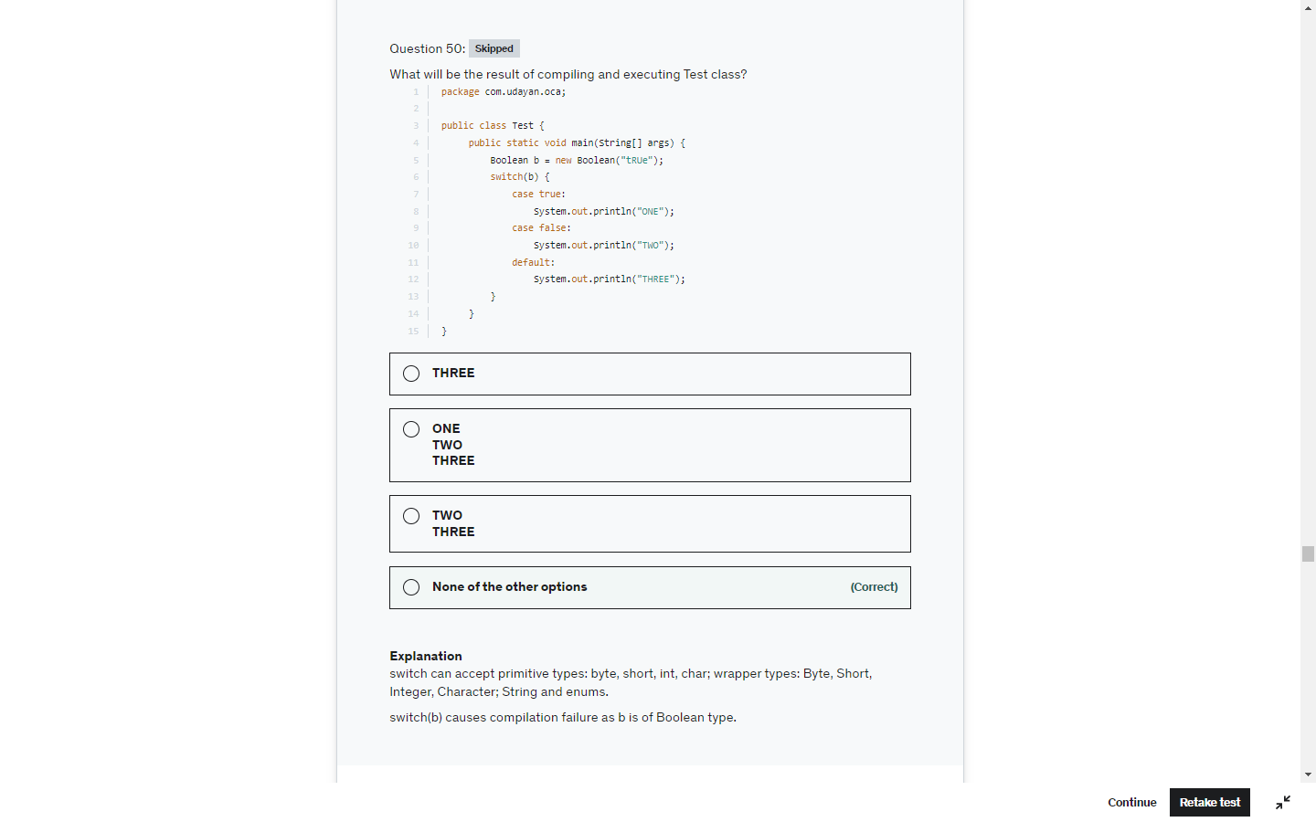

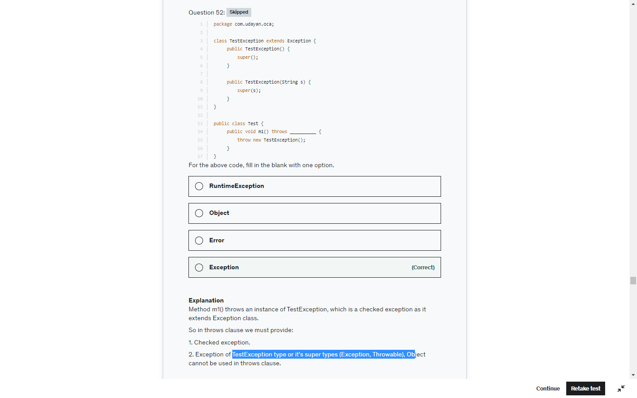

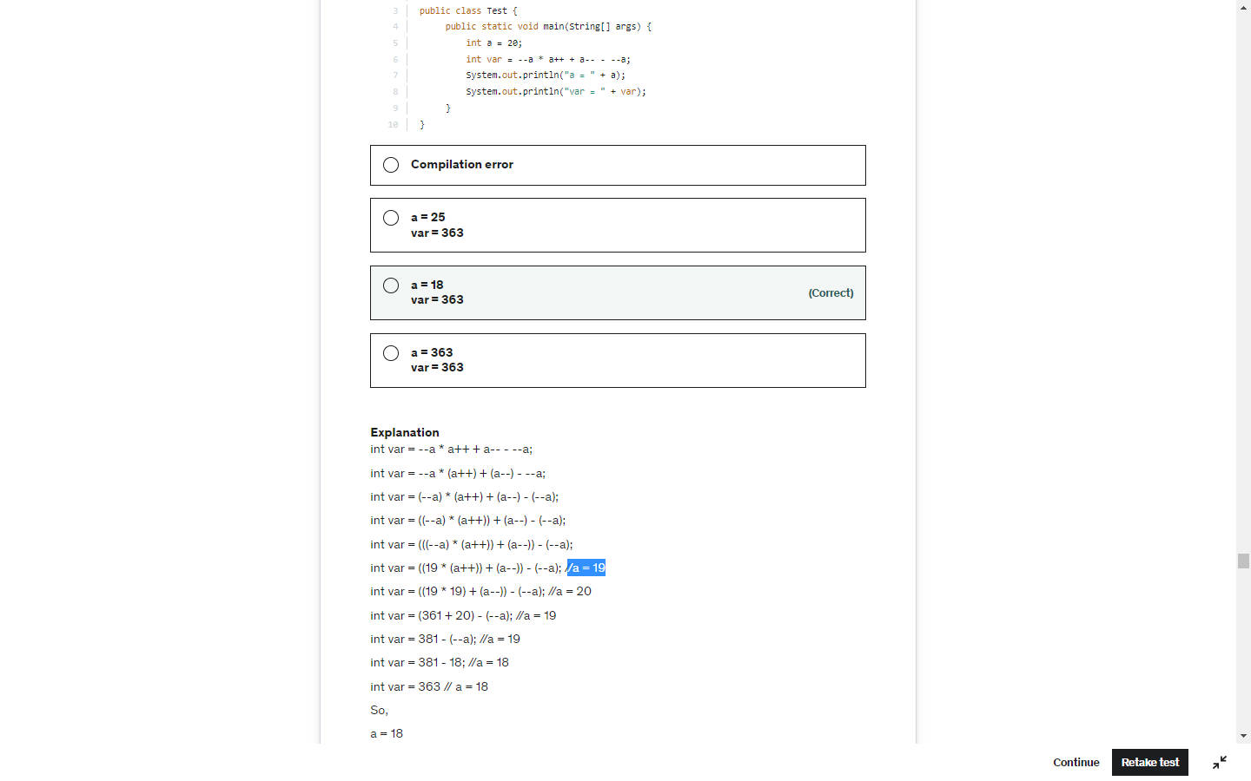

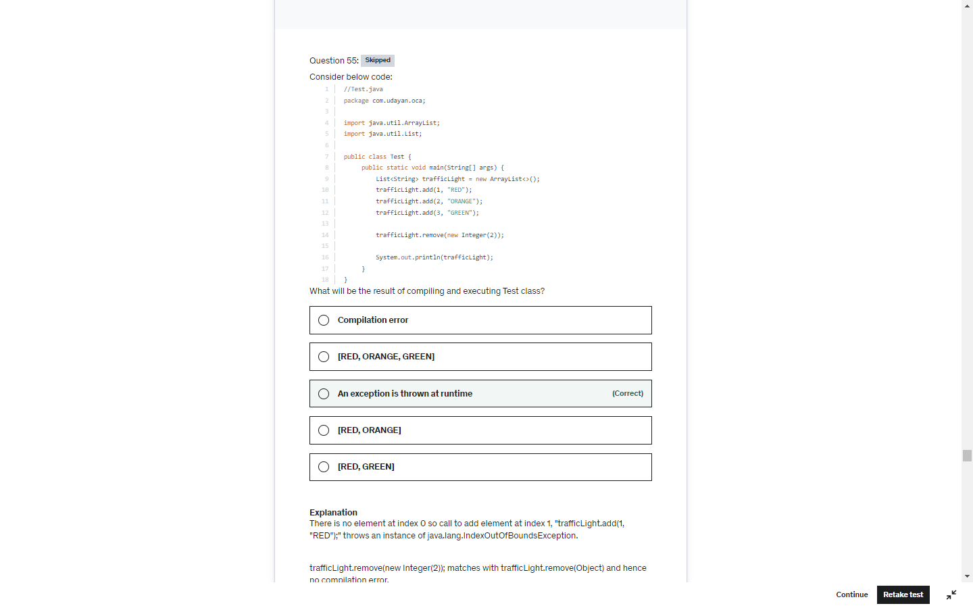

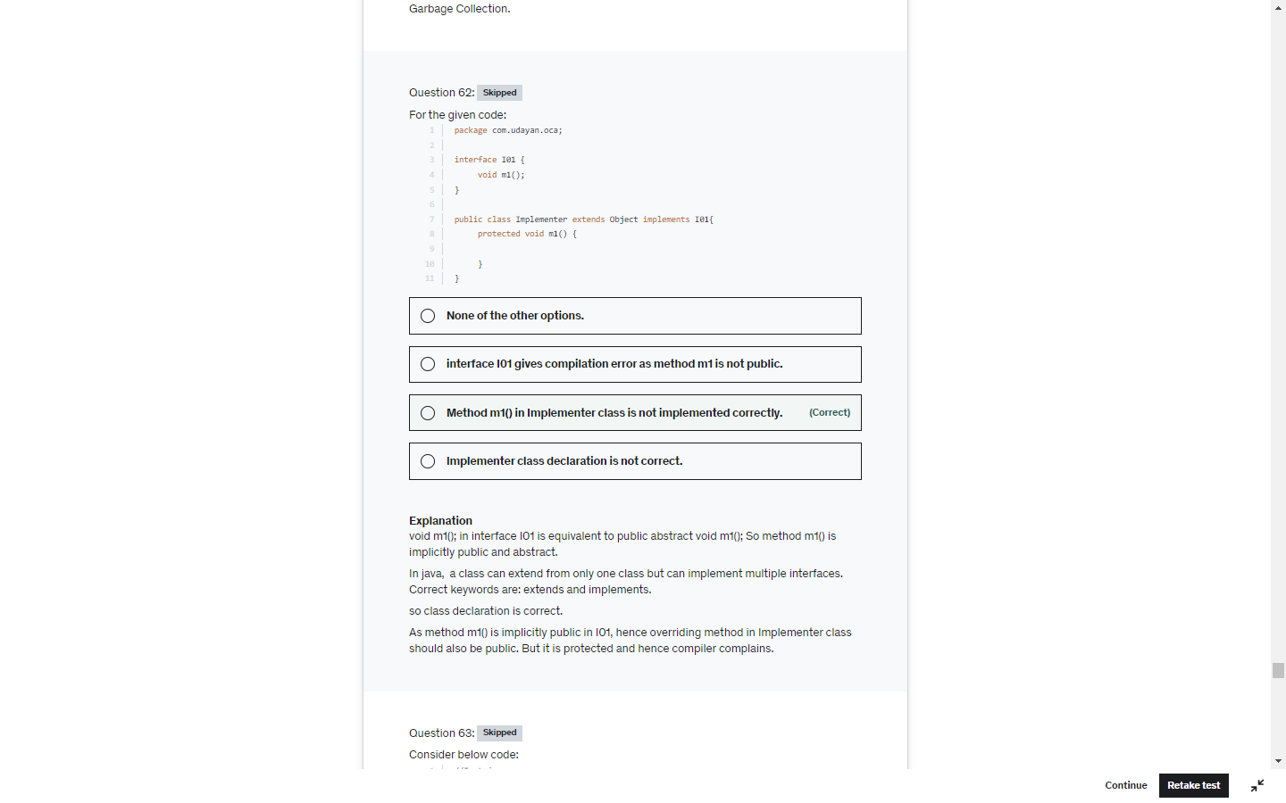

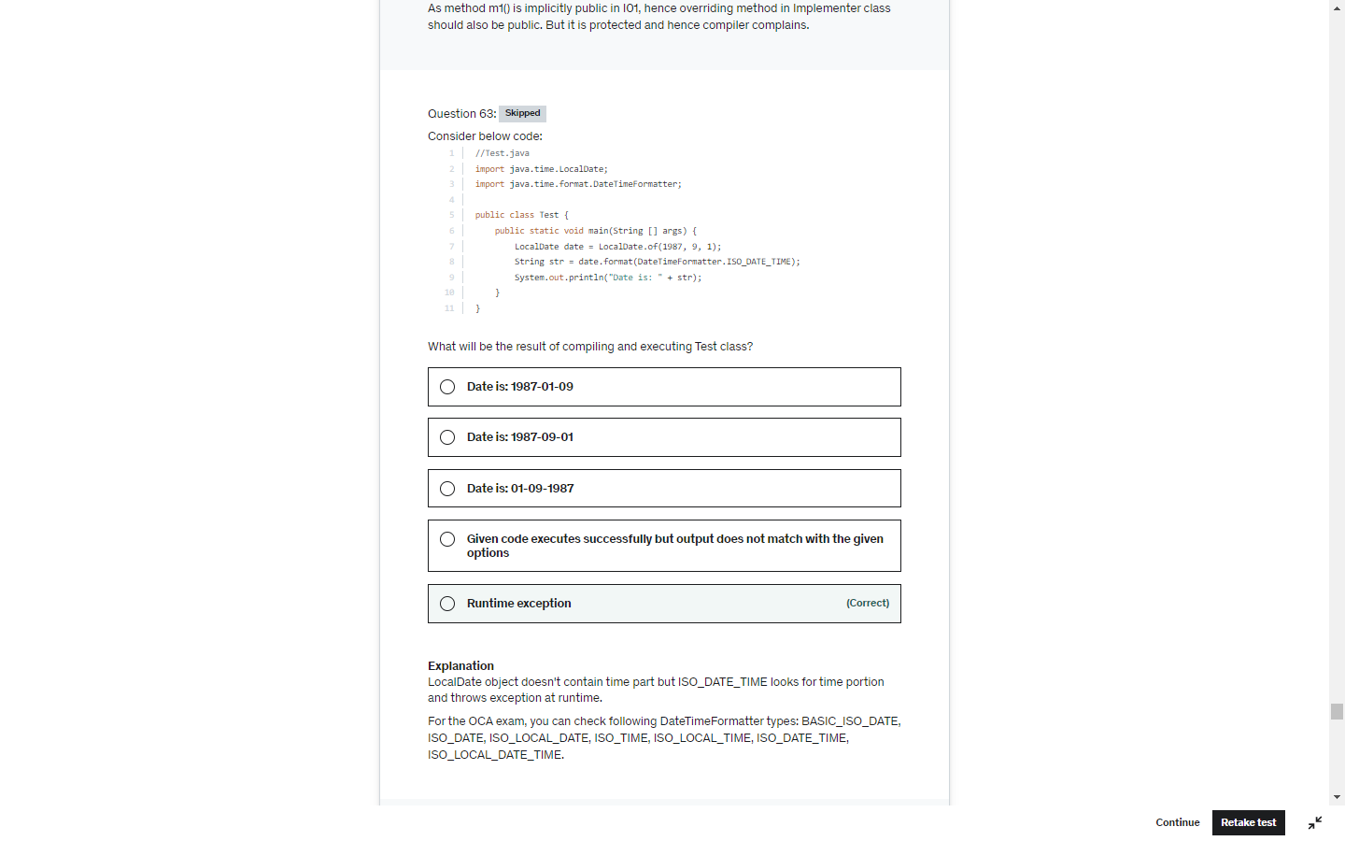

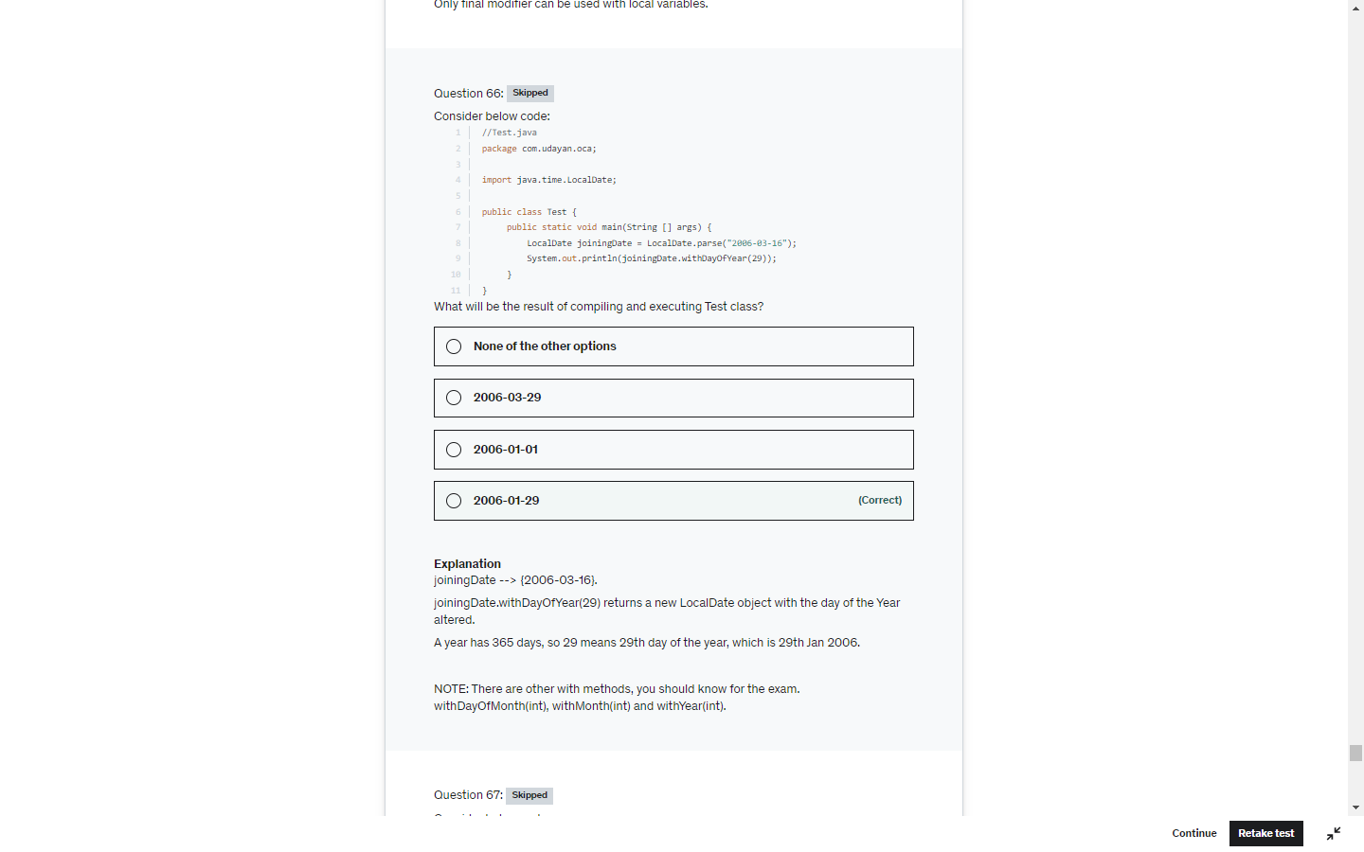

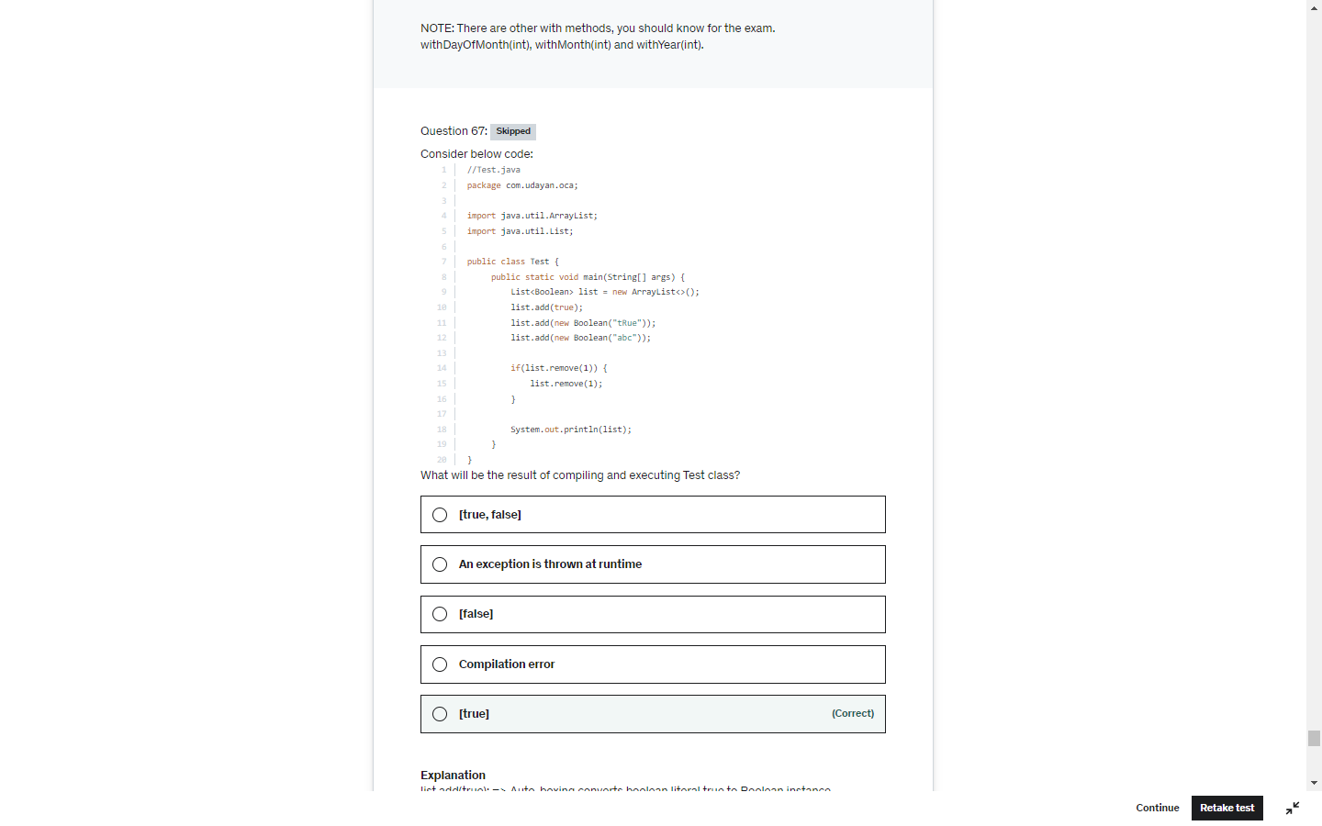

instanceOf should be a relation between two operand . parent child else below error at CE

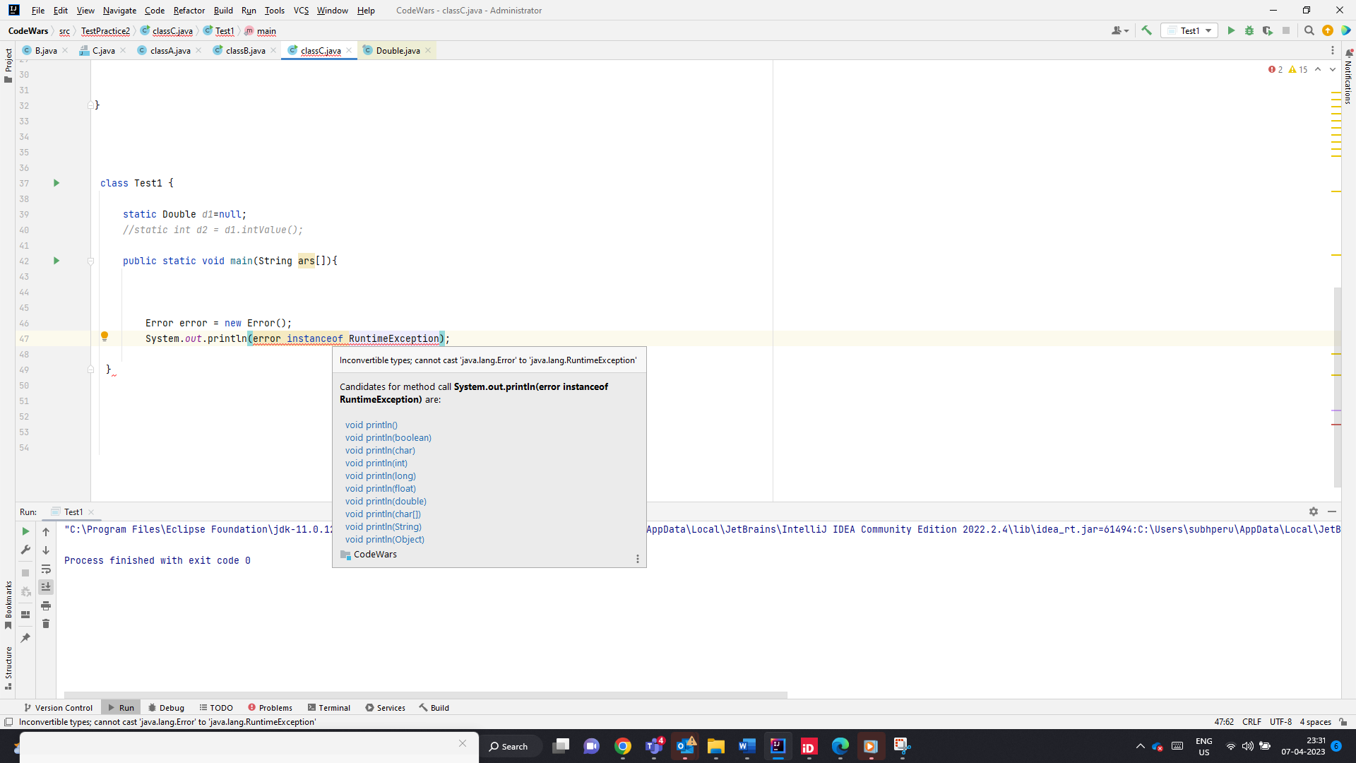

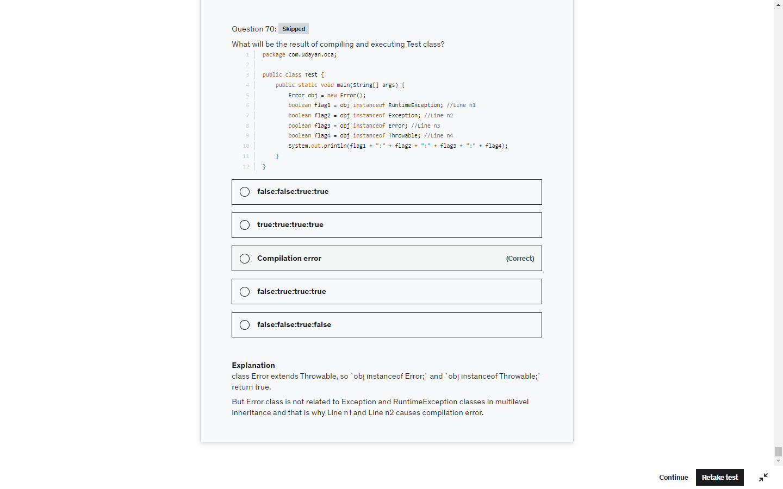

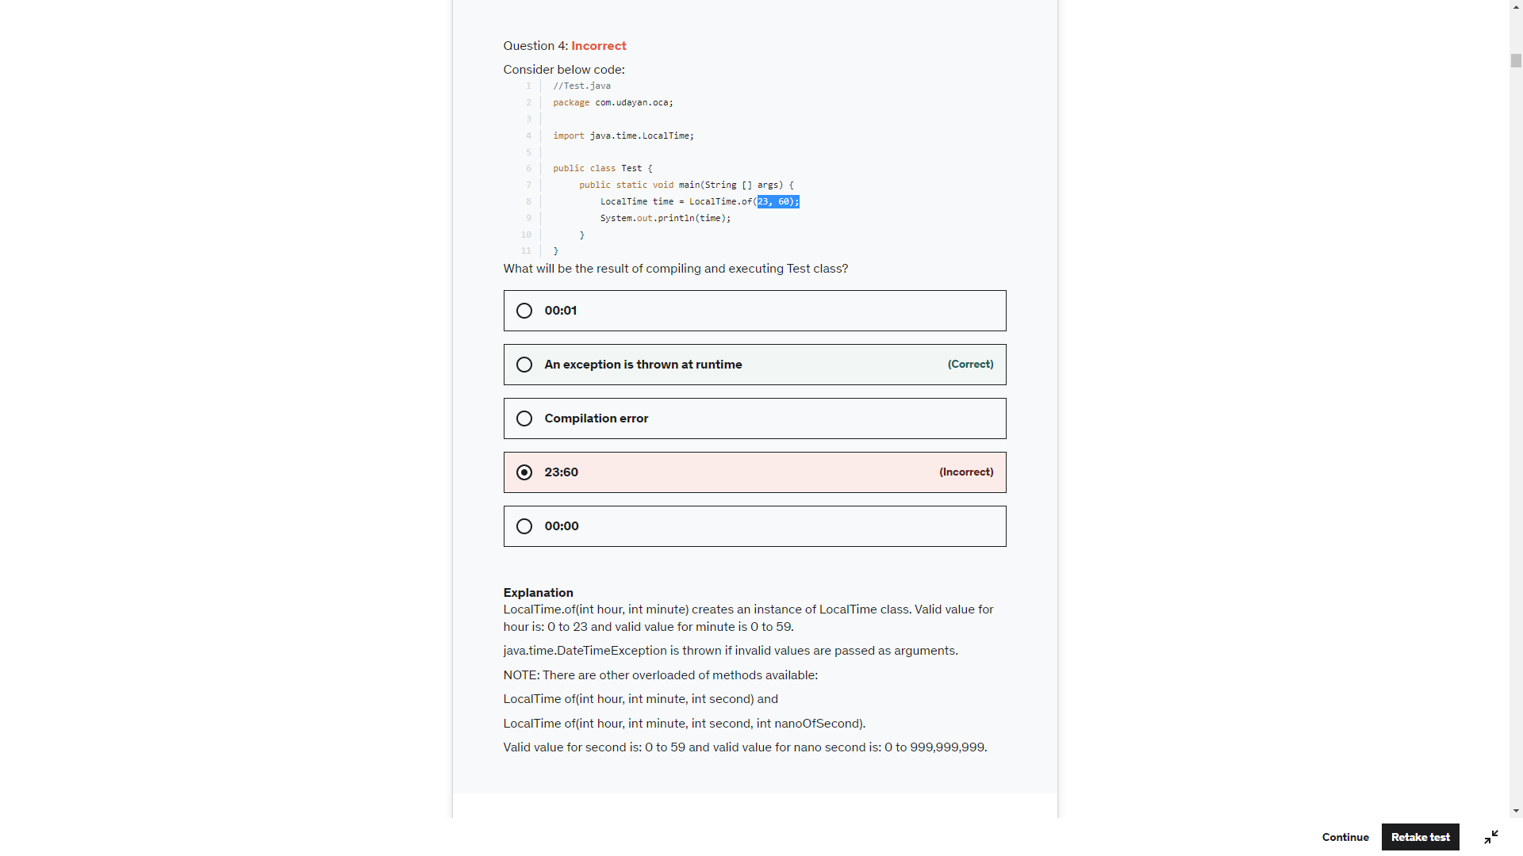

String name= null;

Sop(name)-> null

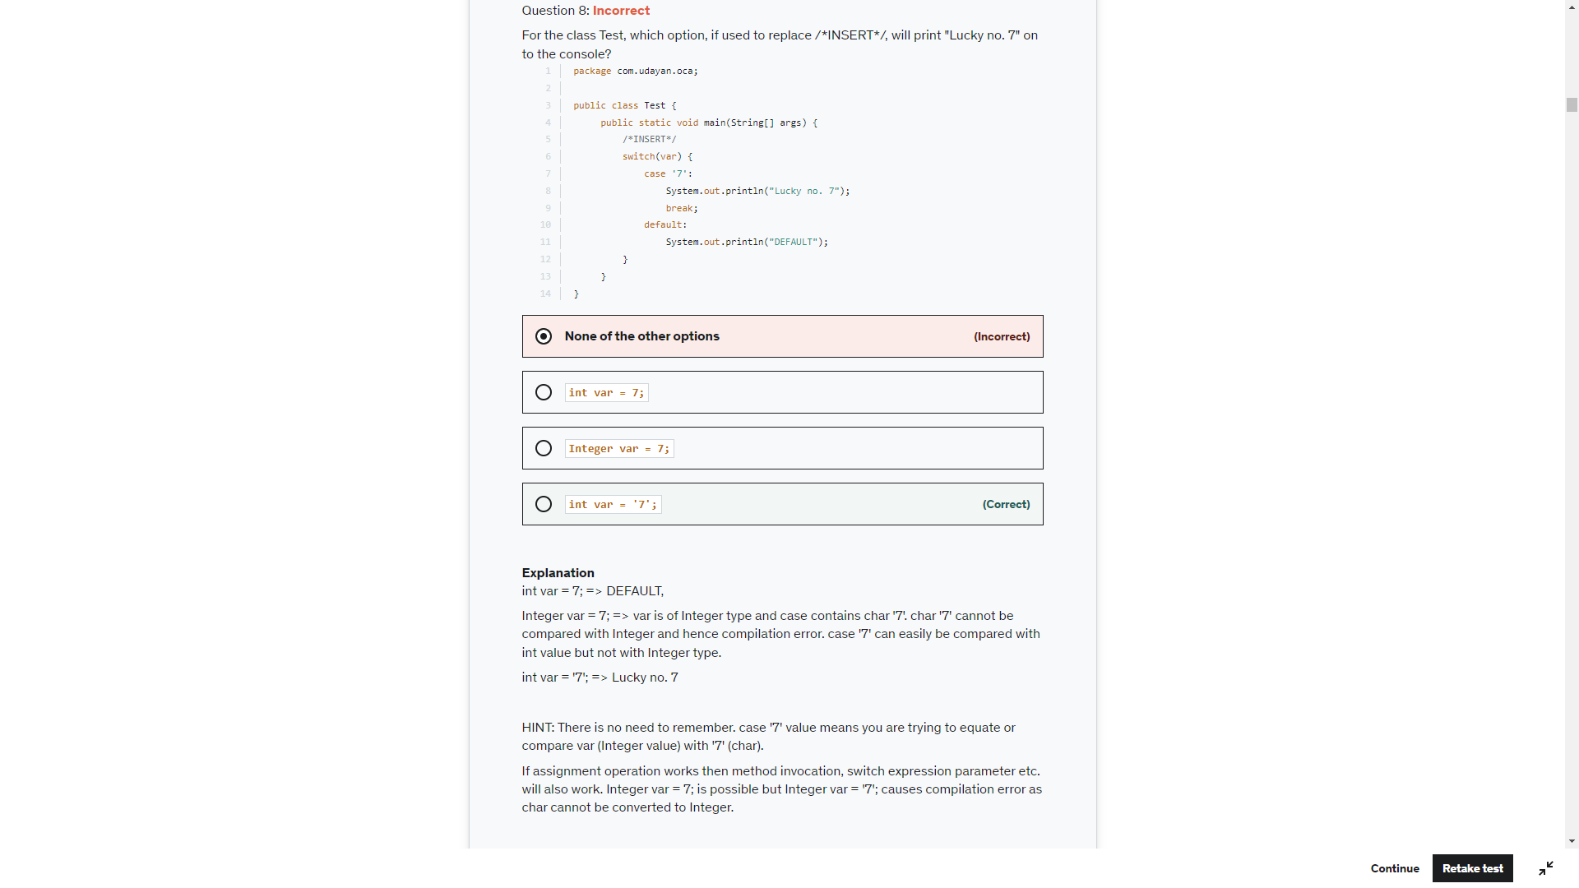

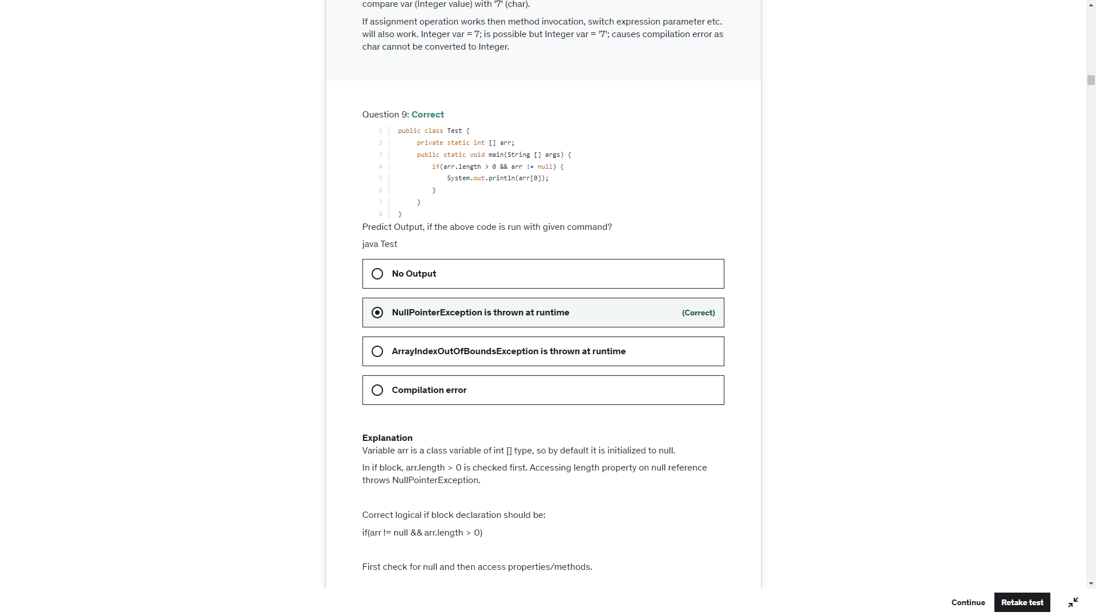

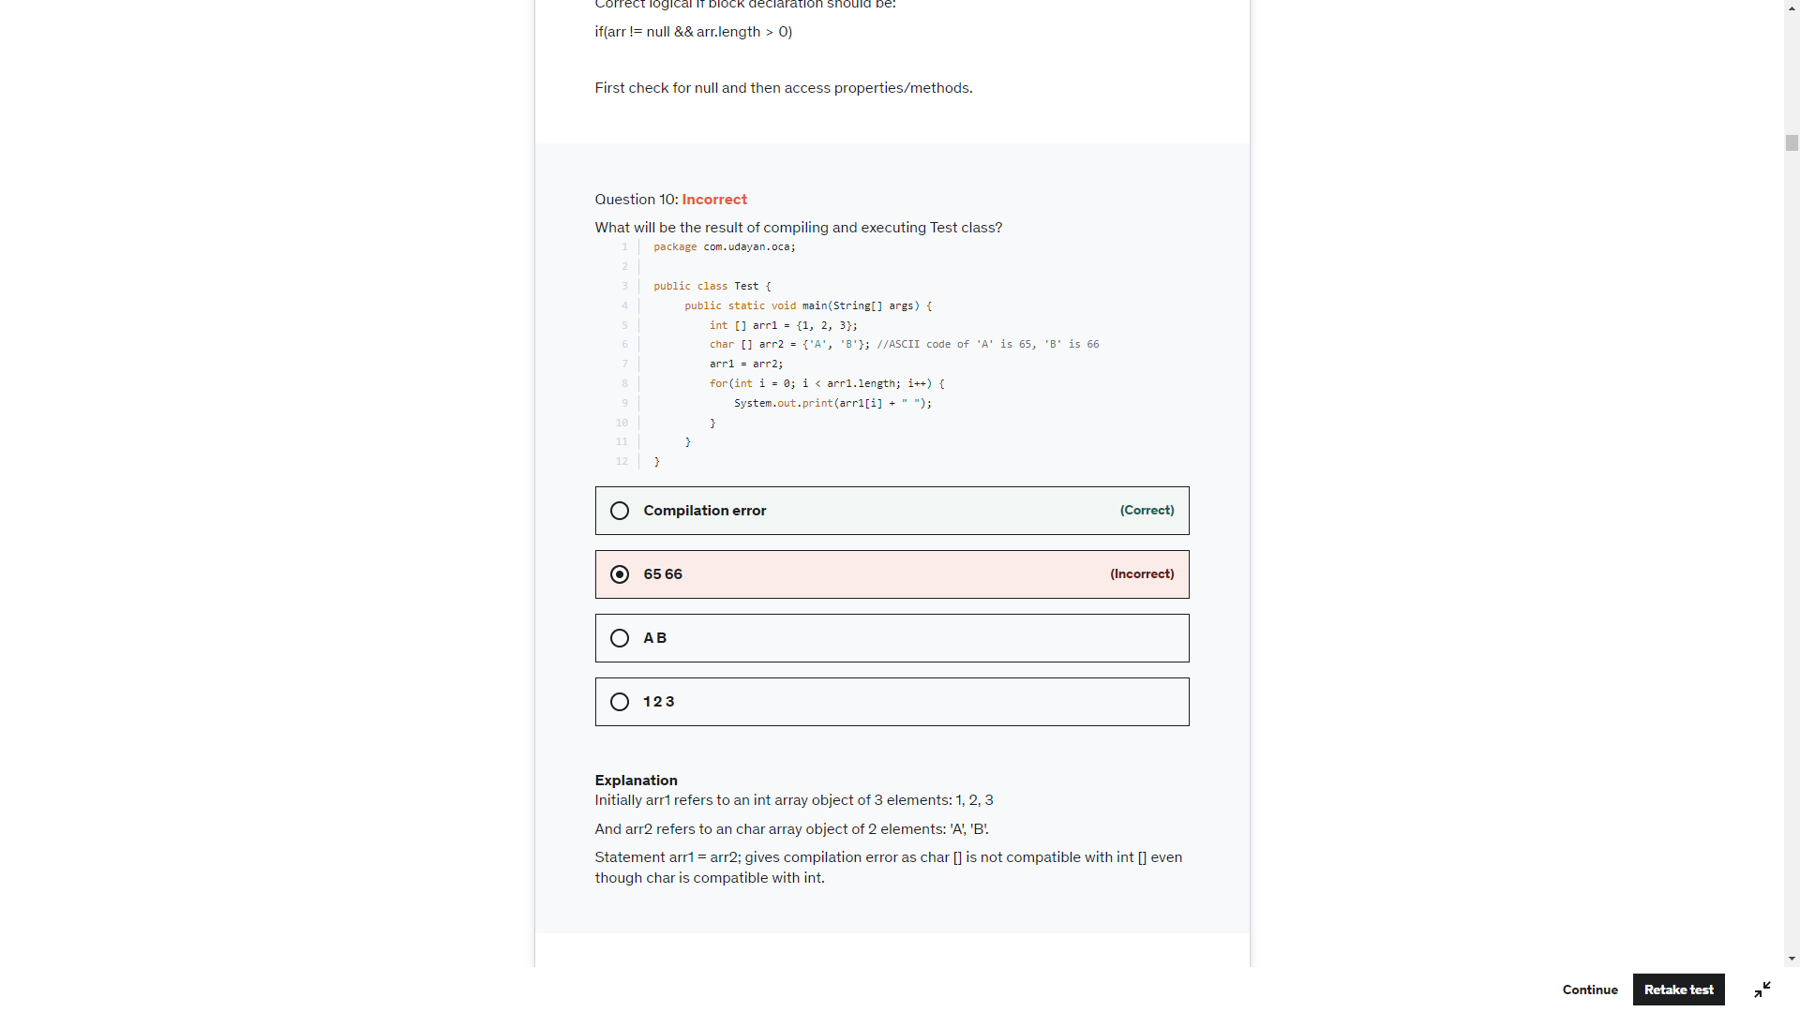

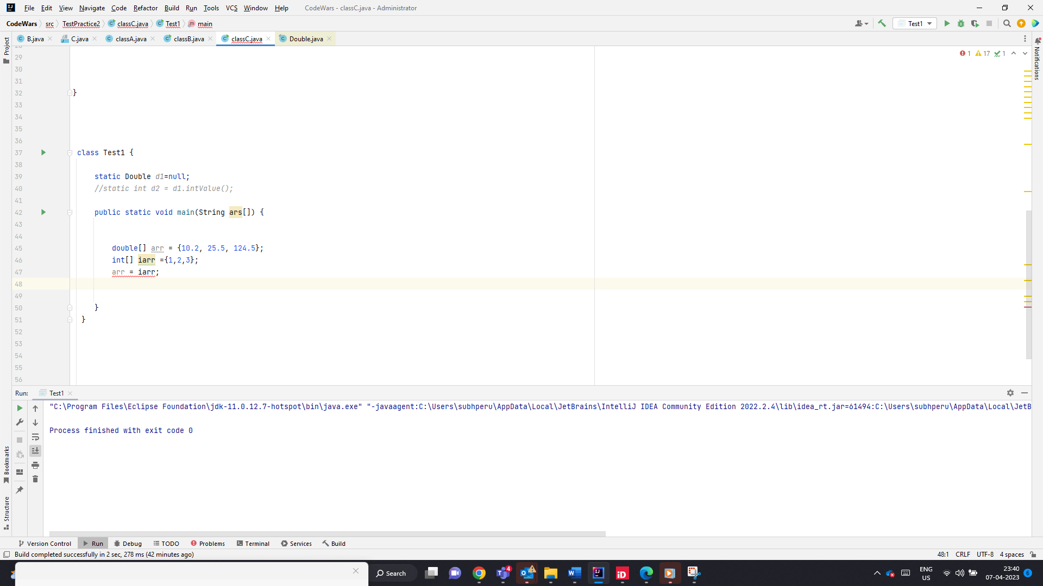

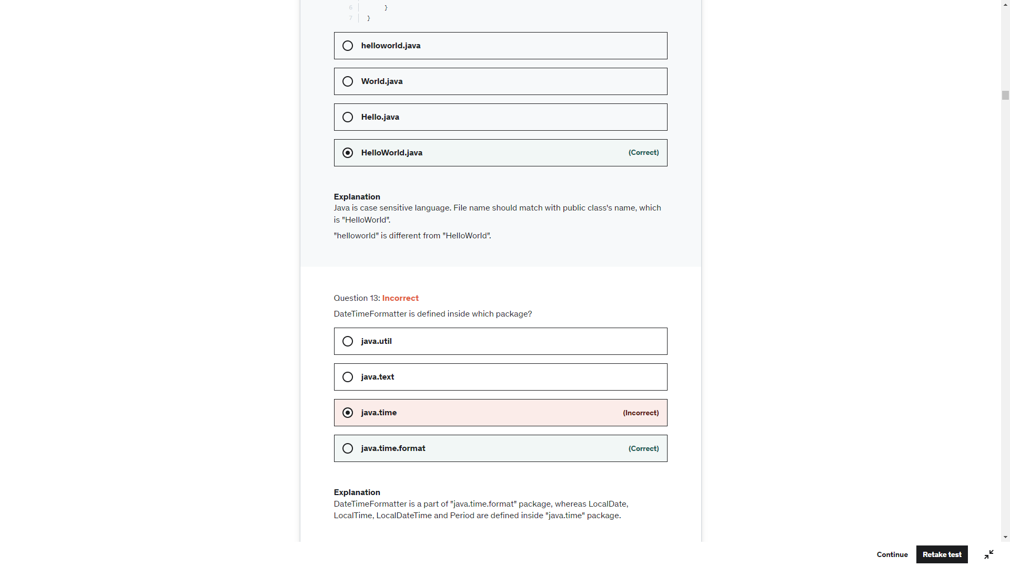

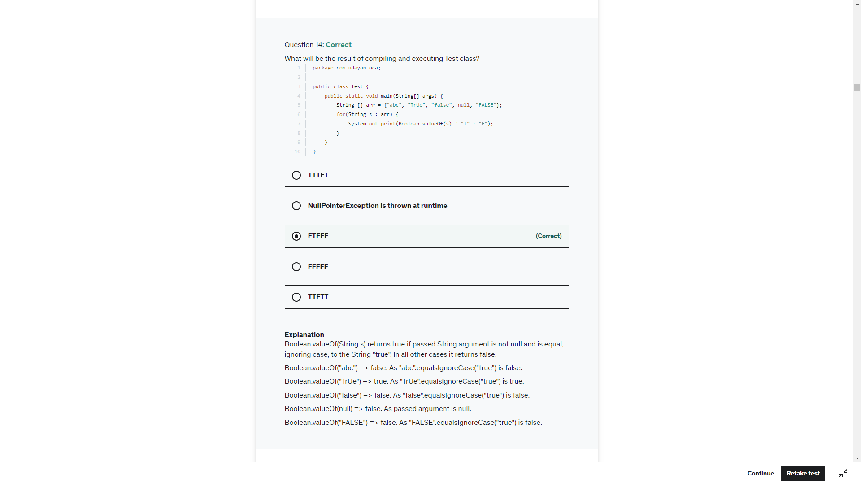

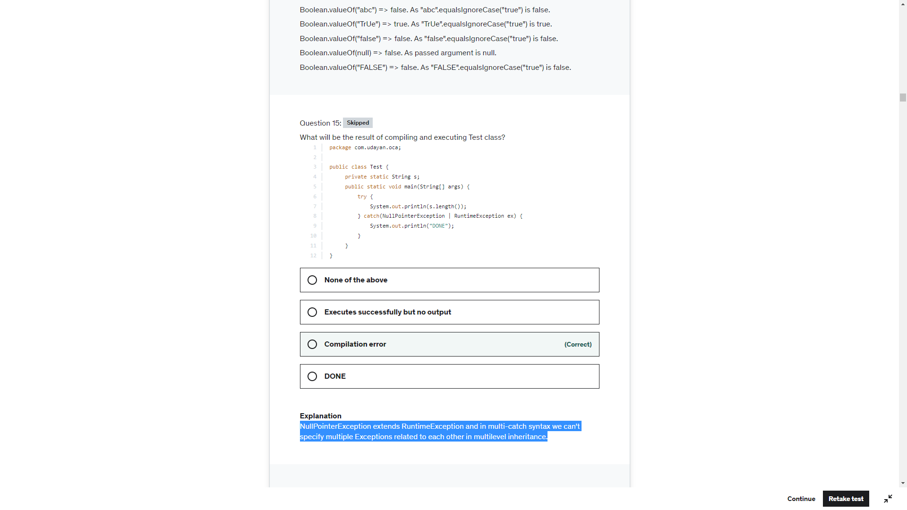

Sb.append(“”).length()->0

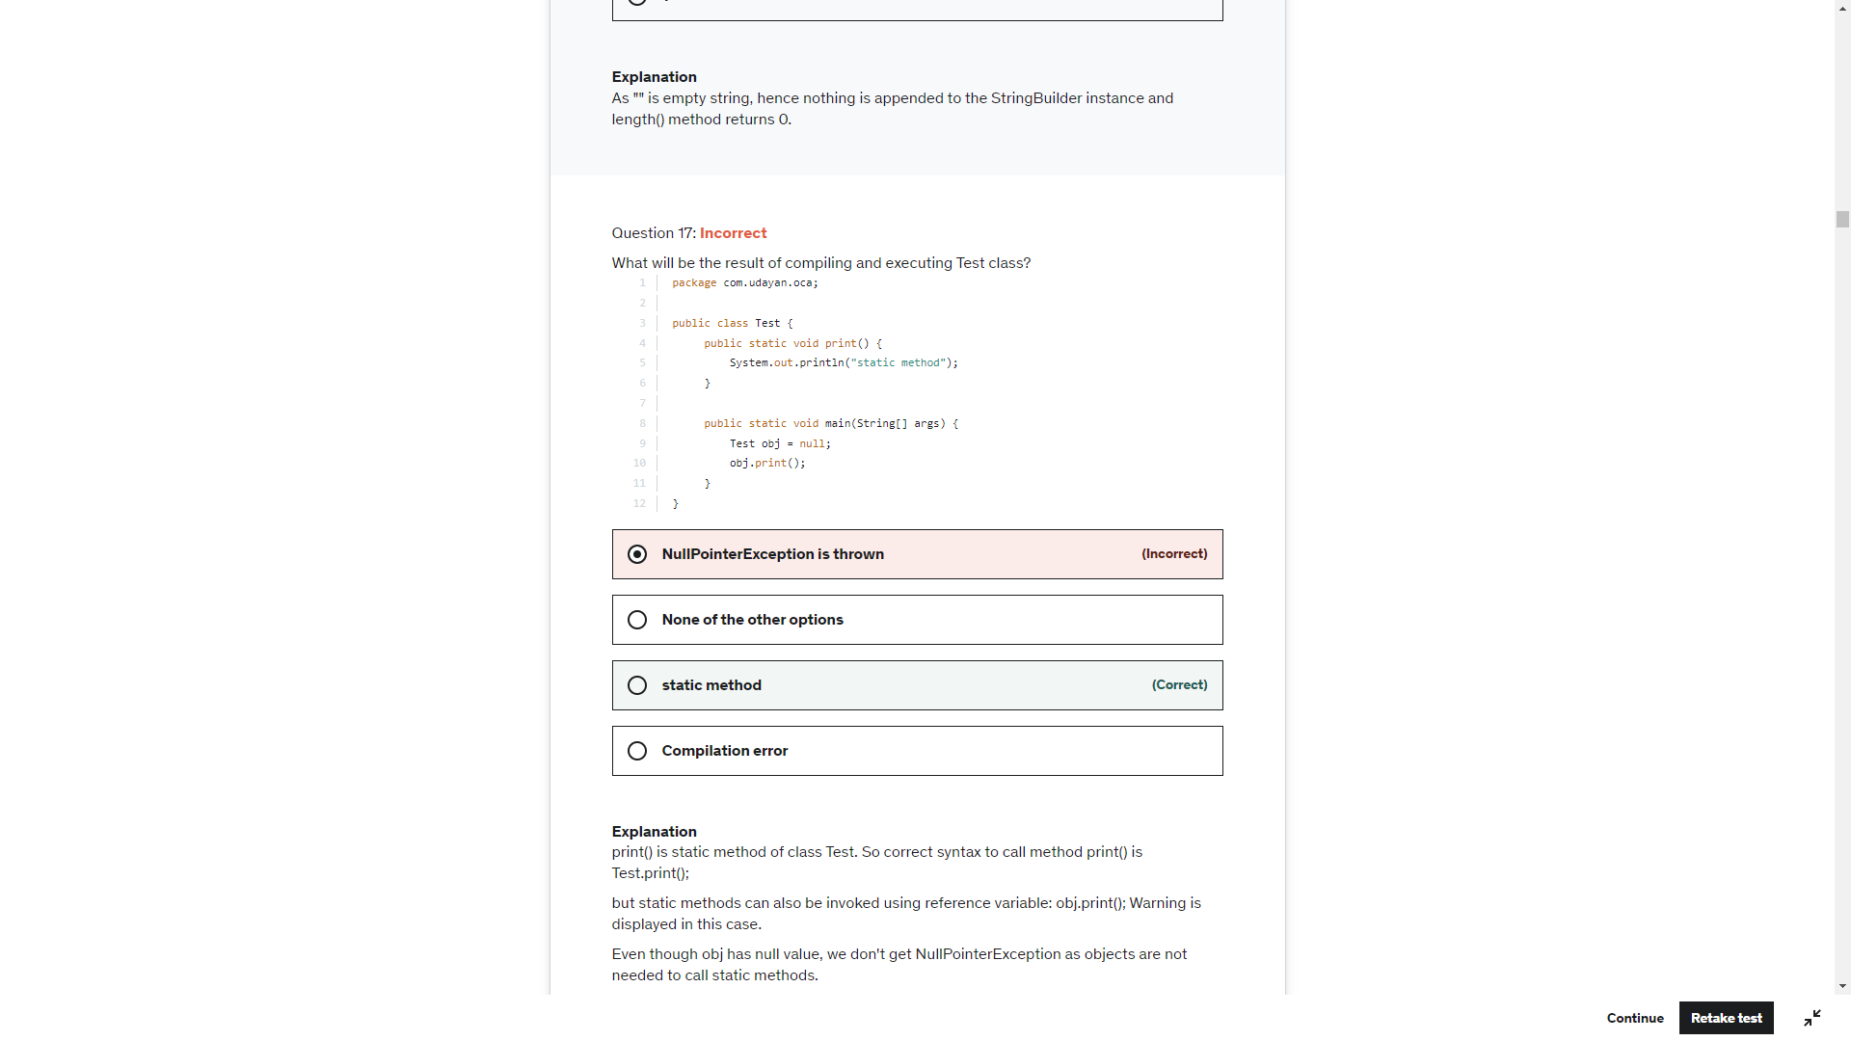

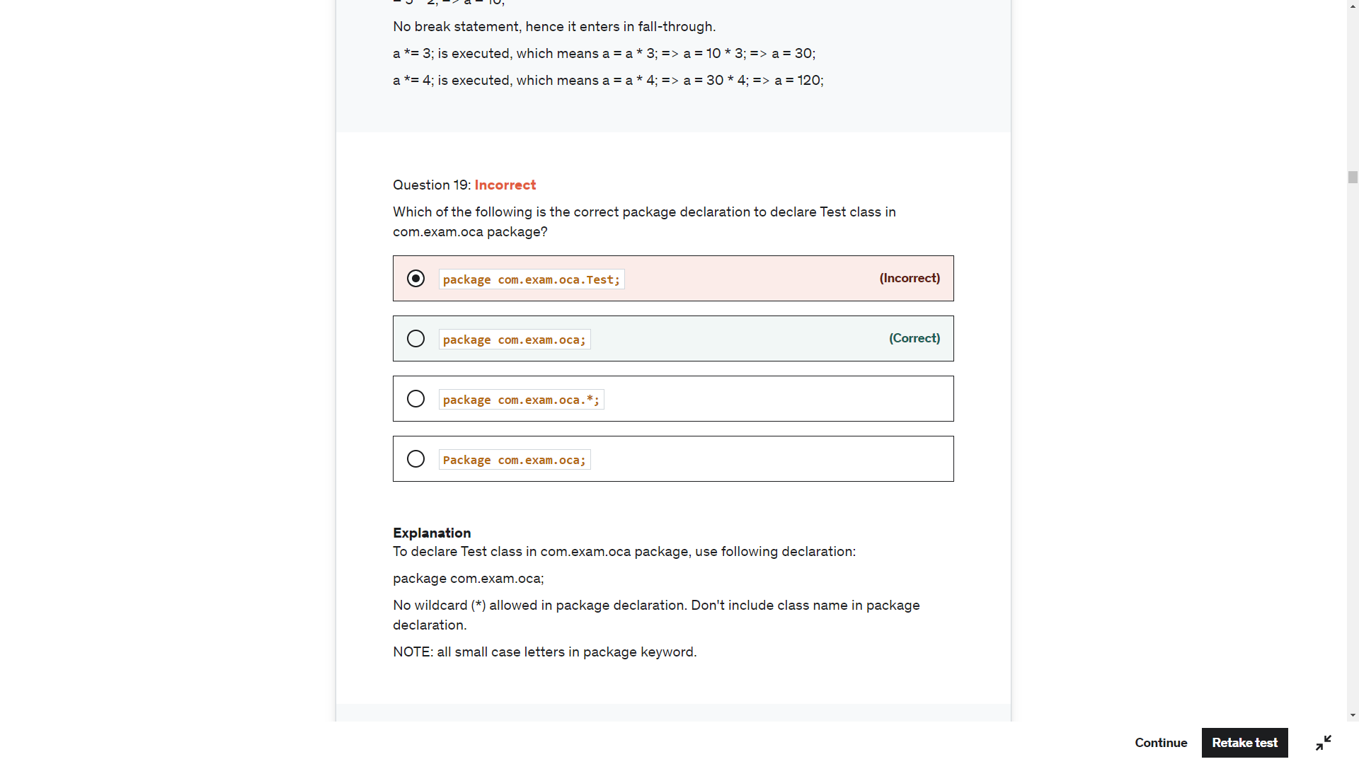

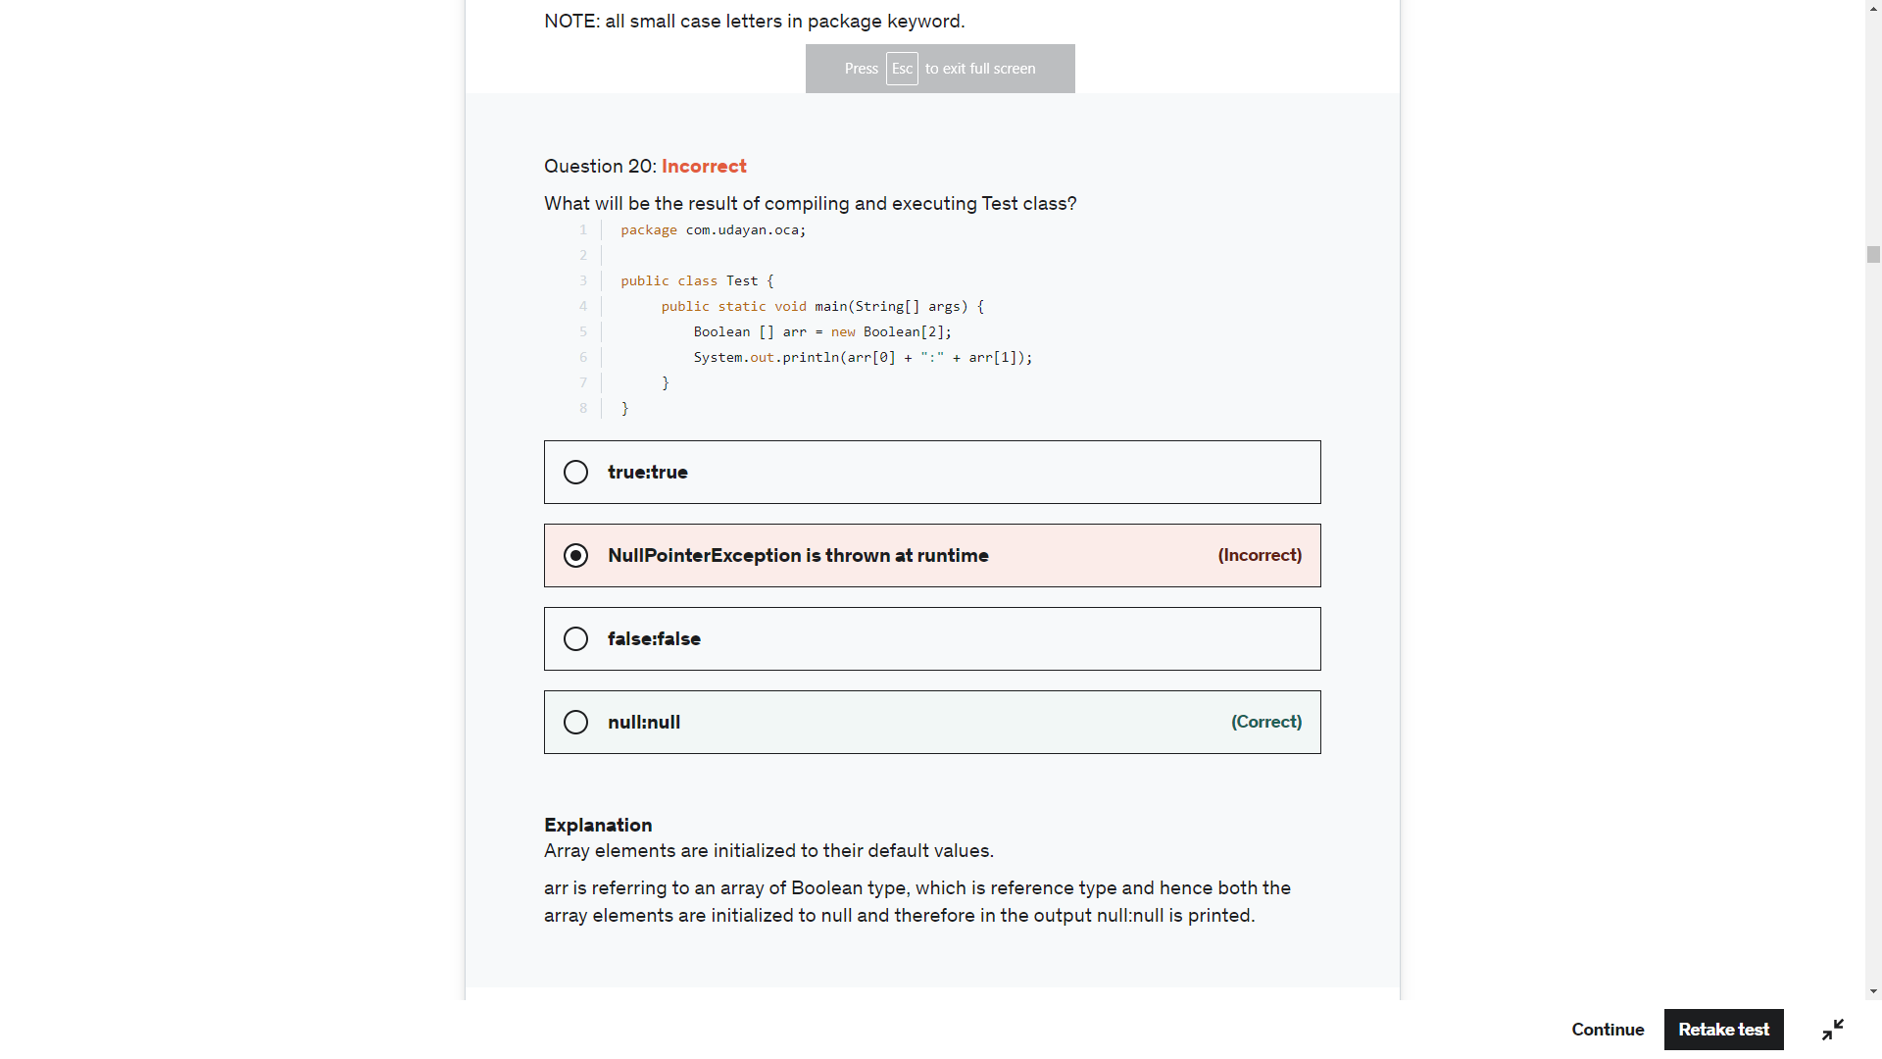

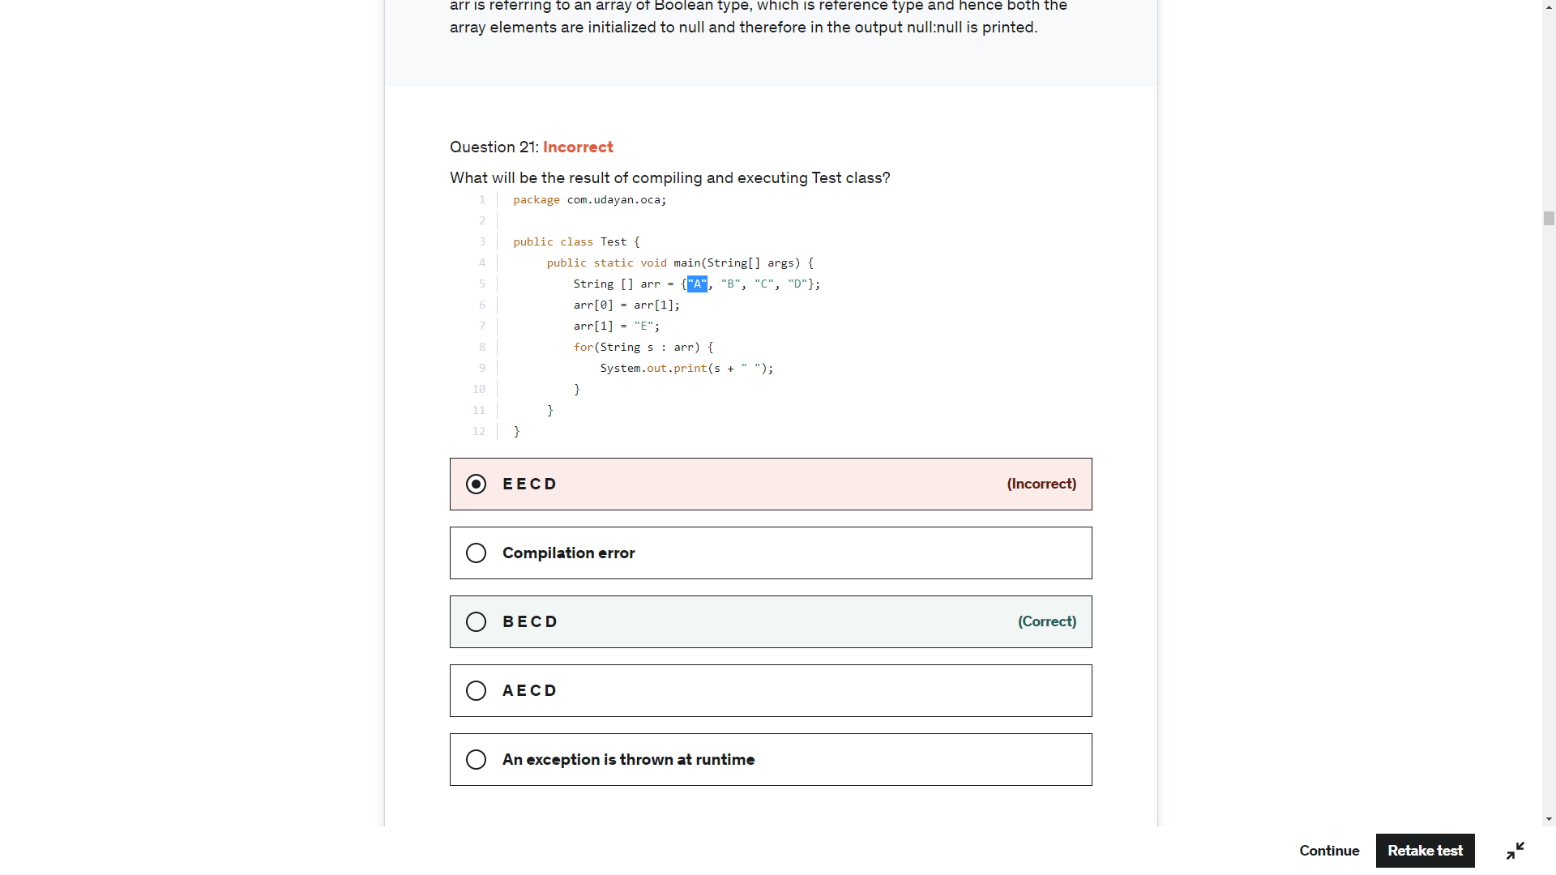

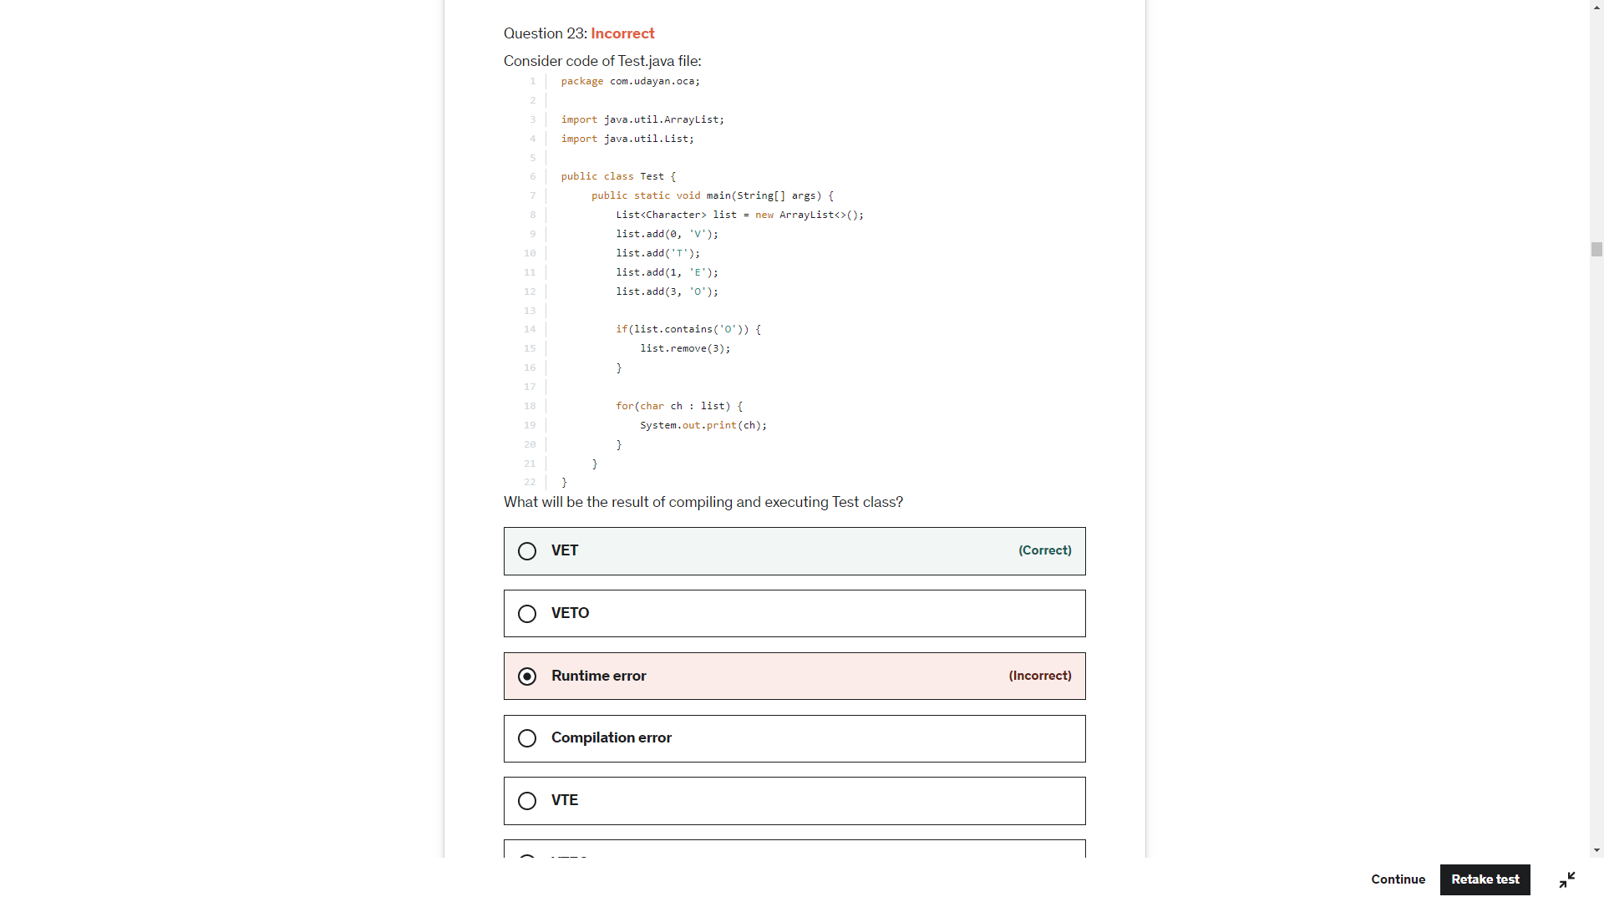

list.contains('O') => char 'O' is auto-boxed to Character object and as Character class overrides equals(String) method this expression returns true. Control goes inside if-block and executes: list.remove(3);.

list.remove(3); => Removes last element of the list. list --> [V,E,T].

for(char ch : list) => First list item is Character object, which is auto-unboxed and assigned to ch. This means in first iteration ch = 'V'; And after this it is simple enhanced for loop. Output is VET.

